Transaction & Multimedia option topics selected
Syllabus Points | Notes
Techniques for managing a project
Communication skills necessary for dealing with others | COMMUNICATION SKILLS
  Project management | The process of planning, scheduling and controlling all activities within each stage of the system development cycle
  Active listening | Restating, reflecting and summarising the speaker’s major ideas and feelings  - Strategy for improving listening skills  - Active listeners encourage the speaker  - Aim: to better receive and understand the speaker’s intended message and for the speaker to know that the listener has received and understood their message  Active listening techniques:
    Mirroring | Involves repeating back some of the speaker’s key words  - Indicates to the speaker interest and desire to know more  - Allows the speaker to reflect on words they spoke  - Doesn’t confirm that the message has been understood
    Paraphrasing | The listener using their own words to explain what the speaker said  - Taking key points out, shortening what was said to make meaning clearer  - Allows the speaker to understand how their message was received  - Listener acknowledges the speakers feeling  - Listener showings meaning and understanding in response
    Summarising | Used to refocus or direct the speaker to some important topic or reach agreement so that the conversation can end  - A summary of an important point will cause the speaker to elaborate in more detail on that point  - A summary confirms understanding in the speaker’s mind
    Clarifying questions | Listener asking questions or making statements that encourage the speaker to provide more detailed explanations  - Open-ended questions allow a free and extended response  - Closed questions encourage single word or short answers
    Motivational responses | Purpose is to encourage the speaker and reinforce in their mind that you are listening and interested in what they are saying  - Can involve self-disclosure where the listener relates a similar experience briefly  - Shows acceptance of the speaker and sympathy or understanding of their situation
  Conflict resolution | Solves arguments and disputes  - Involves listening to the other people’s views and looking at the conflict as a problem to be solved  - Aim of conflict resolution is for all parties to participate, understand and then accept the final outcome  - Conflict is not always a bad thing  Common areas of conflict:  - Allocating limited resources to development tasks  - Funds, time allocated  - Different goals of team members  - Different interests, experience, area of expertise  - E.g. graphic designer would rate visual appearance of a user interface over functionality  - Scheduling of tasks  - Tasks must be performed in a sequence, the ability to complete one task may be reliant on completion of another  - Personal differences  - Cultural, educational, religious, age, experience  - Internal conflict with individuals  - Conflict between personal and work commitments causing stress, frustration and decreased productivity  Strategies for resolving conflict:  - Attack the problem not the person  - Define the problem and explore each person’s perception of it  - Understand each person’s point of view without judging them  - Brainstorming  - Each person expresses ideas as they come to mind, new and innovative solutions can emerge  - Mediation  - Mediators are peacemakers that ensure opposing parties understand and appreciate each other’s feelings and point of view  - Group problem solving  - Each person expresses their point of view whilst other group members listen without criticism
  Negotiation skills | Discussing a problem and arriving at a consensus  - Involves listening to different views and compromising to reach a solution  Negotiation techniques:
    Knowledge of everything in advance | - Knowing in advance everything about the person, product, service, organisation prior to negotiations  - Set limits in advance to know when to back off and reassess the situation
    Considering possible arrangements in advance | - Considering a range of possible acceptable arrangements in advance  - Aim is to anticipate the other party’s position and prepare a reaction in advance
    Approaching the party and making an appointment in advance | - At this time, ensure the party understands the agenda so they can prepare sufficiently and negotiation and agreement will be possible  - Aim is to negotiate the best deal
    Lower expectations | - Improves bargaining power as there is room to compromise during negotiation  - Other party will feel they have negotiated a better deal when they have lowered your initial expectations
    Confidence and assertiveness | - Allows for maintenance of control during negotiation process  - Knowledge and understanding of the situation:  - Makes being assertive easier  - Points will be delivered with confidence  - Formulating logical responses will be more effective
    Establishing trust and credibility prior to negotiation | - A trusting climate where each party feels credible is a cooperative environment, making compromise more likely
  Interview techniques | Used to identify problems, obtain feedback, recruit and assess staff performance  - Involves preparation, implementation and follow up  - Interviews should be relaxed, professional and private - discourage interruptions  - Interviewer controls the topics and direction of the interview  Rules for interviews:  - Make the interviewee aware of the purpose of the interview  - Ask open-ended questions so that the interviewee must provide information  - Check the responses by restating the interviewee’s viewpoint  - Be aware of body language, it may be communicating a different attitude  - Close the interview by reviewing the main points and thanking the interviewee  - Review notes immediately and follow up with the interviewee on any information that is unclear  Interviewer attributes:
    Positive interviewer attributes | Negative interviewer attributes
    - Well-prepared questions  - Attention and careful listening  - Personal warmth and engaging manner  - Ability to sell ideas and communicate enthusiasm  - Putting the interviewee at ease  - Politeness and generosity  - Focus on the topics required | - Lack of preparation  - Insufficient time for the interview  - Talking too much  - Losing focus  - Letting interviewee direct conversation  - Biassed towards people with similar ideas and styles to their own  - Tendency to remember most positively the person last interviewed
  Team building | A group of people working together to achieve a common aim  - Team members negotiate roles in the team with responsibilities  - Team members’ efforts are coordinated to ensure team efficiency  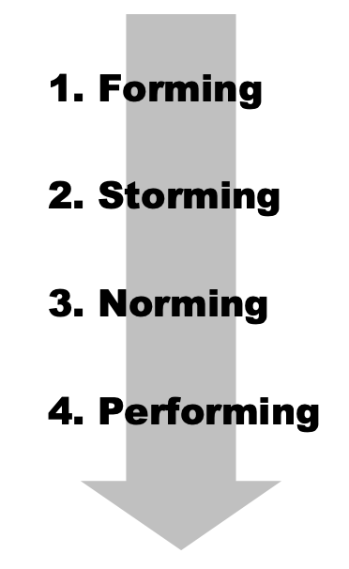  Team building skills and techniques  Tuckman’s (1965) four stages of team development  - Forming  - Team members get to know each other  - Setting overall purpose, goals and expectations  - Storming  - Team members are comfortable with each other  - Team members question issues and fight for position  - Norming  - Team members recognise their differences - personal differences have been resolved  - Roles are established, the team begins to work together  - Team members consider how to adjust procedures and work flows to suit their way of operating  - Performing  - Team is operating as an effective productive unit  - Team members are loyal and supportive of each other, sharing a common commitment to achieve the goals  - Self-regulated and managed  Belbin model  Used to build and develop productive management and work teams.  - Objective is to build a team containing a balance of complementary yet different behavioural and personality types  Classifies potential team members using Belbin’s 9 team role types  - Each person completes a self-assessment questionnaire and similar questionnaires regarding past colleagues  - Compiled results are used as a basis for categorising each person according to Belbin’s role types  - A productive team should include members that include all 9 team roles equally  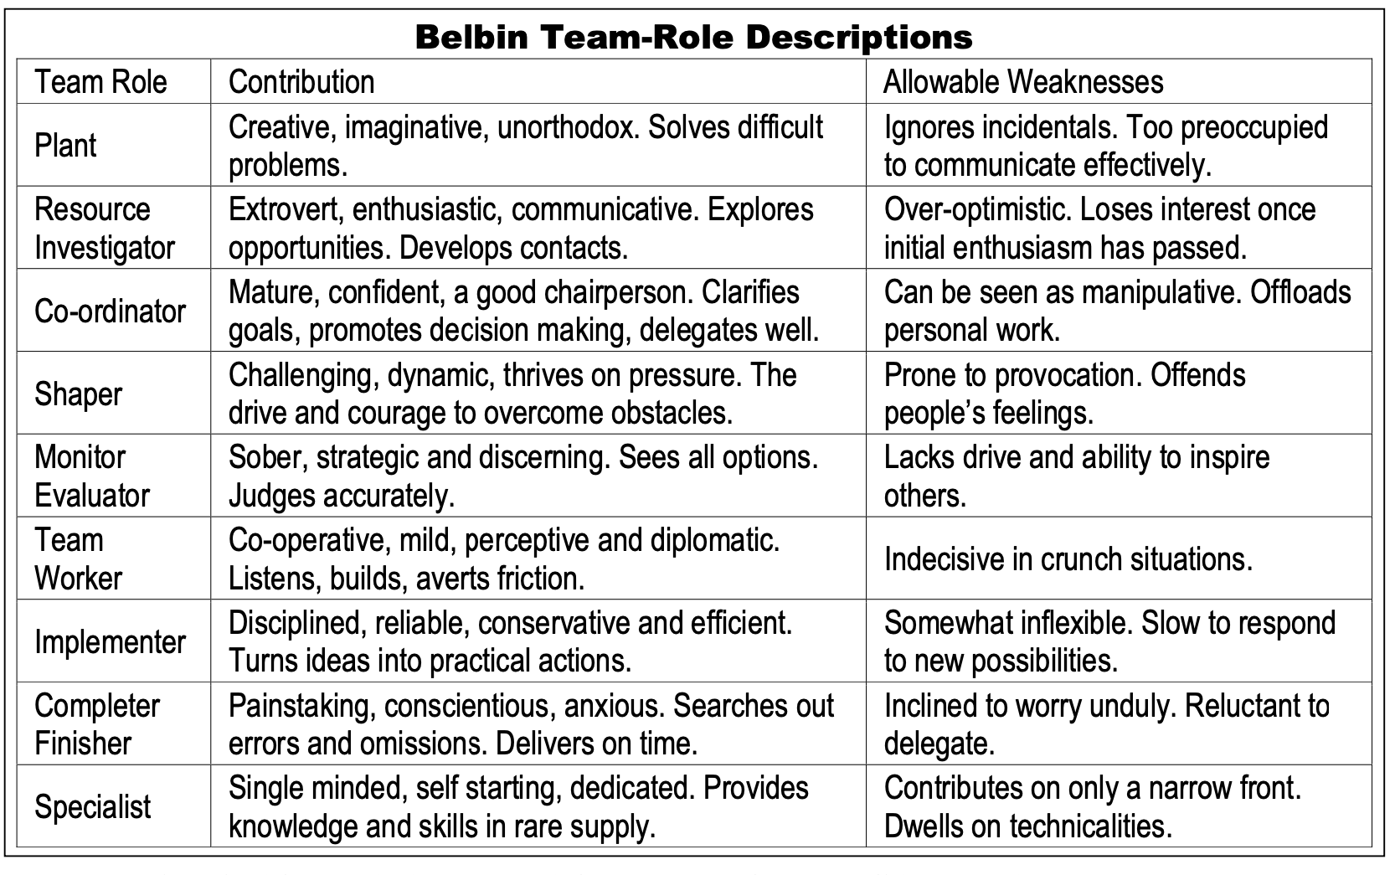
    Advantages of successful teamwork | Consequences of unsuccessful teamwork
    - Development of a quality system - higher quality output  - Enhanced job satisfaction  - Boosted productivity and efficiency  - Shared responsibility  - Less conflict  - Generation of more ideas  - Formulating more solutions  - Skills, experience, attitudes and behaviours complement each other  - Developing collaboration/problem solving skills  - Fewer mistakes  - Building collegial relationships amongst team members | - Financial loss  - Employment loss - retrenched staff  - Missed opportunities for promotion and advancement  - Unable to meet deadlines, produce quality work, operate within financial constraints  - Lower productivity  - Individual skills stagnate
The consequences for groups that fail to function as a team, including:  - Financial loss  - Employment loss  - Missed opportunities | Groups that fail to function as a team result in financial loss, employment loss and missed opportunities.  - These groups are unable to reliably meet deadlines, provide quality work and operate within financial constraints  Financial Loss  Employment Loss  Missed Opportunities  Poor performance of a team reflects poorly on each of its members  Reduced opportunities for promotion and advancement  Unable to operate as a team within financial constraints  If a company is unable to perform, it cannot compete and thus will have difficulty attracting clients  Company profits will fall  Staff will need to be retrenched
Project management tools, including:  - Gantt charts  - Scheduling of tasks  - Journals and diaries  - Funding management plan  - Communication management plan | PROJECT MANAGEMENT TOOLS  Used to document and communicate:  - What each task is  - Who completes each task  - When each task is to be completed  - How much time is available to complete each task  - How much money is available to complete each task
  Gantt Charts | A type of bar chart that shows both the scheduled and completed work over a period of time  - Used in planning and tracking a project  Outlines the activities that need to be performed, the order in which they should be performed and how long each activity is expected to take  Advantages:  - Force a manager to plan the steps needed to complete a task and to specify the time required for each task  - Make it easy to monitor actual progress against planned activities
  Scheduling of tasks | The length of time activities take within the operations process  - Done through using Gantt Charts or other various methods of scheduling
  Journals and diaries | Tools for recording day-to-day progress and detail of completed tasks  - Used to record details of events that have recently occurred
    Diaries | Record factual information  Project managers record when meetings will occur  Team members record appointments that will take them out of the office  - This information is critical for a team to operate smoothly and effectively  - Allows for prioritising tasks  Records:  - Future events/tasks  - Deadlines  - Meetings/Appointments
    Journals | Record detailed analysis and reflection on recent events  Project managers refer to journals to monitor the completion of tasks and identify possible issues  Records:  - Work completed by team members during a project’s development  - As tasks are completed, team members write down what was done and any issues they encountered  - Can include ideas and comments on possible future improvements
  Funding management plan | Aims to ensure the project is developed within budget  - Each development task is allocated sufficient funds at the correct time and funds are spent wisely  Funding management plan specifies:  - How funds will be allocated to tasks  - Whether funds be released in full prior to commencement or progressively during the task, or after the task is complete  - Mechanisms to ensure money is spent wisely throughout the SDLC  - Specifies procedures to be followed when a product a service is ordered during development  - Accountability for each task’s budget  - Someone must be accountable for ensuring each task is completed within its own slice of the budget  - Should detail who is the person for each task, along with the procedures they must follow to allow management to monitor their use of funds  - The procedure for reallocating funds during development  - Should include sufficient flexibility so that funds can be redirected should problems occur
  Communication management plan | Specifies how all parties involved in the system’s development will communicate effectively  - Provides a structure that supports and reinforces effective ongoing communication between all team members throughout the project’s development  Communication management plan specifies:  - The communication medium to be used  - E-mail, newsgroups, facsimile, meetings, weekly bulletins, telephone calls  - The lines of communication  - Specifies how each party is able to obtain answers to questions or communicate other details to and from other project team members and the client directly  - Methods for monitoring the progress of the system’s development  - Includes: completion of tasks, monitoring costs, verifying requirements as part of ongoing testing  - Changing or emerging requirements  - During development, new requirements will emerge or existing requirements will require alteration - Should anticipate this so that new or changed requirements can be effectively communicated to all parties
Identifying social and ethical issues | SOCIAL AND ETHICAL ISSUES  Social and ethical issues related to managing the project team:
  Team members & work environment | - The work environment including WHS  - Ergonomic furniture  - Appropriate lighting/noise levels  - Varied work routines  - Procedures for reporting and resolving WHS problems  - Respect for rights and needs of individual team members  - Respecting a person’s right to privacy - revealing of private life  - Supporting team members - financial support, flexible work hours  - Communication  - Honest and open lines of communication  - Techniques for identifying and resolving conflict  - Encouraging a positive and cooperative climate  - Positive feedback and acknowledgement for completed work
  Project development | - Security of data and information during development  - Mechanisms to protect against data loss - regular backups, physical barriers  - Techniques to restrict access - passwords, encryption, access rights  - Virus protection  - Copyright issues  - Determining who retains the copyrights for the new system  - The individual team member, the company or the client  - Procedures for obtaining permission and documenting the use of copyrighted material  - Includes software used to assist development and software incorporated within the solution  - Privacy issues  - Respect the confidentiality of data
The System Development Life Cycle (SDLC)  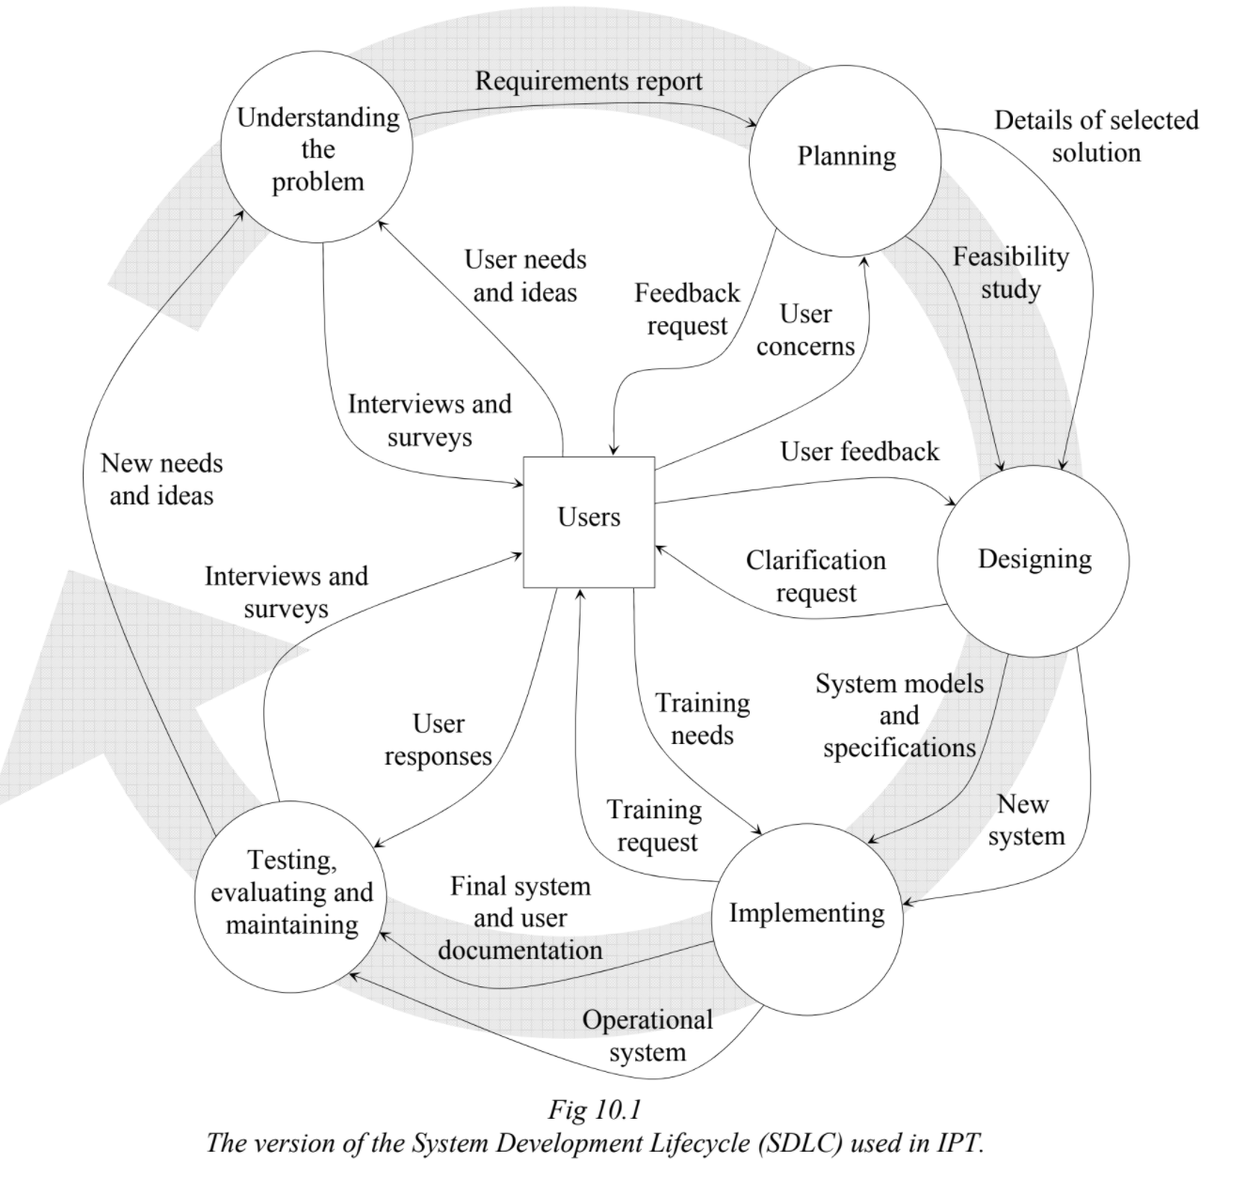 | STAGES OF THE SYSTEM DEVELOPMENT LIFE CYCLE
  1 | Understanding the problem  Working out precisely what problem needs to be solved
  2 | Planning  Possible solutions are considered and the best solutions are selected. Details how the project will be managed
  3 | Designing  The details of the new system are decided upon. Includes the information technology and its interaction with other components and participants to perform the information processes
  4 | Implementing  The components of the new system are purchased and installed. Participants are trained and the system commences operation
  5 | Testing, evaluating and maintaining  Tests are performed to ensure the system meets the requirements and continues to meet its requirements. As new needs emerge and the system is altered to suit, ongoing maintenance is performed to prevent and correct problems during normal operation.
Understanding the problem
Approaches to identify problems with existing systems, including:  - Interviewing/surveying users of the information system  - Interviewing/surveying participants  - Analysing the existing system by determining:  - How it works  - What it does  - Who uses it  Activities performed and deliverables produced during the stage:  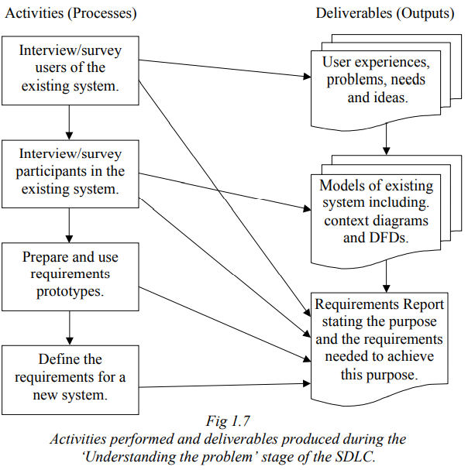 | The purpose of an information system is primarily to fulfil the needs of its users.  APPROACHES TO IDENTIFY PROBLEMS WITHIN EXISTING SYSTEMS  Interviews and surveys are the primary tools for collecting user experiences and problems with an existing system, also for identifying their needs and any new ideas they may have to improve the system  - Compiled results are analysed to determine and prioritise problems with the new system, identify user needs and to document new ideas  INTERVIEW/SURVEY USERS & PARTICIPANTS
  Understanding the problem | Working out precisely what problem needs to be solved  Aim: to determine the purpose and requirements of a new system
  Requirement | A feature, property or behaviour that a system must have  - A system that satisfies all requirements has achieved its purpose
  Users | - Questions are designed created in advance so that they can draw out relevant information so that data acquired can be used to address existing problems and needs  - Results of surveys are useful for highlighting existing problems rather than revealing new needs and ideas that are not currently being addressed  - New needs and ideas are more likely to reveal themselves via personal and informal interviews conducted with users in their own environment  - Interviews conducted with small focus groups of users can informally discuss particular aspects of the system critical to these users  Larger sample → more statistically reliable results  What people say they need and what they actually need is often different
  Participants | Participants within existing systems have an understanding of the part of the system with which they primarily interact  - Are a source of information in regard to the detail of the information processes occurring within the existing system  - Are able to identify problems and have ideas in regard to solving the problems  Results of the interviews/surveys are used to create models (e.g. data flow diagrams) of the existing system and to create the final requirements report for the new system  - Participants are familiar with the procedures required to perform their specific tasks  - They may be unfamiliar with how the system performs the tasks or how the tasks contribute to the larger information system
Requirements report  Requirements Report - Sample Outline  Description of components →  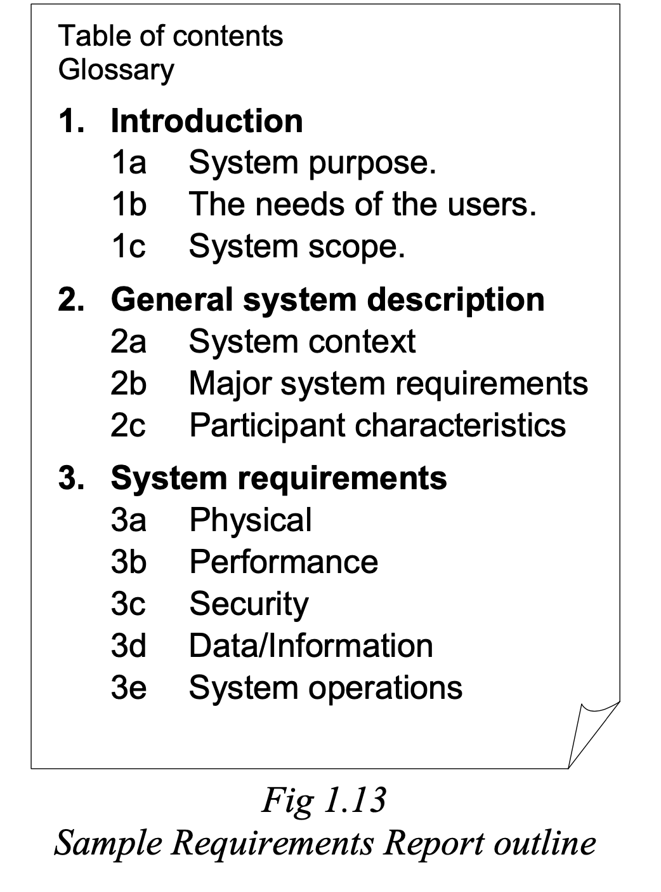 | REQUIREMENTS REPORT  Requirement reports do not attempt to solve the problem.  - System analyst must be careful to avoid references and inferences that imply a particular solution  Use: When planning, the Requirements Report is used to determine possible solution options and their feasibility  - The Requirements Report forms a communication interface between the client and the system’s technical developers  - Developing a Requirements Report requires feedback from both client and technical community  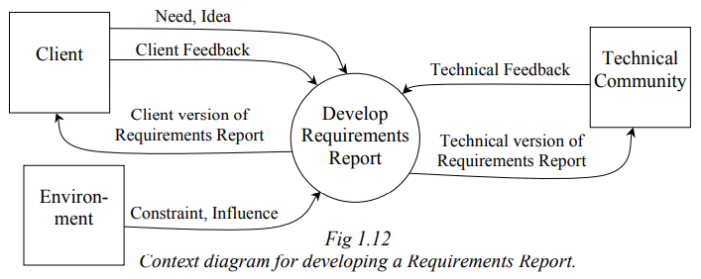  Client → organisation, representative who approves requirements  Technical community → developmental personnel who design, build and test the new system  Environment → an entity that influences and places constraints on the requirements  CONTRACT  - The Requirements Report forms the contract between the client and the system’s development team as it is a ‘blueprint’ of what the system will do  - The contract is a formal legal agreement, signed by both the client and the system’s developers  - The system is complete once all requirements have been met, and hence the contract is also complete
  Requirements report | Specifies the inputs and the outputs together with their relationships to each other.  - A ‘blueprint’ of what the system will do
  Requirements Report Components
  Terminology | Definition of the Terminology
  Introduction
  System purpose | Identifies the overall aims and objectives of the system.  - The needs of the client are included  - Purpose is the reason the system is being developed
  User needs | A set of factors which the users require in order to smoothly use the information system.  - It is the needs which must be addressed by the information system.  - This may not include all identified needs in interviews/surveys.
  System scope | Explanation of what the system will and won’t do.  - Explains all major functionality included in the new system  - Functionality that won’t be included should be excluded  - The boundaries of the system are defined
  General system description
  System context | A summary of all the data/information which enters and leaves the information system.  - This includes the data source and destination.  - A context diagram is used together with a written description.
  Major system requirements | A description of the significant capabilities of the information system.  - The description may include diagrams as well as written descriptions.
  Participant characteristics | A description of each different type of participant identified and the nature of their work using the information system.
  System requirements
  Physical | Any requirements that specify the system’s physical equipment and physical environment in which it will operate.  - Includes requirements of the hardware’s:  - Construction  - Weight  - Dimensions  - Quality  - Future expansion  - Life expectancy  - Includes requirements of the physical environment:  - Temperature  - Humidity  - Motion  - Noise  - Electromagnetic interference levels  - If equipment is outside, the requirements may be in regard to rain and wind conditions.
  Performance | A description of the requirements that relates to the ability of the system to complete its processes efficiently.  - It includes the time taken by the system to complete tasks, the accuracy of the information outputted, and the frequency of tasks.
  Security | A description of all requirements which concern access to the system and the privacy of data/information within it.  - Includes protection against data loss, backup and recovery.
  Data/Information | A description of all requirements about the data and informational needs of the system.  - Includes what data is kept and what information is produced.  - Relates to the organisation and storage of data.
  System operations | A description of the system during its operations.  - Includes human factors regarding user interface, ergonomic design of equipment, hardware and software.  - Involves requirements which support the system’s continual operation, e.g. regular preventative maintenance, reliability and repair times.
Requirements prototype - a working model of an information system, built in order to understand the requirements of the system  - Used when the problem is not easily understood  - Repetitive process of prototype modification and participants’ feedback until the problem is understood  - Can be the basis for further system development | REQUIREMENTS PROTOTYPE  Users and participants use the requirements prototype as they simulate the tasks they will perform with the real system  - Requirements prototypes do not contain any real processing (records are not added, edited or validated)  - Used when the problem is not easily understood  - E.g. to better understand the interface and system requirements  - Repetitive process of prototype modification and participants’ feedback until the problem is understood  - A sequence of requirements prototypes are produced, each being a refinement of the previous version in response to feedback, this occurring until both developers and participants are satisfied that all requirements are understood  - Can be the basis for further system development  - Aside from gathering and clarifying user interface requirements, requirements prototypes can assist with understanding and generating idea for other system requirements  - Software tools create standalone requirements prototypes that allow users to add comments and make changes to screen layouts.  - Prototypes can evolve into the new system if created using the same software that will be used for developing the real system
  Requirements prototype | A working model of an information system, built in order to understand the requirements of the system by simulating the final look and behaviour of the system  Aim: to confirm, clarify and better understand the requirements
Planning
A feasibility study of proposed solutions, including:  - Economic feasibility  - Technical feasibility  - Operational feasibility  - Scheduling | FEASIBILITY STUDY
  Feasibility | Capable of being achieved using the available resources and meeting the identified requirements  - Without a common set of requirements it would be difficult to make a fair comparison between different solution options
  Feasibility study | Feasibility study examines each possible solution option in terms of four feasibility criteria:  - Economic feasibility, technical feasibility, operational feasibility, scheduling
  Economic feasibility | Determined by performing a “cost-benefit analysis”  - Involves calculating all the costs involved in the development and implementation of each solution option  - Issues to consider when performing “cost-benefit analysis”:  - Money spent on the new system could have been invested elsewhere, hence the benefits of the new system must exceed benefits realised without the new system  - Comparing the percentage profitability of each option rather than just the absolute profit (ROI - Return on Investment)  - When will the new system have paid for itself? The ‘break-even point’.  Factors affecting a solution’s economic feasibility:  - Development costs  - Cost of the development team  - System analyst and other consultancy fees  - Software costs to purchase or build the software  - Hardware costs to purchase, lease and/or assemble the hardware  - Infrastructure costs such as new buildings, communication links and power  - Installation of the system  - Training participants and users  - Converting from the old system to the new system  - Ongoing operational costs  - Hardware maintenance and repair costs  - Software licences and upgrade  - Maintenance of infrastructure that supports the system  - Salary/wages for participants  - Support costs for users, including ongoing training  - Consumables such as toner cartridges and paper  - Tangible benefits  - increased sales  - cost reductions  - increased efficiency  - increased profit on sales  - more effective use of staff time  - Intangible benefits  - customer satisfaction  - quality of products or services  - increased flexibility of the system
  Technical feasibility | Concerned with the availability of the required information technology  - Its ability to operate with other technology and the technical expertise of participants and users to effectively use the new technology  Questions used to determine a solution’s technical feasibility include:  - Do we currently possess the necessary technology?  - Is the technology readily available?  - How widely used is the technology?  - Are existing users of the technology happy with its quality and performance?  - Will the technology continue to be upgraded and supported in the future?  - Will the technology operate with other existing and possible future new or emerging technologies?
  Operational feasibility | Evaluates whether each solution option will work in practice rather than whether it can work.  - It considers support for the new system from management and existing employees.  Questions used to determine a solution’s operational feasibility include:  - Do existing staff support the solution option?  - Does management support the solution option?  - Does the nature of the solution ‘fit in’ or conflict with the nature of other systems that will remain in place?  - Will the nature of work change for participants?  - Are participants open to change or resistant to change?  - How do the end-users feel about the delivery of information from the new system?  - Do participants already possess the technical expertise?  - Do users already possess the technical skills to use the technology?  - Is training and support available and will it remain available?
  Scheduling | In regards to the time taken and deadlines involved in the completion of each task.  - It provides an examination of the consequences of failing to complete tasks on time.  Questions used to determine a solution’s schedule feasibility include:  - How long will it take to obtain information technology, employ new personnel and retrain existing employees?  - Will retraining impact the ability of employees to complete tasks on time?  - Are the deadlines mandatory and are they realistically achievable for each task?  - What are the consequences of failing to meet deadlines?  - Is it possible to use an incomplete solution if deadlines are not met?  - How can the development of a solution be monitored to determine if deadlines can be met?
Choosing the most appropriate solution | System Development Approaches - Class Notes
Choosing the appropriate development approaches  - Traditional  - Outsourcing  - Prototyping  - Customisation  - Participant development  - Agile methods | DEVELOPMENT APPROACHES  System development approaches can be used in isolation, combined and/or integrated to form a system development approach appropriate for developing any project.  - Nature of the development team and individual characteristics of each project determines which development approach should be selected
  Traditional | 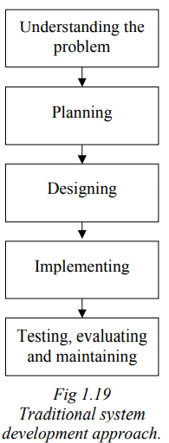  Involves formal step-by-step stages  - Each stage is a prerequisite for the next - each stage produces deliverables that are essential inputs required to begin the next stage  No returning to a previous stage and there are few opportunities for users and others to provide ongoing feedback.  - Results in errors or omissions feeding through the system development cycle without detection until the system is operational  Approach well suited for:  - Large, critical systems  - New hardware products  The performance and reliability of these systems is vital and the requirements of these systems can be determined in advance.
  Outsourcing | Using another company to develop parts of the system or even the complete system  - More cost effective to outsource specialised tasks to experienced companies  Benefits of outsourcing to IT specialist consultancy companies:  - Work with a large number of businesses  - Have extensive experience with all available IT options  - Performs all the system analysis tasks including preparing a feasibility study  - Liaise with suppliers and development companies during design and implementation phases  Extra cost involved to hire consultants is returned through higher quality systems that better meet requirements
    Outsourcing  (Control) | The outsourced company has control for the entire process  - Requirements and time for completion are negotiated  - Project management and development approaches are determined and controlled by the outsourced company
    Contracting  (No control) | The outsourced company performs their tasks under direct management and control of the contracting organisation
  Prototyping | 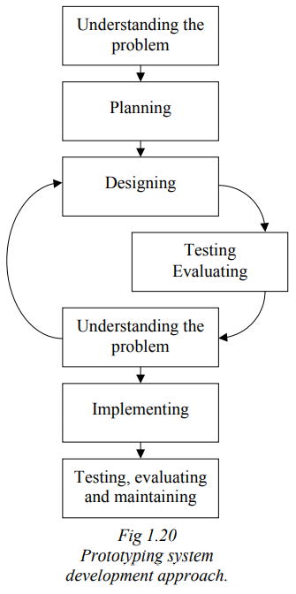  Extends the use of requirement prototypes so they:  - evolve into the final solution OR  - become detailed enough where they can be used to present the concept for full development  Each iteration through the loop in the diagram (→) produces an enhanced prototype that meets more of the system’s requirements.  - Users, participants and stakeholders can view and suggest modifications and additions to the prototype during each “Understanding the problem” phase  - When the prototype reaches a stage where the problem is sufficiently understood, thus meeting the requirements, it is ready for implementation  Prototyping acknowledges that system requirements cannot be determined exactly until development is underway.  - System requirements evolve as the prototype evolves  - Leads to ‘blow outs’ in the scope of the project - users think of new functionality not initially considered as they view a working prototype  Management strategies required to ensure the project remains within budget and time constraints:  - Prioritising necessary requirements - if time/money runs low, the system can still be implemented that meets all necessary requirements  Approach well suited for:  - Development of software components  - Development of information systems  Tools used to design and create software must accommodate quick changes and be appropriate for final implementation:  - Large systems → the performance, reliability and quality requirements typically means this is not possible  - Small systems → rapid application development (RAD) tools (e.g. visual programming environments, customised versions of standard applications) are able to produce software of sufficient quality and performance
    Requirement prototype | Aim to verify and determine requirements for a new system
    Concept prototype | Accurate simulations of the final system
  Customisation  (Existing systems) | Customising an existing system to suit the specific needs and requirements of the new system  - May be economically unviable to develop a new system  - Tweaking and modifying mass produced information technology is more cost effective and able to meet the majority of the system’s requirements  - Business systems are customised versions of existing systems (e.g. global Hotel software and hardware)  Customisation involves alterations to system settings within the hardware and software or may involve underlying customisation of the actual hardware or software itself.  Examples of customisation:  - Servers can be customised in adding RAM or a RAID storage device  - Word processors, spreadsheets and database can be customised to perform new functions  - Existing software applications can have source code modified to implement custom features
  Participant development | The same people who will use and operate the final system develop the system  - Known as ‘end user development’ or ‘participant development’  Approach well suited for:  - Systems that will only be used by the developer/user and few other people  - Systems where there is no need for detailed documentation - the developer is always available to answer questions and make modifications  - Systems that can be developed using common software applications that include reusable and quality components - leads to higher project success  User developed systems perform the processing they must perform with no additional/advanced features.
    Advantages | Disadvantages
    - Little need to consult widely as the users and participants determine the requirements  - Speeds up development considerably  - Small businesses and home users that cannot afford a professional service  - Able to automate functions themselves and modify the solution as requirements emerge | - User must have sufficient skills to create the system and must understand the extent of their skills  - User developed systems will be of lower quality than those developed professionally
  Agile methods  (Software) | Agile methods are for developing software rather than total information systems  - Place emphasis on the team developing the system rather than following predefined structured development processes  - Remove the need for detailed requirements and complex design documentation  - Encourage cooperation and teamwork  A small team of multi-skilled developers working tougher to modify a solution efficiently in a short period of time.  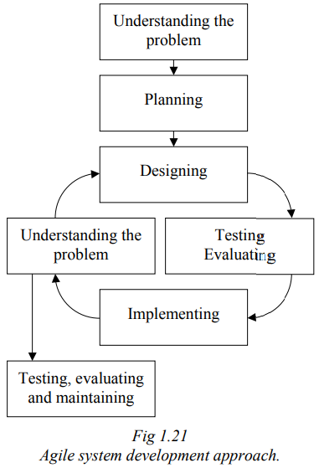  Approach well suited for:  - Web-based software development  - Software applications that are modified regularly as they evolve over time  Approach as outlined by the diagram (→):  - General problem is determined and development team is formed  - Team meet to create basic plan and general design for the software (minimal detail at this stage)  - Idea is to plan, design and document details as they’re needed  - Team create the initial solution through informal consultation and negotiation amongst each other  - User team member is present to ensure the solution will be workable in practice  - An initial solution is produced, tested, evaluated and implemented - it is used by real users and participants, typically the client  - Users can provide feedback, make suggestions about further additions  - Team meets informally to discuss the next part of the design - incorporating feedback from users together with team member ideas  - The solution is produced, tested, evaluated and implemented  - The process is repeated with each iteration implementing further functionality and detail  - Meetings are short, coding and testing consume the majority of development time  Agile methods acknowledge that intricate details are difficult to specify accurately in advance.  - Each part of a software solution is dependent on other related parts - until all related parts exist, it is wasteful to continue designing  Disadvantage:  - How to construct agreements when outsourcing the development  - No detailed requirements exist - they emerge during development  - Solution: fix budget and time and allow requirements to change  - Once time and budget is exhausted the current solution becomes the final solution  - Significant trust required between client and developer  The client is heavily involved throughout the development process and hence is likely to receive the final product that better meets their actual and current requirements.
The requirements report that:  - Details time frame  - Details the subprojects and the time frame for them  - Identifies participants  - Identifies relevant information technology  - Identifies data/information  - Identifies the needs of users | MANAGING THE PROJECT’S DEVELOPMENT AND THE UPDATING REQUIREMENTS REPORT  Techniques and strategies for managing a project’s development can be determined once:  - A specific solution has been identified  - A suitable development approach is chosen  Project management tools, here, are used depending on:  - The development needs of the specific solution  - The system development approach  The requirements report:  - Should identify the following to formulate a strategy for managing the project based on the chosen solution  - Is updated to reflect the following areas that affect project management based on the chosen solution  The requirements report:
  Requirements reports are updated with specifics after determining the chosen solution and system development approach
  Details time frame | The overall time frame in which all components of the information system should be completed
  Details the subprojects and time frame for them | Identifies subprojects that collectively form the complete information system  - Requires the allocation of adequate time and resources to each subproject
  Identifies participants | Identifies the participants of the information system and methods for obtaining participant feedback  - Agile methods → include a knowledgeable system participant on the team  - Other methods → sessions, meetings or other communication should be planned and documented in advance to ensure ongoing, regular communication takes place
  Identifies relevant information technology | Identifies hardware and software for the new system
    Hardware | Hardware is purchased or its development planned  - How purchases are made should be specified  - Obtaining quotes
    Software | - Outsourcing → agreements must be negotiated  - Funding management plans → specify when, how and under what terms agreements are made  - Other methods → software requires extensive planning, management and the addition of new requirements throughout the system development lifecycle
  Identifies data/information | Identifies where data is sourced from and the ability of the system to produce information
    Data | Data can be sourced from other systems or entered into the system by users  - How and when the data is obtained should be documented  - Sample or existing real data will be required for testing
    Information | - Ability of a system to produce particular information is a means for verifying that system requirements have been met  - Each piece of information helps determine the development subtasks  - How each task should be scheduled and costed
  Identifies the needs of users | Identifies predetermined or changing and emerging needs of users  - Traditional development approach → requirements are already established  - Prototyping and agile methods → user needs and requirements emerge and change development processes  - Requires a flexible requirements report with maintained cost, control and time constraints  - Ongoing communication between developers and users is essential  - Communication management plan → specifies communication strategies and techniques  - Journals and diaries → document each communication  - Funding management plan → details mechanisms for reallocating money due to changing and emerging needs
Designing
Clarifying with users the benefits of the new information system | CLARIFYING BENEFITS  - Users must understand the purpose and benefits of upgrading to a new system  - Consultation with users and participants should be ongoing  - Essential that the needs and concerns of all people affected by the final operational system remain central to the design process  - Involves the negotiation of purchase and installation cost  Benefits of new information systems:  - Convenience  - Efficiency  - Access to historical and statistical data  - Automation  - Artificial intelligence automation
  Top-down approach | Divides large, complicated problems into a series of smaller, easier to solve problems.
Designing the information system for ease of maintenance | DESIGNING FOR EASE OF MAINTENANCE  - Hardware or software purchased should be able to be maintained, updated an upgraded for continued future use  - Using open-source software may ensure further ease of maintenance as many people collaborate to ensure it is maintained and updated for new systems  - Hardware or software may need to be customised or purchased in advance  - Specifications and suppliers required for external communication lines, network cabling, furniture, off-the-shelf software and standard hardware are determined  - Agreements with outsourced development should be finished early so development can progress
Clarifying each of the relevant information processes within the system | CLARIFYING RELEVANT INFORMATION PROCESSES  Undertaking a careful analysis of all processes and determining which are relevant when designing the system.  - Enables considerations about hardware and software in relation to all information processes  - Ensuring all information processes are addressed when designing the system
Detailing the role of the participants, the data and the information technology used in the system | ROLE OF PARTICIPANTS, DATA AND INFORMATION TECHNOLOGY  Role of participants  - How will participants use the system?  - What participants require when using the system  - Expectations of participants  Role of data  - What is the data used for?  - How should it be displayed for accessibility and understanding?  Role of information technology  - What information technology should be used?  - Purpose of the information technology
Refining existing prototypes | REFINING EXISTING PROTOTYPES  Involves reviewing existing prototypes, identifying issues and producing new prototypes that resolve the issues.  An ongoing process in the design stage.  Aim: To produce a prototype with no foreseeable flaws that adequately satisfies the requirements of the system.
Participant development, when people within the information system develop the solution  - Participant designed solutions  - Tools for participant development such as guided processes in application packages | PARTICIPANT DEVELOPMENT  Occurs when people within the information system develop the solution.  Software tools for participant development are typically general applications or specific industry applications  Examples:  - Spreadsheets  - DBMS  - Real estate software  - Library software  Used when the project is NOT a basis for other projects and reliability is not crucial.
Tools used in designing, including:  - Context diagrams  - Data flow diagrams  - Decision trees  - Decision tables  - Data dictionaries  - Storyboards | TOOLS USED IN DESIGNING  Used for visualising the vital links between the system’s resources and information processes.
  Context diagrams | Context diagrams identify the data entering and the information leaving the system with its source and destination (sink).  - Top-level data flow diagrams (level 0 DFDs)  - Level 1 DFDs expand the single process into multiple processes  - Level 2 DFDs expand each level 1 DFD process into further processes  - Level 3 DFDs expand each level 2 process and so on  - Specify all external entities with the complete system represented as a single process  Considering participants  - When participants supply the system with data or receive information, they are considered an external entity  - All data entering and leaving the system must be included on the context diagram  How context diagrams assist the design process  - Indicate where the new system interfaces with its environment  - Define the data and information that passes through each interface and its direction of travel  - Descriptions of the data is further detailed in a data dictionary  The data entering the system from all its sources must be sufficient to produce the information leaving the system to its sinks.
    Represent the entire system as a single process.
    External entity  External entity | The system acquires data from each source entity.  The system supplies information to each sink entity.
    System  System | System solely represented using a circle with labelled data flow arrows used to describe the data and its direction of flow between the system and external entities.
    Data flow | - Represents data flows between system and external entities  - Each data flow arrow is accompanied by a label that clearly and simply identifies the nature of the data  - Each data flow describes data, NOT a process
    Example | 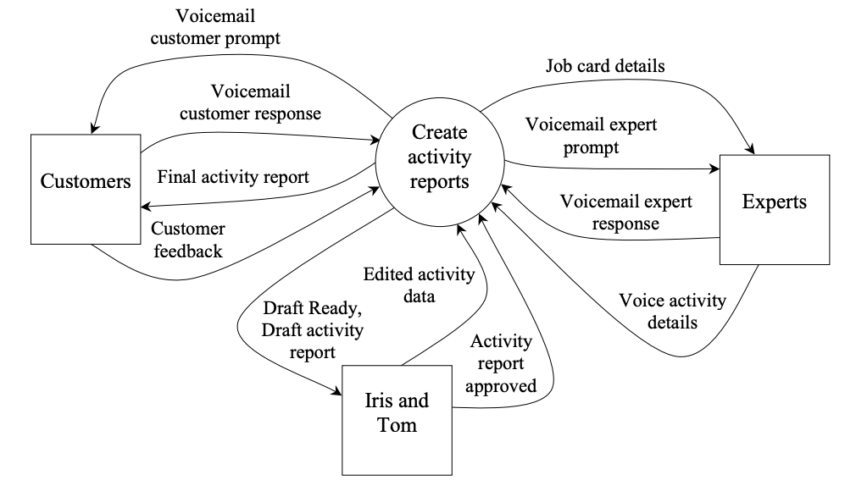
  Data flow diagrams | Represent systems by describing the changes in data as it passes through processes.  - Emphasis on where the data came from and where it is headed  Rules:  - All processes must have a different set of inputs and outputs  - All lower-level DFDs must have identical inputs and outputs as the higher-level process they expand  - External entities and data stores can be reproduced on lower-level DFDs  - External entities must be present on context diagrams (level 0 DFDs) but are optional on lower-level DFDs
    Describe the movement and changes in data between processes.
    External entity  External entity | The system acquires data from each source entity.  The system supplies information to each sink entity.
    Process  Process | Label within the circle describes the process  As processes change data labels should imply some action.  - Verbs: create, update, collect to emphasis some action is performed
    Data flow | Flow of data from an entity or process in the direction of the arrow.
    Data store  Data store | Where data is maintained prior to and after it has been processed.  - Label describes the type of data stored within  - Data stores enable the system to pause or halt between processes and enable processes to occur in different sequences at different times  - Processes are freed to execute independently of each other
    Examples | 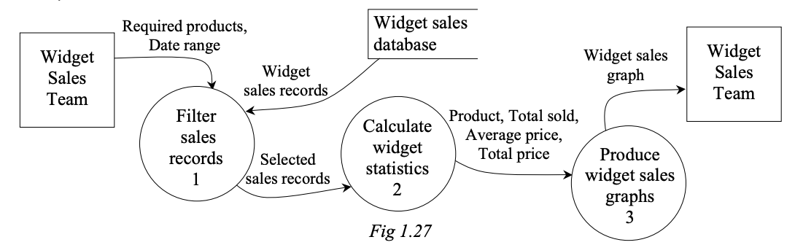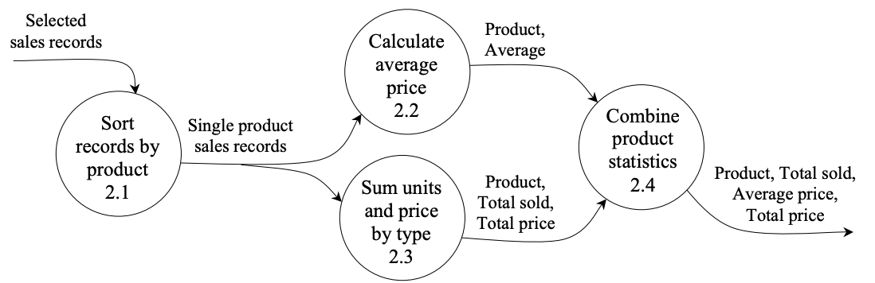
  Decision trees | Decision trees are structured representations of conditional logic used to define rules.
    Example | 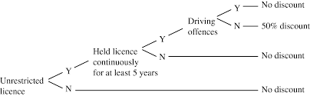
  Decision tables | Decision tables are structured representations of conditional logic used to define rules.  - Highlights what causes rules to trigger and the action to take effect due to that decision
    Examples | 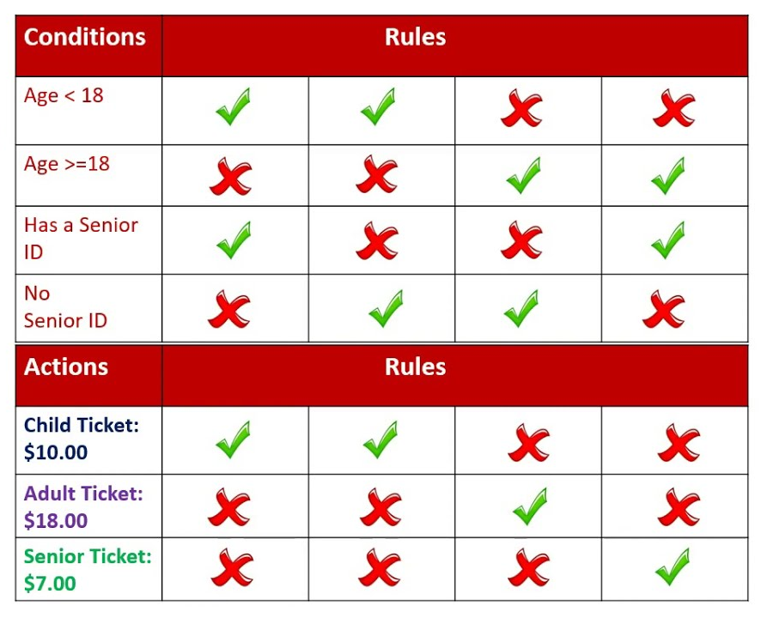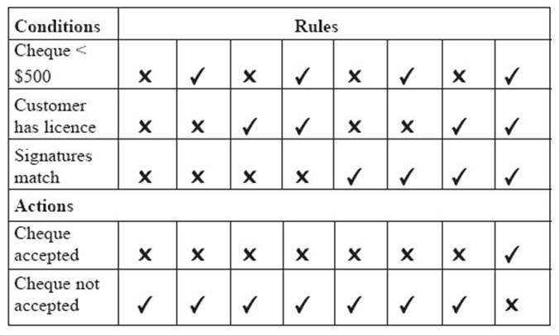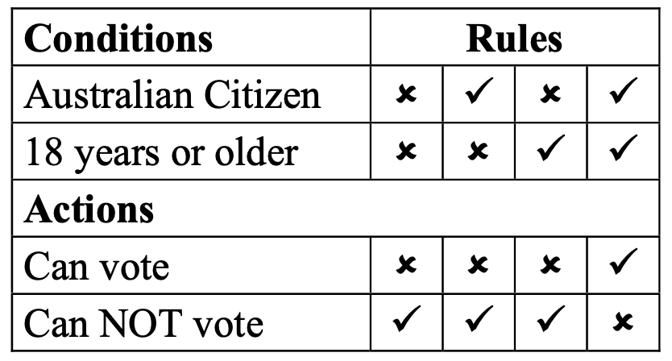
  Data dictionaries | Structure  - Each row describes a particular data item  - Each column describes an attribute or detail of the data item  Solely deal with the design of databases where they are used to document details of each field.  Contains:  - Field name  - Data type  - Data format  - Field size  - Description  - Example  - OPTIONAL: data validation, default value, key field
    Details each of the data items used by the system.
    Example | 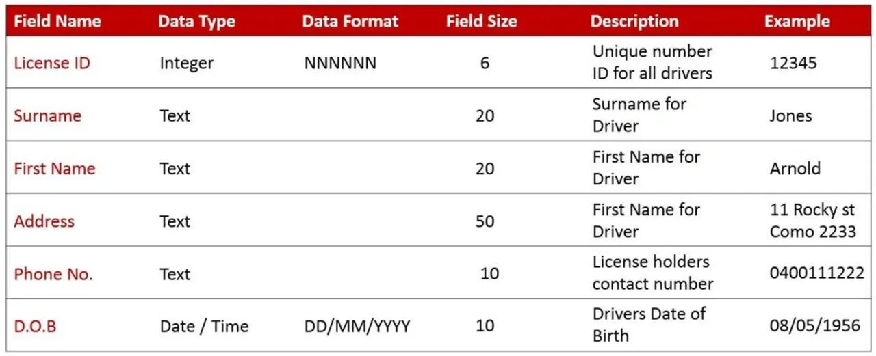
  Storyboards | A series of frames, each representing a different action or screen image.  Used to organise hypermedia.  Composed of two elements:  - Individual screen layouts with descriptions (information, graphics)  - Navigation map illustrating links (navigation paths) between screens  Four storyboard layouts
    Navigation map | Describes the organisation of a hypertext web.
    Linear | A simple sequential path that is set up quickly  Forces the user through a particular sequence of nodes.  - Useful for training where the content of each node requires knowledge obtained from previous nodes  E.g. Used on commercial sites, online purchasing takes customers through same sequence of screens
    Hierarchical | A sequential path in a top-down design.  The user starts at the beginning and moves down through the multimedia project.  - Suited to information that falls into categories and sub-categories  - Presented with more detailed information going down the tree
    Non Linear / unstructured | No structure / unstructured.  The user moves between different layouts in any direction.  - Allows maximum flexibility of design, but it is easy for users to get lost in a maze of screens  - In most cases, a map should be provided for users (sitemap)  - Difficult to visualise  E.g. Games use nonlinear structures. The experience is enhanced when knowledge of what comes next is unknown.
    Composite / combination | A blending of the above layouts.  Composite structures combine aspects of each of the other structures.  - Most hypertext websites use a composite structure
Implementing
Acquiring information technology and making it operational  - Hardware  - Software, customised or developed | INFORMATION TECHNOLOGY AND MAKING IT OPERATIONAL  Hardware  Acquiring the necessary hardware for the information system to be functional and setting it up to be operational.  - Includes the configuring and installing of physical hardware  - Setting up hardware to work with existing systems or for the needs of the business  Software  Determining whether software should be customised or developed.
  Customised | Using software that already exists and customising it to the needs of the business.
  Developed | Developing entirely new software specific to the needs and requirements of the business.
An implementation plan that details:  - Participant training  - The method for conversion  - Parallel conversion  - Direct conversion  - Phased conversion  - Pilot conversion  - How the system will be tested  - Conversion of data for the new system | IMPLEMENTATION PLAN  Used to deliver the new system to participants.
  Participant training | Training ensures participants can use the new system and understand its benefits.  - Vendor training → training carried out by the vendor of software/hardware  - Training specialists → instruct participants in how to operate their system  - Technical support staff → people who assist participants of a system on an as-needed basis
  Conversion methods | Four methods of conversion:
    Direct conversion | The immediate change to the new system on a chosen date.  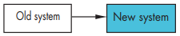
    Parallel conversion | Old and new systems working together at the same time.  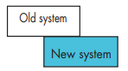
    Phased conversion | Gradual implementation of the new system.  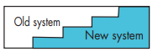
    Pilot conversion | Trialling the new system in a small portion of the organisation.  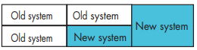
  Testing the system | Tests must examine the system  - Hardware tested using diagnostic software and through general operation  - Software tested using data that has been structured to test all decisions made within the system  - Information processes are continually tested during the implementation of the system over a period of time
  Conversion of data for new system | Ensuring data is in the correct format to be suitable for the new system.  - Data may need to be converted to a new format  - What data should be accessible when the system is initially converted?  - Should data be normalised, and for what benefit?
The need for an operational manual detailing procedures participants follow when using the new system | OPERATIONAL MANUAL  Details procedures participants follow when using a new system.  - Created and customised for employee roles and specific software functions  - Acts as a point of reference and guidance  - Can be used as training material, assisting in inductions and familiarisation  - Assists in troubleshooting issues that could appear  - Specifies required procedures such as log on and log off procedures
Testing, evaluating and maintaining
Testing and evaluating the solution with test data as  - Volume data  - Simulated data  - Live data | TESTING AND EVALUATING THE SOLUTION WITH TEST DATA  Acceptance tests → formal tests conducted to verify whether or not a system meets its requirements. Enables the client to determine whether or not to accept the new system.
  Volume data | Test data designed to ensure the system performs within its requirements when processes are subjected to large volumes of data.
  Simulated data | Aims to test the performance of systems under simulated operational conditions.  - Such as when many users, connections or different processes are all occurring in different combinations and at the same time.
  Live data | Actual data that is processed by the operational system.  - Takes place once the system has been installed to ensure it is operating as expected.
Checking to see that the original system requirements have been achieved | MEETING ORIGINAL SYSTEM REQUIREMENTS  Evaluation determines whether the system is working as expected or whether changes are required.  - System must be evaluated to determine if the requirements are being met  - Evaluation is ongoing  Feedback methods to determine the success of the new system  - Focus groups  - Surveys/questionnaires  - One-on-one interviews
Trialling and using the operation manual | TRIALING AND USING THE OPERATION MANUAL  Details procedures participants follow when using a new system.  Factors for creating an easy-to-use operation manual:  - User-friendly format and structure  - Clear and concise instructions  - Steps listed in point form  - Tasks completed in the simplest way  - Appropriate instructions for file management and security  - Screen dumps included where possible
Reviewing the effect on users of the information system, participants and people within the environment | REVIEWING THE EFFECT ON USERS, PARTICIPANTS AND PEOPLE  Assessing the impact of the new system on individuals.  - Using feedback methods to determine impact  - Observing users, participants and the environment for change
Modifying parts of the system where problems are identified | MODIFYING THE SYSTEM WHERE PROBLEMS ARE IDENTIFIED  Maintenance is the modification of the system by making minor improvements.  - Using bug report forms and help desk tickets to determine issues that arise  - May involve replacement of software or hardware  - Simple changes in large system are complex to implement and requires retesting of other parts of the system

