Transaction & Multimedia option topics selected
Syllabus Points | Notes
Information systems | Information System Diagram  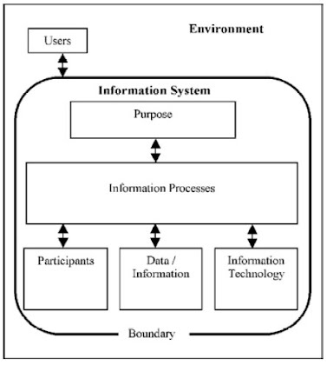
  Environment | The circumstances that surround an information system. Everything that influences or is influenced by the system.  - Includes the physical components that affect the system (network connections, power supply)
  Boundaries | The delineation between a system and its environment. The boundary defines what part of the system is and what part of the environment is.
  Purpose | A statement identifying who the information system is for and what it needs to achieve
  Data /  information | Data: the raw material used by the information processes  Information: the output displayed by an information system. Knowledge is acquired when information is received
  Participants /  users | Participants: A special class of user who carries out/initiates the information processes within an information system  Users: People who view or use the information output from an information system
  Information technology | Hardware and software used by an information system to carry out its information processes
  Information processes | The processes required to collect and transform data into useful information. These activities coordinate and direct the system’s resources to achieve the system’s purpose.
The characteristics of an information system, namely:  - The organisation of data into information  - The analysing of information to gives knowledge | CHARACTERISTICS OF INFORMATION SYSTEMS  The data needs to be appropriately organised and it must be able to be stored and retrieved efficiently.  Characteristics:  - Organisation of data into information  - Analysis of information to give knowledge  Aim of information systems:  - To produce information from data for use by the system’s end-users  - The end-users analyse this information to gain knowledge. It is only when knowledge has been gained that the system’s purpose can be achieved
The different types of and purposes for information systems, including systems used to:  - Process transaction  - Provide users with information about an organisation  - Manage information used within an organisation | TYPES AND PURPOSES FOR INFORMATION SYSTEMS  - Process transactions  - Provide users with information about an organisation  - Manage information used within an organisation  Types of information systems
  Type | Purpose | Resources/processing
  Transaction processing system (TPS) | Collect, store, modify and retrieve the daily transactions of an organisation.  E.g. POS system | - Collection and storage  - Backup of data  - Batch and real time processing
  Decision support system (DSS) | Assist people to make decisions by providing information, models and analysis tools.  E.g. Stock Market analyser to advise purchases | - Risk analysis  - Modelling tools  - Simulation  - Cost benefit analysis
  Expert systems | Expert systems provide information and solve problems that would otherwise require a person experienced in that field (an expert). They are useful in diagnosing, monitoring, selecting, designing, predicting and training. An expert system asks users a set of questions and compares their answers to a knowledge base.  E.g. Doctor diagnosis knowledge base | - Collection and storage of data  - Retrieval and analysis of data from a database
  Management information system (MIS) | Provide information for the organisation’s managers. Presents basic facts about the performance of the organisation. Produces business information reports.  Executive Information System (EIS)  - A type of MIS designed for the information needs of senior managers  - Provides information on strategic issues, using data from the share market, commodity prices, interest rates, etc.  E.g. Daily sales report system | - Report  - Budget summaries  - Production  - Stock inventories
  Office automation system | Provide people with effective ways to complete administrative tasks in an organisation. Uses a range of software tools, such as word processors, spreadsheets, databases, etc.  E.g. Hotmail, Gmail, Messenger, Trello, Notion, Myob | - Network  - Hardware: fax, computer, printer  - Software: word processor, spreadsheet software, voicemail, DBMS software
Database information systems
School databases holding information on teachers, subjects, classrooms and students | SCHOOL TIMETABLE SYSTEM
  Environment / boundaries | Entities: Student, teacher, administration staff, larger administration system  - Larger administration system forms part of the environment within which the timetable system operates  - Teacher and student personal details, including their names, are maintained somewhere else within the larger system  - Timetable system provides data to other parts of the larger administration system via queries  - Teachers and students provide data to the system  - Teachers indicate classes they want to teach  - Students provide subject selections  - Administration staff need to locate particular teachers, and students during the school day
  Purpose | - Provide accurate details to each teacher and student with regard to where and what they should be doing throughout each school day  - Enable the location of any teacher or student to be accurately determined at any time throughout each school day  - Provide flexible retrieval methods so timetable data in various forms can be provided to the school’s administration system
  Data / information | 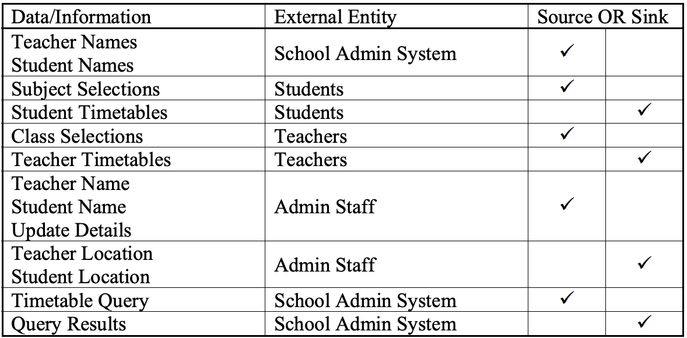
  Participants | - Primary participants are administration staff, including teachers who create and update the timetable
  Information technology | 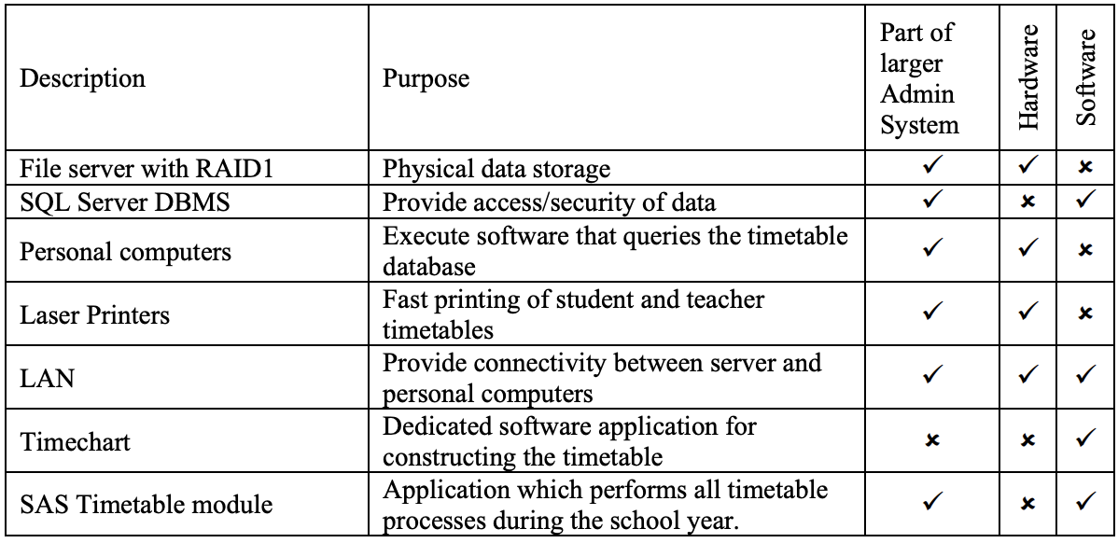
  Information processes | Composed of 5 processes:  - Creation of the timetable – collection of subject selections from students and class selections from teachers  - Generating student timetables – querying timetable database and formatting timetables  - Generating teacher timetables – querying timetable database and formatting timetables  - Locating teachers or students – collecting student or teacher names and then querying the timetable to determine their location at the current time  - Executing SQL statements of various types on the timetable database  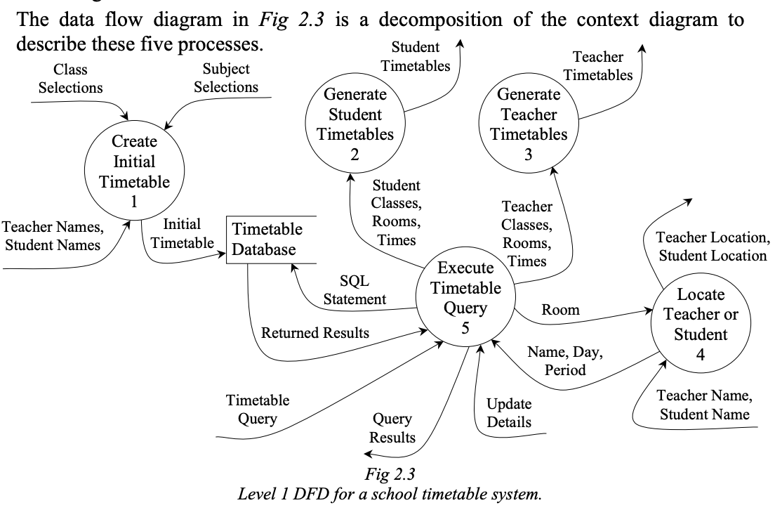
The Roads and Traffic Authority holding information on automobiles and holders of drivers licences | ROADS AND TRAFFIC AUTHORITY
  Environment / boundaries | Entities: Vehicle inspectors, customers, insurance companies, vehicle dealers, other government departments, police department  - RTA is a NSW statutory authority for managing the road network to ensure efficient traffic flows and improved road safety  - RTA operates a system called DRIVES (Driver Vehicle System) that processes all registration and licence transactions
  Purpose | - Maintaining accurate records of all licence and vehicle registrations within NSW  - Assigning demerit points to licence holders as a consequence of infringements  - Ensuring the privacy of customer’s personal details  - Providing information to other government departments
  Data / information | 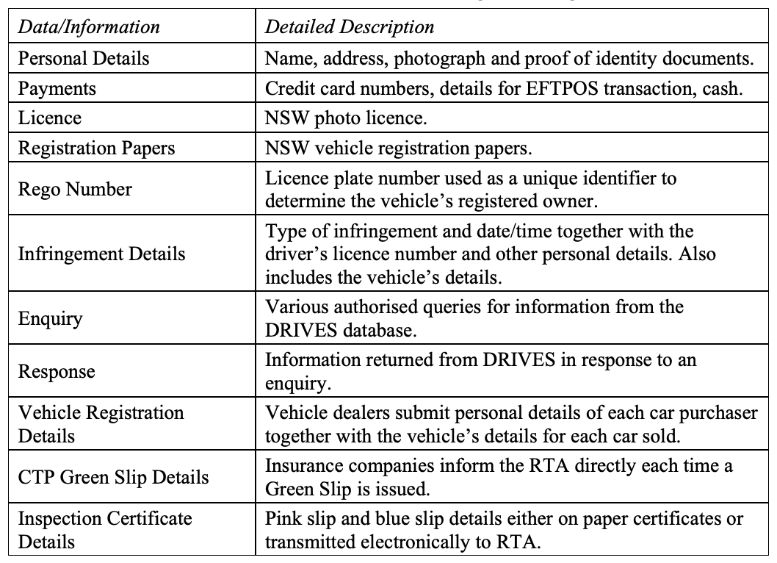
  Participants | Most information processing within DRIVES is performed by RTA staff  - myRTA website allows customers to perform a range of transactions online including renewing registering, changing address and checking demerit points  - Dealer online (DOL) system that enables motor vehicle inspectors to electronically transmit pink slip details to the RTA  - Employees of CTP Green Slip insurers transmit details of each paid Green Slip directly to the RTA system
  Information technology | - NSW RTA outsourced responsibility and provision of its data management technology to Fujitsu since 1997  - Data centre hosts the software and data on Sun Fire™ E6900 servers  - Client computers in 2007 were largely Apple G4 iMacs due to ergonomic design and ability to easily integrate within the Unix-based network  - DRIVES software is capable of processing EFTPOS transactions, capturing photos and producing licences through accessing the main Oracle database
  Information processes | - Renewing vehicle registrations – generating and posting renewal notices, receiving pink and green slip details, processing payments and approving renewals  - Editing registration details – change of ownership/address, collecting stamp duty payments, verifying personal details, creating registration records for vehicles  - Issuing new and renewed licences – testing, processing payments, taking photos, verifying personal details, producing photo licences  - Retrieving and transmitting details of the registered owner of vehicles to police  - Issuing licence supervision notices when twelve or more demerit points are accumulated within a period of 3 years
Video stores holding information on borrowers and videos | VIDEO STORES
  Environment / boundaries | Entities: Customers, sales staff, bank  - Transaction information is sent to the bank via EFTPOS machine
  Purpose | - To maintain accurate records of members and the videos and DVDs they borrow and subsequently return including payments made  - Produce financial and statistical reports for the owner
  Data / information | - Customer details including membership number  - Details of each video including unique number/barcode for each  - Borrowing details including membership number, date borrowed, date for return, unique number for each video and DVD borrowed and payment  - Financial and statistical reports  - EFTPOS details including details from customer’s EFT cards and approval from bank
  Participants | - Owner when generating reports  - Sales staff enrolling new members, processing sales and entering returned movies
  Information technology | - Digital store software, PC, cash drawer, barcode scanner, printer  - EFTPOS machine including its connection to bank
  Information processes | 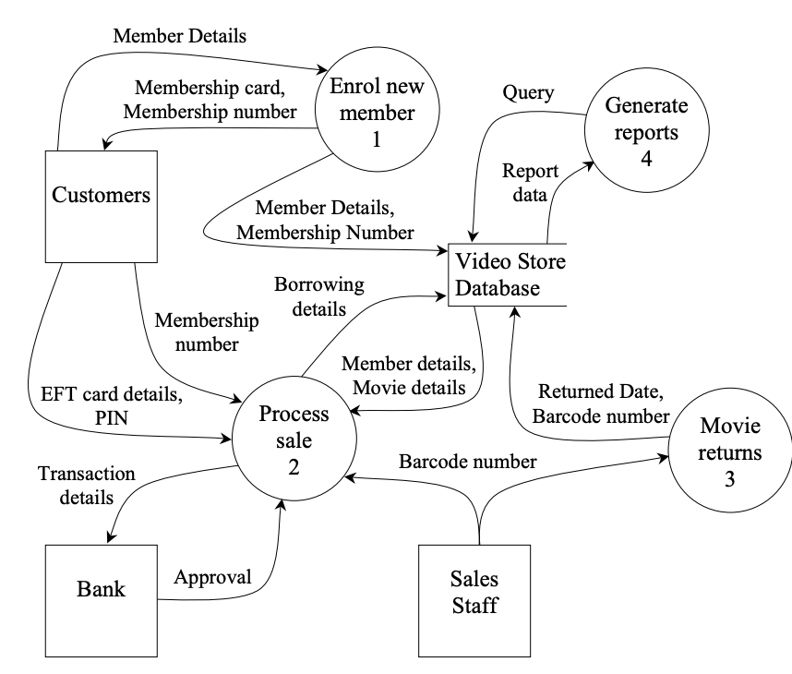
Organisation
Non-computer methods of organising including:  - Telephone books  - Card based applications | NON-COMPUTER METHODS OF ORGANISING  Telephone books  - Used to provide personal contact information about each individual in the book including name and phone number  - Yellow Pages and White Pages arranged alphabetically by surname and into categories, alphabetically within each  Card based applications  - At least two separate card catalogues used in libraries, one catalogue sorted by title and the other by author. When a new book was added, a new card was added to each card catalogue
Computer based methods of organising including:  - Flat-file systems  - Database management systems  - Hypermedia | COMPUTER BASED METHODS OF ORGANISING  Organising prepares data for use by other information processes.  - Organising determines how the data will be arranged and represented  - Organisation method is determined during the system’s initial development. It is difficult to alter significantly once the system is operational  - Designing the most appropriate method of organisation for a database is vital as the quantity of data and numbers of users increase, making it harder to change its structure
  Flat file databases | A single table of data stored as a single file.  - All rows (records/tuple) are composed of the same sequence of fields (attributes).  - Each row includes all data about a single individual item  Flat file database system allows you to use and manage only one database at a time.  - File → all records managed and saved by the flat file database software  - Record → set of one or more related fields (tuple/row)  - Characters → smallest unit of data (letter/symbol)  - Field → Specific category of data in database (attribute/column)  - Key fields → used to uniquely identify a record in each file
  Database Management Systems – DBMS  (Relational Database) | A database structured to recognise relations between stored items of information  - Consists of related tables  - Data organised within tables  - Every record in each table has unique fields  - Data redundancy minimised through normalisation  - Data resides in a single location - consistency and integrity improved  - Relationships:  - ONE TO ONE  - ONE TO MANY  - MANY TO MANY  RDBMS (Relational database management system) is a program used to create, update, and manage relational databases. E.g. Microsoft Access, MySQL, Oracle, SQL Server
  Hypertext / hypermedia
    Hypertext | Bodies of text that are linked in a non-sequential manner. Each block of text contains links to other blocks of text.
    Hypermedia | An extension of hypertext to include non-sequential links with other media types, such as image, audio and video.
  Computer based systems
  Information task | Manual system | Flat file DBMS | Relational DBMS | Hypermedia
  Appointment diary | Ideal for personal use because high portability accessibility | Ideal for business use (tracking more than none person) because of easy maintain | Too complex for the task | Ideal for travellers who have access through the web
  Store sales or product catalogue | Ideal for letterboxes, drops, handouts, etc. | Ideal for simple list only | Suitable but generally to complex for the task | Ideal for access via the web and e-commerce
  Stock and inventory | Tool slow and difficult to maintain | Ideal for simple list only | Ideal for larger and more complex list | Generally not suitable for the task
  Personnel records | Too slow and difficult to maintain | Ideal for simple list only | Ideal for larger and more complex list | Generally not suitable for the task, poor security and privacy
  Phone and address lists | Ideal for personal use of high portability and accessibility | Ideal for larger lists and business use because of east maintain | Suitable but generally too complex for the task | Ideal for access via the web
  Class mark and test results | Ideal for portability and instant access has good privacy and security | Ideal for data processing and to send data to other application | Too complex for the task | Generally not suitable but used for the fast distribution of final HSC result (with access security)
  Mail merging | Not suitable for task | Ideal for the task | Suitable but generally too complex for the task | Generally not suitable for the task
The advantages and disadvantages of computer based and non-computer based organisation methods | ADVANTAGES AND DISADVANTAGES OF COMPUTER AND NON-COMPUTER BASED ORGANISATION  Non-computer  Computer
  Advantages | Disadvantages
  - Doesn’t require a computer therefore no need of power supply or batteries  - More accessible – no need for computers  - No special skills or training is need for use | - A very inflexible layout – not portable  - Access is usually by one method only  - Usually only one person can access the data a time
  Advantages | Disadvantages
  - Faster to retrieve data  - Data does not have to be in a set order  - Data can be easily exchanged between applications and over networks  - Larger storage options  - Easily editable, manageable and maintainable – time convenient  - More ergonomic and accessible display options | - Data can only be accessed if you have a computer  - Training is usually required  - Exchange of data with other computers creates issues around security and confidentiality
The logical organisation of flat-file databases, including:  - Files  - Record  - Field, key fields  - Characters | LOGICAL ORGANISATION OF FLAT-FILE DATABASES  A two-dimensional table containing records composed of files.  - Attributes/fields describe a particular aspect of each individual entity  Logical organisation of data in a flat-file: Character → field → record → file  Data types
  Character | The smallest unit of data that people can use.  Characters include letters, numbers, and special symbols.
  Field | A specific category of data in a database.  A record/tuple is divided into one or more related fields.
  Key fields | Used to uniquely sort and retrieve information from a record/tuple.
    Single key | Field in which each item is unique.
    Composite key / compound key | Made by joining two or more fields together.  Used when no data item in any field can be guaranteed to be unique.
    Primary key | A single key or compound key that must have a value.  Cannot be empty or null.
    Secondary key | Field that contains useful items of data used in searches.  Secondary keys are not always unique.
  Record | A collection of facts about one specific entry in a database.  A record is divided into one or more related fields/tuples.
  File | A block of data.  A file in a database is divided into a set of related records.
  Integer | Exact whole numbers. Positive or negative.
  Decimal, Fixed-point | Exact fixed decimal point numbers with limited precision.
  Real, Float | Approximate fractional numbers with a large range.
  Money, Currency | Exact, optimised for financial accuracy.
  Boolean, Bit | Yes/No or True/False.
  Date, Time | A number representing the days since (or prior to) a specific date.
  Text, Char | String data represented as a sequence of individual characters and symbols.
  Binary, Blob | Raw binary data. Used for images, audio and other non-numeric or text data.
  Enum | Dropdown, selecting values
The logical organisation of relational databases, including:  - Schemas as consisting of:  - Entities  - Attributes  - Relationships  - One to one  - One to many  - Many to many  - Tables as the implementation of entities consisting of:  - Attributes  - Records  - Linking tables using primary and foreign keys  - User views for different purposes | LOGICAL ORGANISATION OF RELATIONAL DATABASES  A relational database organises data using a series of related tables.  - Relationships are built between the tables to provide a flexible way of manipulating and combining data  - Forms are used to view, enter and change data in the tables  - The organisation of data in a relational database involves a schema  - Most commonly used structure  Benefits  - Data redundancy minimised through normalisation  - Data resides in a single location - consistency and integrity improved  Schemas  The data definition for a database.  - The schema defines the entities, attributes and relationships  - An organised plan of the entire database showing how and where the data is found, descriptions of the data, and the data’s logical relationships  - Also known as an Entity Relationship Diagram (ERD)  Relationships in schemas  Relationships are the way entities are related to each other.  Recursive relationships are permitted. Occurs when an attribute of a table is joined to the primary key within the same table.  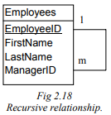  Referential integrity  Ensured when each foreign key always matches a related primary key.  - Only exception is NULL values if they are permitted in the foreign key  Tables  The organisation of data into columns and rows  - Column of a table is an attribute of an entity or a field of a record  - Data in a column must have the same data type and have a distinct name  - A row in a table is also called a tuple of an entity, or one record  - Each row must be uniquely identified by a key  - The intersection of a row and column stores a particular data item  - The rows and columns in a table can be viewed in any order without affecting the contents of the table  Forms  Used to view, enter and change data in a table  - The layout of the form can be changed  - User can position fields, headings, instructions and graphics  - Well-designed form provides information explaining the required data and any data-entry rules that apply to particular fields  - In a relational database, forms can be based on a single table or on multiple tables
  RDBMS – Relational Database Management System | A program used to create, update, and manage relational databases.  E.g. Microsoft Access, MySQL, Oracle, SQL Server
  Entity | Specific things about which information is collected and stored.  Flat-file databases have separate files for each entity.
  Attribute | A defined property of an entity.  ‘Attributes’ are interchangeable with ‘fields’ in flat-file databases. Each attribute contains a data item.
  One-to-one relationship | Each record in the first entity is related to exactly one record in the second entity
  One-to-many relationship | One record in the first entity is related to many records in the second entity, but any record in the second entity only relates to one record in the first entity
  Many-to-many relationship | Each record in the first entity is related to many records in the second entity, and each record in the second entity is related to many records in the first entity
  Primary key | A single key or compound key that must have a value.  Cannot be empty or null.
  Foreign key | A foreign key is an attribute (field) of a table that is a primary key of another table.  Cannot exist in flat-file databases.
  Single key | Field in which each item is unique.
  Composite key / compound key | Made by joining two or more fields together.  Used when no data item in any field can be guaranteed to be unique.
  Secondary key | Field that contains useful items of data used in searches.  Secondary keys are not always unique.
Data modelling tools for organising databases, including:  - Data dictionaries to describe the characteristics of data including:  - Field name  - Data type  - Data format  - Field size  - Description  - Example  - Schematic diagrams that show the relationships between entities  - Normalising data to reduce data redundancy | DATA MODELLING  The process of identifying entities, the relationships between those entities and the attributes of those entities.  - Used to develop a schema for the database  Tools for data modelling:  - Data dictionaries  - Schematic diagrams  - Normalisation
  Data Dictionaries | A comprehensive description of each field (attribute) in the database.  - Reduces data redundancy. Helpful for project management because if people are working on different entities, they can refer to the data dictionary to determine an attribute’s features.  - Contains information about the characteristics of each item:  - Field name → name of the field  - Data type → kind of data that can be stored in the field  - Data format → template of how the field will look with the data in it  - Field size → number of characters allowed per field  - Description → specifies the contents of the field  - Example → provides an example of what could be stored in the field  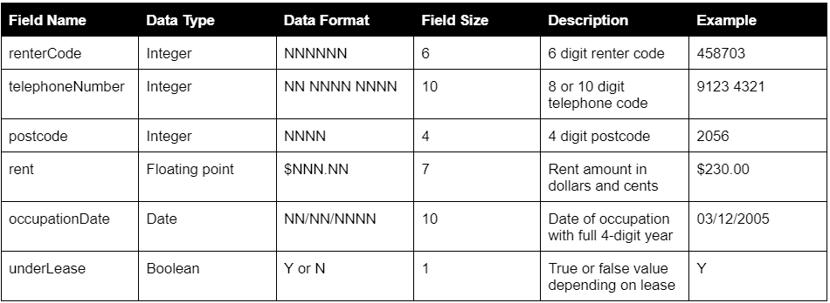  Field sizes:  DD/MM/YYYY = 4 or 10 bytes  Boolean = 1 byte  Money (e.g. $NN.NN) = 4 bytes  Number/Text = 1 byte per character/digit
    Metadata | Information about data.
    Data redundancy | The undesirable duplication of data within a database.
  Schematic diagrams | Graphical tools that help define the database and develop a schema.  - Common schematic diagram is an entity-relationship diagram (ERD) → helps explain a database  - Schemas are a type of ERD  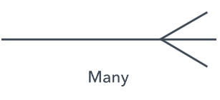  Example:  PatientID  PatientFirstName  PatientSurname  PatientAddress  PatientPostcode  PatientDOB  PatientGender  Patient  DriverID  DriverFirstName  DriverSurname  DriverLicence  Driver  TripID  PatientID  DriverID  TripDate  TripTime  CarRegistration  Trip  One to many  One to many
    Entity-relationship diagram (ERD) | Graphical method of identifying the entities and showing relationships between them.
  Normalisation | The process of organising data into tables so that the results of using the database are unambiguous and intended.  - Reduces data redundancy  - Increase data integrity  - Improves data consistency  The first table of unnormalised data is 3-dimensional because it has blank fields which indicates an inconsistency in the data and doesn’t adhere to the property rules of relational databases.  Normal Forms (NF)  With each normal form, data becomes less redundant and more consistent.
    Data redundancy | Occurs when the same piece of data exists in multiple places.
    Data integrity | Accuracy, completeness, consistency and validity of an organisation’s data.
    First Normal Form (1NF) | Removal of repeating attributes across horizontal rows, ensuring each field holds single data items.  Requirements of 1NF  - Each field stores single data items  - No multiple data items within individual fields, no fields are repeated  Processes  - Splitting fields into smaller units of dat  - Deleting repeated fields  - Creating new records for each multiple data item and repeated field
    Second Normal Form (2NF) | Removes redundant data within vertical columns or fields.  - Creating new tables and a primary key  Requirements of 2NF  - All tables must be in first normal form  - Every non-key attribute is functionally dependent on the table’s primary key  Processes  - Determine functional dependencies  - Determine a primary key  - Create tables containing each set of functionally dependent attributes, including the primary key  - Move each set of functionally dependent attributes including the primary key into new tables
    Third Normal Form (3NF) | Removes further redundant data within vertical columns or fields.  Requirements of 3NF  - All tables must be in second form  - Every non-key attribute is functionally dependent only on the table’s primary key and not on any other attributes within the table  Processes  - Look for non-key attributes functionally dependent on other non-key attributes  - Determine primary key for each set of attributes  - Move each set of attributes including the primary key into new tables
    Domain/key normal form (DKNF) | A key uniquely identifies each row in a table.  - Domain is the set of permissible values for each attribute  - DKNF is the final level of normalisation that designers aim for
The logical organisation of hypermedia, including:  - Nodes and links  - Uniform resource locators  - Metadata such as HTML tags | LOGICAL ORGANISATION OF HYPERMEDIA  Hypertext and hypermedia provide an easy way of navigation between information.  - Information is stored using a set of documents containing media  - Each document is independent and information is retrieved using hypertext  - Each document on the web is accessed through a URL
  Hypertext | Bodies of text linked in a non-sequential manner, enabling an electronic connection.
  Hypermedia | An extension of hypertext to include non-sequential links with image, audio and video media
  Node | Any device connected to the network. Hypertext nodes are connected via links to each other.
  HTML  Hypertext Markup Language | Primary method of organising hypertext online.  A link within a website can redirect to a bookmark within the current page or to another page  Metadata  Meta tags describe the data within a page and anchor tags used to link pages.  - <Meta name = “keywords” />  - <Meta name = “title” />  - <Meta name = “description” />  - <Meta name = “og:site_name” />  - Open graph protocol enables any web page to become a rich object in a social graph  Anchor tags  Used to specify links within and between web pages.  - Can open images, audio, videos, etc.
  URL  Uniform Resource Locator | The address of a file or resource on the web.  Written in lowercase as a single unbroken line with no spaces - must be complete and exact.  Parts of a URL:  - Protocol → transfer method used to access a particular resource on the web (http:// or https://)  - Domain name → address of the specific computer where a resource is located. Interchangeable by IP address.  - File path → full path to the file to be retrieved (filename or directory path separated by /)
Tools for organising hypermedia, including:  - Storyboards to represent data organised using hyperlinks  - Software that allows text, graphics and sounds to be hyperlinked | TOOLS FOR ORGANISING HYPERMEDIA
  Storyboard | A series of frames, each representing a different action or screen image.  Used to organise hypermedia.  Composed of two elements:  - Individual screen layouts with descriptions (information, graphics)  - Navigation map illustrating links (navigation paths) between screens  Four storyboard layouts
    Navigation map | Describes the organisation of a hypertext web.
    Linear | A simple sequential path that is set up quickly  Forces the user through a particular sequence of nodes.  - Useful for training where the content of each node requires knowledge obtained from previous nodes  E.g. Used on commercial sites, online purchasing takes customers through same sequence of screens
    Hierarchical | A sequential path in a top-down design.  The user starts at the beginning and moves down through the multimedia project.  - Suited to information that falls into categories and sub-categories  - Presented with more detailed information going down the tree
    Non Linear / unstructured | No structure / unstructured.  The user moves between different layouts in any direction.  - Allows maximum flexibility of design, but it is easy for users to get lost in a maze of screens  - In most cases, a map should be provided for users (sitemap)  - Difficult to visualise  E.g. Games use nonlinear structures. The experience is enhanced when knowledge of what comes next is unknown.
    Composite / combination | A blending of the above layouts.  Composite structures combine aspects of each of the other structures.  - Most hypertext websites use a composite structure
  Software | Allows text, graphics and sound to be hyperlinked.  - Visual Studio Code, IntelliJ IDEA  - Text editors - Wordpad, Notepad, Notepad++  - Word formatting programs - PowerPoint, Word, Excel
Storage and retrieval
Database management systems (DBMS) including:  - The role of a DBMS in handling access to a database  - The independence of data from the DBMS | DATABASE MANAGEMENT SYSTEMS (DBMS)  A software package that allows users to access a database so they can enter, maintain and view data.  - Data is independent from the DBMS  - Data is organised into tables, viewed in forms, retrieved using queries, displayed in reports  - A DBMS manipulates the data through searching and sorting  A DBMS performs various tasks to help users develop and maintain a database:  - Organising the data using a data dictionary  - Showing relationships between entities using schematic diagrams  - Checking for identifiable errors in data entry  - Allowing flexibility to change the definition of the database  - Restricting access to the data to authorised people  - Providing information about the performance of the database  Data independence  The separation of data and processing.  - DBMSs separate data and its management including storage and retrieval from the software that processes the data  - Provides the ability of data and its organisation to be altered without affecting software applications that process it  - Makes it easier for different software applications to process the same data  Data dependence  Occurs when software defines the organisation of its own data.  - Makes sharing data with other applications difficult - no mechanism for determining the hidden detail of the data organisation  - Data dependence can also occur when specific data values are hard coded within software (e.g. 10% GST)
Direct and sequential access of data | DIRECT AND SEQUENTIAL ACCESS  Two methods of accessing data.
  Sequential access / random access | Occurs when data is accessed in a sequence. (linear sequence)  - Only method of accessing data stored on magnetic tape  - Sequential access processes data in the order it was stored  - Does not require the exact location of the data item  - Slower than direct access and impractical when immediate processing is required
  Direct access | Occurs when data is accessed without accessing previous data items. (any order)  - Data stored in storage location based on mathematical procedure or algorithm  - Uses the algorithm to calculate approximate location of data  - Data is accessed by referring to the index and obtaining the exact location of the data  - Indexed access method requires more processing time to search and maintain the index
    Index | A table that contains information about the location of data.
On-line and off-line storage | ONLINE AND OFFLINE STORAGE
  On-line storage | Available immediately to connected computers.  - Includes hard disks within a computer and network attached storage (NAS)  - Hard disk drives are used for offline backup  - Online storage services allow backup copies of individual files to be opened and saved online
  Off-line storage | Data stored such that it cannot be accessed until the storage media is mounted into a drive.  - Includes magnetic tape, optical media (CDs, DVDs), USBs  - Offline storage is used to maintain backup copies of the online data
Centralised and distributed databases | CENTRALISED AND DISTRIBUTED DATABASES
  Centralised databases | A database stored at a single location.  - Maintained and modified from that location only  - Enables high security and availability  - Typically accessed through LAN or WAN
  Distributed databases | A database located at more than one site.  - Acts as a single collection of data but is geographically dispersed  - Need to be synchronised to be current  - Reduce data transmission costs that come with centralised databases  Types of distributed databases
    Two-phase commit | Part of the DBMS used to maintain consistency across a distributed database.
    Fragmentation | Different parts of the database are stored at different locations.
      Horizontal fragmentation | Stores different records of the same table at different locations
      Vertical fragmentation | Stores different attributes at different locations
    Downloading | Each server downloads copies of data as it is required from remote databases and stores the data within its local database.  - Domain Name Service (DNS) uses the downloading strategy
    Replication | All local databases hold copies of all the data at all times. Each replicant is synchronised with the master at regular intervals.  - Suited where the same records are rarely altered or added
Storage media including:  - Hard disks  - CD-ROMs  - Cartridge and tape | STORAGE MEDIA
  Hard disk | A disk made of metal or glass covered with magnetic material.  - Use direct access to retrieve data  - Data is stored magnetically on aluminium or glass platters  - Read/write heads are attached to an arm and a single pivot point, thus all moving together  - Air pressure created by spinning platters causes sliders to float a few nanometers above the surface of the disk
  Optical disk / CD-ROMs | A polycarbonate plastic disk with a reflective layer of metal covering the surface.  - Use direct access to retrieve data  - Data is read and written using laser technology  - Processes based on the reflection of light - either light reflects well or reflects poorly to the sensor  - Constant reflection = 0  - Transition between reflects (good to poor / poor to good) = 1  Types of optical disks
    CD-ROM | Convenient for storing data that remains constant
    DVD | Can store large amounts of data
  Cartridge and tape | A hard disk encased in a metal or plastic cartridge.  - Use direct access to retrieve data  - Fast, not but as fast as hard disks  Technologies used to store data on magnetic tapes  Types of removable cartridges
    Helical tape drive | Use technology originally developed for video and audio tapes
    Linear tape drive | Designed specifically for archiving data, performing tasks more efficiently than helical in terms of data storage
    Zip disk | Store 100 or 250 MB of data, has a transfer rate of 1mbps
    Jaz disk | Store up to 2 GB of data, has a transfer rate of 5.5mbps
Encryption and decryption | ENCRYPTION AND DECRYPTION
  Encryption | The process of encoding data.  Original data is encoded → data is transmitted → data is decrypted to original form  - Most effective data security method during transmission  - Encryption methods involve complex manipulations of bit patterns  Types of encryption
    Asymmetric encryption | Requires a key for encryption and a key for decryption. (different keys)  Common asymmetric encryption system is public key encryption.  - Involves a public key that is widely available and a private key that is kept secret  - Both keys are developed using complicated number theory  - Public key is used to encrypt the message before it is transmitted, and the private key is used to decrypt the message when it is received
    Symmetric encryption | Requires the same key for both encryption and decryption  Common symmetric encryption system is the Data Encryption Standard (DES).
  Decryption | The process of decoding data. (changing it back)  Converts encrypted data into its original form.
Backup and security procedures | BACKUP AND SECURITY PROCEDURES  Aim of backups  - To prevent data loss in the event data is damaged or lost  - Protects against data theft in which data could be stolen  Reasons for data loss: software faults, theft, fire, viruses, intentional malicious damage, insufficient or inappropriate validation  - Regular backups are required to effectively guard against data loss.  - Backups should be kept in a fireproof/waterproof safe or at a separate physical location.  Types of backups  Backup strategies  Methods of security
  Backup | Process of storing or copying data to another permanent storage device.
  Recovery | Data is retrieved or restored from the backup and placed back into the system.
  Full backup | All files.
  Partial backup | Files that have been created or altered.
  Incremental backup | Backs up files that have changed since the last backup occurred.
  Differential backup | Backs up only copies of all files that have changed since the last full backup.
  Biometric authentication | Prevents physical access to data storage servers
  Two factor authentication | Installing the app on each employee’s personal phone restricts the access code required to only be visible to the account holder
  Strong & periodically changing passwords | If unauthorised persons had gained access to credentials, they would only be valid for a certain period of time
  Intranet | Restricting access to the organisation’s internet to prevent external, unauthorised persons from accessing delicate information via an internet connection
  Encryption | The process of encoding information or data into code to prevent unauthorised access
  Firewalls | Verifies and authenticates all incoming data. Used to detect and prevent external, unauthorised attempts at connecting to the organisation’s network
  Access rights | Provide employees with access only to information they need to do their job
  Regularly updated antivirus software | Protection against malicious viruses and malware infiltrating computers via the internet and leading to compromised information
Tools for database storage and retrieval, including:  - Extracting relevant information through searching and sorting a database  - Selecting data from a relational database using Query by Example (QBE) and Structure Query Languages (SQL) commands, including:  - Select  - From  - Where  - Order by | TOOLS FOR DATABASE STORAGE AND RETRIEVAL  Searching and sorting databases using Structured Query Language (SQL)  SQL Query Commands:  Relational/Logical operators  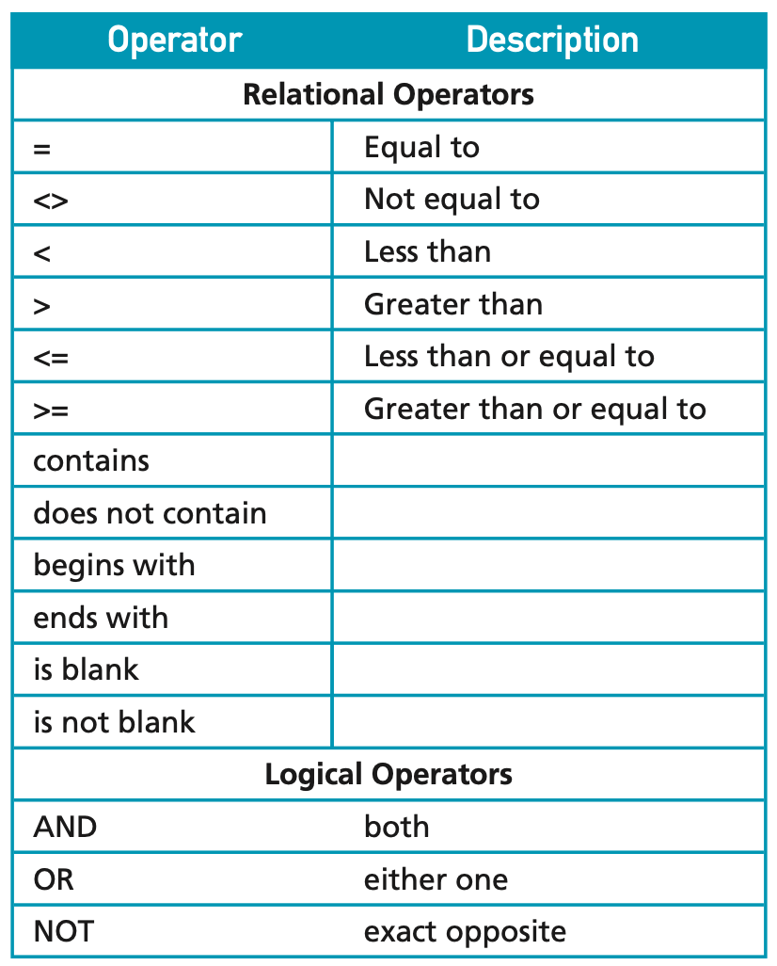
  Sorting | Arranging data in a particular order.
  Searching | Examining the database to retrieve data.
  Query | A search of a database for records that meet a certain condition.
  Query by example | Method for constructing a query. Requires the user to enter the criteria against a field.
  Select | Begins a query through selecting columns in which variables need to be accessed.
    SELECT column
    SELECT column, column, column...
  From | Specifies which table/s the selected columns are stored in so that they can be retrieved from the appropriate location.
    FROM table
    FROM table, table, table…
  Where | Specifies a condition or conditions that the queried data must meet, either an alphanumeric, numeric or date condition.
    WHERE variable = 'alphanumeric'
    WHERE variable = numeric
    WHERE MONTH(date_of_birth) = 12
    WHERE DAY(date_of_birth) = 28
    WHERE YEAR(date_of_birth) = 2005
    WHERE variable = 0 AND variable = ‘value’
    WHERE variable = 0 OR variable = ‘value’
  Order by | Order the queried column by ascending or descending order.
    ORDER BY column ASC
    ORDER BY column DESC
    ASC | Ascending order  A-Z, 0-9
    DESC | Descending order  Z-A, 9-0
  Relational operators | Relational operators indicate relationships between expressions.
  Logical operators | Logical operators combine queries so that the search is carried out on one or more fields.
  Wildcard characters | Wildcard characters represent one or more unknown characters.
Tools for hypermedia search and retrieval, including:  - Free text searching  - Operation of a search engine  - Indexing and search robots  - Metadata | TOOLS FOR HYPERMEDIA SEARCH AND RETRIEVAL  Free text searching  Known as wildcard searching or pattern matching.  Characters are often used as placeholders to represent one or multiple characters in a search query.  E.g. “Smi*” will return “Smith” “Smithson” “Smiley”  E.g. “h?t,” will return “hat,” “hot,” but not “hit” “hut”  E.g. “colo*r” will return “color” and “colour”  Operation of a search engine  - Search engine’s index is built by regularly scanning the web for new sites  - Scanning is completed by programs called spiders, crawlers or robots that send back the URL of any document they find to the search engine’s indexing software  - Software collects titles and keywords in HTML meta tags, indexing them in a database  - Each search engine has a different method of building its index  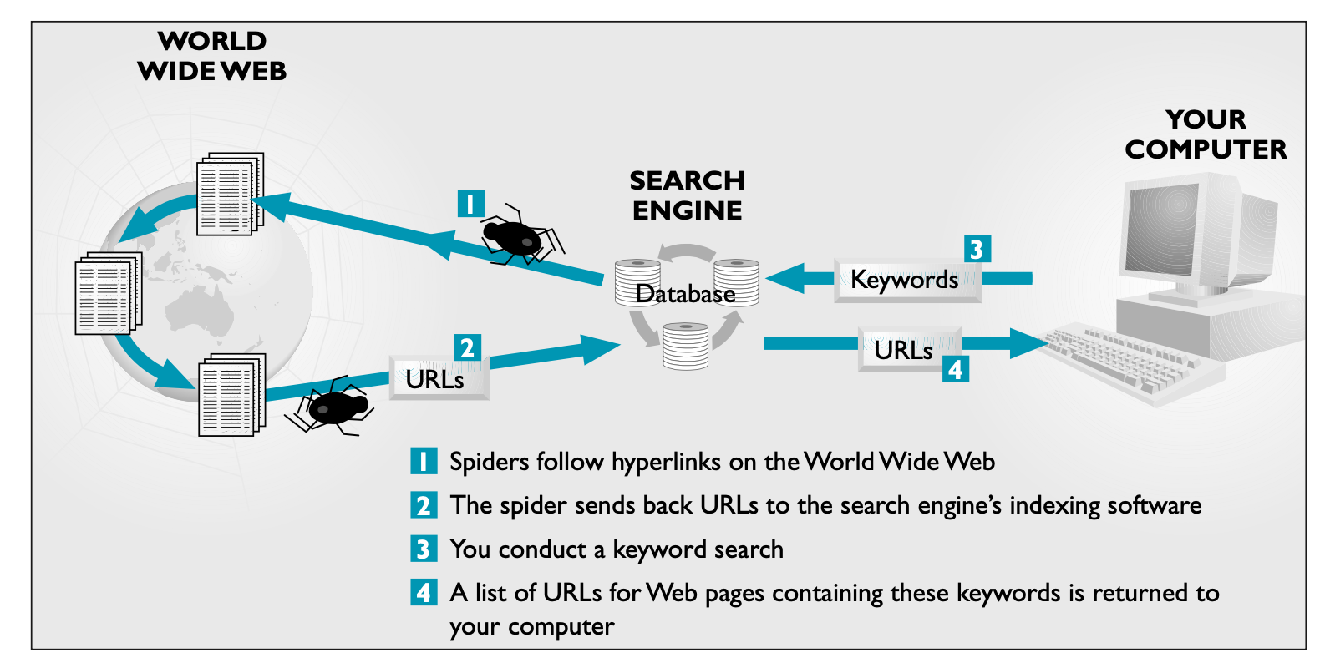  - Keywords relate to topics of interest  Processes of a search engine  - Create search databases  - Crawling the web to locate and retrieve web pages  - Indexing and ranking each web page found  - Process user searches  - Analysing search criteria entered by users  - Retrieving suitably ranked web page results  Dictionaries  Offered by some search engines.  - Owners of a website have to register their site to be included in a dictionary  - A directory is useful for finding information on a general topic
  ? | Question mark represents a single character in a search term.
  * | Asterisk or star represents multiple characters (zero or more) in a search term.
  Search engine | A database of indexed websites that allows a keyword search.
  Index | A table that contains information about the location of data.
  Dictionaries | Lists of websites organised into categories. (e.g. computers, games, sport)
  Search robot | A program that accesses websites and gathers information for search engine indexes.
Reporting on data found in hypermedia systems | REPORTING ON DATA IN HYPERMEDIA SYSTEMS  DBMS allows reports to be designed in a tabular layout or a column layout.  - Can insert headings, sort data, choose the fields, switch fields, change column widths and select rows.  Common report sections
  Report | The formatted and organised presentation of data.
  Report header | Appears once at the beginning of a report.  Contains: logo, report title, data
  Page header | Appears after the report header on the first page of the report.  Contains: title, column headings, information needed at the top of every page
  Details | Displays most of the information.  User has a variety of tools to manipulate and format fields
  Page footer | Appears at the bottom of the page.  Contains: date, page number, information needed at the bottom of every page
  Report footer | Appears once at the end of the report.  Contains: report totals
Other information processes for database information systems
Displaying  - Reporting on relevant information held in a database  - Constructing different views of a database for different purposes | DISPLAYING  Different views are obtained using a form.  Report design requires an assessment of the nature of the information.  - How is it categorised and sorted? What user needs does it hope to address?  - Who are the intended users?  - Are they internal employees or members of the general public?  Aim: To produce a format the best communicates the information to the intended audience.  Screen and report design principles  Additional screen design principles
  Headings | Identify the purpose of a report
  Layouts | Tabular or column layout that efficiently presents the information
  Page numbers & date | Included in header and footer
  Consistency of design | Labels describing data should be placed in consistent places on all screens  Consistency increases readability when sufficient white space is used  - Using the same typeface, sizes, styles  - Using a consistent colour scheme and layout  - Enables users to transfer skills from other applications and data entry screens with your software  Important points to consistency in screen design:  - Setting standards and adhering to them based on industry standards and any other standards you develop specific to your application  - Develop a simple set of rules that apply to your entire application  - Follow recognised standards for all interface elements (text boxes, menus, radio buttons)
  Grouping of information | Logically grouping related items and data together  - Data on reports is grouped into logical categories  - Sort order determines which record appears next as the user navigates through records  - Grouping is emphasised using borders, lines, different fonts, etc.
  Use of white space | Improves readability  - Shouldn’t be distracting but it should break up screen into sections  - White space draws a person’s eyes to important elements, highlighting them
  Judicious use of colour and graphics | Colour and graphics achieve particular purposes  - Blue symbolises hyperlinks, red signals particular danger or a problem  - Different displays show colours differently  - Graphics and icons should deliver clear messages and address their purpose
  Legibility of text | The user’s ability to make out each word or character on the screen or report  Font face and font size influences legibility
  Data validation | A check during data collection to ensure that reasonable data is entered.  Improves integrity and correctness of data, but cannot ensure the data is correct.
  Effective prompts | A reminder or cue as to what is required.  Concise and accurately communicate a message.  - Use verbs to indicate an action that will be performed  - Use nouns that describe the data if the prompt is collecting data  - Use an ellipsis after prompts to signify the prompt doesn’t directly activate a process
Issues related to information systems and databases
Acknowledgement of data sources | ACKNOWLEDGEMENT OF DATA SOURCES  Source of data is the person or organisation that developed the data.  - Informal sources → conversation, meeting, observations  - Formal sources → report, book, official document  Source of data is protected by the Copyright Act.  - Exceptions for students to use a reasonable portion of original work if correctly cited  Reasons for acknowledging the source of data:  - Justification of outputs - surveys only accepted if data is shown to be accurate  - Providing a mechanism for tracking and auditing data  - Requirements of the source organisation
The Freedom of Information Act | THE FREEDOM OF INFORMATION ACT  Allows individuals to find out what data is being kept by the government and other public bodies.  Individuals have the right to access information where it relates to the individual and does not invade another person’s privacy.  - There is a fee for release of this information.  - Can ask for any person or non-personal information  - Agencies and public bodies must give information under FOI.  - E.g. universities, government ministers, state boards and committees, government departments, authorities  Under FOI, agencies are required to make information available.  - Exempt: May be denied right of access to information only where there is a legitimate need for confidentiality or where another person’s privacy may be invaded  Two key documents  - Federal Freedom of Information Act 1982  - NSW Freedom of Information Act 1989  Provides the legal right to:  - Obtain access to information held as records by state government agencies, ministers, local government, etc.  - Request amendments to records of a personal nature that are inaccurate  - Appeal against a decision not to grant access to information or to amend personal records
Privacy principles | PRIVACY PRINCIPLES  Privacy is about protecting an individual’s personal information.  Personal information is any information that allows others to identify you.  - Privacy is eroded by linking databases  Personally identifiable information (PII) enables a person’s identity to be traced.  - People leave a trace of electronic data like credit card information at POS, accessing the internet, subscribing to a newspaper or online SaaS (Software as a service).  Three key documents  - Federal Privacy Act 1988 (Cth)  - NSW Privacy and Personal Information Protection Act 1988  - Health Records and Information Privacy Act 2002  Legislation has 13 Australian Privacy Principles that set standards organisations are required to meet when dealing with PII:  - The collection, use and disclosure of personal information  - An organisation or agency’s governance and accountability  - Integrity and correction of personal information  - The rights of individuals to access their personal information.
Quality of data | QUALITY OF DATA  Accuracy or correctness of data is vital if the information generated is to be current and valid.  Data integrity describes the correctness and quality of data.  - Database integrity is improved using data validation and data verification checks  - Data verification is an ongoing process that aims to ensure data is correct and remains correct over time  - Data verification includes all the procedures that are used to verify the correctness of the data  Checklist to assess the quality of information:  - Accuracy  - Authority  - Objectivity  - Currency  - Coverage
Accuracy of data and the reliability of data sources | ACCURACY OF DATA AND THE RELIABILITY OF DATA SOURCES  Accuracy of data is the extent to which it is free from errors.  Data validation is used to check the entry of data:
  Data integrity | Describes the reliability of the data.  Reliable data is accurate, current and relevant.
  Range check | Used if the data is restricted to a small range of particular values.  Range check could determine if the first digits in a DD/MM/YYYY are in the range of 1 to 31.
  List check | Used when the data can be compared to a set of accepted data.  When data entered is an Australian state, then NSW would be accepted but not NSX.
  Type check | Used to determine whether the data type is correct.  When data is entered for a person’s family name, the software will check whether the data is text.
  Check digit | A digit calculated from the digits of a code number then added to that number as an extra digit.  The ISBN number has a check digit of 4: 0 85859 921 319 4
Access to data, ownership and control of data | ACCESS TO DATA, OWNERSHIP AND CONTROL OF DATA  Access to data is the extent data is available to people.  Implementing access rights to restrict information to individuals who require it for their job.  - Who owns the data, do they have the right to sell or process the data?  - Appropriate use of information systems is a policy statement for users within an organisation  - Policies outline inappropriate activities and consequences should a user violate any of the conditions  Policy statement shows the following as inappropriate usage:  - Unauthorised access, alteration of another user’s data  - Unauthorised access to local or remote computer systems  - Circumventing established security procedures or obtain access to unentitled privileges  - Modifying computer systems or software in an unauthorised manner  - Unauthorised use of computing resources for private purposes  - Transmitting unsolicited material such as repetitive mass mailings, chain messages, etc.  - Release of confidential information  - Unauthorised release of information
Data matching to cross link data across multiple databases | DATA MATCHING TO CROSS LINK DATA  The task of finding records in a data set that refer to the same entity across different data sources.  Data matching is to consolidate and integrate these separate data sources to create a more comprehensive and accurate view of the underlying information.  Process:  - Data collection  - Data preprocessing  - Selection of matching criteria  - Matching algorithm  - Comparing records  - Scoring and thresholds  - Manual review (if required)  - Post-processing  - Validation  - Iterative improvements
Current and emerging trends in the organisation, processing, storage and retrieval of data | CURRENT AND EMERGING TRENDS
  Data warehouse | A database that collects information from different data sources.  - Storage of raw data that can be analysed to assist decision making  - Contents are historical and static
  Data mining | A process that looks for relationships and patterns in the data sorted in a database.  - Sorts through data and turns up interesting and useful connections  - Issue with data mining: Many patterns occur by chance and are not valuable  - Raises issues of privacy and ownership of data  - Uses complex statistical and artificial intelligence techniques
  Online analytical processing (OLAP) | Technique for providing business decision makers with statistical evidence based on past trends.  Aims to provide critical information visually, online, as needed and as quickly as possible.  - Organises and combines multiple databases into multidimensional structures known as data cubes  - Software technology used to analyse business data from different points of view
  Online transaction processing (OLTP) | Allow transactions to be processed immediately by remote users.  Transaction monitoring software: central task is to direct, manage and control operations as they are performed by various systems involved in each transaction

