Year 12 Information Processes and Technology

HSC Topic 1 – Communication Systems

Table of Contents:

Characteristics of Communication Systems 3
Communication systems as being those systems which enable users to send and receive data and information 3
The framework in which communication systems function, demonstrated by the following model 4
The functions performed within the communication systems in passing messages between source and destination 4
Message creation 4
Organisation of packets 4
Signal generation by the transmitter 4
Transmission 5
Synchronising the exchange 5
Addressing and routing 5
Error detection and correction 5
Security management 5
The roles of protocols in communication 5
The client-server model 5
Examples of Communication Systems 6
Teleconferencing systems 6
Messaging systems 6
Other systems dependent on communication technology such as: 6
E-commerce 6
EFTPOS 6
Electronic Banking 6
Transmitting and Receiving in Communication Systems 7
Transmission media, including: 7
Wired Transmission 7
Wireless Transmission 7
Characteristics of media in terms of speed, capacity, cost and security 7
Communication protocols, including: 7
Application Level 7
Communication Control and Addressing Protocols 7
Transmission Level Protocols 8
Strategies for error detection and error correction 8
Network topologies: 8
Star 8
Bus 8
Ring 9
Hybrid 9
Wireless Networks 9
The functions performed by the following hardware components used in communication systems 9
Characteristics of network operating software 9
Similarities and differences between the Internet, intranets and extranets 9
Other Information Processes in Communication Systems 10
Collecting 10
Phone as a Collection Device 10
EFTPOS Terminal as Collection Device 10
Processing 10
Encoding and Decoding Analog and Digital Signals 10
Formation of Data Packets 10
Routing 10
Encryption and Decryption 10
Error Checking 10
Displaying 11
Phone as a Display Device 11
EFTPOS Terminal as a Display Device 11
Managing Communication Systems 12
Network administration tasks 12
Adding/Removing Users 12
Assigning Users to Printers 12
User File-Access Permissions 12
Installation of Software and Distribution with Users 12
Client Installation and Protocol Assignment 12
Log-on and Log-off Procedure 12
Network Based 12
Issues related to communication systems 14
Security 14
Globalisation 14
Changing nature of work 14
Interpersonal relationships 14
E-crime 14
Legal 14
Virtual communities 14
Current and emerging trends in communications 14

Loading IPT Syllabus…

https://arc.net/p/C68301FE-D49A-484B-9102-C094FCDB3531

Characteristics of Communication Systems
Syllabus Points | Notes
Communication systems as being those systems which enable users to send and receive data and information | COMMUNICATION SYSTEMS  - Communication occurs between transmitting and receiving hardware and software on a network.  - Each device on the network is called a node.
  Communication systems | Communication systems refers to systems which enable users to transmit and receive data and information
  The five components of communication systems:
  Data Source | Where the data to be transmitted is produced.  - Application level
  Transmitter | Encodes the data into a form suitable for transmission.  - Communication Control and Addressing level
  Transmitter Medium | A channel, e.g. optic fibre cable, where the encoded data is transmitted to the destination.  - Transmission level
  Receiver | Decodes the encoded data into its original form.  - Communication Control and Addressing level
  Destination | Where the data is received.  - Application level
The framework in which communication systems function, demonstrated by the following model  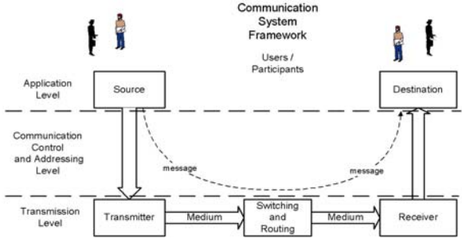 | COMMUNICATION SYSTEM FRAMEWORK  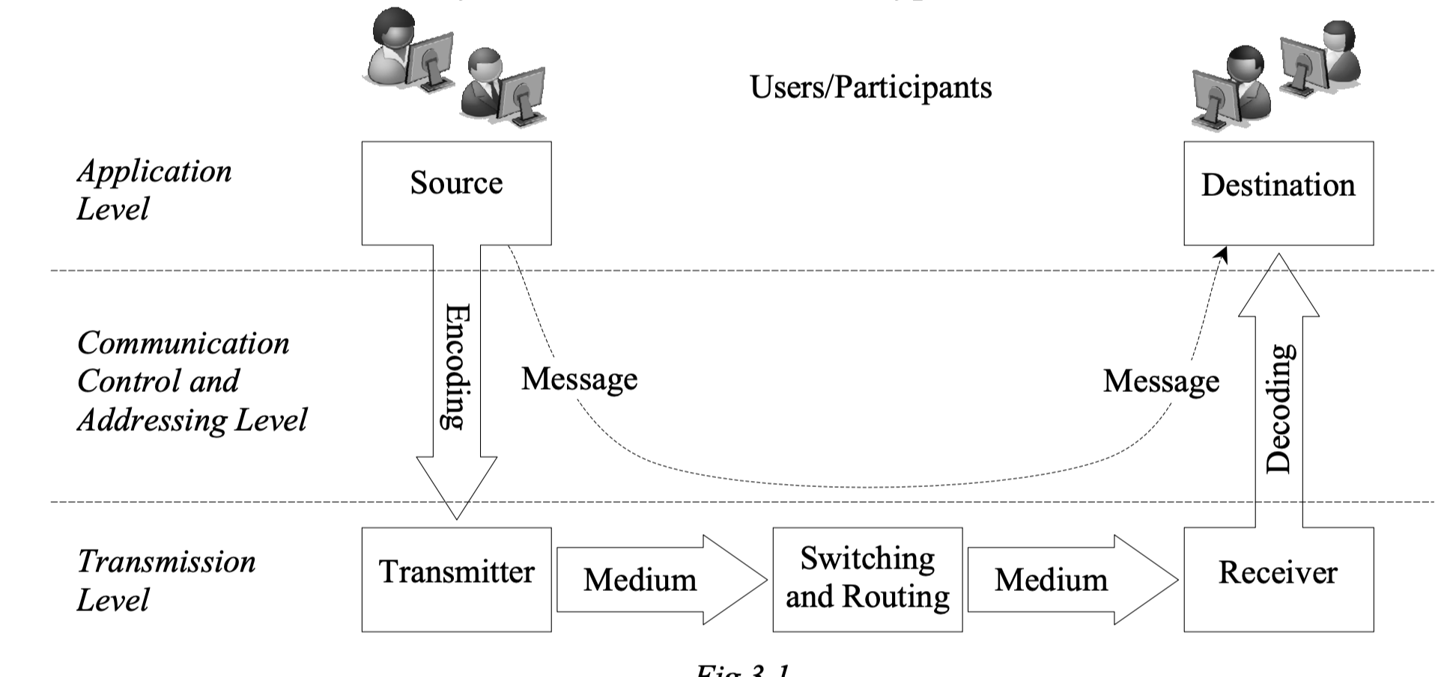  Communication Software Used  Process of Encoding & Decoding Data for Transmission & Receiving  Sending the Data  The communication system framework is a simplified version of the more detailed OSI (Open Systems Interconnection) model.  Protocols are classified according to the level or layer in which they operate:  - Application level  - Communication control and addressing level  - Transmission level  Successful communication requires components to agree on a set of rules (protocols).  - Software is used to control the operation and function of hardware.  - The transmitter and receiver must handshake on how the hardware will be used to transfer messages.  - Hardware, e.g. NIC, resides within the transmission level.  OPEN SYSTEM INTERCONNECTION MODEL  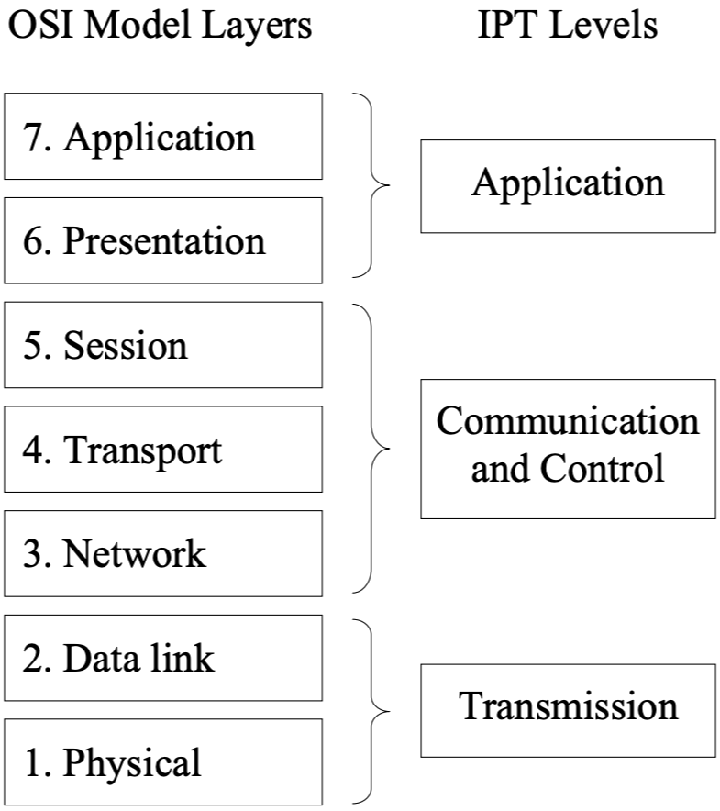  (Abbreviated to OSI)
  Handshaking | Establishing and agreeing on protocols must occur before any data can be transmitted or received
  Interface | Refers to the communication system framework, particularly encoding and decoding data
  Protocol Stack
  Transmitting (Diagram – Encoding) | Receiving (Diagram – Decoding)
  As messages pass through the interface between the sender (source) and transmitter, it is encoded and descends the protocol stack into a form suitable for transmission.  - Each message is progressively encoded using the protocol(s) operating at each level. | When messages pass through the interface between the receiver and destination, the original message is decoded by each protocol and ascends the protocol stack.
  Open System Interconnection Layers
  Steps | Layer | Description
  Application Level
  7 | Application | The data that is transmitted is created by a software application.  - Data is organised in a format that can be understood by the application on the receiving end.
  6 | Presentation | Data is reorganised into a form that is suitable for subsequent transmission.  - E.g. compressing an image and representing it as a series of ASCII characters suitable for the operating system.  - The presentation layer is commonly integrated inside and executed directly by the application itself.  - It is often related to the requirements of the information system.  - Protocols: HTTP, DNS, FTP, SMTP, POP, IMAP and SSL.
  Communication Control and Addressing Level
  5 | Session | Communication with the network is established, initiated and maintained.  - E.g. When performing an internet banking transaction, the session layer ensures communication is maintained until the transaction is completed.  - Determines when a communication session is started with a remote computer.  - Includes security to ensure users have appropriate rights.
  4 | Transport | Manages the correct transmission of every packet of data.  - Ensures that packets that fail to reach their destination are retransmitted.  - E.g. TCP (Transmission Control Protocol) operates on this layer, it is used to ensure the correct delivery of each data packet on TCP/IP networks.
  3 | Network | Responsible for directing packets to their appropriate destination.  - IP (Internet Protocol) operates on this layer, it provides the address and forwards packets to their destination.  - There is no attempt to check whether each packet actually arrives.  - Routers operate at this layer via directing packets along the best path based on their IP address.  - Routers have the software stored in flash memory (outdated) and can be configured remotely from an attached computer
  Transmission Level
  2 | Data Link | Defines how transmission media is actually shared.  This includes:  - The final size of transmitted packets  - The speed of transfer.  - Other physical characteristics of transfer.  Device drivers that control physical transmission hardware operate at this layer.  For example:  - Switches and Ethernet protocol operate at this level, they direct messages based on their assigned destination MAC (Media Access Controller) address,  - Protocols: Token Ring, SONET and FDDI.
  1 | Physical | Where the physical transfers are performed, it is solely composed of hardware.  - Coverts the bits in each message into signals that are transmitted through the transmission media.  Examples of Transmission Media/Hardware in the Physical Layer:  - Twisted Pair within a LAN.  - Copper Telephone Cable in an ADSL connection.  - Coaxial cable.  - Optical fibre  - Wireless connection.
The functions performed within the communication systems in passing messages between source and destination  - Message creation  - Organisation of packets at the interface between source and transmitter  - Signal generation by the transmitter  - Transmission  - Synchronising the exchange  - Addressing and routing  - Error detection and correction  - Security management | Message creation  - The data to be transmitted is created at the source.  - This occurs within software applications and involves the collection of message data from one of the system’s users or participants.  - Happens on the application layer on the OSI Model.  Examples:  - A user writing an email using email client software such as Outlook.  - A web server retrieving requested HTML files from secondary storage in preparation for transmission to a web browser.  - A DBMS server extracted records from a database for transmission to client applications.  - Speaking during a VOIP (Voice Over Internet Protocol) phone conversation.  - Pressing the delete key to remove a file stored on a file server.  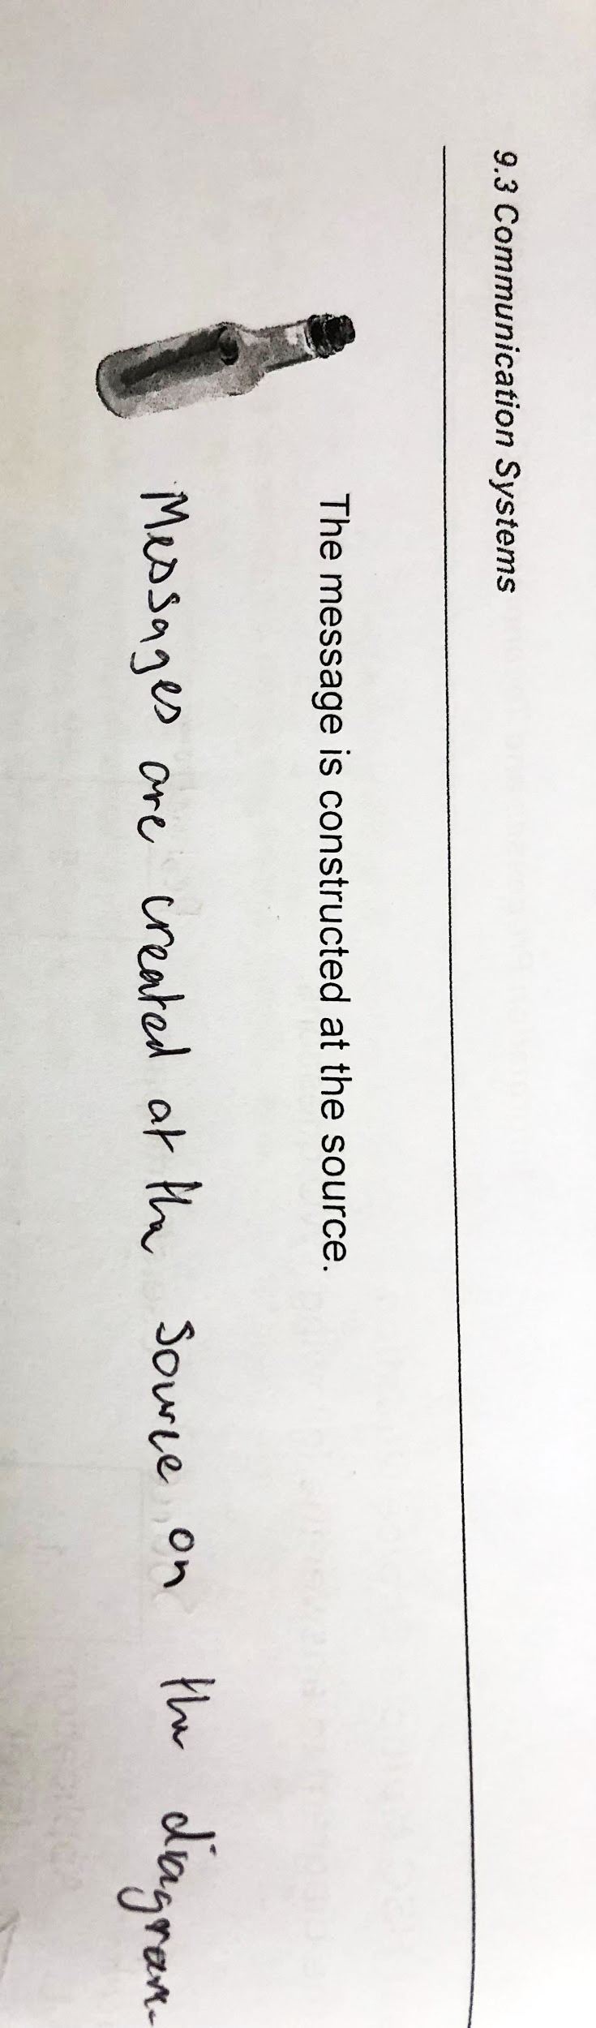  Information is from a verified source (ha get it source)

Organisation of packets

Encoding Process | Description
Encoding – Descending the Protocol Stack | When messages are encoded, they descend the stack of protocols from the Application Level until it is in a form for physical transmission at the Transmission Level.
Wrapping Data Packets – Adding header and trailer | When encoding messages, each protocol wraps data packets (known as frames and segments) from the layer above, applying its own header and trailer.  - I.e. protocols add their own unique header and trailer to each packet moving down the stack from prior layers.  - Protocols within each layer are applied independently of protocols operating in other layers.
Header and Trailer | Some protocols include in the header and trailer:  - The address/destination of the receiver.  - Error detection code.

Decoding Process | Description
Decoding – Ascending the Protocol Stack | At the receiving end, the process is essentially reversed. Protocols remove their header and trailer at the Application Level at each layer until the data is received.
Error Checks | As the message ascends the protocol stack, some protocols perform error checks then passess the data packet to the next layer.

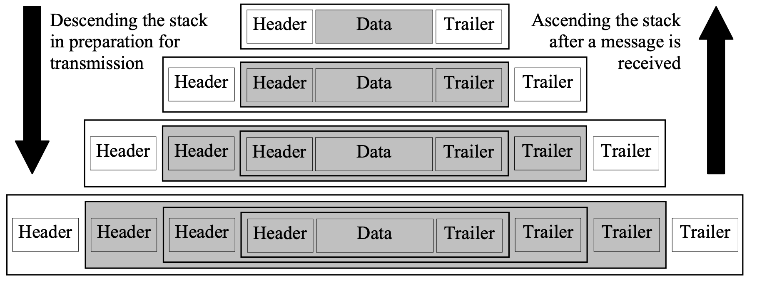
NB: Although the diagram implies each layer creates only a single data packet at each layer, usually multiple packets are created.

Signal generation by the transmitter

Transmitting and Receiving | Description
Transmitter – Encoding Signals | Introduction  The transmitter is the physical hardware which encodes data into a suitable form for itself, thereby creating a signal.  - Hardware is controlled by protocols operating at the Transmission Level.
Transmitter – Encoding Signals | Representing Bits as Waves  The purpose of transmitters is to represent individual bits as a wave – this wave is a signal that is transmitted through the hardware.  Examples of Signal Representations:  - For copper wires, bits are represented by altering voltage.  - For optic fibre cables, light waves.  - For wireless medium radio waves, infrared waves or microwaves are used.
Transmitter – Encoding Signals | Altering Transmission Signals  The rules of the Transmission Level protocol determine how the wave is altered by the transmitter.  - i.e. how each pattern of bits is encoded, the speed of transmission, and the synchronisation of transmission.  Devices that include a Transmitter:  - NICs  - Switches  - Routers  - Cable modem and ADSL  - Mobile phones and Bluetooth devices
Receiver – Decoding Signals | Decoding the Signal  Receivers decode the signal on the physical hardware.  - Usually, transmitters and receivers are contained within the same hardware device.

Transmission

Transmission | Description
How Transmission Occurs | Transmission occurs as the signal travels through the transmission medium (e.g. coaxial wires).  - Each bit moves from transmitter to receiver as a particular waveform.  - The transmitter creates and maintains each waveform on the transmission medium for a small period of time.
How Transmission Occurs | Example  A transmission protocol transmitting at 5 Msym/s means that the transmitter generates 5 million distinct signals (wave patterns representing bit patterns) per second.  - It also means each distinct symbol is maintained for a period of one-five millionth of a second.  - If each symbol represents 8-bits, assuming that transmission occurs as a continuous stream (no interruptions), then 1MB of data is transferred every one-fifths of a second.
Splitting Data into Data Packets | Data signals are split into smaller data packets that aren’t continuously sent because:  - Errors can occur that need to be considered.  - It is inefficient to transmit entire messages all at once.  - E.g. Some transmission mediums can exist over long distances.  Some protocols wait for the receiver for confirmation before sending the next data packet.  - This has the potential to double transmission times.  - Thus, flow control is used by protocols to reduce transmission times.  - Ensures optimal data transmission.  - Messages aren’t transmitted all at once.

Synchronising the exchange

Synchronisation Processes | Description
Signal Sampling | The incoming signal needs to be sampled for the receiver to accurately decode it using the same timing as the transmitter during encoding.  - Data loss or damage may occur if synchronisation does not occur properly.
Synchronisation | The synchronisation process ensures each symbol (waveform) is detected by the receiver.  - If both transmitter and receiver use a common clock, then transmission can occur as sampling will be perfectly synchronised with transmitting.  Example:  - Synchronous communication is used between components of the motherboard through the system clock
Synchronisation | Asynchronous Links  Synchronous transmission systems have replaced older asynchronous links.  - Asynchronous links transfer individual bites, rather than packets, separately using start and stop bits.
Synchronisation | Synchronous communication transfers large data packets (called frames), which vary in size depending on the individual implementation.  - E.g. 10baseT Ethernet networks use a frame size of up to 1500 bytes and frame sizes of over 4000 bytes.

Clocking | Description
Elements of the Synchronisation Process | Preamble  Included at the start of each frame, guides the initial synchronisation of the receive and transmit clocks
Elements of the Synchronisation Process | Representation of Bits  Embedded within data and is used to ensure synchronisation is maintained.
Self Clocking | Two frequencies are required for self-clocking code, a base frequency and another frequency which is double the base.  - Data is transmitted at the same rate of the base frequency.  - E.g. 10baseT Ethernet transfers data at 10MBps and therefore a base frequency of 10 MHz is used.  - Other Transmission Level protocols use similar synchronisation strategies.

Addressing and routing

Addressing and Routing Data Packets | Description
Data Packet Routing – Paths | Data packets may pass through many different links – particularly when communication is over the internet.  - Furthermore, packets forming part of a single file will travel over different paths from the transmitter to the receiver.
Ascending and Descending the Protocol Stack | Each packet must ascend the protocol stack until reaching the addressing or routing protocol.  - Then descend the protocol stack after it is encoded for transmission.
MAC Address | Ethernet and other Transmission Level protocols use the receiver’s MAC address to determine the path to the receiver.  - E.g. an Ethernet switch maintains a table of all MAC addresses of nearby devices, frames are directed down the precise path leading to the receiver.

Datagram | A self-contained message transmitted over a network whose arrival, arrival time, and content aren’t guaranteed.

- Routers mainly use the IP address within IP datagrams with their own routing table to determine the path the datagram travels.
  - The routing table needs to be maintained and updated to reflect the current state of attached networks and surrounding routers.
  - Routers divert datagrams around faulty or poorly performing network connection.

Error detection and correction

Error Detection – Transmitting & Receiving | Description
When Descending the Protocol Stack | When messages descend the protocol stack before transmission, many protocols calculate checksums or CRC (Cyclic Redundancy Check).  - The CRC values are then embedded within the header and trailers of the data packet.
When Ascending the Protocol Stack | When the message ascends the protocol stack when it is received, protocols examine these header and trailers.  - If the protocol performs error detection, the error check is recalculated to ensure that results match the original checksum value.  - However, if the values do not match, then an error is detected and the entire packet needs to be resent.
Other | - CRCs are used within the hardware in the Transmission Level.  - Checksums are used in higher level protocols.

Security management

Security | Description
User Permissions and Rights | Depending on user permissions, protocols restrict messages based on user names and passwords.  - Additionally, some protocols encrypt messages during transmission to prevent unauthorised access.
POP | POP (Post Office Protocol) operates on most mail servers.  - Users retrieving messages from a POP server need to be authenticated, i.e. correct user name and email.
SSL | SSL uses a public key encryption and decryption system to secure critical data transfers, e.g. financial transactions.

The roles of protocols in communication  - Handshaking and its importance in a communications link  - Functions performed by protocols at different levels | PROTOCOLS  Protocols are designed to specify a particular set of rules for particular tasks.  - Devices will not exchange messages until they have agreed upon the rules that will be used during communication  - Handshaking can occur just after the devices are powered up or it may occur prior to each communication session occurring  Application level protocols:  Communication Control and Addressing protocols:  Transmission level:
  Handshaking | Establishing and agreeing on protocols before any data can be transmitted or received.
  Protocol | A formal set of established rules observed by two devices to transfer data efficiently and effectively.  - Involves the transmitter and receiver on the Transmission Layer.
  HTTP | Hypertext Transfer Protocol (HTTP)  - Operates within the Application Level and within layer 6 of the OSI model  - The primary protocol used by web browsers to communicate and retrieve web pages from web servers  - Client-server connection is used where the browser is the client and the web server is the server  Primary HTTP commands/methods:
    GET | Retrieves entire documents  - Browser requests a document from a particular web server using GET command with a URL of the document  - The header which precede the file data indicates the nature of the data in the file  - The browser reads this header data to determine how it should display the data in the file  - E.g. HTML files, image files, video files, etc.
    HEAD | Retrieves the header information for the file to check for updates  - Used to check if the file has been updated since the browser last retrieved it  - If the file has not been updated, the browser doesn’t need to retrieve the entire file, the existing version held in the browser’s cache can be displayed
    POST | Used to send data from the browser to a web server  - Used to send all the data input by users within web-based forms
  SMTP
  SSL
  TCP | Transmission Control Protocol (TCP)  - Operates within the Communication Control and Addressing Level and within layer 4 of the OSI model  - TCP’s primarily responsibility is to ensure that messages are actually delivered correctly  - TCP requires IP to be operating, hence being referred to as TCP/IP  - TCP is a “connection oriented” and “byte oriented” protocol as it maintains information about bytes transferred within a particular communication session  - TCP segments contain 576 bytes (20 bytes for the TCP header, 20 bytes for the IP header, 536 bytes for the data)  - Each packet is a ‘segment’ which contains a string of bytes forming part of the data to be sent  - TCP segments include a header, which in turn includes its own sequence of bytes and a checksum  - Checksum is produced prior to the segment being sent  - Upon arrival of each segment, the checksum is recalculated to ensure it matches the checksum within the header  - If it matches, the bytes received within the segment are acknowledged
    Sliding Window | Controls the flow of data and ensures every byte of data is acknowledged once it has been received (checks for errors within segment)  Sender: continues sending segments of data up to the limit (window size), specified from the receiver  - As subsequent segments are sent and received, the window slides progressively along the length of the total message data  Flow control mechanism allows the reader to adjust the rate of data transfer  - If segments that fail to reach the receive, contain errors or become delayed by network congestion, then the window moves slowly  - If segments do not fail or do not contain errors, the window slides more rapidly and segments arrive quicker  Smaller window size → slower transmission  Larger window size → faster transmission  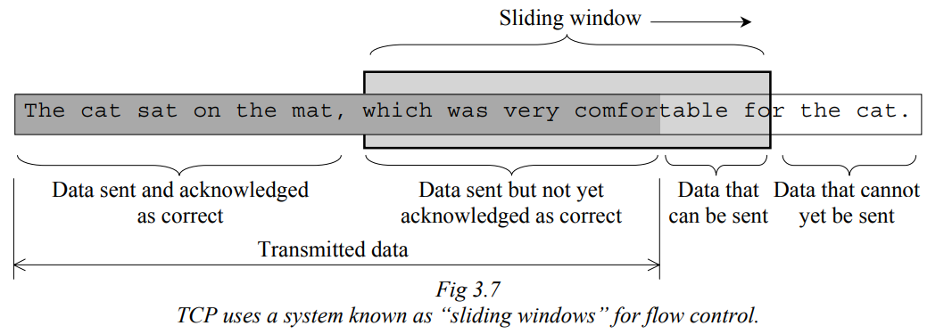
  IP | Internet Protocol (IP)  - IP can operate without TCP  - Causes data packets (datagrams) to move from sender to receiver  - Operates at the OSI Network layer 3  - IP is designed so that it will operate with all types of networks and hardware  - Does not guarantee datagrams will reach their destination, makes no attempt to acknowledge datagrams that are received  - IP is a connectionless protocol  - IP excels in rerouting messages over the most efficient path to their destination, using routers which utilise the ARP (Address Resolution Protocol) to determine the next hop for each datagram  Composition of an IP:  - Composed of four bytes (32 bits)  - Every device on the Internet has one unique IP address  - Routers require more than one IP address – one for each connected network  - Every IP datagram header includes the sender’s and destination’s IP addresses  - Each IP is composed of a network ID and host ID  - Network ID → particular number of bits starting from the left side of the binary iP address  - Host ID → the remaining bits  - Network IDs form a hierarchical structure, splitting larger networks into sub-networks.  - Sub networks lower in the hierarchy have longer network IDs  - The network ID is used by IP and routers to determine the individual destination device that receives the IP datagram  Network hops  - During the transmission of an IP datagram across the Internet, it passes through many varied network hops in it moving from router to router  - The IP includes a mechanism known as “fragmentation” to split complete datagrams into a series of smaller datagrams suited to the protocol operating at the OSI data link layer 2 of the current network hop  - Small IP datagrams created during fragmentation are not recombined until they reach their final destination  - The size of fragments received is determined by the network hop with the smallest maximum frame size (maximum transmission unit – MTU)  The header of each IP datagram is at least 20 bytes long, including a 1 byte time to live (TTL) field.  - Each router encountered during the datagram’s journey reduces the value of the field by one  - If TTL field is zero then the router discards the datagram  - Any errors found within a datagram cause it to be discarded
  Ethernet | - Operates at the Transmission Level including OSI data link layer 2 and OSI physical layer 1  - Ethernet can be applied to any medium – copper wire, optical fibre, wireless mediums  - Ethernet packets are known as frames  - Packets of data from the Communication Control and Addressing Level form the data within each Ethernet frame (length of data must be between 46-1500 bytes)  - If the data is a default TCP/IP datagram then the TCP segment requires 576 bytes with an additional 20 bytes added for the IP header → most datagrams require approx. 596 bytes  Collisions  - Using Ethernet, it is possible for two nodes to transmit a frame at the same time  - If nodes share the same physical transmission line, a data collision will occur and both frames corrupted  - Ethernet uses the system Carrier Sense Multiple Access with Collision Detection (CSMA/CD) to deal with collisions  - Modern Ethernet prevents collision through use of switches where two nodes (including the switch) exist on each segment  Ethernet standards Specify the speed of transmission with details of the transmission medium  Ethernet II (DIX) frame format  - Current ethernet form is Ethernet II (DIX)  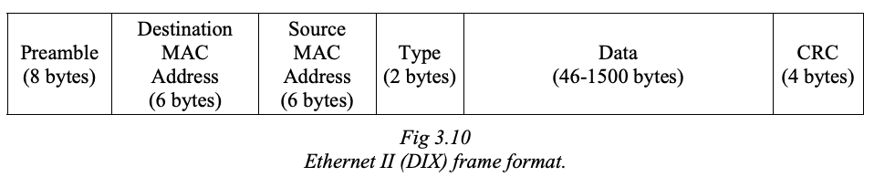  Preamble  - 1s and 0s within each frame are physically represented as transitions from high to low and low to high  - Receiver requires the sender and receivers clocks to be initially in phase with each other  Destination MAC (Media Access Controller) address  - MAC address of both sender and receiver is included in the frame header  - Every node on an Ethernet network must have a unique 6 byte MAC address  - Each node examines the destination MAC address of every ethernet frame sent over their own segment, if it matches their own MAC address then they accept the frame, if not, the frame is ignored  - Any device attached to the network is able to send and receive frames  Type  - Type field indicates the higher-layer protocol being used  - In Ethernet 802.3 frames the type field is replaced by a field indicating the length of the data portion of the frame  CRCs (Cyclic redundancy checks)  - A more accurate error checking technique than checksums  - Sender calculates the CRC based on the contents of the frame  - Receiver performs the same calculation and only accepts the frame if two CRCs match  - If CRCs do not match, the receiver informs the sender so that the frame can be sent
    Preamble | A sequence of altering 0s and 1s used to synchronise the phase of the sender and receiver’s clocks
The client-server model  - The role of the client and the server  - Thin clients and fat clients  - Examples of clients such as web browsers and mail clients  - Examples of servers such as print servers, mail servers and web servers | The role of the client and the server  A client-server system is a type of server where centralised processing is performed for clients.
Client | A participant of the system which sends requests to the central server.
Server | A server is a computer which processes requests for other computers on the network.  - The server executes client requests and returns a response  - This is either retrieved data or an acknowledgement that the request was done.

Interactions between client and server occur over a network – such as LAN or the internet – and usually involve multiple clients making requests to each server.
- This means the server requires a stable connection.
- Different techniques have been implemented to allow local client processing to continue if the server becomes offline.

Thin clients and fat clients
Client machines are referred to as ‘thin clients’ and ‘fat clients’.

Thin Client | A client machine which is connected to centralised mainframe computers and relies on servers for storage and processing.  - Thin clients are basic low specification personal computers, they perform basic processing tasks.  - Has few resources and is reliant on the network for storage and processing.  - E.g. dumb terminal connected to mainframe computer
Fat Client | A client machine that has applications installed which are executed by the CPU within the machine.  - Has many resources and operates independently from the central server  - E.g. a personal computer

Examples of clients
Clients are often in the form of software applications which send requests to servers, such as:
- Web browsers which send requests to web servers
  - E.g. performing transactions on a banking or E-commerce website.

Examples of servers

Types of servers
Print Server | A computer in a network which controls printers and stores data for printing. Print server functions include:  - Managing the printing tasks  - Holding information/data about the print job  - Sends messages to their destination for the user to read
Mail Server | A computer in a network which provides email facilities. Mail server functions include:  - Storing incoming mail for distribution  - Forwarding outgoing mail to the correct destination.
Web Server | A computer in a network which connects nodes to the Internet.  - Internet traffic is directed through this server  - The server sends received data to the correct node

Examples of Communication Systems
Syllabus Points | Notes
Teleconferencing systems | - Teleconferencing systems are used for meetings between an organisation’s head office and branch offices.
  Teleconference | A multi-location, multi-person conference where audio, video or other data is communicated in real time to all participants.  - The essential feature of teleconferencing systems is that they are multiplex and synchronous communication.
  Types of Teleconferencing Systems
  Audio Conference | Telephone calls involving two or more people at different locations.  - It is a service provided by the phone company.  - Uses telephone lines as the transmission medium.
  Video Conference | An online meeting which allows participants, in different locations, to view video and hear audio of each other.
Messaging systems
  Types of Messaging Systems
  Messaging System | Description
  Traditional Phone and Fax | Telephones  - Telephones have a microphone, a speaker, and a switch which connects the phone to the telephone network.  - There are two signals used to dial numbers.  - Pulse Dialling – An older form where the phone switch is rapidly disconnected and connected the same number of times as the number dialled.  - Tone Dialling – A newer method which transmits different frequencies to represent each number.  - Circuit switching creates a direct connection between two phones, electronic switching automates this process.  - By digitising analogue voice signals, it is possible to compress bits and for multiplex, synchronous communication on a single physical connection.  - Modulation schemes are used for different frequencies, e.g. time division multiplexing uses tier 1 lines and samples each voice 8000 times per second, which is coded into 7-bits.  TLDR: Telephones contain a microphone, speaker and a switch connecting the phone to the telephone network. Tone dialling is used to connect to a specific number. By digitising analogue signals, bits can be compressed for multiplex, synchronous communication. Modulation schemes sample each voice and code them into bits.
  Traditional Phone and Fax | Facsimile (Fax)  - Sends analogue signals to each page.  - Messages are sent as a series of tones, white and black, which are then converted to an image using heat sensitive paper.  - Other machines print using inkjet or laser technology.  - Computers are used to produce, send and receive faxes.  TLDR: Fax sends analogue signals onto a paper page. This is then printed using a series of black and white tones. Printing may also be conducted via inkjet or laser technology.
  Voicemail and Phone Information Services | Voice mail is like a digital version of a traditional answering machine.  - Calls that are unanswered are diverted to the voice mail system.  - This plays a pre-recorded outgoing message (OGM)  - Voice mail digitally records the user's voice and stores it for the receiver's voice mailbox.  TLDR: Voice mail is a digital version of a traditional answering machine which records and stores a pre-recorded outgoing message to a receiver’s voice mailbox when calls are unanswered.
  Voice over Internet Protocol (VoIP) | - VoIP transfers voice calls over the public internet.  - It is possible to transfer voice over the internet using any Internet connection with a microphone, speaker and instant messaging applications, e.g. MS Messenger.  - VoIP provides an interface to the PSTN, allowing VoIP calls to be made to any normal telephone across the globe.  - Furthermore, calls are significantly cheaper.  - Audio codecs are included to digitise and compress analogue voice data, and decompress and convert it to analogue at the receiving end.  - Data that has been undergone ADC passes through a stack of protocols – Real Time Protocol and User Datagram Protocol.  - RTP controls the flow of data packets, UDP fires off packets without error checking and flow control.  TLDR: VoIP transfers voice calls using the public internet, enabling global communication. It uses audio codecs to digitise and compress analogue voice data, as well as decompress and convert signals to be received.
  Electronic Mail (E-mail) | Allows communication by sending and receiving messages using a device connected to the Internet.  - Emails are transmitted using ASCII text.  - Email messages are composed of an envelope and contents component.  - The envelope contains information regarding the pathway of the message to its destination.  - The envelope is examined by SMTP servers to relay messages to the destination.  - The contents contain the actual message data, with additional header fields to specify the sender, receiver, date/time and subject.  - Messages are composed of a sequence of header fields followed by lines of text forming the body of the message.  - Destination address fields include, To:, Cc: and Bcc:.  - To: contains the addresses of primary recipients of the message.  - Cc: is carbon copy which is the address of recipients who received a copy of the message.  - Bcc: is the field for recipients who receive the message but their address is not revealed to other recipients.  TLDR: Email allows messages to be sent and received through the internet. They are transmitted using ASCII text and are composed of an envelope and contents component. The envelope contains data regarding the destination address which is used by SMTP to effectively reroute the message. The contents of the message have the actual message data and fields which specify the sender, receiver, date/time and subject.
Other systems dependent on communication technology such as:  - E-commerce  - EFTPOS  - Electronic banking | E-commerce  - Involves financial transactions occurring over an electronic network.  - Electronic commerce systems are used to withdraw cash from ATMs and pay for store purchases using EFTPOS.  - This enables the purchase and sale of goods over the internet to perform electronic banking transactions over the internet.

EFTPOS
- Electronic funds transfer at point of sale (EFTPOS).
- Uses credit and debit cards to transfer money from the customer's bank account to the retailer’s bank account.
- Has made shopping easier and enabled retailers to immediately receive payment for their goods.

Electronic Banking
- Allows customers to view their account balances and transactions.
- Enables customers to transfer money between accounts and pay bills using BPAY.
- Electronic banking is a 24-hour service.
- It cannot account for cash or cheque withdrawals.

Transmitting and Receiving in Communication Systems
Syllabus Points | Notes
Transmission media, including:  - Wired transmission  - Wireless transmission | Wired Transmission  Wired transmission media restricts signals so that they are contained in and follow the path of a cable.  - Wired media can be shielded to prevent external electromagnetic forces from affecting the signal.  - However, signals degrade as distance increases.  - Wired transmission mediums are generally reliable.
  Physical Medium | Description
  Twisted Pair | A twisted pair cable is composed of pairs of copper wires twisted together.  - Regular twists in each pair limit the electromagnetic influence between pairs.
  Twisted Pair | Twisted Pair Cable Structure  - Copper wires are contained within plastic insulation.  - Twisted pairs of wire are enclosed in an outer sheath.
  Twisted Pair | Unshielded Twisted Pair (UTP)  - The most common and economic form of copper cable.  - Used for LAN and telephone connections.  - UTP cables do not have a physical shield against electromagnetic interference.  - Thus it is not suitable for wired transmission exceeding 100m.  - UTP cables are categorised by data transfer speeds, where a higher number supports higher frequencies.  Shielded Twisted Pair (STP) & Screen Twisted Pair (ScTP)  - Include a metal shield or screen and drain wire to prevent electromagnetic interference.  - STP and ScTP cable is more expensive however.  - It is used for limited applications, where high levels of electromagnetic interference is present.
    Cable | Max Frequency | Applications
    Cat-6 | Up to 250MHz | 1000baseT Ethernet
    Cat-5e | Up to 125MHz | 100baseT Ethernet
    Cat-3 | Up to 16MHz | 10baseT Ethernet, telephone lines
  Coaxial Cable | A coaxial cable is suited for broadband applications, it is designed for analog applications.  - It was originally designed to transmit analog broadband TV from antennas to TV sets.  Data Transmission  - The cable transmits frequencies ranging from 30MHz to 3GHz.  - Very High Frequency (VHF) to Ultra High Frequency (UHF) bands.  - A coaxial cable is relatively immune to external electromagnetic waves compared to twisted pairs.  - However, it is more expensive.
  Coaxial Cable | Coaxial Cable Structure  - Coaxial cables are contained in a solid steel core wrapped with copper.  - A nylon insulator surrounds the solid core.  - The nylon insulator is enclosed by aluminium foil wrap that is braided with copper or aluminium  - Finally, a plastic sheath covers the entire cable.
  Optic Fibre Cable | Optical fibre cable is composed of optical fibres which use light to transmit data.  - It is able to support higher transfer rates over greater distances compared to twisted pair or coaxial cable.  - Optical fibre is used for dedicated backbones which connect UTP based networks into a single LAN.  - It is completely immune to external electromagnetic interference.  - Thus, it is used for industrial applications.  Data Transmission  - Light waves are high frequency electromagnetic waves.  - Fibres are designed for wavelengths of 0.85, 1.55 and 1.625 micrometres, which equates to 200,000GHz to 350,000GHz.  - Light waves carry signals within optical fibres.  - It uses the infrared region of the electromagnetic spectrum.  Refractive Index  - Fibres designed for specific frequencies are called single-mode fibres  - Multi-mode fibre operates where the refractive index of the wire varies throughout its diameter.  - Multi-mode fibre supports a range of infrared frequencies.
  Optic Fibre Cable | Optic Fibre Cable Structure  - Optical fibre cables contain optic fibres which transmit light signals.  - The core and cladding are composed of pure glass.  - The lading has a lower refractive index.  - Optical fibres are contained in a protective plastic coating.  - This protects against physical damage and adds strength.

Wireless Transmission
Wireless transmission uses the atmosphere as the medium to carry electromagnetic waves between nodes/devices.
- The advantage of wireless media is that it is able to traverse rugged terrain.
  - Nodes can also freely traverse within the range.
- However, since it is unbound, it is vulnerable to interference or interception.

Wireless Medium | Description
Microwave | Point-to-point ground based (terrestrial) microwaves are used to relay signals across large distances.  - It is typically used to transmit radio and TV programs.  Transponders  - Sequences of transmitters and receivers, known as transponders, are arranged in a chain.  - Transponders are physically located above ground level, typically in the form of a communication tower.  - This is to avoid objects, such as trees, and counteract the curvature of the earth.  - Also, a direct line of sight is required between the transmitter and receiver, usually 40 km apart.
Satelite | Satellites use microwaves to transmit signals between ground based stations and satellites.  - Satellites contain transponders that receive signals and amplify, then transmit them on a different frequency.  - Communication satellites are geostationary.  Applications of Satellite Communication  - Satellite TV broadcasts.  - Broadband internet connection.  - Global Positioning Satellite (GPS)
Radio | Radio frequency uses electromagnetic waves generated by the transmitter and detected by the receiver to transmit data.  - Radio waves are reliable at passing around walls.  - A direct line of sight is required between the source and destination.  - Radio frequencies travel at slower speeds, it is slower compared to cabled methods.  - There is minimal security to radio waves as they are unbound (can’t be controlled).  - This means that it is susceptible to interference and accessing from other sources.
Infrared | Infrared waves consist of electromagnetic frequencies above microwaves and below visible light which transmit data.  - Infrared waves travel in straight lines.  - Hence, a direct line of sight is required between source and destination.  - It is typically used for short distances.  - E.g. remote control products (like TV remotes)

Characteristics of media in terms of speed, capacity, cost and security | Speed  Data transmission speeds are typically measured in bps (bits per second). The standard units of data/information are defined as:  Binary conversion is the preferred method since the binary numbering system is the base for all computers, whereas decimal conversion is for everyday usage.  Adam Schon - Network speeds are measured in bps student copy Page 246
  Binary Conversion (Base 2) |  |  |  | Decimal Conversion (Base 10)
  Value |  | Data Unit (SI) |  | Value |  | Data Unit (SI)
  — | – | 1 Bit (b) |  | — | — | 1 Bit (b)
  8 Bits | – | 1 Byte (B) |  | 8 Bits | – | 1 Byte (B)
  1024 Bytes | 2¹⁰ | 1 Kilobyte (kB) |  | 1000 Bytes | 10³ | 1 Kilobyte (kB)
  1024 Kilobytes | 2²⁰ | 1 Megabyte (MB) |  | 1000 Kilobytes | 10⁶ | 1 Megabyte (MB)
  1024 Megabytes | 2³⁰ | 1 Gigabyte (GB) |  | 1000 Megabytes | 10⁹ | 1 Gigabyte (GB)
  1024 Gigabytes | 2⁴⁰ | 1 Terabyte (TB) |  | 1000 Gigabytes | 10¹² | 1 Terabyte (TB)
  1024 Terabytes | 2⁵⁰ | 1 Petabyte (PB) |  | 1000 Terabytes | 10¹⁵ | 1 Petabyte (PB)

Capacity
The capacity of transmission media is determined by its bandwidth, which regulates the speed of transmission:

Bits per second (bps) | The maximum volume of bits which can be transmitted in one second.
Baud rate | The maximum number of unique electrical signals/symbols which can be transmitted in one second.

 | Cost
 | Security
Communication protocols, including:  - Application level protocols  - http  - smtp  - SSL  - Communication control and addressing protocols  - TCP  - IP  - Transmission level protocols  - Ethernet  - Token ring | Application Level
  HTTP | Hypertext Transfer Markup Protocol
  SMTP | Simple Mail Transfer Protocol
  SSL | Secure Sockets Layer

Communication Control and Addressing Protocols

TCP | Transfer Control Protocol
IP | Internet Protocol

Transmission Level Protocols

Ethernet
Token Ring

Strategies for error detection and error correction
Network topologies:  - Star  - Bus  - Ring  - Hybrid  - Wireless networks | 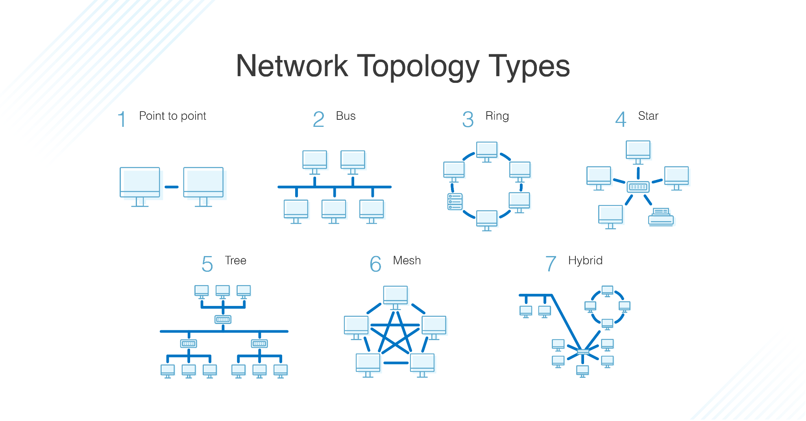
  Network Topography | A model describing the arrangement of nodes and their connections (wired or wireless) within a network.

Star

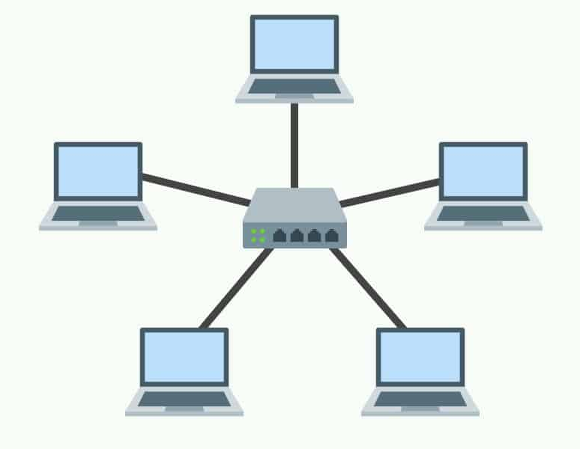

STAR Topology
What is STAR topology? | A type of network arrangement where nodes are connected to a central switch (device that receives and forwards data), forming a ‘star-like’ shape.
Advantages | - Effective use of cables as it reduces the distance between network devices through concentrating connections in the central switch.  - STAR topology is a common type of network arrangement meaning that it is standardised.  - Able to add additional nodes without rebooting or redesigning the network.  - If cabling is broken, the network continues operating
Disadvantages | - Requires consistent monitoring and maintenance to function.  - If the central switch fails, the whole system stops working properly.

Bus

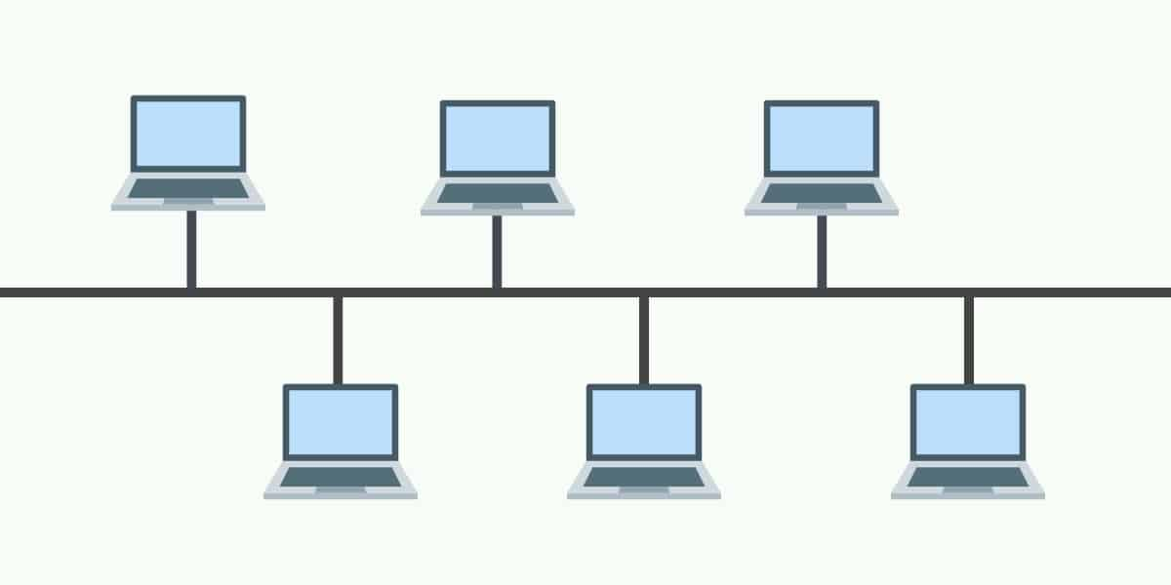

BUS Topology
What is BUS topology? | A type of network arrangement where nodes are connected to one wire line.
Advantages | - Quite simple and easy to set-up.  - New nodes can be added to the network without redesigning the network.  - Extremely cheap to establish since there is only one line of connection.
Disadvantages | - Prone to failure because if the line fails, then the network stops working properly.  - Data can only be transferred in one direction, which limits the network’s function (simplex).  - It is only suitable for low volumes of traffic since each node takes a part of the total bandwidth; this limits connections and means data transfer is slow.

Ring and Dual Ring

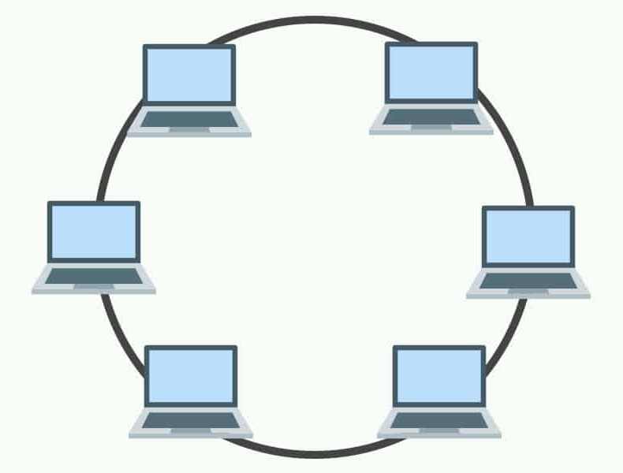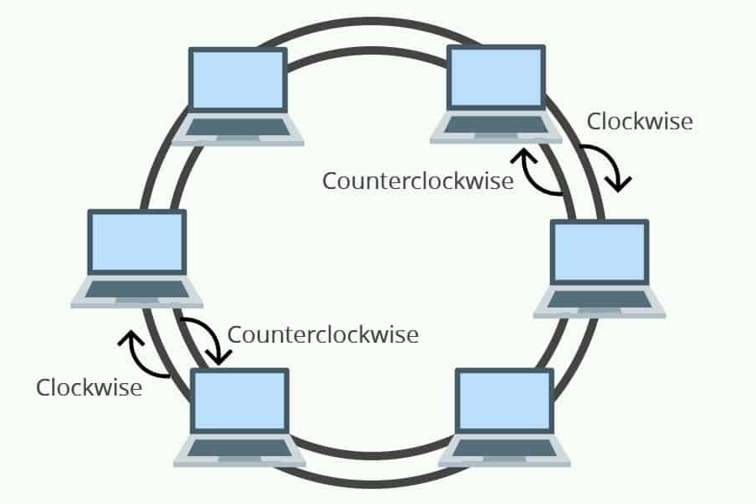

RING Topology
What is RING topology? | A form of network arrangement where each node is connected to each other in a circular order forming a continuous circle.
Advantages | - Relatively inexpensive to implement.  - In Dual Ring, there is a lower chance of network collision compared to a bus network since they aren’t linked to a central wire.  - Network collision: when data is being transferred by multiple devices on a single medium causing data corruption.  - The RING structure is able to be updated to a dual ring arrangement.  - Suitable for small size businesses.
Disadvantages | - Adding new nodes reduces the total network bandwidth and requires a shutdown of the system.  - If one wire breaks, the system fails.  - Requires constant monitoring and maintenance to function properly.

Hybrid

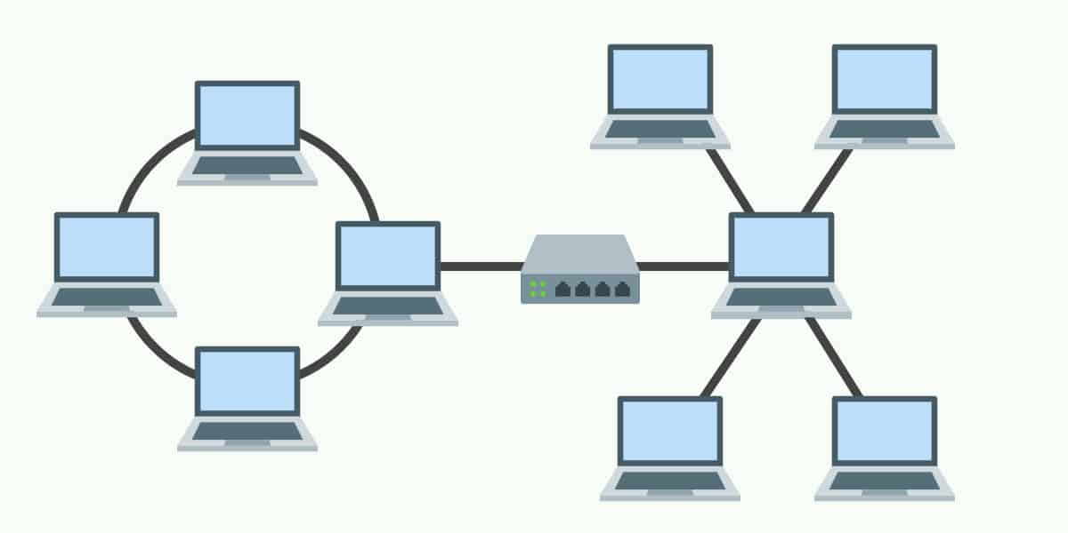

HYBRID Topology
What is HYBRID topology? | A network arrangement which is a combination of a BUS, STAR, or RING structure; depending on the network’s needs.
Advantages | - Flexible for the network’s needs as it is a specialised design.  - It is infinitely expandable without compromising the network bandwidth.  - Suitable for middle-large size businesses.
Disadvantages | - Very expensive equipment costs and wire costs.  - Professional management and experts are needed to implement the system.

Wireless Networks
Wireless networks utilise wireless transmission media to connect nodes together for communication on a network. It is particularly suited for locations where physical cabling may be impractical or where nodes move around frequently, such as laptops, tablets and mobile devices.
The functions performed by the following hardware components used in communication systems  - Hubs and Switches  - Router  - Modem  - Bridges and Gateways  - Network Interface Card (NIC)  - Mobile Phones  - Cables  - Wireless Access Points  - Bluetooth Devices
  Component | Function
  Hubs and Switches
    Repeater | Any device which receives a signal, amplifies it and transmits the amplified signal to another link. They are used to increase the physical range of transmission media.
    Bridge | A device that connects a network made of multiple segments into one network.
    Hub | A central device which connects nodes together into a single network segment. They broadcast data to all connected devices and are multiport repeaters.  - Retransmits data packets to all attached nodes regardless of their intended destination  - All nodes attached to the central hub share the same transmission channel  - Slow transmission speeds  - Once used to connect UTP ethernet networks, being phased out for switches
    Switch | An intelligent hub and multi-port bridge, which broadcast data packets only to their intended destination.  - It reads the MAC address of the sender and receiver to forward packets to the destination node  - Establishes a direct connection between sender and receiver; thus each node exists in its own independent network segment  - Prevents data collisions from occurring; nodes can transmit messages at any time  - Enables full duplex communication between nodes  - Fast transmission speeds
  Router | A device which directs messages over the most efficient path between networks to their destination in a process called network hopping.  - Routing decisions depend on each datagram’s destination IP address  - They are capable of communication with networks using different protocols and transmission media  - A routing table is maintained to determine the pathway a datagram should travel  - If a network fails, the routing table determines the next most efficient alternate path
  Modem | Modems are devices which perform the process of modulation and demodulation on data packets. This involves encoding and decoding data to and from a digital format suitable for analogue transmission.  - Modems are used to connect nodes to a local Internet Service Provider (ISP)  - They provide an interface between modulated analogue waves and digital data suitable for computers
  Bridges and Gateways
    Bridges | A bridge separates a network into different segments at the transmission level.  - They determine the destination MAC address of each frame  - If the destination node with the MAC address is located on the other side of the bridge, the frame is duplicated  - A bridge splits a bus network into two collision domains  - Connect networks of the same protocols  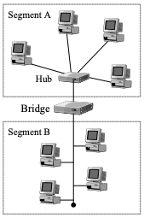
    Gateways | A gateway connects two networks together.  Functions:  - Used to connect networks at different lower level protocols  - Used to filter traffic movements between two networks  - Used to connect any two networks together  - This includes networks using different transmission mediums  - Gateways connect LAN to the Internet  - Such gateways use both a Local IP address and Internet IP Address  - Connect networks of different protocols
  Network Interface Card (NIC) | Network interface cards convert data between computers into a form suitable for transmission across a network. The NIC negotiates access to a network, including collision detection.  - The NIC has its own unique MAC Address to uniquely identify the computer (node) on the network  - NICs are connected to the motherboard of a computer and enables Ethernet functionality
  Mobile Phones | A mobile phone is a device which connects to a mobile phone network.  Mobile phone networks are divided into areas called cells, each containing their own central base station which transmits and receives data between individual phones.
  Cables | Physical transmission media which are used to connect nodes together in a network. They facilitate the transmission of data through them.
  Wireless Access Points | They are access points or central nodes on a wireless LAN which improve the coverage area of a network. Access points broadcast to all wireless nodes within their area.  - WLAN access points do not direct packets to specific nodes or control the order of transmission, they are repeaters.  - It acts as a wireless version of a hub device  - An issue with WLAN is security since any user within the coverage range can access the network  - Thus, access points include encryption security in the form of Wired Equivalent Privacy (WEP) and WiFi Protected Access (WPA)
  Bluetooth Device | A device which uses Bluetooth, a form of communication system for wireless short range transmission.  - It is suitable for connecting portable devices together  - Designed for low-bandwidth  - Uses radio signals
Characteristics of network operating software | Network operating systems (NOS) function at the network at the above layers of the OSI models.  - NOS is installed on one or more servers  - It provides various services to secure and support the network’s resources and users  - E.g. the authentication of users based on their usernames or passwords
Similarities and differences between the Internet, intranets and extranets | The primary difference between intranet and extranets is that an intranet is a private network comprising one network whereas an extranet is a public network which comprises multiple networks.  The interface between the extranet and intranet must be secure – in the form of firewalls, usernames, passwords and encryption.
  Intranet | An intranet is a private network that is maintained by an organisation and based on Internet Protocol.
  Extranet | An extranet is a public network which is an extension of an intranet which enables users to communicate with outside organisations.

Other Information Processes in Communication Systems
Syllabus Points | Notes
Collecting  - The phone as the collection device with voice mail  - EFTPOS terminal as a collection device for electronic banking | Phone as a Collection Device  Voicemail is a digital version of an answering machine. Calls that are unanswered are diverted to voicemail where the system stores and plays a pre-recorded message.

EFTPOS Terminal as Collection Device
An EFTPOS terminal includes a keypad and magnetic stripe reader for collecting input data.
Processing  - Encoding and decoding analog and digital signals  - Formation of data packets  - Routing  - Encryption and decryption  - Error checking  - Parity bit check  - Check sum  - Cyclic redundancy check (CRC) | Encoding and Decoding Analog and Digital Signals  The modem modulates and demodulates signals to produce electrical signals that can be used in transmission.

Formation of Data Packets
The form of a packet of data starts with a preamble, address information, other transmission-related information (e.g. protocol) then finishes with a few more bytes of error detection (e.g. checksums, cyclic redundancy check).

Routing
Data packets which are transmitted over communication links have their own protocols. Data packets ascend the protocol stack on their path and are encoded by protocols towards the route protocol. Once they reach the route protocol, the data packets descend the protocol stack and are decoded.

Encryption and Decryption

There are two forms of encryption: asymmetric encryption (public-key encryption) and symmetric encryption.

Symmetrical Encryption | Also known as single key encryption, which involves the same encryption key being used to encrypt and decrypt messages.  - If the computer decrypting and encrypting the data is different, then a secret key needs to be shared between both parties.
Asymmetrical Encryption | Also known as two-key encryption, which uses a public key for encryption and a private key for decryption.  - The public key can be shared  - The private key cannot be divulged

Error Checking

Method | Process | Error Detection
Parity Bit Check | Parity Bit  A parity bit is a 9th bit that is appended to existing 8-bit binary code, so that the total number of 1’s is odd or even.  - During handshaking the transmitter and receiver agrees on whether an odd or even party will be used.  - It is suited for error detection of small packets. | When data is transferred, the motherboard tests the parity bit.  - If bits are corrupted and do not match the odd or even parity then the receiver detects an error and the message must be resent.  - If the bits match the parity then the message is acknowledged
Checksum | Checksums are calculated by summing up all bytes, as if they were integers, within a message.  - The calculated value is sent to the receiver.  - When the packet is received, the checksum value is recalculated and matched with the original value. | - If the recalculated value matches the original value, then the packet is acknowledged and received.  - If the value doesn’t match, the error is detected.  - The receiver requests the transmitter to resend the package.
Cyclic Redundancy Check (CRC) | CRCs calculate values by dividing instead of summing.  - The entire message is considered a complete number.  - The number is divided by another predetermined number.  - The remainder becomes the CRC value. | When the remainder is calculated, it is appended to the message as it is sent.  - When packets are received, the calculation is performed again.  - If the recalculated divisor does not match, an error is detected.

Displaying  - The phone as the display device with voice mail  - EFTPOS terminal as a display device for electronic banking | Phone as a Display Device  Mobile phones will have a screen which displays user options for voice mail, e.g. pressing 0 to delete a message or pressing 1 to relay a message.

EFTPOS Terminal as a Display Device
A typical EFTPOS terminal includes a monochrome LCD screen and a small thermal printer as display devices.

Managing Communication Systems
Syllabus Points | Notes
Network administration tasks  - Adding/removing users  - Assigning users to printers  - Giving users file access rights  - Installation of software and sharing with users  - Client installation and protocol assignment  - Logon and logoff procedures  - Network-based | Adding/Removing Users  Each added user has an individual account which includes their username and password, and details of their assigned policies and privileages (read & write).  - A user’s account is removed if inactive or unused.

Assigning Users to Printers
Printers can be assigned to specific workplaces or users. As printers are physical devices that are installed in specific locations, printers are assigned to workstations rather than users.
- Users will have access to a printer that is physically located close to the workstation they are currently logged in on,

User File-Access Permissions
File access rights are known as permissions. System file access rights are a type of privilege and include:
- Read – Ability to view files
- Write – Ability to modify files

Installation of Software and Distribution with Users
- Network operating systems are able to automate the installation of software to multiple users
  - This saves time for network administrators as it eliminates the need for manual installations on client workstations

Client Installation and Protocol Assignment
- Each node on a network is assigned an IP address which allows the transmission of data to specific destinations
- Software that is installed on client workstations have their own protocol

Log-on and Log-off Procedure
- Procedures for logging on and off a specific page is important to prevent trespassers from viewing sensitive data
- A login token is used to track what actions the user has taken
- Once actions are completed, users must log off by entering appropriate commands or clicking a link which powers off the browser

Network Based
- Network applications use the client-server infrastructure, which involves two computers connected to the network
- The server is programmed to provide some service to the client
- Network applications run a web client

Issues related to communication systems
Syllabus Points | Notes
Security | Systems which handle critical information, such as banking, need to ensure that their services are safe from interference and secure user data.  - This includes prevention of:  - Data loss and damage  - Unauthorised access
Globalisation | The improvement of data transmission speeds have lifted physical location restrictions. This means that organisations can communicate across the globe through cyberspace.  This has lead to advantages and disadvantages  - Virtual communities can be created without regard to geographical location  - However, this has brought legal implications in terms of criminal activity and taxation laws
Changing nature of work
  Changing nature of work | Workplaces need to adapt to technology as it improves, this leaves a loss of jobs for individuals with few IT skills and closure of automated jobs.
  Branch closure and job loss | An example of job loss is automated checkouts which have reduced the need for in-person shop clerks.
Interpersonal relationships | In cyberspace, relationships can form on common interests. Information and knowledge is shared between people who may never physically meet. The exchange of physical appearances, cultural backgrounds, location and experiences can occur over the Internet.
E-crime | Internet fraud when detected rarely results in a conviction since it is perceived as a lesser offence. This type of fraud involves deception, such as providing false statements, which intentionally aim to cause harm.
Legal | Authorities may illegally access data using an on-board computer to access a wider range of data, as data-matching methods allow the linking of data from multiple sources. This has many potential implications on society, particularly the abuse of data-matching by legal authorities to convict individuals.
Virtual communities | Virtual organisations are created ad hoc as needs arise. They are based on common areas of interest, to collaborate on a particular project, or to form relationships.

Current and emerging trends in communications
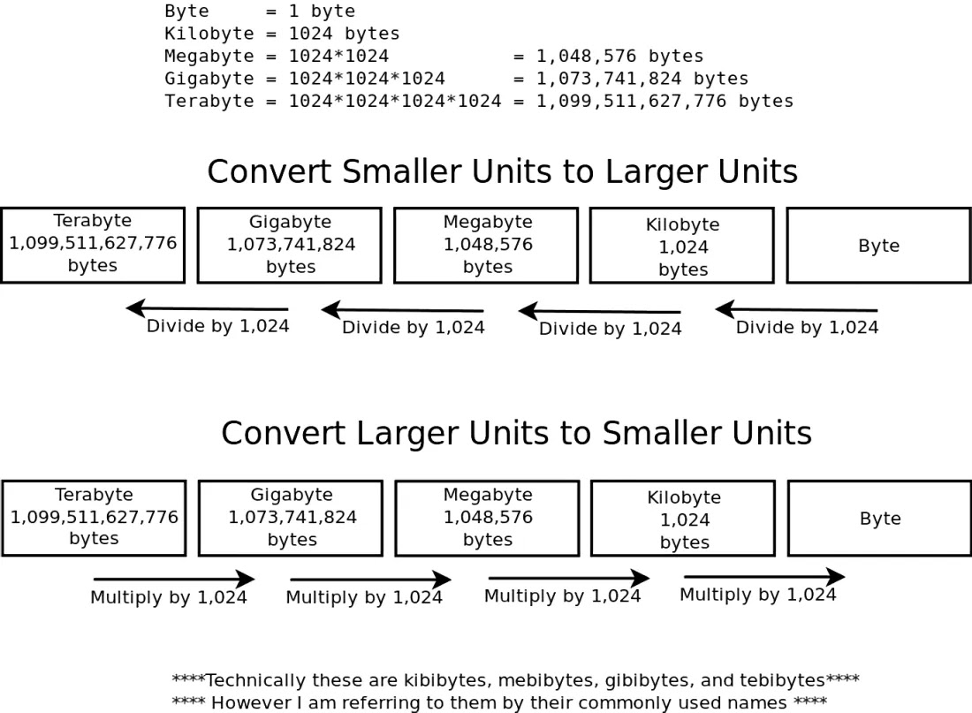

Transaction Processing Systems (Included in Exam)

Data Backup and Recovery

Backup | Backup refers to the process of creating a duplicate set of data in case the original is damaged.  - E.g. hard disk failure and viruses.
Recovery | Recovery is the process where a backup copy of data is restored and placed into the system.

Syllabus Points | Description
Grandfather, father, son | A backup strategy is the creation of full backups at regular intervals. The grandfather, father, son (GFC) is one of the most commonly used media rotation schemes.
  Grandfather | Data is backed up monthly
  Father | Data is backed up weekly
  Son | Data is backed up daily
Off-site storage | Involves the use of storage-based hardware that is physically separated from the main system location to backup and recover data.  - E.g. Cloud storage which uses a cloud provider to maintain data backups.
Secure on-site storage | The use of physical storage hardware within the working/main location where another mirrored copy of data (stored via RAID) is safely secured through passwords, encryption or biometric.
Full and partial backups | Full Backup  - A complete copy of all data within the system is created.  - I.e. a complete image of the entire hard disk, including the OS, program files, configuration settings and data itself.  - For transaction processing systems, the financial data is of particular value.  - Full backups are the easiest to restore.  - Backing up requires time and large storage.  - As such, backups are made on a weekly basis.  TLDR: A full backup copies the entire hard disk, including the OS, program files, configuration settings and the data itself. They are the easiest to restore but require lots of time and large storage, meaning that they should only be performed weekly.
Full and partial backups | Partial Backup
  Partial Backup | A partial backup is a copy of a file containing only what has been changed since the last full backup.
  Differential | Creates multiple partial backups of the file which has been altered since the last full backup.  - Before incremental backups can be performed, a full backup needs to be made prior.  - Backing up is significantly faster and requires less storage.  - It takes more time to restore as each partial backup overwrites the recovered file in the order in which they were made.  TLDR: Incremental backups only copy changes to the file since the last full backup. It stores multiple partial backups.  Backup is faster and requires less storage as it only stores changes, but recovery takes longer as each partial backup overwrites the file sequentially in the order they were made.
  Incremental | Creates a single partial backup of the file which has been altered since the last partial backup.  - Unlike incremental, it stores a partial backup of only the most recent changes.  - This means backing up is faster and requires less storage than incremental.  - It also means it takes less time to restore.  - However, a particular version of the file cannot be restored as a result.  TLDR: Differential backup is similar to incremental, except it only stores one partial backup copy of the most recent changes that have occurred.  Backup is faster and requires less storage compared to incremental and recovery is also shorter as multiple partial backups aren’t stored, however a particular version of the system cannot be rolled back.
Recovery testing | A testing technique which determines how fast a system recovers from system crashes and hardware failures. It involves intentionally crashing a system to test recovery speeds.  - Uses a small subset of files and recovers them to a new location.
Suitable media
  Magnetic Tape | A sequential access media and form of storage.  - Convenient and cost effective for backing up large volumes of data.  - Can store in excess of 500GB of data.
  Hard Disks | Use an external hard disk for recovery, they connect to computers through high-speed USB/firewire ports.  - Convenient for backing up smaller systems.  - More expensive than magnetic tape (outdated).  - Mirrored RAID systems use multiple hard disks to store copies of data and prevent data loss.
  Optical Media  - CD  - DVD | Include CD and DVD storage mediums.  - A single CD layer stores 4.7 GB while a single DVD layer stores 8.5GB of data.  - Recordable write-once read-many CDs and DVDs are used for archiving data in an unalterable form.
  Online | Uses Internet Cloud Storage for backup and recovery.  - Online systems automate the backup process for users.  - Data is transferred via the Internet to a secure remote site which manages the data.  - It is continuously backed via communication lines.  - After a full backup is made, incremental backups are made at regular intervals.
Specialised backup software | Software that can be configured to enforce a particular backup procedure.  - It allows:  - Scheduling of unattended backup  - Reports  - Compression
Transaction logs | - Transaction logs contain historical data of each transaction.  - This includes details of transactions currently being processed.  - Historical data can be used to restore a transaction processing system back to a state at a precise point in time.  - Completed transactions can be recommitted/rolled back.  - Incomplete transactions can be continued or rolled back.
Documenting backup and recovery | - The same backup media shouldn’t be used to continuously perform backups.  - Multiple sets of backup media should be used to prevent data loss from damaged backups.  - E.g. if a virus is undetected for some time.  - Multiple complete backup copies should be produced so that data can be recovered in different past states.
Procedures | Establishing the way in which full backups occur.
Mirroring | Involves using RAID storage, where hard disks are exact copies of each other.  - In the event where one backup drive is unreadable and fails, an exact backup of the disk can be recovered on another drive.
Rollback | Refers to returning to a previous state by restoring mirrored transactions in a RAID system, in the case a system error occurs.  - This mitigates further complications resulting from incomplete transactions.

Types of Transaction Processing Systems

Syllabus Points | Description
Web-based | Characteristics of Web-based TPS  A web-based TPS involves customers starting a transaction through a business or E-commerce website.  - Involves entering personal information to create an online account including:  - Credit card and billing information  - Email addresses  - Delivery addresses  - Full name  - Customers check out once selecting their items to be purchased.  - This data is then transmitted to the supplier’s database to initiate delivery to the customer.  TLDR: A TPS system involving users entering information, e.g. billing information and delivery addresses, onto an internet website to initiate a transaction. Data is transmitted to the supplier for delivery.
Web-based
  Examples of Web-based TPS
  E-commerce websites:
  - Ebay
  - Amazon
  - Alibaba
  - Facebook Marketplace
Non web-based | Characteristics of Non Web-based TPS  Involves physical TPS wherein clerks enter data onto paper forms at the point of sale.
Non web-based
  Examples of Non Web-based TPS
  - Manually performing calculations at a store front.
  - Cash cheques at a cash register.
Online real-time | Characteristics of Real-time TPS  The immediate processing of transactions performed on the internet.
Online real-time
  Examples of Online Real-time TPS
  - Online credit card transactions are performed partly in real-time to check that funds can be guaranteed by the financial institution.
    - EFTPOS
  - ATM
  - Booking systems (to prevent double bookings and backlogs)
Batch processing | Characteristics  The processing of transactions at a scheduled time or when there is sufficient data.  - The collection and storage of data for later processing.  - E.g. Electricity and water bill statements  - Transactions are held in batches where they may be held and input into the computer later.  Purpose  Batch processing addresses the fact that the resources available to computer systems may be limited.  - Transactions are scheduled to be completed in a timely manner.  - Batch processes are scheduled to occur when real time processing requirements are at their lowest, and computer servers are not busy.  - E.g. in the evening where there are less customers.
Batch processing
  Examples of Batch TPS
  - Electricity bills
  - Water bills
  - Subscription services
Batch processing
  Advantages | - Automated process  - Limited human intervention required  - Scheduled at a convenient time  - Processing resources aren’t dedicated to transactions that don’t need to be immediately processed
  Disadvantages | - Cannot update and input data in real time  - Could lead to data loss if batches of data aren’t stored correctly  - Takes time to produce financial information
Systems that appear real time, responding as the transactions occur, but where the actual updating is batched processed.  Such as credit card transactions. | Credit Card Transactions  Credit card transactions appear to be processed in real time from the customer’s perspective.  - The customer presents their card and interacts with the EFTPOS terminal.  - Or the customer enters their billing/credit card information onto a website.  - The transaction is approved if there are available funds and, from the customer’s perspective, processing is completed.  - Funds are deducted from the customer’s credit account in real-time, however the transfer of funds are batch processed overnight.  TLDR: Credit card transactions appear processed in real-time from the customer’s point of view, however the transfer of funds is batch processed overnight after sale.

