SAFETY

WHS & Industry Terminology Glossary
Union | An organisation consisting predominantly of employees or workers, the principal activities of which include the negotiation of rates of pay and conditions of employment for its members.
Non-compliance | Failure to abide by rules the WHS Act, 2011 can result in:  - Improvement notices (PIN)  - Prohibition notices  - Infringement notices  - Fines/Imprisonment
Teamwork | The process of working collaboratively with a group of people in order to achieve a common goal.
Agenda | A document used to record an act or event related to the business before having a meeting
Brainstorm | A group problem-solving method that involves the spontaneous contribution of creative ideas and solutions
Collaboration | Working together and sharing ideas
Critical thinking | Intellectually disciplined process of actively and skillfully conceptualising, applying, analysing, synthesising, and/or evaluating information gathered
Customer focused workplace | Putting your customers' needs first.
Rapport | A harmonious relationship in which the people or groups concerned understand each other's feelings or ideas and communicate well.

Code of practice | Guidelines which should be implemented to maintain safe work practices
PCBU | Person conducting a business or undertaking  - Responsible for removing or minimising possible causes of harm  - Induction training for employees is essential
Regulation | A legally enforceable rule created by a State or Federal government
Duty of care | The legal obligation that individuals and organisations have to anticipate possible causes of injury and illness that may exist in their work environment
WHS Committee | 5+ employees developing and carrying out measures to improve the health and safety of workers
Focus group | A group of people assembled to participate in a discussion about a product before it is launched, or to provide feedback on something

OOS (Occupational overuse syndrome) | Used to describe damage and pain caused by repetitive movement and overuse
RSI (Repetitive strain injury)

➤ WHS Key Bodies
- Safe Work Australia
Develop policies, practices, reports, renew licences, workers compensation claims
- WorkCover NSW
Insurance, workers compensation, Health & Safety inspections, licenses & registration, laws & policy
- Local councils
Work on continually improving safety of community
- Unions
Fight for the rights of workers and ensure fair treatment of all workers under a union

Participation | To take part in WHS processes in the workplace, in order to ensure their own health and safety at work, as well as that of others in the workplace who may be affected by their actions
Consultation | Listen to concerns and raise your concerns - seek and share views and information, and - consider what your workers say before you make decisions

➤ WHS Legislation
WHS Health and Safety Act 2011 (NSW) | Act: A legally binding document that defines expected legal behaviour in a specific circumstance  - Covers health, welfare and safety of people at work in NSW
Work Health and Safety Regulation 2011 (NSW) | Regulation: A legally enforceable rule created by a State or Federal government  - Protects people at workplaces from risk to their health or safety and promotes safe and healthy work environments

➤ Ergonomics
Adjustable chair | - Posture support reduces back pain and lower back strain  - Height adjustment reduces neck and eye strain
Adjustable table | - Innovative: choice of sitting or standing whilst working
Document holder | - Hold papers and reference material in a comfortable position for viewing
Foot rest | - Position feet at a correct height or tilting angle which prevents strain on the lower back
Lighting | - Adequate lighting is essential for a hazard-free environment  - Reduces hazards such as glare, flickering, dim lights and shadows

➤ Manual Handling


➤ Electrical tagging

Electrical Test Tag

Test date: ____________________________

Result: ______________________________

Tester name: _________________________

Next test date: ________________________

➤ Risk control
Hazard | A situation or substance which could cause injury or illness.  - Chemical, physical, behavioural hazards
Risk | An activity, current or future, involving danger
Safety Data Sheets (SDS) | Contains information about hazardous chemicals used within the workplace and measures and precautions for handling them safely

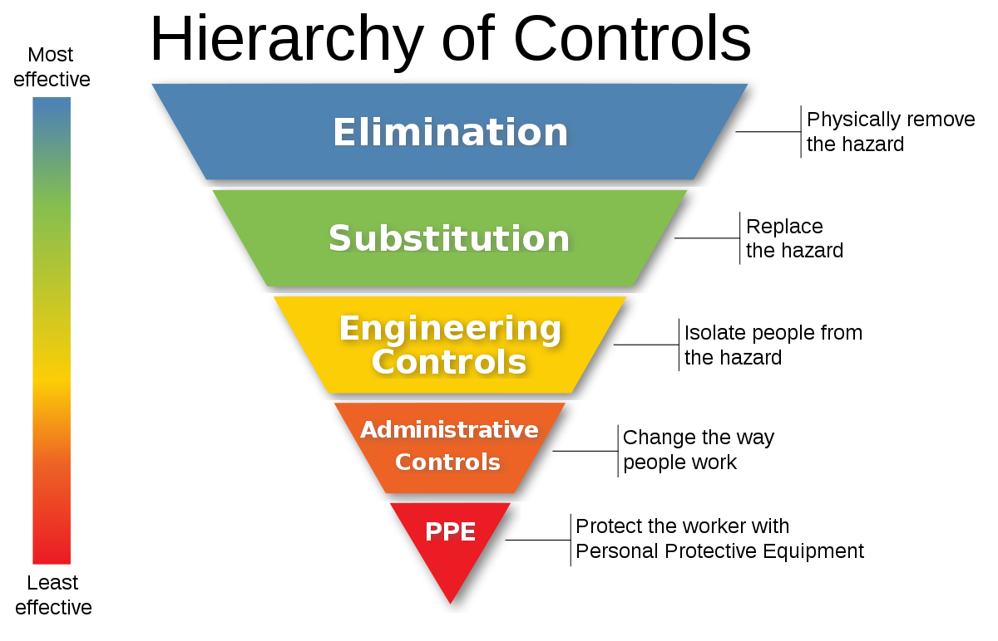

- Risk Assessment
- Identify hazards
- Analyse/evaluate the risk associated with the hazard
- Determine appropriate ways to eliminate or control the hazard

➤ Safety Signs & Meanings
Safety colour & Symbol | Meaning
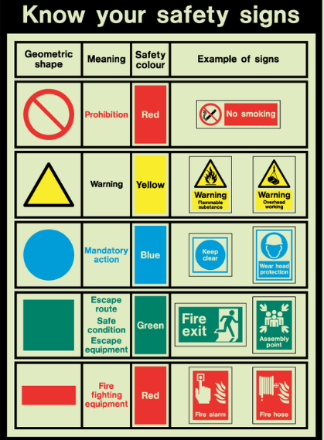 | Prohibition  E.g. No smoking
Warning

E.g. Flammable substance, overhead working
Mandatory action

E.g. Protective gear
Emergency

E.g. Escape route, safe condition, escape equipment, first aid
Fire fighting equipment

E.g. Fire alarm, fire hose

INNOVATION
Positive effects of innovation on:
- Day-to-day business routines and operations
- Overall business performance and growth
  - Enhanced business reputation
  - Increased competitiveness
  - Increased productivity

How employees can facilitate innovation:
- Contributing ideas, assisting in promotion of innovative ideas
- Contributing ideas to higher staff members such as managers
- Demonstrating innovative layouts and researching innovative designs

Teamwork Innovation:
C. Creating
A. Advancing
R. Refining
E. Executing/Implementing

Hot Desking | No ownership of desk space, move, sit plug-in anywhere at anytime - saves on resources.

➤ Communication
- Types of questions:
Closed questions | - Limited to a yes/no answer  - One word answer  - One choice from a list
Open questions | - Allow for longer responses  - More information is required  - Allows for elaboration
Reflective questions | Questions designed to encourage someone to discuss and analyse their practice
Probing questions | Questions that ask for more detail on a matter. They are often follow-up questions to clarify a point.

- Types of communication:
Verbal | Communication via means of spoken language
Nonverbal | Communication via means of body language, gestures and facial expressions
Written | Communicate via means of written text

- Communication used within an ICT organisation:
Memo | Telephone call | Text messaging | Business/organisational software (e.g. Trello) | Email
Verbal/speech | Social media | Fax | Voicemail | Letter
Video conferencing (e.g. Zoom, Skype) | Notes for clarity | Visualisations (demonstrate links, inputs/outputs)

➤ Obtaining feedback
- Staff meetings
- Surveys
- Interviews
- Online rating and bug report system

➤ Creative Thinking
- Creative thinking techniques
Brainstorm | A group discussion to produce ideas
Conceptualise  - Mind map  - Concept map | Form a concept or idea of something. If you have an idea or understand something fully, you conceptualise it.  - Mind map  - A diagram used to visually organise information, showing relationships among pieces of the whole.  - Concept map  - A diagram that depicts suggested relationships between concepts.
Sketching | A rough drawing of something.
Prototyping | Making an early sample, model or release of a product to test a concept or process.
Logbook/diary | A book containing a record of events.

- Common blockers to creative thinking
Boundaries | Small budget  Workplace not inclusive  Employees feel uncomfortable giving ideas
Ethics/code of conduct | Strict policy that can block creative thinking and risk taking
Legal ramifications | Copyright laws, Work Health and Safety Act
Organisation/workplace policy and procedures | Strict guidelines
Risks | Management may not be willing to take risks
Individuals and naysayers | People who are afraid of change and deskilling

➤ Critical Thinking Skills
Observation | Employees who are observant can quickly sense and identify a new problem and predict when a problem might occur before it happens based on their experience.
Analysis | The ability to analyse the situation includes knowing what facts, data or information about the problem are important.
Inference | Involves drawing conclusions about the information collected. May require technical or industry-specific knowledge or experience.
Communication | Important when explaining and discussing issues and possible solutions with colleagues and other stakeholders.
Problem solving skills | Problem solving requires critical thinking to implement the best solution and understand whether or not the solution is working as it relates to the goal.

WORKING IN THE INDUSTRY

➤ Impact of technology on businesses
- Improves business efficiency/production
- Improves communication between customers and the business
- Allows for online businesses and ordering
- Increased advertising capabilities

➤ Issues faced by businesses and workers
Businesses | Workers
- Financial management  - Monitoring and managing performance  - Insufficient staff  - Legal regulation and compliance (WHS, etc.)  - Meeting competition  - Responding to consumer demands | - Lack of communication/motivation  - Lack of training  - Poor work-life balance  - Inflexible schedule  - Little recognition/representation  - Workplace harassment and bullying

➤ Employment Types
Pro-rata | Dependent on how many days the employee works

Full Time | Part Time | Casual | Contract
Hours:  38+ hours per week  Sick leave:  10 sick days per year or as negotiated  Annual leave:  4 weeks annual leave | Hours:  Less than 38 hours per week  Sick leave:  Worked out on pro-rata basis  Annual leave:  Worked on on pro-rata basis | Hours:  Work on call - employer calls you when they need you  Sick leave:  No sick leave  Annual leave:  No annual leave | Legally binding documents  Terms & Conditions set out in the contract and must be equivalent to or above the award  Only work for a set period of time or until the job is complete, set out in the contract  Both parties must agree and sign the contract

- Types of Leave
Sick leave | - Illness  - Injury  - Carer's leave (caring for immediate household member)
Maternity leave | - Paid parental leave after having a baby  - Can get 18 weeks paid leave and up to 12 months unpaid
Paternity leave | - Male employees are entitled to paternity leave if their partner has a baby

➤ Awards & Agreements
Agreements cannot be lower than the award
Award | - Minimum pay and conditions  - Different awards for each job
Agreement | Enterprise agreements or other registered agreements set out minimum employment conditions and can apply to: one business, a group of businesses, a group of people in a business

➤ Staff turnover
Staff turnover is the total number of employees that leave a company over a certain period of time.

Causes:
- Unsupportive or authoritative environment
- Bullying or harassment in the workplace
- Seeking greater opportunities elsewhere

➤ Interpersonal skills
The ability to communicate or interact with others well.

Importance:
- Ensuring employees feel supported, thus increasing productivity
- Decreasing staff turnover
- Make employees feel more comfortable

Active listening | The ability to listen then paraphrase what was heard

➤ Key Internal & External Stakeholders in the ICT industry
Internal Stakeholders | External Stakeholders
- Employees  - Employers  - Managers  - WHS Officer  - IT Department | - Software vendors  - Clients  - Government

➤ Harassment
Harassment is unwelcome conduct that humiliates, offends or intimidates people.
- Harmful to victim and organisation:
  - Decreases productivity
  - Increases staff turnover

Types of Harassment
Verbal | E.g. swearing at someone, not valuing their work
Sexual | E.g. inappropriately touching
Physical | E.g. pushing, shoving
Psychological | E.g. spreading rumours, talking behind someone’s back

Recifty harassment:
- Informing a supervisor, manager or business owner
- Informing their health and safety representative, human resources (HR) or union representative
- Using established reporting procedures

➤ Bullying
- Unfair excessive criticism
- Publicly insulting victims
- Constant changing or setting unrealistic work targets
- Undervaluing employees’ efforts at work

➤ EEO (Equal employment opportunity)
Hiring someone for their qualifications or skills, not discriminating based on culture, disabilities, etc.

Anti-Discrimination Act 1977 (NSW) protects workers in NSW through ensuring equal employment opportunity for all and anti-discrimination.

- Workplace Diversity
Diverse workplaces contain different perspectives, ideas and are stronger. They are more flexible and innovative and promote out-of-the-box thinking.

➤ Team work
The collaboration of workers to achieve a common goal, particularly when effective or efficient.

Benefits of an effective team:
- Shared responsibility
- Generation of more ideas
- Boosted productivity
- Increased staff satisfaction and happiness
- Developing collaboration/problem solving skills
- Fewer mistakes
- Different expertise collaborating
- Building collegial relationships amongst team members

Team cohesion | When a team remains united whilst working to achieve a common goal

➤ Team building
People working together to achieve a common aim.

Staff Meetings
- Open questioning techniques used for elaboration
- Feedback can be collected through staff meetings

➤ Industry currency
Being up to date and current with skills, knowledge and experience within a particular industry.

Importance: Must be up to date to understand new operating systems or hardware, particularly in the ICT industry in order to effectively carry out work or train and provide advice to others.

Professional development | Training to maintain industry currency

➤ Working Sustainably in ICT
- Saving energy
  - Turning of electrical products when not in use
  - Using high energy star rating labelled products
  - Using LED lighting
  - Install solar panels
- Saving water
  - Install rain water tanks for toilets and gardening
  - Fix leaking taps
  - Use high star water rating toilets and one flush toilets
- Saving resources
  - Being conscious about the use of resources - don’t waste
  - Recycle where possible (e.g. paper)
  - Reduce, reuse, recycle
  - Reuse housekeeping products
  - Refill ink and toner cartridges
E-waste | Discarded electronic appliances such as mobile phones, computers, and televisions

Sustainability | Sustainability is a societal goal that aims for humans to safely co-exist on Earth over a long time.
Waste management | A waste management system is the strategy an organisation uses to dispose, reduce, reuse, and prevent waste.
Recycling | The process of converting waste into reusable material.
Resources in ICT | Resources in ICT include any hardware or software that is accessible by a computer, network or computer peripheral.

Environmental issues affecting the ICT industry:
- Energy consumption
- E-waste
- Lack of natural resources for components
- Silicon shortage
- Using computers contributes to global warming

Encouraging sustainability in the workplace:
- Environmental program
- Environmental awareness days
- Policies and practices to reduce carbon footprint
- Incentives to encourage environmental consciousness
- Reprimand employees that do not follow policies and procedures correctly
- Refill ink and toner cartridges
- Using green energy production methods
- Encourage greenery in the workplace
- Include recycling and e-waste bins
- Discuss the importance of being environmentally conscious at team meetings

PROTECTING DATA

De-identification | The process used to prevent someone’s personal identity from being revealed
Destruction (disposal) | Documents and discs may be shredded and placed in a lockup bin and then picked and disposed of by a private company
Encryption | Is a security measure to scramble data to make it unreadable. It is used on many websites where some sort of payment is required by credit card.

➤ Intangible security in ICT
Biometric authentication | Prevents physical access to data storage servers
Two factor authentication | Installing the app on each employee’s personal phone restricts the access code required to only be visible to the account holder
Strong & periodically changing passwords | If unauthorised persons had gained access to credentials, they would only be valid for a certain period of time
Intranet | Restricting access to the organisation’s internet to prevent external, unauthorised persons from accessing delicate information via an internet connection. Acts as a gateway only employees can pass through with periodically changing credentials
Encryption | The process of encoding information or data into code to prevent unauthorised access - using an encryption and decryption key
Firewalls | Can be used to detect and prevent external, unauthorised attempts at connecting to the organisation’s network via the internet
Access rights | Provide employees with access only to information they need to do their job  Compass School Management System: Wellbeing can see sensitive data of a student. Classroom teachers can’t see as much information.
Regularly updated antivirus software | Protection against malicious viruses and malware infiltrating computers via the internet and leading to compromised information

➤ Tangible security in ICT
Lockup filing cabinet | A cabinet for storing files that is physically locked to prevent access. Only the authorised people to view files will have access to the key
Handling confidential information | - Control access - Access rights  - Use confidential waste bins and shredders  - Lockable document storage cabinets  - Secure delivery of confidential documents  - Employee training and organisational guidelines

➤ Policies and procedures for security in ICT
Prohibiting USBs and local storage devices | Restricts the access of information to the workplace, ensuring information is not transferred potentially posing a security risk
Ensuring all computers are signed out when unattended | Ensures that if a staff member was not provided with access credentials, they would not be able to gain access to the information through an unattended signed in computer

➤ Workplace ICT issues & system failure
Common ICT Workplace Issues | Classifications of System Failure
- Unlicensed software  - Faulty computer hardware  - Internet filters  - VPN usage  - Out of date software  - ICT help availability  - Lack of training  - Sharing usernames | - Electrical failure  - Voltmetre  - Distribution board  - Surge-protected power board  - Hardware fault  - Multimetre  - Anti-static mat & wrist-band  - Software failure  - Verifying installation files  - Check if computer parts are correctly connected  - Operating system troubleshooter  - Antivirus protection  - Peripheral devices  - Updating peripheral drivers  - User generated error  - Guidance from device manual  - Validate files of software that could have been damaged  - Connectivity  - Ensure WiFi or bluetooth is available with stable strength  - Ensure WiFi or bluetooth is enabled on the device  - Check WiFi or bluetooth communication cards are not damaged

Preventative maintenance | Preventative maintenance is the regular and routine maintenance of systems. Preventative maintenance ensures that the hardware and software of systems are regularly checked and repaired if necessary to prevent any major, unexpected failure or issue that could arise from neglect in future. This supports systems as it ultimately ensures they function without the need to diagnose and troubleshoot issues.
Backup procedures | Backups ensure that data can be retrieved if lost when making changes to a system. Making regular backups also protects against data theft and other ways in which data can be compromised as any data stolen could be replaced by the backups.

Partitioning | Splitting up a drive into specific segmented parts to store files.  - Allows for different filesystems to be installed for different kinds of files  Do not partition an SSD  - Does not damage the SSD  - SSDs write to empty sectors, regardless of the sector’s placement, eliminating any performance benefit from partitioning

➤ Copyright & Licencing
Copyright | A legal right created by the law of a country that grants the creator of an original work exclusive rights for its use and distribution.
EULA (End User Licence Agreement) | Acts as a contract between the software developer and user. Grants the user a licence to use the app and covers a series of important clauses that limit obligations as the vendor.
Proprietary licence | Software is controlled and maintained my the vendor and thus unofficial modification and distribution is prohibited
Open source licence | Software allowed for use, modification and distribution by any user

➤ System diagnostic tools
Disk cleanup | Optimises disk and removes any unnecessary files
Disk defragmentation | Optimises disk by removing blank spaces
Performance monitor | Monitors the performance and activities of computer components including memory usage, CPU and GPU statistics
Event viewer | Allows for viewing logs of critical, error, warning and information events
Device manager | Displays the hardware that is installed on the computer. Used to view and manage hardware devices and their drivers.
Virtual memory | Increases available memory to the system by mapping data back and forth between RAM and the hard drive
Schedule system backup | Backs up computer files and settings periodically so they can be retrieved and restored if necessary
Virus scanner and removal | Removes a virus or infection from a computer to protect computer files against theft and malicious activity

➤ Types of software
Operating system software | Manages all of the other application programs in a computer  Install operating system via bootable USB drive
Application software | Performs a specific personal, educational, and business function

➤ Power management modes
Hibernate | The hibernate power management setting saves the state of the computer to the hard disk and completely powers it off. When resuming, the saved state is restored to the RAM.
Suspend | The suspend power management setting does not turn off the computer, rather, it puts the computer and all peripherals on a low power consumption mode. If the battery runs out or the computer turns off, the current state of the computer will be lost.

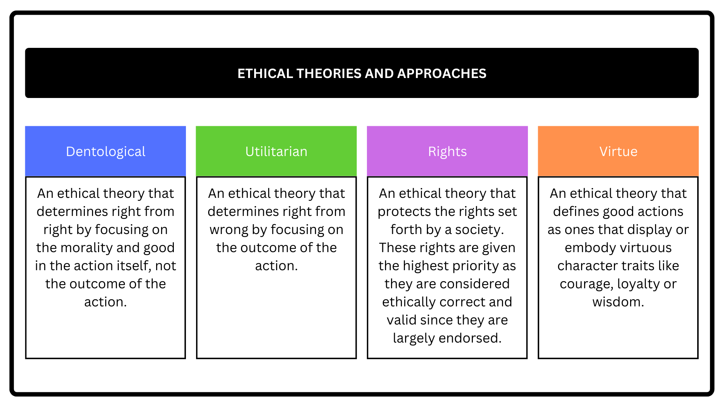

Adam Schon - GLOSSARY_IDT

Compliance and privacy.docx
Legal Requirements of Computer Crime
Part B- Securely Manage Information.docx

HSC IDT: Syllabus

- Do not open an email if there is no subject or from an unknown sender
- Look at questions on Optus for examples

