Cybersecurity IDT Syllabus_HSC Content.docx
Phone numbers are not numeric, they’re strings.

Strategies on how to implement cybersecurity
- Implement policies and procedures
- Report suspicious emails
- Log in/out procedures
- Acceptable use of Technology
- Password policies
- Remote work guidelines
- Incident response protocols
- Training and awareness of staff, industry currency
- Access rights provide information needed only
- Reporting procedures
  - Employee > Supervisor > Network administrator > PCBU > (if required) Public

What does cybersecurity protect?
- Participants (Login credentials, connected data, access rights)
- Users/Customers (PII, sensitive information)
- Infrastructure (servers, computers, modems, network)

Consultants for reporting on cybersecurity
- PCBU → Person conducting a business or undertaking
- Network analyst/administrator/engineer → Design, implement, manage and maintain systems including security, access rights, troubleshooting, stay industry current, etc.
- Chain of command and reporting procedures should be consulted

Cybersecurity methods
- Firewalls
- Antivirus
- Update virus definitions
- Multi-factor authentication
- Biometric authentication
- Strong passwords
- Encryption
- Access rights → read, write, execute

Offsite and onsite storage
- Offsite improves data redundancy and provides a way for retrieving backed up data in the event of a physical hazard or hardware failure.
- Onsite does not require an internet connection, centralised but may be more expensive to initially install. Security is the responsibility of the organisation.

Flowcharts
- Pre-test → testing first (diamond first)
- Post-test → testing after (diamond after) so the program has to be iterated once for the test to occur

Feasibility study
- Technical → hardware, software, communication media.
- Operational → how the new system will interact with the existing system, is it suitable?
- Economic → budgeting and costs, can the expenses of implementing the system be managed in both short and long term
- Scheduling → When will the project be completed, Gantt chart could be used to schedule the development of the project.

SaaS - Software as a service
SaaS is delivered over the internet, where a third-party vendor handles it. Applications run directly on the web browser such as Microsoft Word and Trello. Therefore, clients don’t need to download or install them locally. The vendor handles the applications, useful for enterprises. Maintenance and support is easy for enterprises. Third-party vendors run applications, operating systems, virtualizations, servers, runtime and storage.

Features of SaaS:
- It is accessible over the internet
- SaaS can be easily managed and handled from a central location
- You don’t need to build your servers since a remote server will host the application
- It is highly scalable

Input, process and output diagram
Input | Process | Output
- Visitor personal details  - Full name  - Phone numbers  - Category  - Authentication code into system | - Authentication code sent to phone  - Printing name tag | - Printed verified name tag

Structure chart
MAIN

Module 1
Module 2
Module 3
Module 4
Module 5

A
B
C
D

Flag - must fulfil a condition, indicates a condition has been met
Parametres - what data is moving between processes
Loop
Pseudocode
Pseudocode

Employability skills
- Good and reliable communication skills
- Motivation and initiative
- Leadership skills to lead and develop a team
- Reliability/dependability → everyone needs to contribute
- Following instructions to do the job right
- Adaptability → being able to adjust to new ideas or changes
- Use of technology → skills required to do the job effectively

Key terms
Compiler | Software tool that translates the entire source code of a high-level programming language into an equivalent machine/intermediate code. E.g. C++
Debugger | Software tool used by programmers to identify and resolve errors, bugs and issues in their programs.
Interpreter | A program that translates and directly executes the source code of a high-level programming language line-by-line without the need for separate compilation. (Slower than a compiler) E.g. Python  Java is both a compiling and interpreting language.
Intellectual property | The property of your mind or exclusive knowledge.
Source code editor | Specialised software tool designed for writing and editing source code in programming languages. E.g. Visual Studio Code, Xcode.
FAQs | Common questions that users might ask.
Top-down design | Breaking a large problem into smaller more manageable ones.
Troubleshooting guides | Outlines ways of fixing problems.
Conflict resolution | Methods used to solve misunderstandings and conflict when working with others.
Desk checking | Check the logic of a computer program’s algorithm to reduce the likelihood of errors occurring.  - Occurs during the maintenance phase of the software
Inference | Conclusion reached on the basis of evidence and reasoning.
Reflective | Relating to deep thought.

E-waste impact
- Hazardous materials such as mercury let into the environment
- Health risk due to hazardous materials being exposed to the environment
- Resource depletion due to the consumption of important metals and materials
- Mitigation: Dismantling, reusing and recycling products to mitigate the issue, sending to specialist disposal centres

- High power usage
- Resource usage

Blockers to creative thinking
- Naysayers
- Financial constraints
- Policy and regulation
- Ethical concerns

Job roles and skills
Job | Role
Programmer | Creates code and develops software applications.  - Uses standard library modules for time efficiency, open-source, wide support and security due to being more widely used
Network administrator | Develops, maintains and secures an internet/intranet/extranet network. Also manages file access rights within a system.
Engineer | Creates and designs physical hardware, infrastructure and computer parts.
Technical support | Supports employees within an organisation with technical help.
Ethical hacker | Individuals permitted to hack into an organisation to test security.
Project leader | Leads and directs the development of projects, organising teams.

Notifiable incident form
- Filled out in an event of an onsite electrocution
- Filled out to record details of the incident and actions the organisation took to assist the employee

Privacy Impact Assessment (PIA)
To assess the impact a business has on the privacy of its customers, employees and business. It should be conducted when a new process or change is made to the business’s technology infrastructure.

Feedback
- Direct formal
- Direct informal
- Indirect formal
- Indirect informal

Spreadsheets
- Absolute references: $G4:$A3 → do not change when duplicated
- Relative references: G4:A3 → change when duplicated, relative to their position
- IF statements: =IF(A3=100%, “Complete”, ”Incomplete”)
  - Green > If true
  - Red > If false
- Rows → records
- Columns → attributes

Legal documentation
- Acts → laws
- Regulations → guidelines for the workplace

Screen design
- Input masks → if spaces, then the data type is text. E.g. 04 _ _ _ _ _ _
- Text boxes
- Check boxes
- Radio buttons
- Forms are designed to reduce the most error possible

Mail merge
Merge fields are substituted in with data from a spreadsheet to be distributed to individuals.

Notifiable data breach
Data breaches must be reported to authorities if the breach has a potential to cause harm.

Linear search
Sequentially checks each element of the list until a match is found or the whole list has been searched.

Binary search
- Array must be in order
- Finds the position of a target value within a sorted array
- Binary search compares the target value to the middle element of the array
- Mean = 1+(highest position number) / 2
Determine how many comparisons are required to know that an element is not in an array: log2(n)
n = number of elements in the array

Selection sort
Sorted part of an array increases by one element each pass.
- Scanning to look for the next current minimum until fully sorted
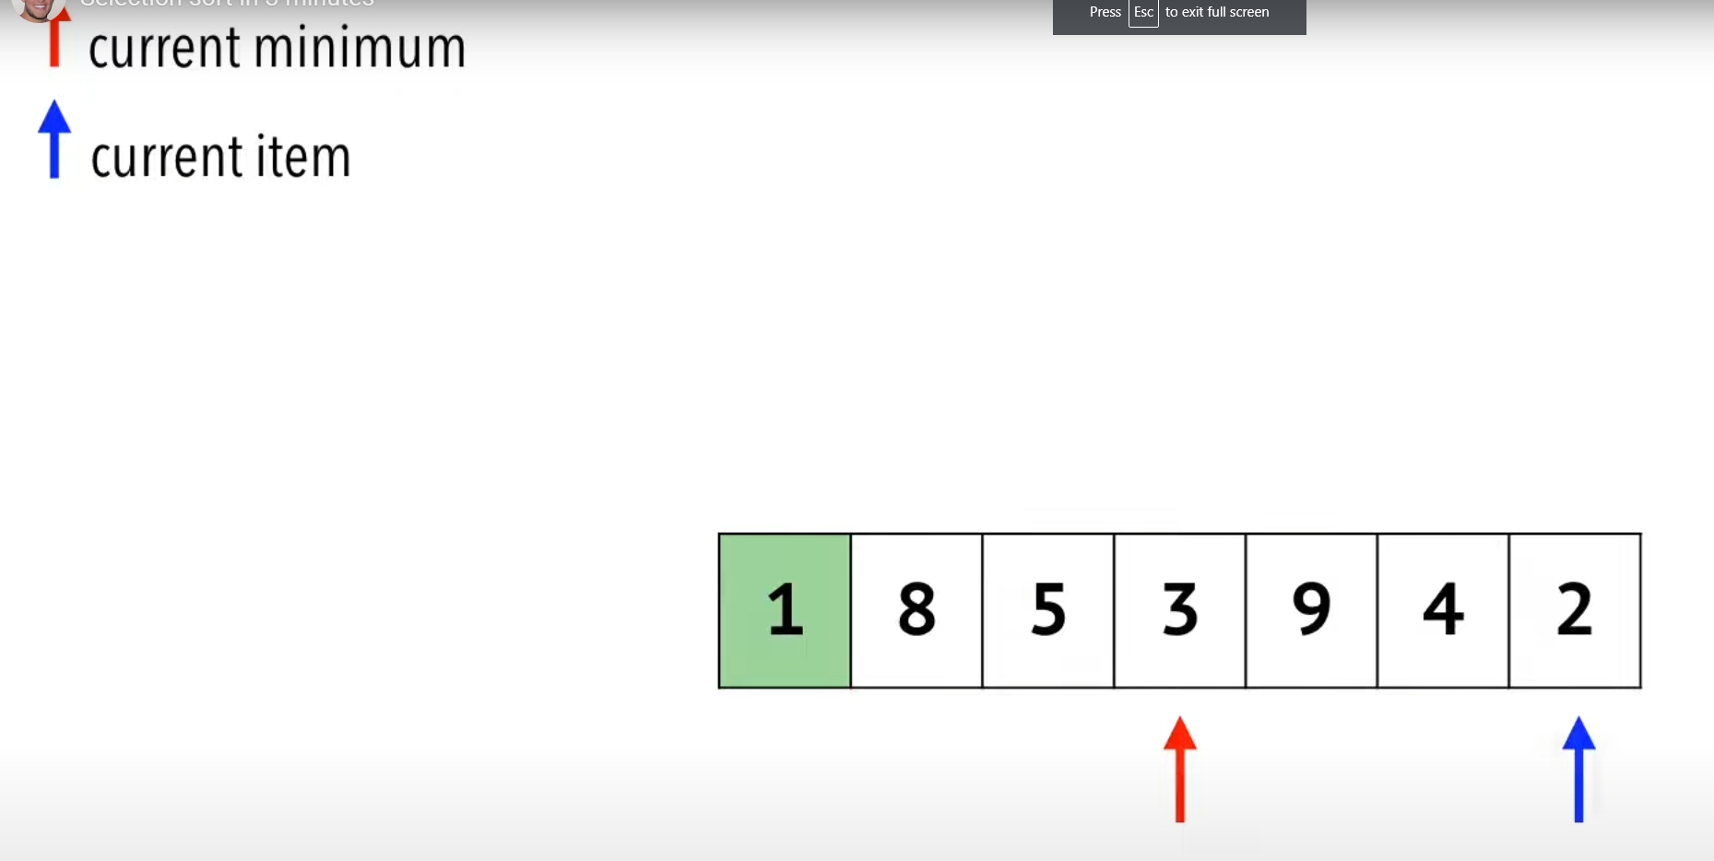

Bubble sort
Pairs of adjacent elements are compared and swapped if necessary.

9, 12, 2
Pass 1
9, 12, 2

Compare 9 and 12, no swap.
9, 12, 2

Compare 12 and 2, swap.
Pass 2
9, 2, 12

Compare 9 and 2, swap.
2, 9, 12
Array is sorted in ascending order at the end of second pass.

Electrical test tag

Test date: ……………….…………………
Result: ……………………………………..
Tester name: ……………………………...
Next test date: ……………………………

