Business Notes Topic 1 : Operations Adam Schon - 1. Role of Operations
Case studies: Operations: Apple – Case Study

Syllabus Points | Notes
Exam Notes - Business Report | Business report format  - Heading: ‘Business Report for {{business_name}}’  - Executive summary  - Headings, subheadings  - Numbered headings - 1.0, 2.0, 2.1, 2.2, 3.0…  - Reference to ‘the’ business  - Final heading ‘Recommendations & Conclusion’  - Dot points, list  - Abbreviations  - Tables  - Define the strategy before explaining it  - Link back to issues identified in the question  - Describe what the strategy refers to, how it can be implemented and the effect of its implementation  - Incorporate business examples to justify points  Syllabus 'Operations' (1).pdf
  Executive Summary
  - A summary of the report and its recommendations
  - Include the answers to the report questions with some justification → summary only
Role of operations management
Strategic role of operations management  - Cost leadership  - Good/service differentiation | STRATEGIC ROLE OF OPERATIONS MANAGEMENT  - Output is worth more than all the inputs combined  - Operations assists the business in achieving its overall goal of profit maximisation  - The effective management of operations is required to ensure goals are achievable  Two key approaches of operations in achieving strategic goals include cost leadership and good/service differentiation.  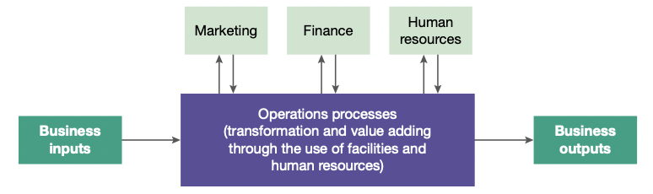  Operations processes include aspects of activities undertaken in business:  - The production of goods and services  - Production controls and associated quality controls on processes  - Inventory controls  - Supply chain management (SCM)  - Logistics and distribution  - Management decisions making in terms of operational processes  Operations and the customer focus  Customers desire firms to engage in processes that:  - Minimise resources in their production  - Reflect fair value for any labour used in processes  - Operate at low cost so as to maximise affordability  - Integrate environmental awareness and a need for ecologically sustainable practices  - Reflect changes in the needs of consumers over time  Operations: Inputs and Outputs  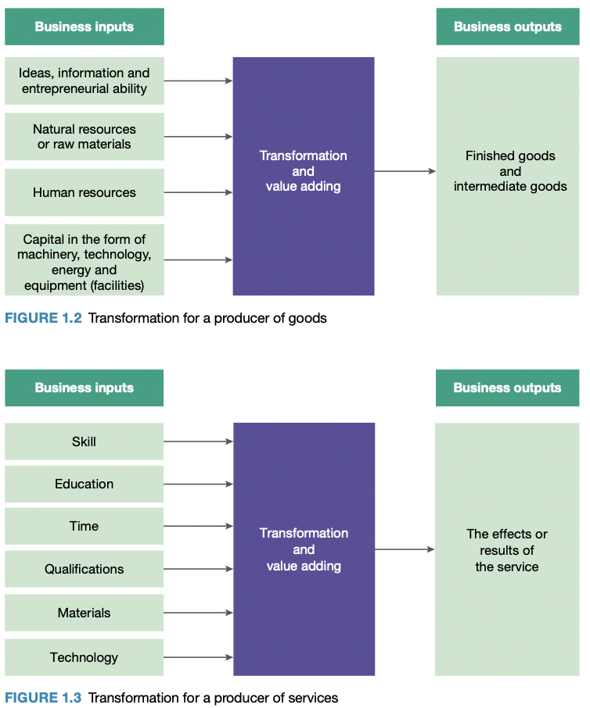  COST LEADERSHIP  Aiming to have the lowest costs, being the most price-competitive in the market.  - Operations is a cost centre; it generates costs for the business  - Businesses can compete based on their prices  - Balancing cost and quality is essential  Advantages  - Businesses can make a larger profit  - Businesses can drop their prices creating a competitive advantage  Achieving cost leadership  - Invest in technology, research and development  - Lower production costs  - Use of economies of scale (EOS)  - EOS are cost advantages created when a business increases the scale of its operations  - Businesses can:  - Spread costs across more areas and units of production  - Afford more machinery and technology, thus improving efficiency  - Create products at a lower cost per unit, and sell them for less  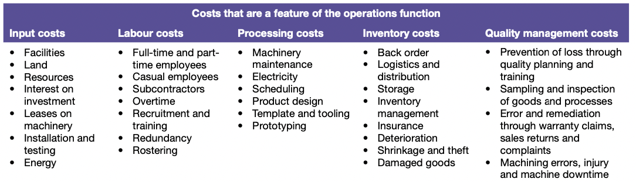  DIFFERENTIATION  - Distinguishing products from competitors based on factors other than price  - Creating unique goods/services so businesses can compete  Product differentiation: goods  Product differentiation: services  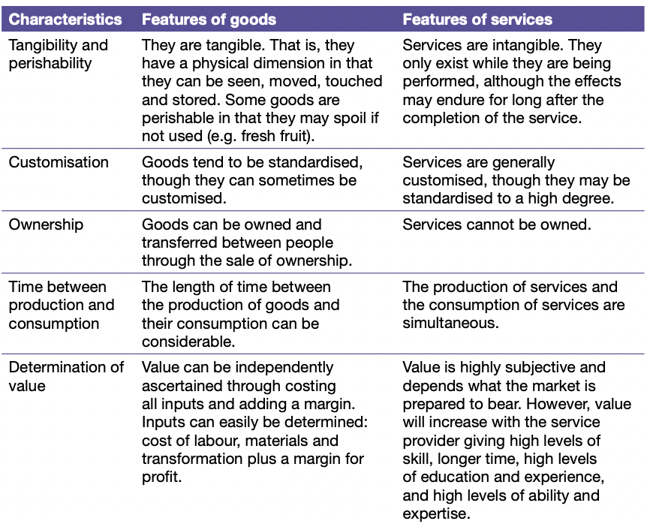  Cross branding  Differentiation can be created from cross branding or strategic alliances. This adds value to the products by offering consumers added benefits from a cross-branding arrangement. E.g. Woolworths-Caltex, Coles-Shell
  Operations | The business processes that involve transformation; production
  Strategic | Long-term broad aims affecting all key business areas; managers of each function contribute to the strategic direction or plan of the business
  Profit centres | Those aspects of a business that directly derive revenue and profits
  Cost centres | Areas, departments or sections of a business to which costs can be directly attributed
  Transformation | The conversion of inputs (resources) into outputs (goods/services)
  Value adding | The creation of extra or added value as inputs are transformed into outputs
  Key business functions | Operations, Human resources, Marketing, Finance
  Lean production | Aims to eliminate waste at every stage. It involves analysing each stage of the production process, detecting where inefficiencies are and correcting them
  Ethical sourcing | Business practices of sourcing from suppliers that engage in ethical conduct such as the payment of fair wages and the use of environmentally friendly practices
  Cost leadership | Involves aiming to have the lowest costs or to be the most price-competitive in the market  - Although trading with the lowest cost, the overall business should still be profitable
  Economies of scale | Cost advantages created when a business increases the scale of its operations
  Standardisation | Refers to the making of products that are homogeneous; identical  - Mass producing items with no variety and at a low cost per unit  - Directly related to economies of scale
  Differentiation | Distinguishing products (goods/services) in some way from those of competitors
  Augmented features | Add-ons or additional benefits associated with particular goods
  Varying the actual product features
  Varying product quality
  Varying any augmented features
  Varying the amount of time spent on a service
  Varying the level of expertise brought to a service
  Varying the qualifications and experience of the service provider
  Varying the quality of materials/technology used in service delivery
Goods and/or services in different industries | GOODS AND/OR SERVICES IN DIFFERENT INDUSTRIES  GOODS  Operations decisions vary for goods depending on whether they are standardised goods or customised goods.  Goods can be classified as perishable or non-perishable.  Perishable goods and operations processes  Operations processes must integrate:  - High standards of quality, safety and cleanliness in all operating processes  - Very short lead times and distribution that is as quick and effective as possible  - Appropriate and robust packaging and cold storage processes both through production and distribution  Non-perishable goods and operations processes  Non-perishable goods are more durable than perishable goods and therefore the issues of quality and inventory management arise for the operations function. Operations processes must integrate:  - Manage all aspects of quality in the process, from sourcing through to production and distribution  - Implement effective inventory management strategies and be highly responsive to market demand in order not to over produce  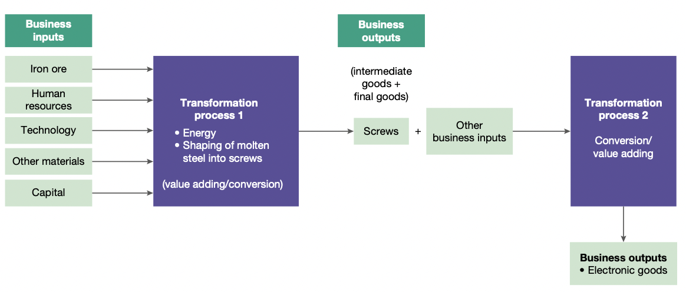  Intermediate goods  Goods may be processed more than once. This means that completed goods have gone through one set of operations processes, then they may become inputs into further processing.  SERVICES  Services can either be both standardised or customised.  - Accounting services, dental surgeries, medical services, legal services, etc. are typically customised unless the nature of the request from a client is standard  - Fast-food restaurants are subject to standardised processes of order taking and customer service  Cost leadership and standardised products (goods and services)  - The costs associated with the production of standardised products can be minimised  - Standardising how the service is performed can bring cost leadership
  Standardised goods | Goods typically mass-produced, usually on an assembly line  - Uniform in quality and meet a predetermined level of quality  - Produced with a production focus
  Customised goods | Goods that are varied according to the needs of customers  - Produced with a market focus
  Self-service | Encouraging customers to take the initiative to help themselves
  Drip pricing | A business advertises one price but in the process of a customer purchasing the service, numerous additional charges and costs are added  Effect: Final price is significantly higher than the price advertised  E.g. airline ticketing, travel products
Interdependence with other key business functions | INTERDEPENDENCE WITH OTHER KEY BUSINESS FUNCTIONS  Interdependence occurs when each key business function area is committed to the same business goals as the other key areas and they each work in a coordinated and collaborative way to achieve these goals  Tasks within the key business functions  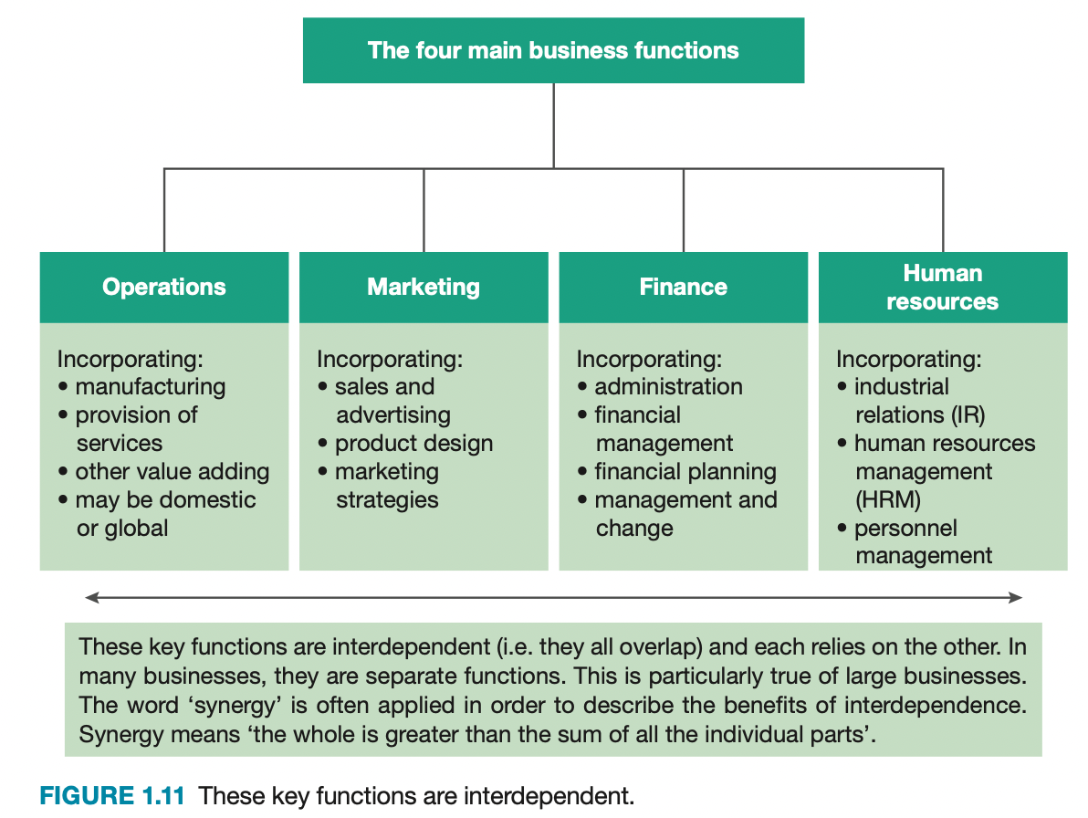  Operations  - Operations refers to the business processes that involve transformation or, more generally, ‘production’  - It is a term that applies both to the manufacturing and services sector  - In manufacturing, operations refers more specifically to the processes involved in turning raw materials and resources into outputs of finished goods or products.  Marketing  - Marketing is about meeting the needs and wants of consumers through provision of products (both goods and services) at prices that the market is prepared to pay. Marketing is a highly specialised field of business that looks at all aspects of buying and selling  - Marketing and operations are interdependent and their functions overlap  - Marketing is concerned about the design of products, and their subsequent sale, to meet the needs of consumers. The operations function involves the acquisition or sourcing of products for resale or the sourcing of inputs for production  Finance  - This is the function that is concerned with recording and summarising financial transactions into a series of reports that can be easily interpreted.  - Reports such as income statements (also called revenue or profit and loss statements), which determine the amount of money the business has earned after its expenses have been paid, are very useful to managers and other stakeholders. Other key reports include balance sheets and budgets.  - A key marketing objective is profitability. Profitability requires that a business maximise sales (revenue) and minimise costs (expenses).  - The operations function is that aspect of business that produces. If costs of production can be minimised then profit margins can be increased.  Human Resources  - The function of human resources is to deal with the people the business employs and the issues arising from their employment.  - It covers all aspects of employment resourcing and includes the acquiring, developing, maintaining and motivating of staff in addition to those processes involved when staff members leave the business — separation.  Outsourcing  - Outsourcing is changing the nature of operations and has a direct impact on human resources
  Interdependence | The mutual dependence that the key business functions have on one another
  Synergy | Describes the benefits of interdependence. Synergy means ‘the whole is greater than the sum of all the individual parts’
  Profitability | The excess of revenue or income over expenses or costs
  Outsourcing | Involves the use of third-party specialist businesses (e.g. recruitment firms). Outsourcing aims to take advantage of the specialist skills provided by them and to achieve a reduction in labour costs
Influences
Globalisation | GLOBALISATION  - Source of market opportunities both from other nations and to other nations  - Threat to business as businesses that effectively apply cost leadership principles can undercut the market and dominate  - Characterised by an increasing integration between national economies and a high degree of transfer of capital (facilities and/or machinery), labour, intellectual capital and ideas, financial resources and technology  Globalisation & Operations Management  - Significant influence on operations management  - Orienting practices towards the global market allows the business to meet needs of consumers globally  - Global consumers seek global brands and standardised products  Effect → Operations is then structured around a series of global production facilities  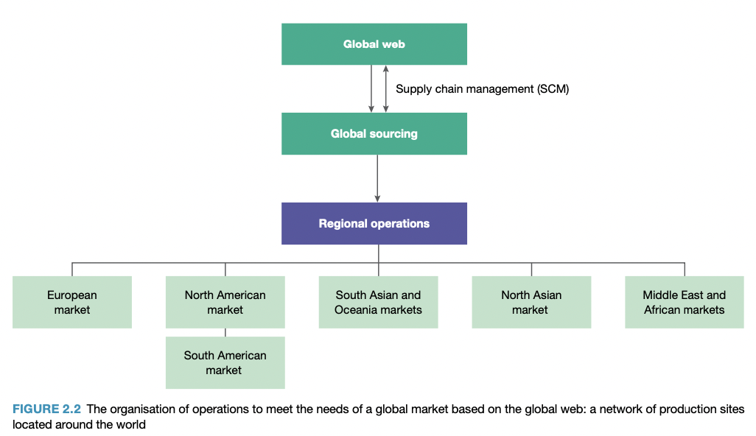  Organising operations around a global market  - Supply chain management (SCM) and the global web  Features of a global business:  Supply chain management (SCM) and the global web  Involves integrating and managing the flow of supplies throughout the inputs, transformation processes (throughput and value adding) and outputs in order to best meet the needs of customers  - Businesses require predictable and reliable supply chains - highly responsive to changes in demand as experienced by the business
  Globalisation | The removal of barriers of trade between nations
  - Product design that meets the needs of global consumers
  - The choice of location for manufacturing facilities
  - The management of quality
  - Logistics and inventory management processes
  Supply chain | The range of suppliers a business has and the nature of its relationship with those suppliers
  Sourcing | An operations strategy that requires finding the suppliers needed so that production processes can flow smoothly
  Global web | The network of suppliers a business has chosen on the basis of lowest overall cost, lowest risk and maximum certainty in quality and timing of supplies  - The business aims to minimise costs across the range of its suppliers  - Businesses will opt for a location with appropriate proximity to suppliers
Technology | TECHNOLOGY  - Enables people to communicate easily and enables improved business processes  - Technology is both a range of devices and a range of enabling processes and applications  Technology & Operations Management  - Administrative level usage of technology: Technologies assist with organisation, planning, decision making, control of operations processes  - Processing level usage of technology: Technologies are used in manufacturing, logistics and distribution, quality management, inventory management, supply chain management and sourcing  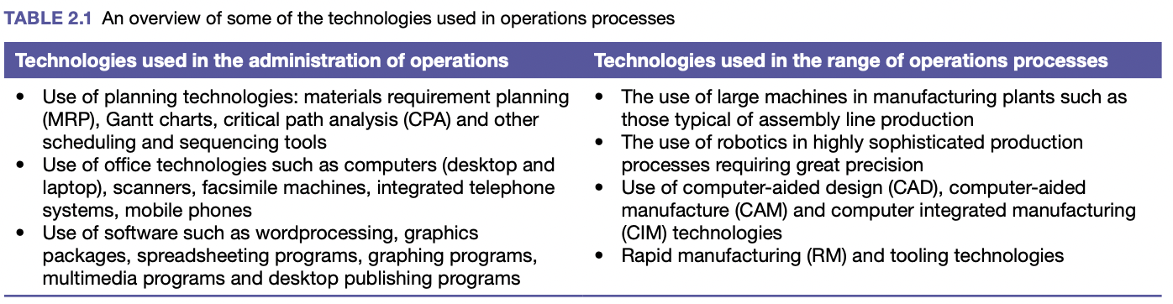
  Technology | The design, construction and/or application of innovative devices, methods and machinery upon operations processes
Quality Expectations | QUALITY EXPECTATIONS  - Quality and expectations are inseparable  People have a belief in what the quality standards should be for products (goods/services) and their personal level of satisfaction with their experience of the product will indicate whether the quality has met their expectations or not  Quality Expectations & Operations Management  - Quality informs all operations processes  - Expectations that people have of a business determine the way the products are designed, created and delivered  - Thus, operations processes must follow particular standards or prescribed minimum levels of excellence.  Quality expectations for goods and services  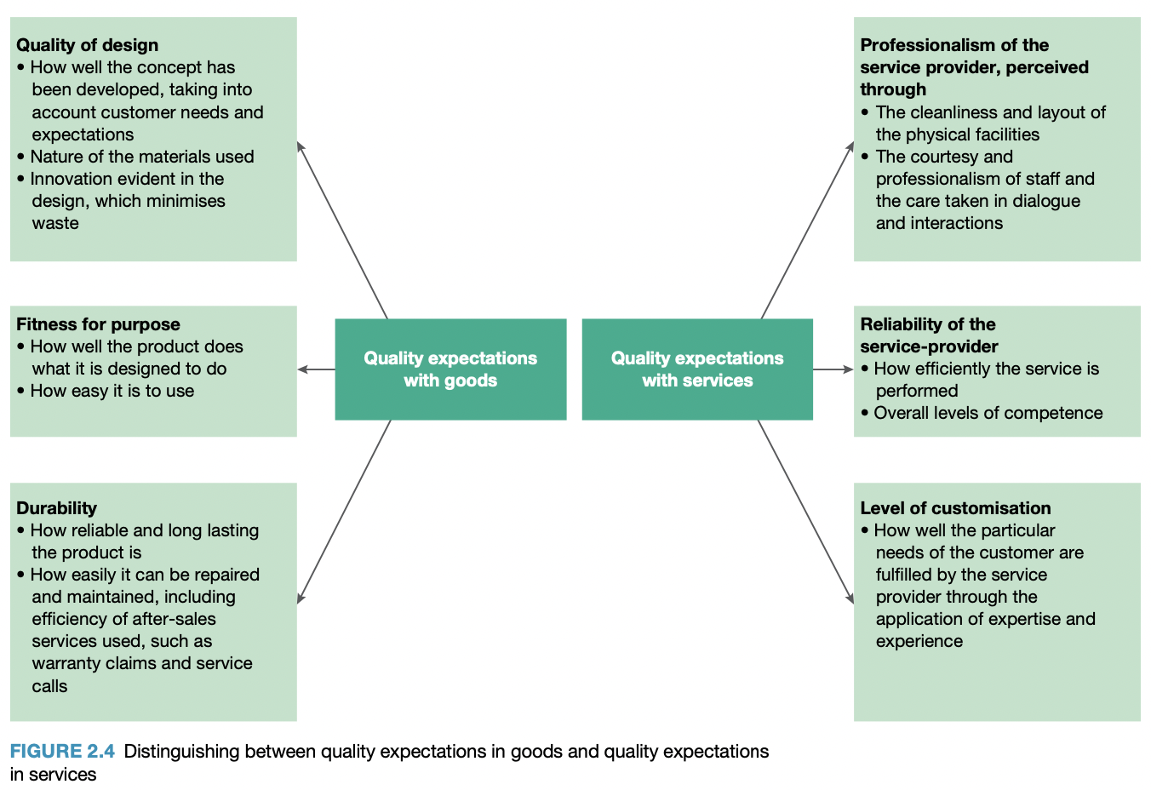
  Quality | How well designed, made and functional goods are, and the degree of competence with which services are organised and delivered
Cost-based competition | COST-BASED COMPETITION  - Acknowledges that prices cannot keep increasing; thus, reducing costs is a way to maximise profits when revenues are fixed  - Mass customisation enables cost-based competition even when products are differentiated rather than standardised  Cost-based Competition & Operations Management  - Cost-based competition is part of operations management when a business focuses on reducing costs to a minimum whilst maintaining profit margins  - Applying a cost leadership approach to operations management allows cost to be analysed from several different perspectives, HSC Topic 1: Operations.
  Cost-based competition | Derived from determining breakeven point and applying strategies to create cost advantages over competitors
  Fixed costs | Costs that are not dependent on the level of operating activity in a business. Fixed costs do not change when the level of activity changes - they must be paid regardless of what occurs in the business.
  Variable costs | Costs that vary in direct relationship to the levels of operating activity or production (e.g. labour costs, costs of energy)
Government policies | GOVERNMENT POLICIES  All businesses operate in a political-legal environment.  - Policies can inform law-making and lead to business opportunities  - Operations managers must be aware of the contemporary government policies and what they entail  - Political decisions affect the business rules and regulations which affect the management of key business functions  Government policies change, due to change in government or social expectations  Policies that impact businesses:
  Taxation rates
  Required material handling practices
  Work Health and Safety (WHS) standards
  Industry training requirement
  Public health policies
  Environmental policies
  Employment relations
  Trade and industry policies
Legal regulation | LEGAL REGULATION  Businesses are expected to comply with the standards of behaviour imposed by the legal regulations.  Legal regulation and operations management  Operations management has particular laws that influence how practices and processes are conducted.  - Operations function involves transformation and value adding  - Transformation/conversion → involves the use of any labour, technology, finance, machinery and energy  Laws that relate to labour, labour management, the environment and public health include:  Laws affecting business operations in Australia
  Compliance | The range of laws with which a business must comply
  Compliance costs | The expenses associated with meeting the requirements of legal regulations (abiding by all laws)
  Work health and Safety (WHS) | In using machinery, interacting with the business environment  - Requires employees to be given appropriate safety training, use of protective equipment, work with machines abiding by noise, pollution and safety standards
  Training and development | In using and applying technology and the appropriate methods required to work effectively
  Fair work and anti-discrimination laws | Requiring that employees be treated with dignity and respect
  Environmental protection | In minimising pollution, eliminating and safely disposing of any toxic residues
  Apply rules related to public health | Including any fair trading rules which influence product safety standards and fitness for purpose of products
  Racial Discrimination Act 1975 (Cwlth)
  Sex Discrimination Act 1984 (Cwlth)
  Workers Compensation Act 1987 (NSW)
  Disability Discrimination Act 1992 (Cwlth)
  Age Discrimination Act 2004 (Cwlth)
  Anti-Discrimination Act 1977 (NSW)
  Work Health and Safety (WHS) Act 2012 (Cwlth)
  Environment Protection and Biodiversity Conservation Act (1999) (Cwlth)
  Superannuation Guarantee Act 1992 (Cwlth)
  Taxation Act 1953 (Cwlth) Corporations Act 2001 (Cwlth) Fair Work Act 2009 (Cwlth)
Environmental sustainability | ENVIRONMENTAL SUSTAINABILITY  Business operations should be shaped around practices that consume resources today without compromising access to those resources for future generations.  Three aspects to environmental sustainability:  - Sustainable use of renewable resources  - A reduction in the use of non-renewable assets  - The application of the precautionary principle  Environmental sustainability and operations management  Operations management is affected by the need to include the following into business planning and practice:  - The rise in climate change awareness  - The need to integrate a long-term sustainable view of resource management  Seen in businesses moving to:  - Reduce and minimise waste  - Recycle water, glass, paper and metals  - Reduce carbon footprint
  Environmental sustainability | Business operations should be shaped around practices that consume resources today without compromising access to those resources for future generations
  Precautionary principle | Requires that, where environmental impacts are uncertain, a business undertake actions that are most likely to cause least environmental impact
  Carbon footprint | Refers to the amount of carbon produced and entering the environment from operations processes
Corporate social responsibility  - The difference between legal compliance and ethical responsibility  - Environmental sustainability and social responsibility  Adam Schon - Corporate and social Responsibility  Influences - Corporate Social Responsibility | CORPORATE SOCIAL RESPONSIBILITY (CSR)  Refers to open and accountable business actions based on respect for people, community/society and the broader environment.  - Encouraging businesses to make a positive impact on the world  - CSR is a behaviour that exceeds the bounds of legal requirements  CSR refers to businesses focusing on the three areas of the triple bottom line:  - Financial profitability  - Social impact  - Environmental impact  Businesses that maintain CSR are conscious of:  - Legal compliance and ethical responsibility  - Environmental sustainability and social responsibility  Corporate social responsibility and operations management  - Principles of CSR require a business to manage the effects of its activities on society/community and the environment  CSR requires:  - A business to understand how its inputs are sourced so that it only draws from suppliers that adhere to appropriate standards  - A business shapes its processes in such a way as to minimise environmental damage and waste  - Managers to ensure recruitment practices draw from a diverse range of employees and are inclusive of people from all backgrounds  In CSR, avoid:  - Choosing unrelated initiatives  - Using CSR as a marketing scheme  - Waiting for industry to catch up  Advantages and disadvantages of CSR  The difference between legal compliance and ethical responsibility  Environmental sustainability and social responsibility
  Corporate Social Responsibility | Refers to open and accountable business actions based on respect for people, community/society and the broader environment. It involves businesses doing more than just complying with the laws and regulations.
  Triple bottom line | Refers to the financial profitability, social impact and the environmental impact of a business
  Advantages | Disadvantages
  - Improved business reputation  - Increase in brand recognition  - Increase in customer satisfaction and loyalty  - Increase in employee satisfaction, attraction and retention  - Ability to meet strategic goals beyond financial (Triple bottom line)  - Organisational growth  - Easier access to capital | - Can be very costly to implement  - Opportunity costs - trade off between time spend participating in CSR activities vs other core business activities  - Sunk costs - associated with the initial investment of new equipment (e.g. greener energy installation)  - Recurrent costs - ongoing costs (e.g. higher wages)
  Legal compliance | Legal compliance is the ability to keep up to date and compliant with the legal obligations that affect a business.  Compliance falls in a number of areas in business, not limited to:  Legal compliance in outsourcing  Compliance requirements are different between nations that businesses choose for operations, allowing businesses to take advantage of significant cost savings; e.g. taxation rates, lower standards of labour, weaker environmental and intellectual property regulations. Although, this behaviour raises ethical issues.  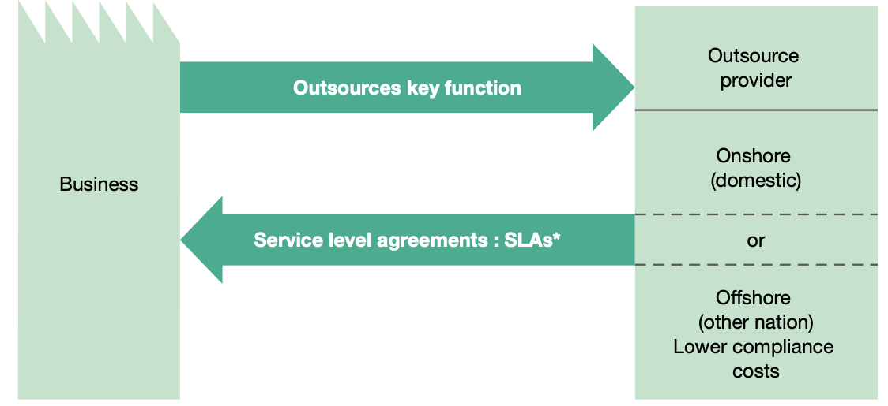
    - Labour law compliance  - Environmental and public health compliance  - Business licensing rules  - Taxation including levies and duties  - Trade practices and fair marketing deals | - Migration and rules around the use of offshore skilled labour  - Intellectual property  - Financial and accounting regulations and corporations law  - Corporate laws (AKA Antitrust’ law)  - Human rights
    Fiduciary | A person in a position of financial trust with respect to others’ money
    Outsourcing | The use of third-party specialist businesses to take advantage of specialist skills provided by them, achieving a reduction in labour costs
    Onshore outsourcing | The use of domestic businesses as the outsourcing provider
    Offshore outsourcing | Taking the activities to a provider in another country
    Service-level agreement (SLA) | Contracted minimum standards of service
  Ethical responsibility | Ethical responsibility involves businesses going beyond the law and taking into account broader social, community and environmental concerns.  Examples of ethical responsibility:  - Doing beyond what is legally required  - Following the spirit or intention of the law rather than doing the bare minimum  - Setting a higher minimum wage  - Guaranteeing all materials are ethically sourced  - Ensuring that all employees receive competitive pay and comprehensive benefits as well as treated with respect  Benefits of behaving in a consistently ethical manner:  - Strong reputation  - Long-term financial rewards for companies  - Employees remain loyal and perform effectively  - Increased customer loyalty and attraction    International Labour Organisation (ILO)  Due to significant international differences in standards for labour in terms of wages, health and safety, training, etc. Businesses may choose to follow international labour standards that come from the International Labour Organisation (ILO).  ILO’s annual convention, ‘International Labour Conference’ raises matters of importance to workplaces and the rights of employees. Including:  - Working women and maternity protection  - The provision of safe working conditions  Workplace issues raised are put into a report. If two-thirds of the nations in the ILO agree to the report’s recommendations, it becomes an International Labour Standard.
  Environmental sustainability | Establishing a balance between economic concerns and environmental concerns.  - Economic development must be accomplished sustainably; conversing natural resources  AIM: Ensure business development isn’t at the expense of the environment.  Businesses can contribute to environmental sustainability in operations through:  - Ethically source materials  - Materials that businesses use may be legal but not sustainable  - Responsible outsourcing  - Outsourcing to countries with stronger environmental laws  - Adopt policies on conservation, recycling and sustainable production  - Apple encouraging customers to give back old iPhones for recycling  - Reduce carbon footprint  - Choosing solar energy, employees encouraged to ride bikes
  Social responsibility | AIM: Contribute to the greater good of society while still expanding the business  Socially responsible businesses try to achieve two goals simultaneously:  - Expanding the business  - Providing for the greater good of society  Businesses are expected to show more concern for the societies in which they operate by:  - Adopting greenhouse reduction measures  - Encouraging the development of long-term sustainable strategies  - Social initiatives  - Maximising profits → business activity can positively impact society through economic prosperity  Businesses can contribute to environmental sustainability in operations through:  - Ethical production  - Businesses should observe human rights with the working conditions of employees → particularly in outsourcing  - Product quality  - Operations managers must observe quality standards and ensure products meet safety requirements
  Business examples | Apple  - Undertaking its own investigations into issues surrounding operations in Apple, including accusations of underage labour  - Commitment to 100% carbon neutrality by 2030  - Recycling resources used in production  - Carbon neutral headquarters in Apple Park  Foxconn  - Not socially responsible due to strict and repetitive working environment  McDonalds  - Commitment to promote sustainability, social responsibility and acknowledge the triple bottom line  Google  - Investment in renewable energy sources and sustainable office spaces
Operations processes
Inputs  - Transformed resources (materials, information, customers)  - Transforming resources (human resources, facilities) | INPUTS  Common direct inputs  - Labour  - Energy  - Raw materials  - Machinery and technology  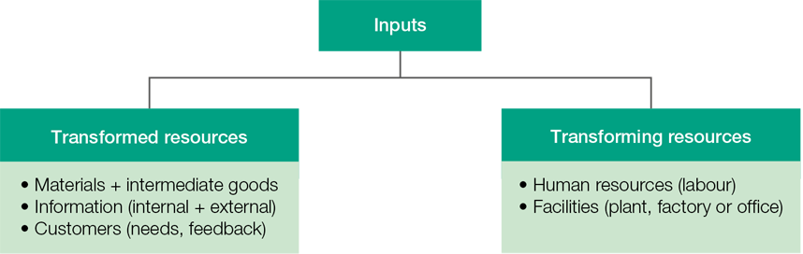  Transformed resources  - Materials  - Information  - Customers  Transforming resources  - Human resources  - Facilities
  Inputs | The resources used in the transformation (production) process
  Capital-labour substitution | Means that machinery and technology displace people by doing the work they do
  Labour | Labour is essential in all areas of operations processes. These areas include:  - Sourcing and supply chain  - Technical support  - Maintenance for machinery  - Inventory management and control  - Quality processes  - Production  - Logistics and distribution
  Energy | - Electricity  - Fuels
  Raw materials | - Wood  - Unprocessed agricultural products  - Natural resources (minerals, fossil fuels, water)
  Machinery and technology | Enable the transformation processes.
  Transformed resources | Inputs that are changed in the operations process
  Materials | Basic elements used in the production process.
    Raw materials | Essential, unprocessed materials
    Intermediate goods | Goods manufactured that are used in further manufacturing or processing
    Raw materials | Intermediate goods
    Unprocessed materials  - Wood  - Grains | Semi-finished and will be manufactured further  - Flour
  Information | Information defines how each input is used and where it’s sourced from.  - Information available transforms into a decision via operations management
    Information | Knowledge gained from research, investigation and instruction
    Key performance indicators (KPIs) | Specific criteria used to measure the efficiency and effectiveness of the business’s performance
    Internal data sources | External data sources
    - Financial statements  - Employee knowledge  - Market research  - Sales reports  - Internal key performance indicators (KPIs) | - Australian Bureau of Statistics  - Scientific studies
  Customers | Customer choices define a business’s goods and services through customer orientation.  - Customers are transformed by the use of the goods or services delivered
    Custom relationship management (CRM) | Systems that businesses use to maintain customer contact  - Used to understand the preferences and
    Goods | Services
    E.G.  Customer → exercise machine → lose weight and become fitter | E.G.  Customer → visit to hairdresser → new hair colour or length
  Transforming resources | Inputs that perform the transformation process
  Human resources | Employees that design, create and deliver products  - Responsible for combining other resources to create goods and services  Staff should be:  - Motivated  - Skilled  - Well qualified  - Hard working (effort)  - Disciplined  as this makes transformation efficient and effective, resulting in:  - Fewer accidents and absences  - Less waste  - Faster completion times  - Higher volume production  To achieve an efficient workforce:  - Improve employee skills through training and development  - Set performance objectives for individual staff members  - Adhere to work health and safety standards  - Ensure staff motivation remains high  Well-designed human resource management policies and practices and targeted and appropriate training, flexible work practices and open communication contribute to maximising efficiency.
  Facilities | Considerations when designing facilities:  - Design layout of facilities  - Optimum plant and process layout - arrangement of machinery, equipment and people  - The most efficient plant design  - Number of facilities  - Whether facilities should be located in large sites or divided among many smaller sites  - Facility locations  - The impact of zoning and other restrictions on location and size  - Special conditions like energy and water requirements  - Facility capacity  Considerations of machinery:  - Type  - What machinery is required to perform certain processes  - Amount  - Quantity of machinery required to efficiently and effectively perform processes  - Extent to which it is used  - Where is human labour more effective than machinery?
    Facilities | Plants and machinery used to carry out the transformation process
  Business examples | Apple  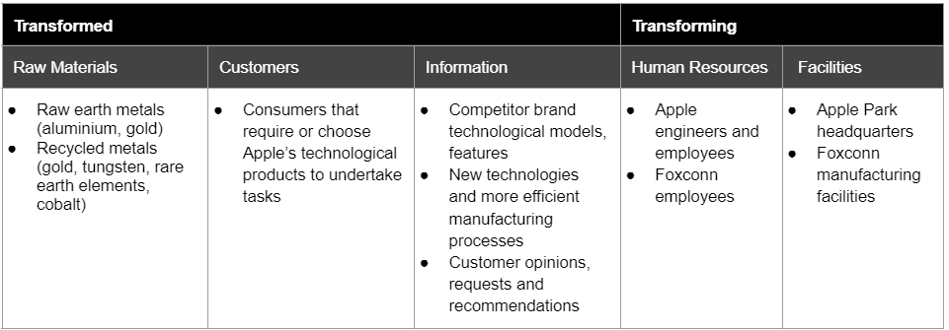
Transformation processes  - The influence of volume, variety, variation in demand and visibility (customer contact)  - Sequencing and scheduling - Gantt charts, critical path analysis  - Technology, task design and process layout  - Monitoring, control and improvement | TRANSFORMATION PROCESSES  Influence of the 4 V’s  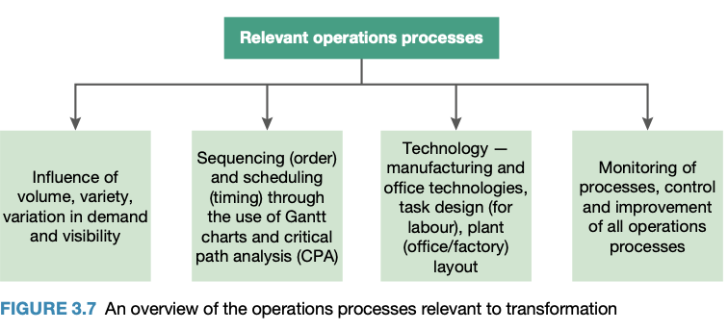  4 V’s effects on production costs  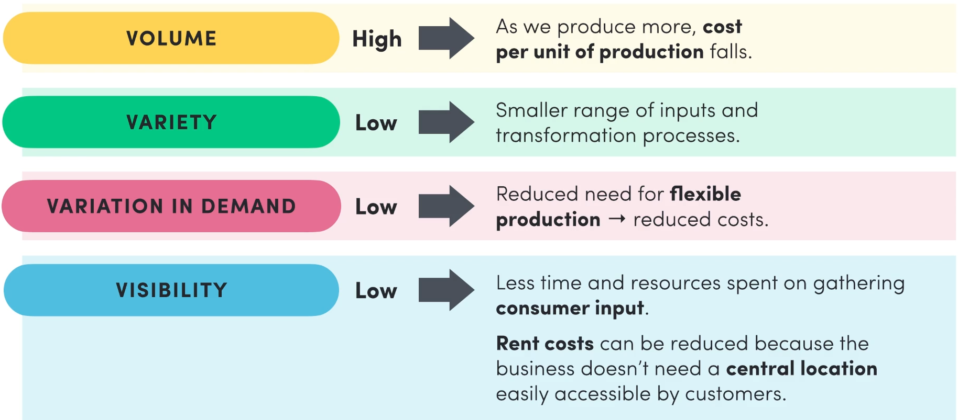  Sequencing and scheduling  Assist in structuring and ordering the transformation process.  - Provides direction and organisation to operations processes, provides overall coordination and enables a means of control  Gantt Charts  - Outlines the activities that need to be performed, the order in which they should be performed and how long each activity is expected to take  Advantages:  - Force a manager to plan the steps needed to complete a task and to specify the time required for each task  - Make it easy to monitor actual progress against planned activities  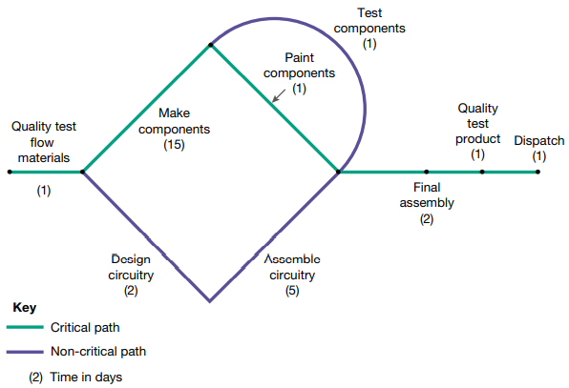  Critical Path Analysis (CPA)  - The critical path is the shortest length of time it takes to complete all tasks necessary to complete the process/project  - Each activity on schedule must be completed to make the final product  The critical path will be the longest path through a process as all necessary tasks need to be completed  - Enables a manager to see what needs to be completed, allowing the timing to be considered and what activities need to be completed as well as whether such activities can be completed concurrently  Technology, task design and process layout  Monitoring, control and improvement  - Processes are monitored for effectiveness  - Transformational processes are subject to control  - Requiring effective monitoring and a focus on continuous improvement  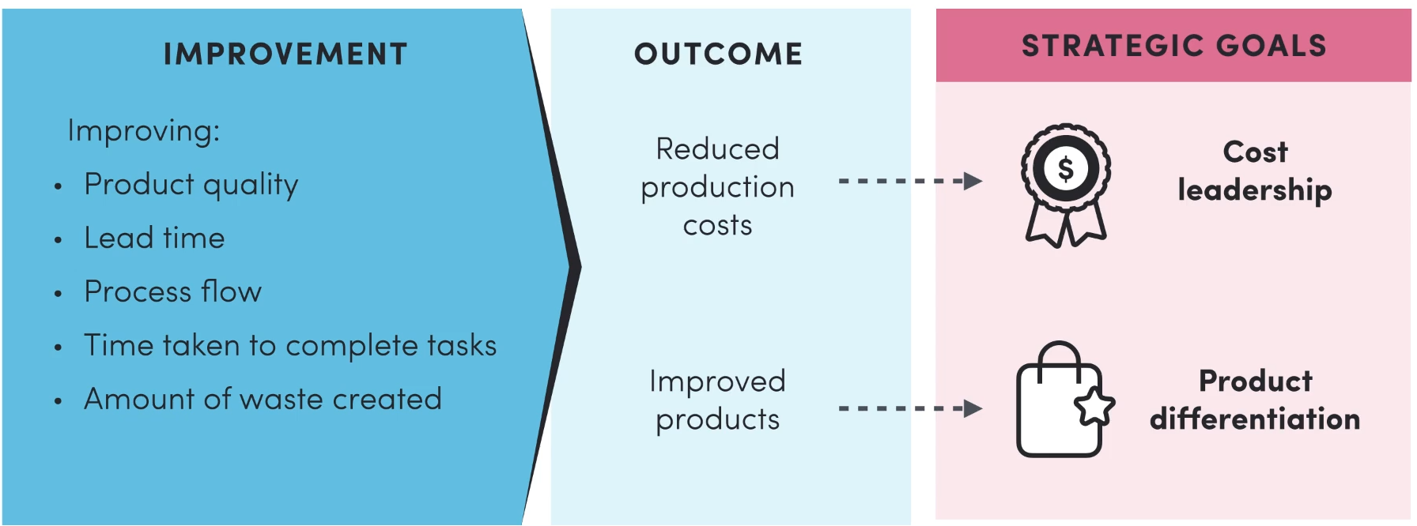
  Transformation | The process of converting inputs (resources) into outputs (goods and services) and is affected by the 4 V’s
  Volume | How much of a product is made  - Influenced by consumer demand and available inputs  The responsiveness to the required changes in volume is essential to effectively managing lead times  Slow response to falling demand → overproduction → high inventory costs and wastage  Slow response to rising demand → underproduction → backorders → lost in sales and profits
    Volume flexibility | How quickly the transformation process can adjust to increases or decreases in demand
    Lead time | The time it takes for an order to be fulfilled from the moment it is made
  Variety | The greater variety made, the more the operations process needs to allow for variation  - Consumers know mix flexibility as product range or variety of choice  The more variety, the more that operations has to adapt.  More inputs → wider range of materials  Larger range of transformation processes → more facilities
    Mix flexibility | The mix of products made, or services delivered through the information process
  Variation in demand | How much variation in demand will there be and how can we respond to changes in demand.  Predicting demand:  - Businesses must forecast changes in demand so adjustments can be anticipated and the business can adapt accordingly → FLEXIBILITY  - Some variations are predictable such as Christmas and seasonal sales  Increase and decrease in demand:  Increased demand may be hard to achieve if:  - Suppliers cannot supply quickly enough  - Labour is not flexible enough, skilled or available  - The adopted machinery/facilities cannot adjust to increased capacity quickly, either because it is not designed to or because it bread down  - Increased energy and power are not able to be readily sourced
    Increase in demand  requires operational flexibility | Decrease in demand  requires operational flexibility
    - Increased inputs from suppliers  - Increased human resources  - Increased energy use  - Increased use of efficient machinery and technology | - Staff hours many need to be reduced  - Production may need to slow to avoid inventory build up  - Suppliers may put on pressure due to contractual agreements
  Visibility  (customer contact) | How much consumer contact a business should have and how it should influence the operations process  Customer contact or feedback directly affects transformation processes due to customers and their preferences shaping what businesses produce.  Visibility is interdependent between operations and marketing.  - Marketing → consumer needs and wants shape the products that businesses create  - Operations → business decides how much customer input there should be  Direct and indirect customer contact:  Customer contact can be direct or indirect
    Direct customer contact | Indirect customer contact
    Customers provide feedback through:  - Surveys  - Interviews  - Warranty claims  - Letters  - Wikis  - Blogs  - Verbal contact | - A review of sales data that gives an indication of customer preferences  - Market share data, through an observation of peoples’ decision-making processes and through consumer reviews
  Sequencing | The order in which activities in the operations process occur
  Scheduling | The length of time activities take within the operations process
  Gantt charts | A type of bar chart that shows both the scheduled and completed work over a period of time.  - Used in planning and tracking a project
  Critical path analysis (CPA) | A scheduling method/technique that shows what tasks need to be done, how long they take and what order is necessary to complete those tasks.
  Technology | Enables businesses to do new things or perform established tasks in new and better ways  - Involves the use of machinery and systems, enabling the business to undertake the transformation process more effectively and efficiently  Office Technology  - Create the opportunity for people to do more work in less time  - People telecommute and work from home  Examples of office technology:  Manufacturing Technology  Key manufacturing technology includes robotics, computer-aided design (CAD) and computer-aided manufacturing (CAM).  Advantages and disadvantages of technology
    Computer or tablet | Keyboard and mouse | USB & storage devices | Modem
    Mobile telephones | Paging service & answering machines | Combined printer, photocopier, scanner, facsimile | Ability to electronically transfer funds (EFT) and EFTPOS machine
    Telecommute | To ‘commute’ or travel to work, electronically – the home or another location becomes the worksite and work is delivered via email or the internet
    Robotics | Used in engineering and specialised areas of research, as well as on assembly lines where a programmable machine capable of doing several different tasks is required  Robotics shape transformation processes so they are:  - Very high quality  - Of a consistently high standard  - Efficient  - Minimally wasteful  Robotics allow precision and accuracy unmatched by human labour  - Robotics are high-cost, however, work without complaint or demand
    Computer-aided design (CAD) | A computerised design tool that allows businesses to create product possibilities from a series of input parameters  Generates three-dimensional diagrams from a set of given input data (parameters)  ADVANTAGES:  - From the design, material usage can be calculated and time for the task to be completed  - Can design the sequence of steps that would need to be taken to create the desired product in the shortest possible lead time using the least amount of material  - Linked to printers so that ‘hard’ or paper copies can be made and distributed  - Allows for easy customisation and less costly drafting
    Computer-aided manufacturing (CAM) | A software that controls manufacturing processes  ADVANTAGES:  - CAD software can be linked to CAM software to allow instantaneous manufacturing of designs  - CAM can be used to calculate how much of each input resource would be required  - CAM software can store historic purchasing records to assist with present purchasing decisions
    Advantages | Disadvantages
    - Provides access to higher quality inputs (materials, customers, information)  - Makes transformation more efficient, thus reducing costs  - Reduces waste → full utilisation of materials | - Need to be leased if expensive  - Requires retraining and redundancy costs  - Associated financial costs  - Time consuming  - Reduces employee morale
  Task design | Involves classifying job activities in ways that make it easy for an employee to successfully perform and complete the task.  - Breaks a larger task down into a series of jobs in order to match the right employee to a specific job  Steps to task design:  - Define what needs to be done in a general statement  - Analyse the general job into specific duties  - Allocate a degree of difficulty and a time element  - Match tasks to existing state/federal awards (base)  - Articulate the task via job descriptions and a pay scale to allow for a range of experiences in a range of work settings (indicates the types of skills/experience and qualifications needed to complete the task successfully)  Workplace layout  Designing a workplace to boost productivity and ensure processes run smoothly  - Dependent on the type of manufacturing operations or services, the machinery required and the volume to be produced.
    Task design → Job descriptions → Person specification → Recruitment → Selection
    Skills audit | A formal process used to determine the present level of skilling and any skill shortfalls that need to be made up either through recruitment or training.
    Process layout | E.G. The typical layout of hospitals; where areas are dedicated to particular types of medical care.  Process layout is used when:  A product is highly varied and being produced in low volumes
      The arrangement of machines and equipment are arranged according to the function (process) they perform.
      Process Production | Deals with high-variety, low-volume production.  - Each product has a different sequence of production and the production is intermittent, moving from one department to another  - Machinery is arranged according to the sequence  - Cellular or team-based work is used to create combinations of machinery and equipment to produce products.
    Product layout | Used for mass-produced goods.  E.G. Assembly line is the most common layout for this type of production; it aims to achieve the best possible combination of personnel and machine use – ‘assembly line balancing’  Product layout is used when:  A product is standardised and being produced in very large volumes
      Machines and equipment are arranged according to the sequence of operations / the order in which a product is made.
      Product production | (mass production) – the manufacturing of a high volume of constant quality goods
    Fixed position layout | Fixed position layout is used when:  A product cannot be moved around due to size, shape, weight etc.  E.G. The construction of buildings, aircraft, ships or bridges
      Employees and equipment are brought to the task or products. The product remains in one location due to its weight or bulk.
      Project production | Deals with layout requirements for large-scale, bulky activities
    Office layout | Office layout is used to:  Allow employees to work efficiently in a safe office environment.  E.G. In an accountant's office clients must feel welcome as they seek advice, in a doctor’s surgery privacy is a concern for patients so the layout must reflect this.
      Employees are provided with equipment at different workstations.
      Workstations | The desk areas required by office workers.
  Monitoring, control and improvement are used for achieving the strategic goals of operations.
  Monitoring | - Measuring how the business is progressing to see if goals are being achieved  - Involves monitoring all parts of the operations process, including:  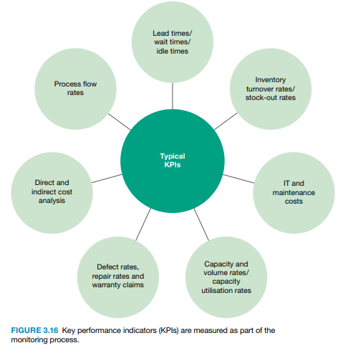  - Supply chain management  - Use of inputs  - Transformation processes  - Outputs  Monitoring is arranged around the needs to measure key performance indicators (KPIs) so that appropriate controls to operations can be made.  Monitoring KPIs allows the business to assess performance against targeted levels of performance
    The process of measuring actual performance against planned performance.
    KPIs
    Used to measure the efficiency and effectiveness of the business’s performance
  Control | Control requires operations managers to take corrective action.  - If there is a discrepancy between performance and goals, changes and improvements are made  Operations managers should:  - Control the transformation processes and supervise employees  - Set challenging but reasonable performance targets that focus on optimising productivity
    Comparing KPIs against predetermined targets and taking corrective action if required.
  Improvement | Achieving ‘Kaizen’ (continuous improvement)  Improvement is sought in time (speed), process flows, quality, costs and efficiency.  - An ongoing commitment to achieving perfection.  - Striving for improvement is important to business culture.  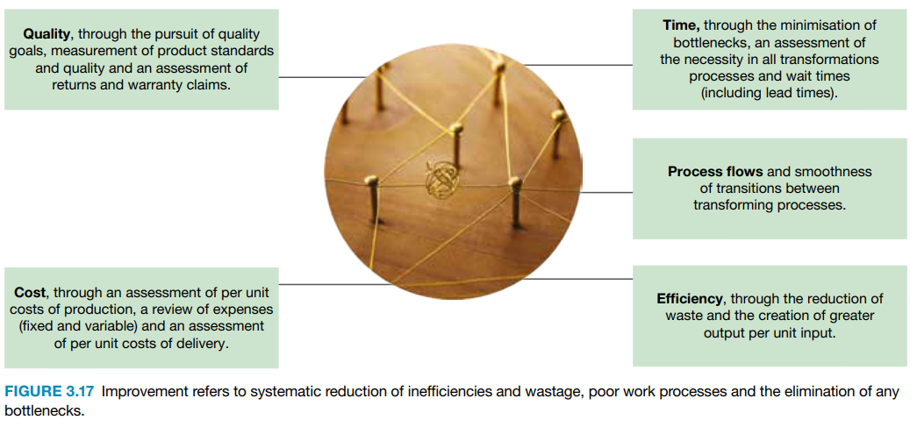
    Systematic reduction of inefficiencies and wastage, poor work processes and the elimination of any bottlenecks.
    Bottleneck | An aspect of transformation that slows down the overall processing speed or creates an impediment leading to a backlog of incompletely processed products.
Outputs  - Customer service  - Warranties | OUTPUTS  - Output must be responsive to consumer demand  - Desired output is what shapes the rest of the production process
  The end result of the transformation process. The good/service that is provided or delivered to the customer.
  Customer service | Businesses use the input of customers to meet customers’ needs and wants.  Purpose of customer service:  - Ensures customers feel valued  - Creates long-term relationships  - Helps the business maintain a good reputation in situations where the customer is dissatisfied  Responding to customer dissatisfaction:  - Respond to complaints with a solution in a timely and courteous manner.  - Review and reshape their processes and output  Business’ with good customer service can:  - Charge an average of 10% more for the same good or services  - Grow twice as fast as their competitors  - Increase their market share and profits
    How well a business meets and exceeds the expectations of customers in all aspects of its operations.
  Warranties | Businesses have a legal obligation to protect consumers with warranties.  Purpose of warranties:  - Can be a great tool for monitoring the effectiveness of operations processes  - Monitoring the reasons behind each warranty claim can indicate issues in the operations process  Warranties cost time, money and resources so operations should:  - Implement effective quality management processes  - Aim to reduce the number of warranty claims to zero
    A promise made by a business that they will correct any defects in the goods they produce or services they deliver.
Operations strategies
Performance objectives  - Quality  - Speed  - Dependability  - Flexibility  - Customisation  - Cost | PERFORMANCE OBJECTIVES  - Performance objectives are targets that operations managers are aiming to reach; changes must be made if targets are not reached.  - Performance objectives are set so businesses become more efficient, productive and profitable  - Operations managers allocate resources to performance objects they expect will increase profits the most  Each objective is allocated a specific target based on the metrics used to assess the objective and is used to assess the business’s performance.  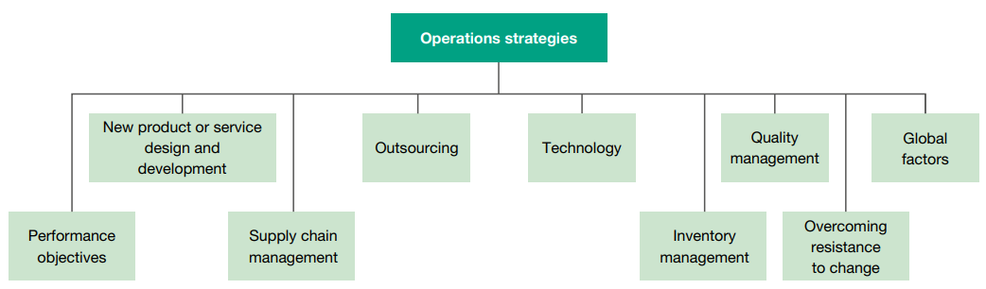
  Goals that relate to particular aspects of the transformation processes.
  Quality | Quality distinguishes products in the market.  Aims of quality:  - Exceed customer expectations  - Offer “value-for-money”  - Boost sales revenue  Achieving quality:  - Adopt quality management processes throughout the transformation processes
    Quality of design | Arises from an understanding of consumers and their preferences.  Higher quality designs:  - Require advanced inputs and detailed quality management processes  - Allow the business to charge higher prices as high-quality inputs add cost
      How well a product is made or delivered.
    Quality of conformance | A measure of how consistently products achieve compliance (conformance) with the desired specifications regardless of the standard of the specifications.  Higher conformance means:  - Products accurately meet the design specifications  - Production processes are effective
      How well a product meets the standard of a prescribed design with certain specifications.
    Quality of service | - How reliable the service is  - How well the service meets the specific needs of the client  - How timely or responsive the service delivery is  - Pleasant interactions between customer and service provider
  Speed | Requires that changes in input levels and processing times can be made in response to consumer demand. Change input levels and processing times to avoid under-production or over-production.  Aim of speed:  To satisfy customer demands as quickly as possible.  Goals of speed:  - Reduced wait times  - Shorter lead times  - Faster processing times  Achieving speed:  - Reduction in procedural and technical bottlenecks  - Smooth internal communications
    The time it takes for the operations process to respond to changes in market demand.
    - Response to rising or falling demand
  Dependability /reliability | Aims of dependability:  - To reduce warranty claims (goods)  - To reduce customer complaints (services)  - To gain a positive business reputation and long-lasting relationships with customers  Achieving dependability:  - Use quality management processes  - Use research and development to access high-tech quality management procedures and equipment  Dependability of goods  - Measure for dependability: warranty claims  - Fewer warranty claims → dependable good  Dependability of services  - Dependability refers to the consistency of service standards and reliability  - Measure for dependability: number of complaints  - Fewer complaints → dependable service
    How consistent, reliable and long-lasting products are.
    Non-perishable goods | Perishable goods
    Dependable if they’re highly durable. | Dependable if their quality is consistent - if they are of consistent and predictable standard.
  Flexibility  /adaptability | Connection between TIME and FLEXIBILITY:  The faster the processing time, the greater the likelihood that processes can be adjusted quickly.  Aim of flexibility:  - To improve processing times → allows for a better chance of adapting quickly when necessary  Achieving flexibility:  Increased demand for:  - New products → change inputs and processes  - Existing products → increase the volume and variety of outputs by increasing capacity  …for goods:  - Increase the capacity of production through using plant and machinery better  - Purchase new technologies that increase flexibility and capacity  - Change product design, creating a broader variety  - Increase the number of employees  ...for services:  - Increasing the number of service providers  - Increasing the provider’s skill level through improving the level of technology used when providing the service
    How quickly operations processes can adjust to changes in the market.
    - Response to all changes
  Customisation | Aim of customisation:  To satisfy customers by using their specific desires as inputs in the transformation process.  - Businesses can then charge higher prices while increasing customer satisfaction  Achieving customisation:  - Using a differentiation strategy  Full customisation is rare, only offered when products are created after an order specifying the requirements.
    Creating individualised products to meet the specific needs of customers.
    Mass customisation | A process that allows a standard, mass-produced item to be personally modified to specific customer requirements.  E.G. Tesla modifications: Choosing the paint colour and finish on a car → allows customers to choose certain features
  Cost | Aim of cost:  To achieve cost leadership  - Lower costs can lower prices for customers → wider market share and competitive advantage  Achieving cost:  - Source inputs from lower cost suppliers  - Make better use of technology to get the most out of inputs  - Minimise waste or the need for employees → lean production techniques  - Reduce post-production costs  - Hire cheaper distributions  - Manage quality during production
    The minimisation of expenses so that operations processes are conducted as cheaply as possible.
New product or service design and development | NEW PRODUCT OR SERVICE DESIGN AND DEVELOPMENT  Consumers have ever-changing needs and wants, so products have a limited lifespan  Product design and development process  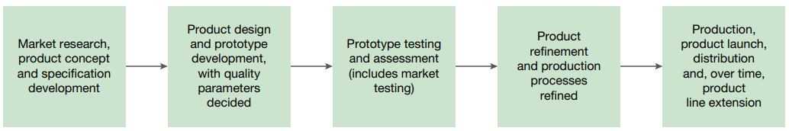
  Developing goods | Through product development, businesses can:  - Maintain customer satisfaction  - Achieve a greater market share for long-term growth  - Gain competitive advantage and keep their business relevant  Key considerations
    How are goods developed?
    In response to consumer preferences
    - Undertaking a great amount of market research to determine what customers desire
    From advances in technology
    - New and improved technology can create more functional, appealing and better quality products
    Supply chain management | - Determine whether existing suppliers can respond to the needs (quality and quantity of inputs) of new products  - Business may need to extend the range of supplies, the timing or volume of supplies
    Quality management | Ensure new products meet the business’s existing quality standards and customer expectations
    Capacity management | Businesses need to have the facilities (factories and machinery) to produce a new product at the right volume and continue to produce existing products
    Cost | Time, money and effort used in processing.  - The costs shouldn’t outweigh the benefits of designing a new product.
    Product utility | The usefulness and value that a product has from the consumer’s point of view.
  Developing services | Key considerations
    How are services developed?
    In response to consumer preferences
    - Most of the elements in service delivery require customer input
    From advances in technology
    Explicit service
      The tangible aspect of the service delivery
      - Time, expertise, skill, effort
    Implicit service
      The intangible aspect of the service; the service experience
      - Psychological wellbeing, feeling of being looked after
    Goods required | - What goods are required for the service  - How much the goods cost  - How the goods add value to the service
  Business examples | Apple  Maintains complete control over the design and development of both software and hardware.  - Develops all its products and services at its headquarters in Apple Park, California
Supply chain management  - Logistics  - E-commerce  - Global sourcing | SUPPLY CHAIN MANAGEMENT (SCM)  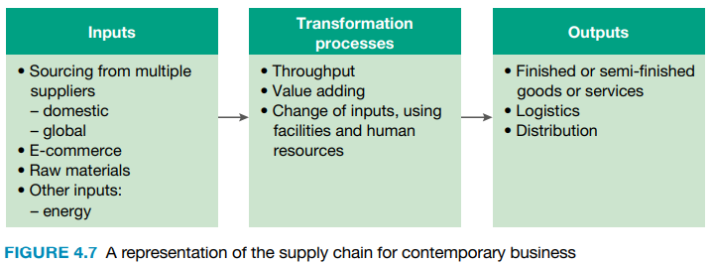  - Supply chain is influenced by what is sold and returned  - Involves sourcing, logistics and distribution  Three key aspects to supply chain management:  - Sourcing, including global sourcing  - E-commerce  - Logistics  Managing supply chains effectively:  Increased speed leads to faster transactions and more revenue through satisfying customer demand quicker resulting in reduced inventory and thus saving on the costs of storage, insurance and obsolescence. → efficiency and reduced costs
  Supply chain | A sequence of processes that enables businesses to coordinate supplies throughout operations to meet customer needs. → making products available to customers
  Supply chain management | Involves integrating and managing the flow of supplies throughout the inputs, transformation processes (throughput and value adding) and outputs in order to best meet the needs of customers.
  Sourcing  /procurement | Global sourcing  - Due to globalisation, businesses now have a wider variety of suppliers to choose from  Key considerations  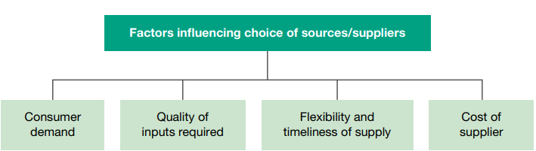
    The purchasing of inputs for the transformation processes.
    Purchasing supplies or services without being constrained by location. Global sourcing means buying or sourcing from wherever the suppliers are that best meet the sourcing requirements.
    Advantages | Disadvantages
    - Inputs are usually cheaper, especially from low-cost regions  - More suppliers to choose from, so businesses can access better quality resources, new technologies and expertise | - Economic costs - exchange rate fluctuations and taxes  - Time and logistical costs to get supplies from one country to another  - Legal and ethical issues which turn customers away
    Volume of inputs | Businesses need to balance consumer demand with input volume.
    Suppliers | Businesses need suppliers who:  - Are flexible and timely (reliable)  - Respond quickly to changes in demand  - Deliver on time and keep costs as low as possible
    Quality | Quality of inputs need to match the quality of the business’s products.
  E-commerce | Business sourcing and e-commerce (e-procurement)  - Suppliers can supply without formal request from the buyer when stock falls to a predetermined level  - This is enabled by business-to-business arrangement (B2B)  E-commerce and the consumer  - Businesses sell directly to consumers in transactions called business-to-consumer (B2C)  - Businesses that sell directly to consumers online must manage stock levels effectively  - Information should be exchanged frequently so that accurate stock levels can be presented to the customer
    The buying and selling of goods and services via the internet.
    E-procurement | The use of online systems to manage supply, allows suppliers direct access to the business’s level of supplies.
    B2B | Direct access from one business (the supplier) to another (the buyer), allowing the supplier to assess the needs of the buyer and meet them in a timely manner.
    B2C | The selling of goods and services to consumers over the internet, with payment usually by credit card
    Advantages of E-commerce
    - Heps establish networks of suppliers
    - Makes collecting and storing data easier
    - Provides access to more information → more markets and flexibility → saves time, money and effort in the supply chain
  Logistics | Logistics includes:  - Transportation (including transportation modes)  - The use of storage, warehousing and distribution centres  - Materials handling and packaging  Distribution  Methods of physical distribution:  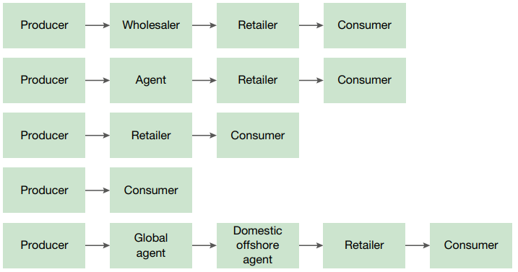  Transportation and distribution  Concerned with the physical movement of inventories.  - Type of product and cost of transportation determines the mode of transportation selected  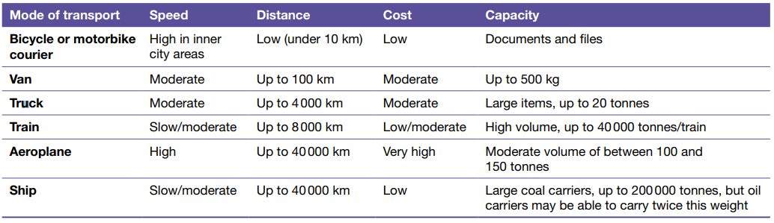  Storage, warehousing and distribution centres  Materials handling and packaging  Particular standards and methods of operating must be applied  Delicate goods  - Delicate goods must be transported and stored carefully  Dangerous goods  - Dangerous goods carry hazards when transported and stored  - Government regulations must be followed that require dangerous goods to be stored and handled in particular ways and requires packaging to be of a particular standard and to carry warnings
    Refers to the distribution and transportation, the use of storage, warehousing and distribution centres, materials handling and packaging.
    Distribution | The ways of getting goods or services to the customer.
    Storage | Necessary when there are numerous outlets through which stock is sold and when demand is variable needs a responsive supply chain  - Long-term or short-term storage, cold storage for perishable goods  - Storage does not require the use of warehouses  Alternative inventory options  - just-in-time (JIT) - minimises storage and associated costs
      Finding a secure place to hold stock until it is required
    Warehousing  /distribution centres  /distribution hubs | Costs associated with warehouses:  - The premises  - Insurance and security for the stock  - Stacking and moving the stock  - Carrying excess stock or redundant stock if not sold  - Stock subject to damage if not correctly stored  Useful for storing durable items that may need to be transported with little notice.  - Warehousing saves costs if used well.
      The use of warehouses for the storage, protection and distribution of stock
    Distribution centres (DCs) | Unlike warehouses, distribution centres are not intended for long-term storage.  - Strategically located to minimise the time it takes to supply stock to retail outlets  - Requires managers to balance the costs of DCs with the time saved in logistics  Can be air-conditioned, have cold storage facilities or co-located with transportation hubs
Outsourcing  - Advantages and disadvantages | OUTSOURCING  Examples of outsourcing in businesses:  Forms of outsourcing  - Captive/in-house outsourcing  - Non-captive (outsourced to third parties through the market). External providers/vendors  - Onshore  - Offshore  Deciding whether to outsource  - Cost - is it cheaper and more efficient than performing the work in-house  - Location - which geographical location is favoured  - Vendors - which vendors should be used  - Contract - length of the contract, the KPIs and service levels  Co-sourcing  - Two parties are followed involved in managing the success of the particular aspect of business  - Work is done by an external expert who works within the business as a contractor  Advantages and disadvantages of outsourcing
  Using external providers to perform business activities
  - Businesses outsource to companies that specialise in certain activities
  - Tasks can be completed at a lower cost and with better efficiency
  Operations | Manufacturing, value-adding, manufacturers, design, merchandising, sourcing, distribution, logistics
  Human resources | Employee remuneration, employee counselling, pensions, data management, training and development, travel and expenses management
  Administrative work | Data entry
  Information technology | Data workshop, desktop outsourcing, network outsourcing (remotely hosted software applications)
  Finance and accounting outsourcing (FAO) | Preparation of financial accounts and reports, analytics and taxation compliance
  Knowledge process outsourcing (KPO) | Marketing strategy, public relations, management decision marketing
  Legal process outsourcing (LPO) | paralegal support, legal support, legal services (patents, trademarks)
  Creation of shared services centres (SSC) | - In-house outsourcing option  - Involves the creation of an in-house centre that performs work for multiple subsidiaries
  Use of ‘fee-for-service’ arrangement | - Low-risk, short-term strategy that involves engaging a supplier for fixed services at a predetermined price  - Allows for testing the outsourcing market prior to making a change
  Joint ventures | - Business engages an outsourcing services provider but the provider is also free to outsource to other businesses in the same industry
  Use of a ‘build-operate-transfer’ approach | - Involves offshore outsourcing and involves contracting with external organisations  - Use of contracts that detail agreed levels of service against predetermined KPIs  - Relocation of services to a new offshore location (build-operate) is then transferred to an independent vendor that the company contracts
  Advantages | Disadvantages
  - Cost and efficiency  - Employees have skills to complete tasks faster and to a higher degree of quality  - Cheaper labour and less stringent laws  - Business requires fewer employees → cost savings  - Simplification, capacity to focus, performance  - Reducing variety of activities that businesses need to perform, thus allowing the business to focus on core activities, improving in-house performance  - Increased process capability  How well operations can meet production targets  - Outsourcing provides better access to new technologies and efficient labour, allowing them to deliver products to customers with better efficiency and service thus improving process capability  - Increased accountability  - Detailed contracts ensure outsourcing partners reach important KPIs, creating an incentive to meet KPIs  - Accessibility to skills/resources  - Improved accessibility of skills, resources and knowledge, so resources aren’t spent in training employees  - Strategic benefits  - Using outsourcing to get around trade barriers  - Use of a vendor that outsources for others within the same industry can bring benefit of expertise gained from outsourcing to competitors  - Trading in different time zones → conduct operations during the day, processing work done overnight by outsourcing vendor  - Strong partnerships between business and the outsourcing vendor suggesting innovative solutions to the business that may increase business efficiency and productivity over time | - Payback periods and cost  The amount of time it takes to repay outsourcing costs  - Can take time before cost savings are achieved  - Communication and language  - If the outsourcing contract isn’t clear, there can be communication issues → confusion about the tasks to do and KPIs to meet  - Language barriers or differences in management styles  - Requires lots of technology for communicating with service partners → costs and time shortages  - Lack of control and information security  - Operations managers might have less control over product quality and how business information is used.  - Organisational change  - Redundancy costs: Outsourcing certain activities means businesses need fewer employees  - Lower motivation: Remaining employees may lose motivation  - Employee relationships: Outsourced employees sometimes have to work with in-house employees → tension and low productivity if relationships aren’t managed well  - Loss of corporate memory - loss of business knowledge  - Business might rely on outsourcing too much and forget how to perform certain activities  - Information technology  - As the use of outsourcing grows, so does the need for supporting information technology → cost and time associated with the use and adaptation of IT to the specific requirements of the business and outsourcing vendor
  Business examples | Apple  Outsources:  - Production of iPhones to Foxconn and Pegatron  McDonald's  Outsources:  - Management IT services and POS software  - Inputs – hamburger buns, potatoes, beef, eggs, sundae mix  - Logistics – delivery of supplies  Australia Post  - Used by many businesses to deliver products  Qantas  - Outsources its aircraft maintenance  Adam Schon - Operations Strategies - Outsourcing
Technology  - Leading edge  - Established | TECHNOLOGY
  The use of machinery and systems to perform the transformation processes more efficiently, effectively and productively
  - Leads to cost leadership through improving operations processes
  - Leads to product differentiation through improved product offerings
  - Creating competitive advantage and boosting profits
  Leading edge technology | Involves some risk as the technology is not mainstream.  - Improves the efficiency of production processes  - Reduces error and waste in production → thus reducing cost  - Creates high quality and leading edge products resulting in competitive advantage  Leading edge technologies are created by innovative processes and innovative thinking.
    The technology that is the most advanced or innovative at any point in time
  Established technology | Improves speed and productivity in management and administrative processes.  Examples:  - Barcoding and POS → inventory management  - Robotics → complex and detailed manufacturing  - CAD, CAM, CIM (computer-integrated manufacturing) → integrating processes  - Information processing technologies, IT → administration, logistics, input modelling, demand analysis, distribution  - FMS (flexible manufacturing systems) → transformation processes
    Technology that has been developed and widely used and is simply accepted without question
  Business examples | Apple  - Employees were reduced at one Foxconn factory from 110,000 to 50,000 with the introduction of robotics → lead to cost savings  - Robotic technology lacks flexibility of human labour in adapting to new product specifications  - High costs of robotics are presenting challenges in the smartphone market due to the trend in shorter product life cycles  McDonald's  - Automated voice recognition → testing drive-thrus with voice recognition so that labour can be devoted to other aspects of the operations process  - McDonald’s smartphone app  - Acquired Dynamic Yield to personalise the electronic menu boards depending on factors like weather  - McDonald’s Global Technology known as McD Tech Labs in Silicon Valley now is the home of McDonald’s digital advancements  Adam Schon - Technology as an operations strategy
Inventory management  - Advantages and disadvantages of holding stock  - LIFO (last-in-first-out)  - FIFO (first-in-first-out)  - JIT (just-in-time) | INVENTORY MANAGEMENT  Inventory valuation methods  Inventory management approach
  Inventory/stock | The raw materials, works-in-progress and finished goods that a business has on hand
  Advantages of holding stock | Disadvantages of holding stock
  - Consumer demand can be met when stock is available  - An alternative product line can be offered when one runs out  - Reduces lead times between order and delivery  - Provides the option to generate immediate revenue  - Stocks can be distributed to distribution centres, rapidly transporting products to places according to demand  - A store of stock allows the business to promote use of products in non-traditional and new markets  - Older stock can be sold at reduced prices, encouraging cash flow and attracting sales of other products  - Making products in bulk may reduce costs due to economies of scale in purchasing inputs | - Costs associated with holding stock  - Storage charges  - Spoilage  - Insurance  - Theft  - Handling expenses  - Invested capital, labour and energy cannot be used elsewhere  - Cost of obsolescence, occurring if stock remains unsold
  Determining the value of unsold stock at the time of the valuation.
  LIFO  last-in-first-out | - Stock bought last would assume to have been sold first  - Used to calculate the cost of sales  - Thus, gross profit is more recent and more closely reflects economic value  - Used for goods that are non-perishable, homogenous or innovative technology products (new products)  Due to inflation, the cost and value of stock rises over time.  Impact:  Stock bought is more expensive  - Overstates the costs of stock  - COGS is higher on financial statements  - Understates gross profits  - Gross profit is lower  - Undervalues stock on hand at the end of the period  - The value of unsold stock is higher because the new stock remaining is worth more
    Assumes the last goods purchased are the first goods sold, therefore the cost of each unit sold is the last cost recorded.
  FIFO  first-in-first-out | - Stock bought first would assume to have been sold first  - Used for perishables and products that become obsolete quickly  Due to inflation, the cost and value of stock rises over time.  Impact:  Stock bought is cheaper  - Understates the costs of stock  - COGS is lower on financial statements  - Overstates gross profits  - Gross profit is higher  - Overvalues stock on hand at the end of the period  - The value of unsold stock is higher because the new stock remaining is worth more
    Assumes the first goods purchased are the first goods sold, therefore the cost of each unit sold is the first cost recorded.
  JIT  just-in-time | AIM: To overcome the problem of end-of-period stock valuation → (Used for lean production)  Businesses need to:  - Have a clear idea of the demand for their products  - Have flexible production and reliable suppliers  - Order frequently and in lower volumes
    Ensures that the exact amount of material inputs will arrive only as they are needed in the operation process.
    - Used to manage inventory, not value it.
    Advantages | Disadvantages
    Labour: easier to evaluate and count stock  Space: less space is required for storage  Cost savings: storage, waste | Delivery costs: Can’t achieve economies of scale  Labour: harder to cater to sudden boosts in demand
  Business examples | Apple  - Apple uses LIFO inventory valuation, selling newer and more expensive models to increase their profits before pushing for sales of older technology products to clear stock  - Apple must order components for its products and build inventory in advance of new product launches  - Apple forecasts and purchases inventory to meet manufacturing requirements for periods up to 150 days. Highly competitive smartphone market is subject to rapid technology and price changes, thus a risk that Apple forecasts incorrectly leading to errors, excess or insufficient levels of inventory  - Affects their ability to meet production schedules and customer orders on time  Qantas  - Qantas do not ‘store’ product to meet customer demand, thus the issue of inventory management does not affect Qantas like it would a manufacturing business  Adam Schon - Inventory Management
Quality management  - Control  - Assurance  - Improvement | QUALITY MANAGEMENT  Importance of quality:  - A fundamental expectation of consumers  - Meeting or exceeding expectations will improve the business’s image and increase sales and profits  Ensures products are:  - Consistent  - Durable  - Safe  - Fit for purpose  Common quality management approaches
  Quality management | Processes that a business undertakes to ensure consistency, reliability, safety and fitness of purpose of product
  Quality control (QC) | A reactive quality strategy that focuses on finding and correcting any defects.  INSPECTION → MEASUREMENT → INTERVENTION  - Most costly quality management approach  - Quality assurance is reactive rather than proactive  - It doesn’t prevent faults, only detects them  Steps of quality control:  - Business needs to define quality standards and parameters  - A range of tests needs to be designed to assess the quality of products and processes against the standards  - Pre-determined quality targets are set, any failure to meet the targets needs to be assess and appropriate action taken to correct any issues  Inspection and quality control:  May require that labour is appropriately trained to apply quality standards throughout working processes.
    The use of inspections at various points in the production process to check for problems & defects
    Attribute inspection | Goods or services are inspected to be passed as ‘okay’ or ‘defective’
  Quality assurance (QA) |   A proactive quality strategy that focuses on preventing faults from occurring.  APPLICATION OF INTERNATIONAL QUALITY STANDARDS  - Quality assurance is proactive rather than reactive  Quality important to QA:  - ‘Fit for purpose’ → how well a product does what it is designed to do  - ‘Right first time’ → products do not need to be reworked, wasting time, energy, resources  ISO 9000 series standards  - Quality certifications to maximise quality  - ISO → International Organisation for Standardisation  - Voluntary to adopt, but businesses comply to enhance domestic and international competitiveness
    The use of a system to ensure set standards are achieved in production
    Benchmarking | Setting quality standards
  Quality improvement (QI) | Two aspects of quality improvement:
    Continuous improvement (‘Kaizen’) | - Over time, processes will be made more efficient and effective  - The inclusion of staff into improvement processes  - Improvement may be monumental (achieved through innovation), incremental or gradual over time  Improvement helps business’ obtain and maintain competitive advantage
      An ongoing commitment to improving a business’s goods or services
      Six Sigma | A quality management approach that seeks to identify and remove the causes of problems in the operations processes, achieving virtually defect-free production
    Total quality management (TQM)  By: W. Edwards Deming | - A ‘holistic’ approach - Quality becomes a commitment and the responsibility of every employee of the business  TQM results in:  - Reduced production errors and waste → reduced costs  - Strong, positive business reputation → increased sales  To achieve TQM objectives require four elements:
      Focuses on managing the total business to deliver quality to customers
      1 | Benchmarking | Comparing actual product quality to predetermined standards
      2 | Employee empowerment | Ensuring employees feel comfortable to suggest improvements
      3 | A focus on customer | Quality products are those that satisfy customer expectations
      4 | Continuous improvement | Ongoing commitment to improvement by all employees
  Business examples | Apple  Quality control  - Employees in Foxconn factories are adequately trained in the assembly and monitoring of iPhone production → interdependence of operations and human resources  - On October 5 2012, there were quality control issues in a Foxconn factory, leading to a strike  - In 2013, 5 million iPhones were returned to Foxconn due to an unnamed defect, leading to Foxconn spending $1.6bn to cover the costs  Quality assurance  - Apple engages in teams of QA employees to troubleshoot and overcome issues with new models of iPhones prior to product launch  - Established and leading technology is employed to test both hardware and software of iPhones  - Some defects and problems were not identified or resolved prior to launch:  - 2012 Apple Maps app  - 2018 iPhone X facial recognition  McDonald's  Quality control  - McDonald’s checks the quality of raw materials for freshness and levels of bacteria  - Adheres to strict temperature and time controls throughout the entire supply process and in restaurants to minimise hazards  Quality assurance  - McDonald’s Supplier Quality Management System (SQMS) applies to businesses who supply food products (excluding meat) to McDonald’s  - BSI Group conducts food safety audits - announced or unannounced - on McDonald’s suppliers, ensuring consistently safe food that adheres to laws and regulations  - McDonald’s safety plan is based on Hazard Analysis Critical Control Point (HACCP) approach to quality management  Adam Schon - Operations Strategy - Quality Management
Overcoming resistance to change  - Financial costs  - Purchasing new equipment  - Redundancy payments  - Retraining  - Reorganising plant layout  - Inertia | OVERCOMING RESISTANCE TO CHANGE  Businesses need to adapt to remain competitive and survive long-term.  - Must alter product offerings to accommodate demand  - Incorporate new technologies and processes to remain competitive  Resistance to change arises from two principal sources within a business:  - Financial  - Psychological/emotional  Financial reasons for resistance to change  Psychological resistance to change  Strategies to overcome resistance to change  Businesses need strategies to overcome resistance and should manage change in a way that allows it to be accepted by everyone in the business.  Changes must:  - Occur at a pace to be absorbed by and integrated into the business  - Be evaluated thoroughly to assess their overall impact  - Poorly managed changes result in employee resistance, tension and lost productivity  - Be introduced into a workplace culture that supports employee participation  Change management strategies
  Change → uncertainty → stress, risk
  Purchasing new equipment | Change is about improving processes, thus requiring new equipment.  Purchase of machinery and technology is very costly, yet advantageous.  - Recouped through use (adds value in transformation processes) and through depreciation  Businesses may find some key operational goals are better achieved such as:  - Improved processing flexibility  - Improved processing speeds and shorter lead times  - More consistency in production  - Higher overall quality of processing  - Reduced wastage and losses from equipment failure  Cost of purchase can be assessed against leasing new equipment/technology.  - Leasing does not require high upfront payment but can be expensive as an ongoing operational cost
  Redundancy payments | Redundancy occurs due to:  - Lack of work due to a fall in demand  - Position may have been restructured or replaced by technology  Significant cost associated with redundancy is redundancy payouts  Redundancy payouts are high because the value of the payout depends on:  - The length of the employment the employee had with the business  - Legislation regulates a certain number of weeks of pay must be paid  - The level of pay the employee is on prior to being made redundant  - The amount of unused leave that the employee has accrued  - Any outstanding wages  Typically occurs when capital in the form of machinery and technology replaces labour in ‘capital-labour substitution’
    Employees losing their jobs where their job or work is no longer needed
  Retraining | Job roles may change requiring employees to acquire different work skills to fulfil skills gaps  - Achievable through training  Purchase of technology requires training or retraining on new software  Retraining can be performed on or off the job.  Costs arise from:  - A reorganisation of the business’s internal hierarchy  - The acquisition of technology
  Reorganising plant layout | Major changes such as the re-engineering of systems require extensive reorganisation of the layout within the facility.  Costs arise from:  - Reduced productivity and higher costs resulting from downtime and staff orientation to the new workplace arrangements  - Structural costs: transporting, testing and installing of new equipment, machinery and technology
  Inertia | Affects all employees because people are generally risk averse.  - Risk averse → avoid taking risks with uncertain returns  Reasons for inertia:  - Fear of being replaced  - Changes that put employee’s jobs at risk or limiting their career opportunities  - Fear of the new  - New technologies may seem intimidating and learning new skills may be daunting  - Stability  - Some employees like the way things are  - Fear of uncertainty or the unknown
    Describes a psychological resistance to change
  Evaluate sources of change | Identify the sources of change and assess whether there is a need to accommodate change through adjustments to business processes  - Poorly managed changes result in employee resistance, tension and lost productivity
  Include employees | Lower resistance to change through being transparent with employees by communicating about the why change is necessary and obtain widespread support for change
  Change agents | Internal staff or external professionals to assist in facilitating the change process positively through providing tips and tools
    Change agents | Somebody who initiates change or facilities the change process
  Change models
    Kurt Lewin’s unfreeze-change-refreeze model
      1 | Unfreezing  Breaks down the forces supporting the existing system and prepares the business for change
      2 | Change  New procedures and behaviours must be communicated and implemented
      3 | Refreezing  Requires that a manager offers positive reinforcement to ensure change lasts
    Kotter's eight-step change model
      1 | Establish a sense of necessity  Examine the current business environment to highlight impending threats or potential opportunities
      2 | Form a guiding group  Establish a team of people to act as facilitators
      3 | Create a vision  Provide employees with a clear, shared sense of direction that will allow them to achieve a common objective
      4 | Communicate the vision  Communicate the vision with everyone that the change will affect to build cohesion between employees and dispel fear of the unknown
      5 | Empower people to fulfil the vision  People who have the opportunity to be actively involved in the change process typically develop a sense of ownership
      6 | Recognise and reward achievements  Recognition and reward should be given to encourage further risk taking and reinforce the positive aspects of embracing change
      7 | Consolidate improvements  As the change process proceeds, assemble the benefits attained into the business’s operating procedures and systems
      8 | Institutionalise the changes  Make a clear statement to show the connections between the new procedures and the success of the business
  Culture of continuous improvement | Staff included in the process of creating a culture of change and setting goals will be more supportive and familiar with change  - Create a workplace culture that supports employee participation
  Be proactive | Anticipate change and adapt to it according to allow for more control over changes
  Gradually implement change | Gives employees time to adjust to changes and thus a lack of resistance
  Business examples | Apple  - Technological change is required when releasing a new product, new equipment or machinery may be required and the plant layout may need to be reworked  - Workers may need to be retrained to assemble new Apple products  - Associated financial and psychological resistance  - As Foxconn adopts new machinery, workers are being made redundant, thus redundancy payments are a significant financial cost of change in Foxconn and a factor of resistance to change  McDonald's  - Workers need to be constantly retrained to be up-to-date with new products and recipes  - Workers may need to be retrained to use new technology such as POS systems, machines, etc.  - Associated financial costs of retraining employees  Adam Schon - Overcoming resistance to change (change management)
Global factors  - Global sourcing  - Economies of scale  - Scanning and learning  - Research and development | GLOBAL FACTORS  Opportunities and strategies available to operations managers on a global scale.  - Enables businesses to compete in a competitive and vast global market
  Global sourcing | Global sourcing exposes outsourcing decisions to the global market.  - Allows for the best decision to be made based on cost, efficiency, productivity, technical ability and an ability to operate over more hours of the day
    Businesses sourcing and outsourcing operations or resources without being constrained by location (across geopolitical boundaries)
    Benefits | Challenges
    Lower costs  Access to new technologies  Expertise and labour specialisation  Access to other resources  Ability to operate over extended hours | Relocation: possible relocation of aspects of operations  Increased costs: costs of logistics, storage and distribution  Regulatory conditions: managing different regulatory conditions between nations  Complexity: increasing complexity of overall operations when sourcing from diverse locations
    Complexities
    Financial
    - Risk associated with exchange rate fluctuations
    Contractual
    - Language and culture variations
    - Regulatory differences
    - Misunderstandings created by poorly negotiated SLAs (service-level agreements)
  Economies of scale | - Businesses respond to increases in demand and volume that necessitate making higher product volumes  - When expanding into the global market, the need to source globally becomes a strategic decision
    Cost advantages gained by increasing the size or scale of production
    Benefits
    Increased profitability | More units of output ‘spreads’ fixed or overhead costs → costs per unit decreases → profitability increases
    Boosts efficiency and cost savings | Global businesses are larger, investing more in technologies and machinery → boosts efficiency and cost savings
    Cost savings on marketing | Standardised marketing in MNC (multinational corporations) → no extra modification costs
    Added production value | Product life cycles are extended → greater added value on production
  Scanning and learning | Sources:  - Reading management journals  - Industry experts and business associations  - Attending conferences or forums  - Observing and questioning employees and managers from other backgrounds  - Diversity of experience helps businesses learn how to handle issues with flexibility and insight.  Benefit:  Businesses can learn from the best of the best and implement these practices into their businesses.
    Scanning: Investigating what is occurring in the global environment
    Learning: Using the gained information to improve operations
  Research and development (R&D) | Investigating what customers need and want, creating products to meet preferences.  Research and development:  - Ensures new products meet current preferences  - Helps develop innovative products and leading edge technologies, improving innovation and quality, thus creating competitive advantage  Government incentives and grants:  Governments offer taxation incentives and grants to assist businesses in investing and allocating resources into R&D.
    Developing a marketable product through research, prototyping and testing
  Business examples | Apple  Global sourcing  - Benefits with the global sourcing of iPhone components include cost savings achieved by outsourcing, proximity to suppliers and overseas markets and access to leading technologies  - Majority of iPhone components are sourced from China and Mongolia  - Reduces costs of transportation and storage due to the proximity of suppliers to the assembly factories  - Other components with specific requirements are sourced from USA, Korea, Taiwan, France and Italy  - Significant threat to Apple’s strategy of global sourcing lies in the uncertain outcome of the China-US trade war  Economies of scale  - Efficiency in production by using skilled labour of mega factories like Foxconn  - Technical expertise shared by Foxconn as a manufacturer for other leading electronics companies  - Global branding reduces associated costs with marketing as a multinational business  Scanning and learning  - R&D teams need to scan and learn from competitors in the design, manufacturing and delivery of smartphones to remain competitive  - Apple benefits from the information that comes with a global approach to recruitment  - Apple’s strong brand reputation attracts highly talented and experienced employees from a range of businesses and cultural backgrounds  - This diversity is a major source of new and innovative ideas for Apple  Research and development  - Apple’s investment in R&D is a crucial strategy in maintaining a competitive position in the smartphone market  - Some media commentators have suggested that Apple’s growing R&D budget is largely focused on innovation of autonomous vehicles and artificial intelligence  McDonald's  Research and development (R&D)  - Understanding external factors that affect consumer spending habits (changing customer needs, general economic conditions, competitive behaviour)  - This data analysis is completed via McD Tech Labs  - Engages with suppliers, customers and franchises to ensure product and service offerings satisfy needs of key stakeholders  - Test kitchen allows McDonald’s to replicate any of its global restaurants to ensure new processes can be smoothly executed  - Employ an Executive Chef and Vice President of Culinary Innovation to help the creative team of chefs to develop new menus  - Once ideas are developed, the new product and processes are simulated in the test kitchen  - R&D enables the business to maintain relevance and be a pioneer in the fast-food industry

