Business Studies Task #2

Syllabus Points | Notes
Role of marketing | 1. The Role of Marketing
Strategic role of marketing goods and services | STRATEGIC ROLE OF MARKETING GOODS AND SERVICES  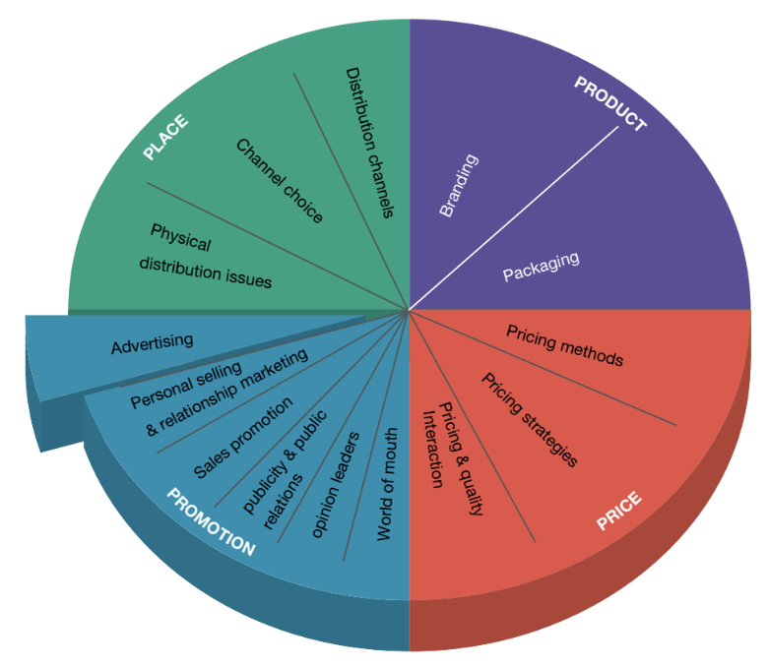  Marketing  Marketing satisfies the needs and wants of customers while benefiting the business.  Four features of marketing:  - Involves a wide range of activities  - Directed at a wide range of goods, services and ideas  - Stresses the importance of satisfying exchanges - transaction should benefit the customer and business  - Marketing is not limited to the activities of businesses  Aims of marketing:  Purpose of marketing will depend on whether a business exists to generate profit or operates as a non-profit organisation:  Strategic role of marketing goods and services  - The strategic role of marketing is to translate the goal of profit maximisation into reality  - To achieve the goal: a marketing plan must be prepared that sets out a series of actions or strategies that can be used to attain greater sales, achieving the strategic goal  Marketing plan  - Customer should be the central focus of the marketing plan  The marketing plan should be the focus of short-term and long-term planning for three reasons:  Steps of the marketing plan:  - Situational Analysis  - Market Research  - Establishing Market Objectives  - Identifying Target Markets  - Developing Marketing Strategies  - Implementation, Monitoring and Controlling
  Marketing | Marketing is a set of interrelated activities to plan, price, promote and distribute products to both current and potential customers.
  Profit-generating businesses | - Goal: generate sales by satisfying the needs and wants of customers to achieve profit maximisation  - Profit maximisation → can better cover costs, increase returns to investors, grow the business  This means:  - Can better cover costs  - Increase returns to investors  - Grows the business  Purposes of marketing for these businesses:  - Achieve competitive advantage  - What sets a business apart and provides it with an edge  - Marketing activities such as: lowering prices can mean customers will be more likely to purchase them  - E.g. McDonalds provides a wide range of products at low prices → competitive advantage  - Increasing market share  - The business’ share of total industry sales for a product  - Maintaining strong customer relationships can be used to increase market share  - Improving brand awareness  - How familiar customers are with an company’s brand or how well they can recognise a brand  - High brand awareness = higher sales → customers prefer trusted brands  - Consumer knowledge can be improved through marketing  - E.g. Apple has high brand awareness
  Non-profit organisations | - Goal: to inform, not to sell  This means:  - Informing people  - Objectives are social, rather than financial  - Increasing awareness of an issue
  Strategic | Refers to long-term based aims affecting all key business areas; the strategic role of each key business function involves the managers of each function contributing to the strategic direction or strategic plan of the business
  Profit maximisation | Occurs when there is a maximum difference between the total revenue coming into the business and total costs being paid out
  Marketing plan | A document that lists activities aimed at achieving particular marketing outcomes in relation to goods or services  - Provides a template for future action aimed at reaching business goals (profit maximisation)
  1 | Marketing plan outlines the strategies to be used to bring the buyer and seller together  Business will need to identify:  - Where the market is  - Who will buy the product  - Why they will buy the product  - How often they will buy the product
  2 | The core of marketing is satisfying existing customer wants → leading to repeat sales
  3 | Marketing is the revenue-generating activity of businesses → nothing achieved until a sale is made
  Business examples | Apple  - In addition to the goal of profit maximisation, the development of brand awareness and customer loyalty are key contributors to the success of Apple
Interdependence with other key business functions | INTERDEPENDENCE WITH OTHER KEY BUSINESS FUNCTIONS  Interdependence  E.g. Marketing must work closely with operations in the design and development of new products.
  Interdependence | The mutual dependence that the key business functions have on one another
  Marketing concept | Business philosophy that states all sections of the business are involved in satisfying in a customer’s needs and wants while achieving the business’s goals
  Business examples | Apple  Operations  - Changes in marketing activities aim to increase the demand for a good, needing to be managed by operations  - When Apple discontinued the unsuccessful iPhone 5c and 5s, Foxconn factories required new process layouts, new components and new quality control systems for new models  - Combines marketing data on consumer preferences with operational knowledge → financial considerations also influence the design and development of new products  Human Resources  - Changes in marketing activities including the launch of a new iPhone give rise to the need for staff training and development (human resource management)  - Ensure that employees in the Genius Bar are capable of repairing and replacing iPhone components  Finance  - Budgets will be allocated by finance to all key business functions to effectively control costs and minimise expenses  Conflict arise between key business functions  Marketing sets deadlines:  - Operations may require more time to test and develop the product  - Pressure on human resources, leading to ineffective practices (inadequate training, excessive hours of overtime)
Production, selling, marketing approaches | PRODUCTION, SELLING, MARKETING APPROACHES  Approaches  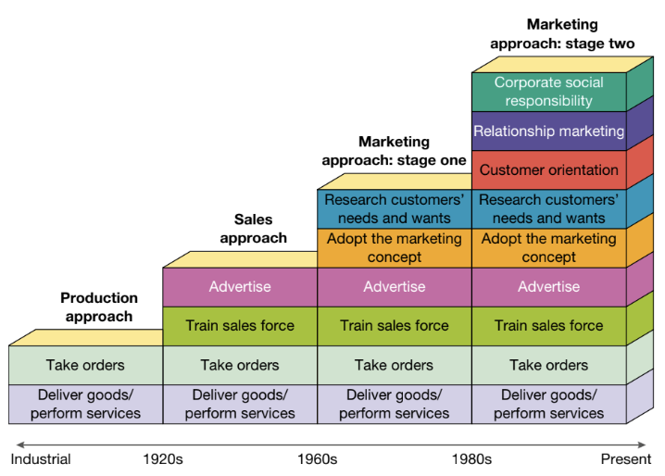
  Production approach  (1820s – 1920s) | Considered marketing as a spin-off of production  ‘If we make it, they will buy it.’  - Describes the attitude of marketing during this approach  - Production design was based more on the demands of mass production techniques than on customer needs and wants  - Business was production-oriented, consisting of taking orders and delivering the products
    Focused on the production of goods and services
  Selling approach  (1920s - 1960s) | Competition between businesses increased due to high-quality, mass-produced products coming to the market  Businesses increased spending on advertising  - Using new electronic communications systems (radio, film)  Businesses faced challenges of persuading customers to buy a specific brand  - Sales representatives were hired and trained  - Salespeople reached thousands of people  - Using high-pressure tactics to convince customers to purchase products  Marketing continued as a secondary role to other functional areas; production, finance.  Most businesses were still neglecting the needs of customers
    Emphasised selling because of increased competition
  Marketing approach  STAGE ONE  (1960s - 1980s) | Began with economic boom after World War II, as businesses began to practise marketing in its current form.  - Australian families used discretionary income to satisfy needs  Method of achieving success changed:  FROM: Focusing on production/pushing goods and services on customers  TO: Placing customers at the centre of all marketing activities  Importance of identifying and satisfying customer needs and wants prior to producing the goods or services  - Businesses would produce what the customers desired  - Customers would then buy the good or service
    Focuses on finding out what customers want, through market research, then satisfying the need
    Discretionary income | Disposable income, available for spending and saving after an individual has purchased the basic necessities (food, shelter, clothing, etc.)
  Marketing approach  STAGE TWO  (1980s - present)
    Changing economic and social conditions over the past 3 decades have seen a modification to the marketing approach.
    Corporate social responsibility (CSR) | Realisation that businesses have a corporate social responsibility  External pressure from customers and environmental organisations and political forces presently influences marketing plans  - E.g. Increase in demand for ecologically sustainable products
    Customer orientation | Businesses with strong customer orientation contribute to success
      Refers to the process of collecting information from customers and basing marketing decisions and practices on customers’ wants and interests
      Customer satisfaction | Measures how goods and services supplied by a business meet or exceed customer expectation
    Relationship marketing | Places high priority on customer retention and continual satisfaction  Core of relationship marketing is customer loyalty  - Generates repeat sales  - Achieved through rewards programs, customer care or good after-sales service
      The development of long-term and cost-effective relationships with individual customers
      Business examples | Coles & Woolworths  - Focus on creating relations with consumers through relationship marketing which is evident in their rewards programs such as ‘Everyday Rewards’  - Rewards provides customers with discounts off future purchases which entices the customers to return in the future  Costco Membership & IKEA Family  - Price discounts entices customers to return to the store and make use of their membership
  Business examples | Apple  Selling approach  - The innovative nature of smartphone design created a selling approach to marketing  - Apple was creating new products with capacities beyond consumer expectations  - They were able to focus on the design and development of technologies, with marketing strategies aimed at educating customers on the features and capabilities of earlier iPhones  Marketing approach  - Smartphones have become more established in the market, thus the focus of marketing iPhones has become persuasive than informative → shift from selling to marketing approach  - Greater focus on market research and marketing products that meets the needs and wants of consumers  - Apple conducts regular surveys of existing iPhone customers, providing valuable information that becomes an input in the production of future models  - Led to changes in iPhone design such as larger screen size, a lighter and thinner phone, longer battery life and improved camera capabilities  - Marketing approach is essential to apple to maintain a competitive position  Ford  Production approach  - Model T Ford was the first motor vehicle to be mass-produced and sold to the mass market and was only available in black
Types of markets  - Resource  - Industrial  - Intermediate  - Consumer  - Mass  - Niche | TYPES OF MARKETS
  Market | A group of individuals, organisations, or both that:  - Need or want products (goods/services)  - Have the money to purchase the product (purchasing power)  - Are willing to spend their money to obtain the product  - Are socially and legally authorised to purchase the product  ‘Market’ refers to the total population or mass market that purchases products.
  Market share | Portion of a market controlled by a particular company or product
  Marketing mix | Combination of factors that can be controlled by a company to influence consumers to purchase its products
  Target market | Group of potential customers that you identify to sell products or services to
  Resource | - Made up of more than 165,000 enterprises or customers  - Has a large purchasing power  E.g. Farmers purchase machinery, seed and fertiliser
    Consists of those individuals or groups that are engaged in all forms of primary production
    - Mining, agriculture, forestry, fishing
  Industrial | - Made up of more than 932,000 businesses (secondary or tertiary)  E.g. Tip Top Bakery buys flour to make bread, Sony buys plastics and metal produce televisions
    Includes industries and businesses that purchase products to use in the production of other products or in their daily operations
  Intermediate | - Made up of more than 187,000 retailers and 61,000 wholesaler intermediaries  E.g. Subway buys goods and makes them into sandwiches and salads for sale to customers
    Consists of wholesalers and retailers who purchase finalised goods and resell them to make a profit
  Consumer | - Do not intend to use the products to make other goods and services  - Each of us is part of numerous consumer markets for products including:  - E.g. Housing, clothing, food, entertainment, appliances, music recordings, cars and personal services  Marketing managers:  - Examine closely the behaviour of consumers to better understand their motivations as an individual to purchase particular products  - Try to influence consumer buying behaviour by developing a mix of marketing strategies
    Consists of individuals (members of a household) who plan to use or consume the products they buy
  Mass | - Assumes customers in the market have similar needs and wants  - Due to greater choice, the mass market has been replaced by segmented or niche markets  E.g. Model T Ford was the first motor vehicle to be mass-produced and sold to the mass market and was only available in black
    The seller mass-produces, mass-distributes and mass-promotes one product to all buyers
  Niche | Market segments  - Mass market is divided into smaller market segments consisting of buyers who have specific needs of lifestyles  - Smaller group of consumers becomes the target market in which marketing efforts are aimed towards  E.g. Rows of magazines are in the newsagent that appeal to specific niche markets (male, female, young, old, high income, low income, urban, rural, outdoor lifestyle, indoor lifestyle, etc.)
    A narrowly selected target market segment
    (Also known as a concentrated or micro market)
  Business examples | Apple  - Operating within the industrial market and mass market segments  Qantas  - Operating with the consumer/mass market
Influences on marketing
Factors influencing customer choice  - Psychological  - Sociocultural  - Economic  - Government | FACTORS INFLUENCING CUSTOMER CHOICE  Businesses try to influence customer choice by modifying their marketing strategies to appeal to the customer’s motives  Influences
  Customer choice (buying behaviour) | The decisions and actions of customers when they search for, evaluate, select and purchase goods and services
  Psychological | Five psychological factors:
    Influences within an individual that affect his or her buying behaviour
    Perception | Marketing managers must create a positive or favourable perception about their product in the mind of the customer  - Customers typically do not purchase products they consider inferior  - The perception customers have of a product is the result of some type of advertising that attempted to create a certain ‘image’ of the product
      The process through which people select, organise and interpret information to create meaning
    Motives | Advertising attempts to motivate the customer to buy the product.  Primary motives:
      An individual’s reason for doing something
      - Comfort  - Health  - Safety  - Ambition  - Taste | - Pleasure  - Fear  - Amusement  - Cleanliness  - Approval of others
    Attitudes | Customer attitudes to a business and its products influence the success or failure of the business’s marketing strategy  - Negative attitudes to a business or its products force the business to change its strategies
      A person’s overall feeling about an object or activity
    Personality | Widespread belief of ‘you are what you buy’  Marketers highlight the image value of their products to make the most of an individual’s desire to express their identity through what they purchase  - Self-image is a major determinant of what products customers purchase
      The collection of all the behaviours and characteristics that make up that person
      Self-image | Relates to how a person views himself or herself
    Learning | Successful marketing strategies assists customers to learn about them and encourages brand loyalty  - Most of customer behaviour is learned  Direct experiences of learning:  E.g. The first time a customer tasted Coca-Cola  Indirect experiences of learning:  E.g. If a customer sees an advertisement for Coca-Cola that shows other people enjoying a new flavour, the customer might assume they would like it too
      Refers to changes in an individual’s behaviour caused by information and experiences
      Brand loyalty | Occurs when a favourable attitude towards a single brand results in repeat sales over time
    Business examples | Apple  - iPhone 5c was released in 5 colours (green, blue, yellow, pink and white), straying from their tradition of only producing black and white iPhones  - Promotional information for the 5s was targeted at consumers with psychological preference for quality, leading technology and innovation  - “Meticulously considered. Precision crafted.”  - iPhone 5s was released in 3 metallic colours (silver, gold and grey), those colours associated with quality and refinement
  Sociocultural | Four sociocultural factors:
    Forces exerted by other people and groups that affect an individual’s buying behaviour
    Social class / socioeconomic status | Social class influences:  - Type of products purchased  - Quality of products purchased  - Quantity of products purchased
      Refers to a person’s relative rank in society, based on his or her education, income or occupation
    Culture | Culture influences buying behaviour because it infiltrates all that we do in our everyday life.  Culture influences:  - What people wear  - What and how they eat  - Where and how they live
      The learned values, beliefs, behaviours and traditions shared by a society
    Family & roles | These roles influence buying behaviours.  E.g. Market research shows women still make purchasing decisions related to healthcare products, food and laundry supply  E.g. Studies show teens greatly influence households, their opinion on purchases is sought by parents in:  - Clothes, shoes, music, books, food and beverages, household goods, travel and spending on family excursions
      The roles occupied within the family and groups within the wider community
    Reference / peer groups | Customer buying behaviour may change to match the rest of the group’s beliefs and attitudes.
      A group of people with whom a person closely identifies, adopting their attitudes, values and beliefs
    Business examples | Apple  - Exploding popularity of social media, online gaming and video streaming in recent decades has led to a strong focus on design features that support these capabilities → social trends  - Marketing of iPhones tends to heavily promote the camera, screen and processing specifications in an attempt to differentiate the product from competitor smartphones
  Economic | - Economic activity fluctuates from boom to recession  - Each of the two distinct phases influences the marketing environment:  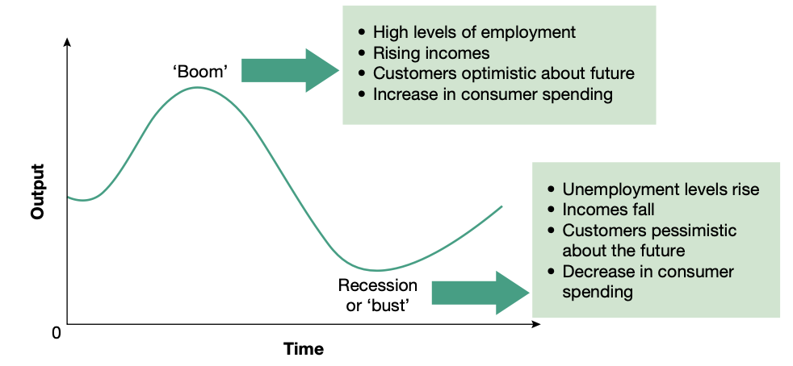  Two phases:
    Economic forces influence a business’s capacity to compete and a customer’s willingness and ability to spend.
    Boom | - Businesses and customers are optimistic about the future  - Businesses increase production lines and attempt to increase their market share by intensifying their promotional efforts  - Customers are willing to spend because they feel secure about their jobs and source of income  - Marketing potential during a boom is large → sales respond to all forms of promotion
      A period of low unemployment and rising incomes.
    Recession | - Customers and businesses lack confidence in the economy  - Customer and business spending reach very low levels due to caution and pessimism  - Customers become more price-conscious  - Customers look for value and products that are functional and long-lasting  - Marketing plans should stress the usefulness and value of a product  - Marketing plans should concentrate on maintaining existing market share
      A period of high unemployment and dramatically falling incomes.
    Business examples | Apple  - During the Global Financial Crisis (GFC) and subsequent years of economic recession, Apple experienced negative growth in iPhone sales in some regions of Europe and the USA  - Led to implementing strategies including developing the ‘low-cost’ iPhone SE in 2016 as well as marketing older and cheaper iPhone models in growth markets including India  - In April 2020, the release of the updated iPhone SE proved timely in the midst of the Covid-19 economic crisis, also releasing a ‘mini’ version of the iPhone in 2020 and 2021 to target price conscious customers affected by the Covid economic downturn
  Government | - Government put in place policies that expand or contract the level of economic activity, depending on the prevailing economic conditions  - Policies directly or indirectly influence business activity and customers’ spending habits, therefore influencing the marketing plan  Regulatory forces influence business behaviour and consist of:  - Laws (statutes)  - Regulatory bodies  Regulatory forces exert a significant influence over the marketing activities of businesses because the breaking of these laws or regulations may result in financial penalties.  Laws that influence marketing decisions:  - Competition and Consumer act 2010 (Cwlth)  - (Formerly Trade Practices Act 1974)  - Sale of Goods Act 1923 (NSW)  - Fair Trading Act 1987 (NSW)
    Use a number of economic policy measures to influence the level of economic activity
    Business examples | Apple  China  - In 2014, the launch of the iPhone 6 and 6 Plus was delayed for Chinese customers due to government concerns regarding Apple devices  - Issues surrounded privacy and accessibility of third parties to iPhone customer accounts (such as iCloud and location tracking features) were subject to Chinese government inquiries  - China is the largest and fastest growing market for smartphones in the world, the influence of Chinese government policy has far-reaching implications for Apple’s competitive position  India  - India has eased its regulations around tariffs, logistics and infrastructure, allowing Apple to open an Apple Online store in 2020  - Further growth in India may be achieved following the launch of a $6.6 billion incentive program by the Indian government, aimed at boosting local smartphone manufacturing  Russia  - In 2017, Russia’s antimonopoly agency found Apple guilty of forcing retailers to coordinate over prices of iPhones  - The Federal Antimonopoly Service (FAS) said Apple’s local subsidiary told 16 retailers in Russia to fix the prices of iphone 5 and 6 models  - Apple could face a fine of up to 15% of its Russian sales
Consumer laws  - Deceptive and misleading advertising  - Price discrimination  - Implied conditions  - Warranties | CONSUMER LAWS  Federal and state Governments introduce laws to improve the protection and rights of consumers and to clarify rights and responsibilities of businesses.  Laws  Misleading practices illegal under the Competition and Consumer Act
  The Australian Consumer Law | The Australian Consumer Law (ACL) was introduced in 2011 to replace 17 existing national, state and territory laws.  - Applies to Australian consumers and businesses regardless of where the business operates or where consumers shop  Australian Consumer Law:  - Mirror protections in the ASIC Act enforced by ASIC  - Enforced by the ACCC as a law of the Commonwealth  - Applied by the Competition and Consumer Act 2010 as a law of the Commonwealth  - Implemented by the Competition and Consumer Act 2010  - Enforced by the state and territory consumer agencies as state and territory laws  - Applied by each state and territory’s application Act as a law of each state and territory  Businesses may need to introduce alternative advertising promotion, repackaging of a product or a change in the credit policy for customers to adhere to Australian Consumer Law.
  Competition and Consumer Act 2010 (CCA)  Formerly the Trade Practices Act 1974 (Cwlth) | PURPOSES:  CCA applies to all businesses in Australia (inc. commercial activities of the government).  CCA IS ENFORCED BY:  - Australian Competition and Consumer Commission (ACCC)  - Each state and territory’s consumer agency  - The Australian Securities and Investments Commission (ASIC) in respect of financial services  BREACH OF THE ACT:  Results in ACCC taking civil or criminal proceedings against the business or individual concerned  CCA allows courts to impose penalties for unconscionable conduct and other breaches  - of up to $1.1 million for companies  - of up to $220,000 for individuals  Consumers can also sue the business for compensation.  ACCC has the power to issue on-the-spot infringement notices (fine) to manufacturers making false claims about their products.  ACCC can (without having to undertake court action):  - Fine a company up to $12,600 (or $126,000 for a listed corporation)  - Fine an individual up to $2520 for each infringement of the CCA  ACCC can issue ‘public warning notices’ to warn consumers of suspected illegal activity.  Businesses must ensure they are up to date with current laws and apply them to all marketing practices.
    1 | To protect consumers against undesirable purchases such as:  - Misrepresenting the contents of products  - Misrepresenting place of production  - Misleading and deceptive advertising
    2 | To regulate certain trade practices that restrict competition  - The government ensures a number of businesses are operating at any one time in the same market to encourage competition
    Unconscionable conduct | Any practice by a business that is not reasonable and often illegal
    Consumer guarantees | Basic rights that consumers have.  Consumers have the right to:  - Repair  - Replacement  - Refund  - Compensation for damages and losses  - Cancellation of faulty service  When you buy goods, the seller guarantees that:  - Goods will be of acceptable quality  - Goods will be fit for a particular purpose  - Goods will match their description  When you buy services, the provider guarantees that:  - They will provide the services with due care and skill  - The services will be fit for a particular purpose  - The services will be provided within a reasonable time
  Deceptive and misleading advertising | Due to the influential nature of advertisements, false or misleading advertising is the most serious unfair trading practice.  Methods of deceptive and misleading advertising:  Two most common deceptive and misleading advertising techniques:
    Fine print | Important conditions are written in a small-sized print; difficult to read
    Before and after advertisements | Consumers mislead when comparison is distorted so that ‘before’ images are worsened and ‘after’ images enhanced
    Tests and surveys | Advertisements make unsubstantiated claims, ‘9 out of 10 people’ prefer a product when no survey has been conducted
    Country of origin | Accuracy in labelling is important; ‘made in Australia’, ‘product of Australia’
    Packaging | Size and shape of the package may give a misleading impression of its contents
    Special offer | If advertisements imply that a special offer is available for only a limited period, when it is actually continuously available
    Greenwashing | Lying about the eco-friendliness of products
    Bait and switch advertising | Involves advertising a few products at a reduced price, therefore, enticing prices to attract consumers. When the advertised products quickly run out, customers are directed to higher priced items
    Dishonest advertising | An advertisement uses words that are deceptive or claims that a product has some specific quality when it does not  - Price reduction, specials or free-gift offers must be genuine
    Business examples | Apple  - In 2015, a class action was filed against Apple by more than 100 iPhone 4 users in the United States who claimed the company was intentionally rendering their phones unusable via iOS upgrades  - Apple encouraged users to upgrade iOS to improve battery life and processing speeds when they knew it would do the opposite  - In 2016, structural problems were presented with the screens of iPhone 6 Plus devices which could freeze and become unresponsive  - Apple announced it would repair the affected devices for a service fee of US$228.95  McDonald’s  Labelling  - Must comply with with labelling requirements of the Australia New Zealand Food Standards Code  - Bound by state and territory laws including Food Act 2003 (NSW) and Food Regulation Act 2015 (NSW)  - Mandatory for businesses to label the kilojoule intake for each food item  Advertising  - Consumer Protection Act in Quebec, Canada forbids advertising to children under 13  - Timed the release of new Happy Meal toys to coincide with popular film releases and directly targeting children by displaying its toys in store at “eye level” for children  Aldi  Bait and switch advertising  - Special buys → Aldi stocks special buys in short supply to attract customers into the store  Nurofen  - Selling various types of pain relief medication at different prices, although they all contained the same ingredient and thus were not specific to each type of pain  Virgin and Jetstar  - Advertised airfares displayed on their websites were false or misleading, drawing customers in and then disclosing the additional fees and charges that would apply
  Price discrimination | Prohibited price discrimination  Competition and Consumer Act prohibits price discrimination if the discrimination could substantially reduce competition.  - The prohibition applies to discounts given, credits, rebates, services and payment arrangements  - A business cannot give favoured treatment to some customers while denying it to others  Permitted price discrimination  Price discrimination is legal in some circumstances, if:  - Differences exist in the cost of getting the product to different markets; geographically separated (e.g. city and country prices)  - If there is product differentiation within one market (e.g. electricity prices for domestic and business users)  Rationale behind price discrimination  Price discrimination is a firm’s attempt to capture the difference between the value a consumer puts on a product and how much they actually play  - Achieved by charging different prices to different consumers and exploiting differences in willingness to pay (WTP)  - Objective is to exploit the different WTP between consumers and thereby increase profits  - Consumers differ in incomes and other circumstances, this presenting an opportunity that firms may exploit through price discrimination
    The setting of different prices for a product in separate markets
    Willingness to pay (WTP) | The maximum amount a consumer would pay for a particular product or service
    Business examples | Apple  - Apple must sell iPhones at the same price to all customers in Australia  - This does not prevent other retailers of iPhone from determining their own price for the same product  Other examples  - Movie ticket prices differ between adults and children  - Car dealers negotiate and sell for different prices  - Airlines discriminate based on the time the booking is made, type of seat and route flown
  Implied conditions | Australian Consumer Law states:  When you buy products and services they come with automatic guarantees that they:  - will work AND  - do what you asked for  if you buy something that isn’t right, you have consumer rights.  Competition and Consumer Act 2010:  New national consumer guarantees were introduced which replaced the previous statutory implied conditions and warranties of the Trade Practices Act.  Consumer guarantees provide consumers with rights to certain remedies from retailers and manufacturers where goods purchased fail to comply with the consumer guarantee provisions in the ACL.
    The unspoken or unwritten terms of a contract.
    - Conditions that are assumed to exist regardless of whether they are written
    Consumer guarantees | Basic rights that consumers have.  Consumers have the right to:  - Repair  - Replacement  - Refund  - Compensation for damages and losses  - Cancellation of faulty service  When you buy goods, the seller guarantees that:  - Goods will be of acceptable quality  - Goods will be fit for a particular purpose  - Goods will match their description  When you buy services, the provider guarantees that:  - They will provide the services with due care and skill  - The services will be fit for a particular purpose  - The services will be provided within a reasonable time
    Business examples | Apple  - Implied conditions in the sale and marketing of iPhones include:  - The smartphones are fit for purpose  - They correspond with their description  - Apple will make available spare parts, repairs, and comply with express warranties
  Warranties | - Businesses have obligations designed to offer a degree of protection to the customer if the good is faulty or the service is not carried out with due care and skill  - Warranties are used as a marketing tool:  - Businesses that give longer warranties than competitors entice customers  - Warranties give the impression that the good is of superior quality  - Government legislation makes it necessary for businesses to state, clearly and simply, the terms and conditions of the warranty  - False or misleading statements concerning the existence, exclusion or certain conditions of the warranty are prohibited under the Competition and Consumer Act.  - Legislation outlines the rights of consumers with regard to refunds and exchanges  Refunds and exchanges (returns)  Required by law to offer a refund:  - If the products provided are faulty  - Do not match the description or a sample  - Fail to do the job they were intended for  No obligation to offer a refund if:  - The customer has changed their mind  - Found the same product at a cheaper price in another store  - Damage has occurred after the purchase was made  The Competition and Consumer Act gives consumers certain rights and remedies.  Accurate signage must be displayed:  “no refunds or exchanges unless your purchase is defective” instead of  “no refunds on sale items” which is meaningless
    A promise made by a business that they will correct any defects in the goods they produce or services they deliver.
    Business examples | Apple  - Must be compliant with ACL and other Australian laws and regulations  - Apple’s iPhone (1 year) warranty states that:  “Customers are entitled to a replacement or refund for a major failure and for compensation for any other reasonably foreseeable loss or damage… to have the goods repaired or replaced if the goods fail to be of acceptable quality… Repair of the goods may result in loss of data”
Ethical  - Truth  - Accuracy and good taste in advertising  - Products that may damage health  - Engaging in fair competition  - Sugging | ETHICAL  Ethical behaviour exceeds legal requirements.  Australian Association of National Advertisers' Code of Ethics  Consumers can report advertisements they feel breach the code to the Advertising Standards Bureau (ASB) who then investigate the claim and request advertisers to remove the advertisement if it is found to breach the code.  - ASB administers a national system of advertising self-regulation  - Businesses must self-regulate their ethical behaviour  Ethical criticisms of marketing  Dishonest or unethical marketing strategies eventually drive customers away  Ethical issues
  Importance of ethical behaviour:  Leads to marketing and business opportunities:  - Positive publicity  - Customer loyalty  - Higher sales/profits  - Strong employee relations  - Attracts investors | Importance of government regulation:  - Protects consumers and businesses  - Encourages competition and fair trade  - Promotes an equal playing field  - Positive societal impact  - Increases consumer trust and confidence in businesses
  Creation of needs – materialism | Businesses use sophisticated and powerful promotional strategies to persuade and manipulate customers to buy whatever the firm wants to sell
    Materialism | An individual’s desire to constantly acquire possessions
  Stereotypical images of males and females | In advertisements:  - Males tends to user power tools, watches sport  - Females are preparing meals, cleaning the house of caring for children
  Use of sex to sell products | - Unrealistic images are portrayed as attainable  - Use of ‘sex appeal’ to suggest to consumers that the product will increase the attractiveness or charm of the user  - Can have subtle and persuasive impacts
  Product placement | - Enables businesses to reach savvy, but advertisement-weary consumers  - Insertion of products is subtle  - E.g. Apple laptop when a computer is used, Apple Watch on celebrity’s arm
    Product placement | The inclusion of advertising in entertainment
  Invasion of privacy | - Online advertising tracking web users and using information to target advertisements at them  - Websites infer consent to their web services being tracked unless a person opts out  - Behavioural data is collected and resold by data exchange companies
  Truth and accuracy in advertising | Businesses must ensure advertising is truthful, clear and undeceiving; they can be held morally and socially responsible for misleading the public through using untruths.  Unethical marketing practices:
    Concealed facts | - Advertisements are not perceived to be believable or honest; customers are aware that advertising takes liberties with ‘truth’  - Can severely harm consumer trust in a product or business
      Information purposefully excluded from an advertisement
    Vague statements | ‘Weasel words’ deliberately misleading or ambiguous language  - Vague words that allow the marketer to deny any intention to mislead or deceive
      Statements so unclear that the consumer will not understand what is being communicated.
      - The consumer will assume the intended message
    Exaggerated claims  Known as ‘puffery’ | - Cannot be proved
      Claims that most reasonable people would not perceive as factual, but nonetheless are still misleading
    Advertising | A paid, non-personal message communicated through a mass medium
  Good taste in advertising | ‘Good taste’ is highly subjective  - Marketers must ensure that advertising is sensitive to beliefs and values of all people  - Some consumers regard advertisements as offensive, whilst others view it as inoffensive  Growing role that mass media is playing in children’s lives leading to advertisers and marketers targeting children.  - Premature sexualisation of children can result in:  - Increased risk of depression  - Self-esteem and identity disorders  - Premature sexual activity
  Products that may damage health | Businesses must be aware of government regulations and societal outlooks related to advertising potentially harmful products.
    Example | Advertising junk food to children  - Criticised by nutritionists and health advocates as childhood obesity rates approach epidemic proportions  - Nutritionists argue that self-regulatory advertising codes are not working:  - Responsible Children’s Marketing Initiative  - Australian Quick Service Restaurant Industry Initiative for Responsible Advertising and Marketing to Children  - Only advertisements screened during designated children’s programs or ‘designed for children’ are covered by the code of nutritional guidelines  - Does not cover television programs popular with children  - Federal government sets restrictions of children’s advertising – no advertising is allowed during programs for preschool children  - Smartphone apps and social-networking sites (Facebook, Bebo, Twitter, MySpace) provide marketers with new and largely unregulated ways of advertising junk food to children
  Engaging in fair competition | - Businesses should be fair when referring to their competitors in marketing and advertisements should not insult or make false assertions towards their competitors  - Competition and Consumer Act 2010 requires businesses to compete fairly and contains provisions relating to fair competition.  - Part IV of the Act aims to deter certain anti-competitive behaviour that limits or prevents competition.  - Predatory pricing → setting extremely low prices to undercut competitors  Examples of prohibited anti-competitive conduct:
    A competitive environment provides consumers with the choice of price and quality of goods and services.
    Cartel conduct | - Designed to increase the profits of the cartel members while putting other companies out of business  - It is illegal for competitors to agree to fix, control or maintain prices
      When businesses agree to act together rather than compete with each other
    Anti- competitive agreement | Contracts or arrangements containing provisions that substantially lessen competition in a market are prohibited
    Misuse of market power | Prohibits corporations who have a substantial degree of market power from taking advantage of that market power for the purpose of:  - Damaging a competitor  - Preventing a business from entering the market
    Exclusive dealing | When one person or business trades with another and then imposes restrictions on them
    Resale price maintenance | - Suppliers can recommend that resellers charge a certain price for particular products; however, they cannot stop resellers from charing below that price  - Illegal for suppliers to pressure other businesses to charge their recommended retail price or stop them from selling goods or services below a specified price
    Mergers | - Most mergers are legal and very beneficial  - Prohibited if it can be demonstrated that they have the effect of substantially lessening competition in a market
  Sugging | - Not illegal but raises ethical issues including invasion of privacy and deception  - Intentionally misrepresents the purpose of an activity to generate sales leads  Effects:  - Reduces trust customers place in businesses  - Less people willing to participate in actual market research
    Selling under the guise of a survey; sales technique disguised as market research
    - When you’re surveyed about a particular product only to discover the person was really trying to sell something
  Business examples | Apple  Product placement  - Increasing presence of product placement in movies and music videos  - Ethical concerns around subtle nature of product placement, particularly when aimed at children  - Apple’s product placement include movies Transformers 4, Birdman, The Verge, Birdman and Boyhood, as well as prominent TV shows such as Saturday Night Live and The Daily Show  E-waste  - Apple aggressively markets each new model of iPhone, attempting to convince consumers of the need to upgrade or switch brands  - Contributes to high levels of consumerism and environmental issues of e-waste  Damaging to health - microwave radiation  - World Health Organisation (WHO) in 2011, ranked mobile phone radiation alongside lead and DDT  - Findings found potential implications for reproductive health, hearing, memory, sleep and various neurological disturbances associated with mobile phone radiation  - Belgium – Since 2016, it has been illegal to give a mobile phone to a child aged 7 years or younger  - France – Wi-Fi is banned in nursery schools and must be turned off in elementary schools when not in use
Marketing process
Situational analysis  - SWOT  - Product life cycle | 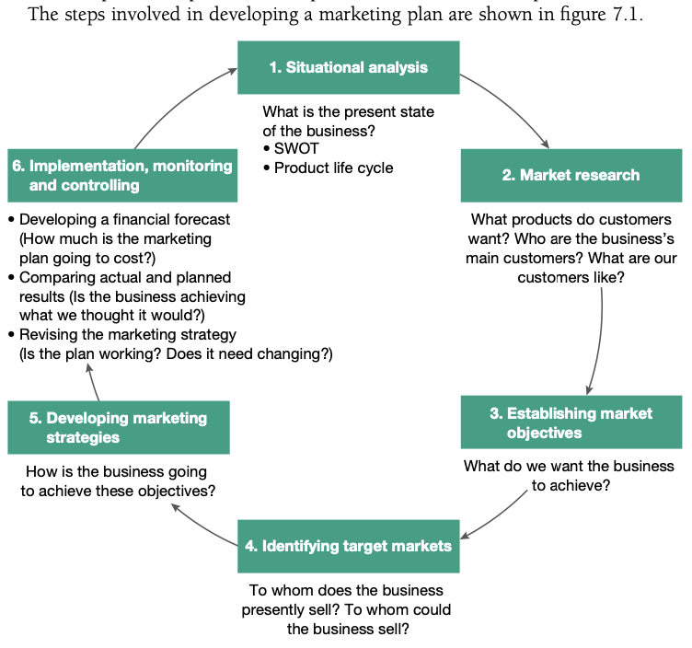  SITUATIONAL ANALYSIS  Steps in developing a marketing plan: SMEIDI  SWOT analysis  Product life cycle (PLC)
  SMEIDI | Situational analysis  Market research  Establishing marketing objectives  Identifying target markets  Developing marketing strategies  Implementation, monitoring and controlling
  Integrated marketing plan | - Everyone in the business must know the plan to work toward the goal  - Marketing plan needs to ‘mesh’ with the business’s operational plan, financial plan and human resources plan
  SWOT analysis  – Strengths  – Weaknesses  – Opportunities  – Threats | SWOT analysis is used by the business to develop a clear understanding of both the internal and external environments.  - Internal forces are unique to each business are within the control of the business  - Management can assess the strengths and weaknesses of the business through analysing them  - Provides the information needed to complete the situational analysis  - Gives a clear indication of the business’s position compared with its competitors  - Once the SWOT analysis has been conducted, an assessment of the product’s position on the product life cycle should be carried out.  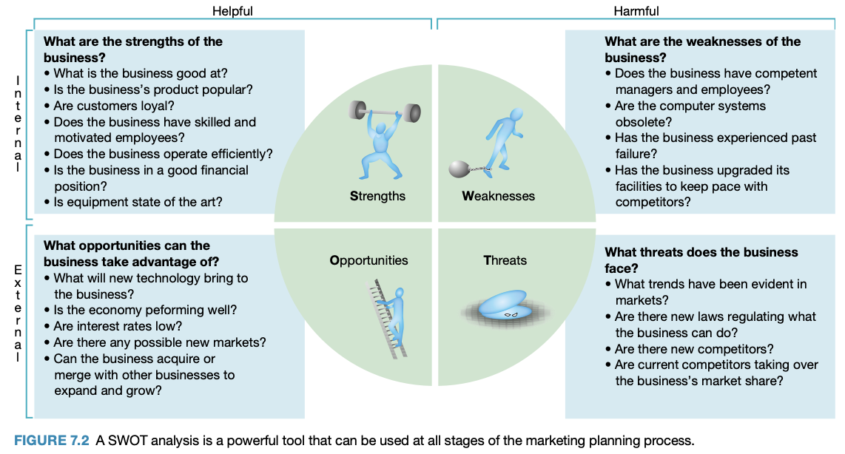
    Involves the identification and analysis of the internal strengths and weaknesses of the business, and the opportunities in, and threats from, the external environment
    Business examples | Apple  Strengths  - Strong global brand and customer loyalty  - Whole ecosystem (integration of apple products such as iPhone, iPod, Macs, Watch)  - Own operating system (iOS)  - Apple is considered an industry leader in supply chain management  - Apps and App Store  Weaknesses  - High price relative to competitors, particularly in the Asian market  - Over-dependence on the iPhone, which has experienced declining market share  - Incompatibility with different operating system (OS)  - High R&D costs associated with technological innovation  - Expensive accessories need to be upgraded with some new models  Opportunities  - Design and development of new products that differentiate Apple from its competitors and create a competitive advantage  - Expansion of Apple Pay in the international market; compatible with iPhone, Apple Watch and iPad  - Supply chain management strategies that reduce variable costs (expense controls) as well as improve inventory management  Threats  - Increased competition, particularly from Asian manufacturers (particularly Oppo and Xiaomi)  - Global shortages of semiconductor chips may impact on future sales and profitability  - Covid-related supply chain bottlenecks and other disruptions to sourcing and distribution  - Rising pay levels and greater regulation of labour and the environment in China may lead to higher costs in producing the iPhone  - An appreciation of the US dollar may affect demand for iPhones in overseas countries  McDonald’s  Strengths  - Diversified income stream  - Technology  - Large market share / scale  - High quality standards and product specifications  - A highly detailed growth plan  - Extensive access to capital  - Goodwill / global brand  - Largely uniform menu with some geographic variations  Weaknesses  - Lack of central control over daily operations of franchised restaurants  - Perception of unhealthiness  - Operating in multiple jurisdictions  Opportunities  - Innovation and differentiation of the McDonald’s experience  - Reinvest in restaurants  - Drive improvements to achieve optimal capacity  - Anticipate and respond to changing consumer preferences  - Utilise digital media advertising  - Improve social and environmental performance / reputation  - New products  Threats  - Covid-19 (ongoing)  - Negative publicity  - Increased governmental environmental protection  - Interruptions in supply chain  - Food safety breaches  - Competition from Burger King Worldwide Inc, Domino’s Inc, Yum! Brands, Inc., Starbucks Corporation, Wendy’s Company  - Increasing wage costs  - Trade union action and industrial disputes  - Extreme weather conditions, natural disasters, terrorism, war and social unrest  - Increasing legal complexity and litigation
  Product life cycle (PLC) | - Consists of the stages a product passes through: introduction, growth, maturity and decline  - Businesses must be able to launch, modify and delete products in response to changes in the product life cycle  - Failure to do so will result in declining sales and reduced profits  - Helps reframe renewal marketing strategies  Marketing strategies relevant to the different stages of the product life cycle:  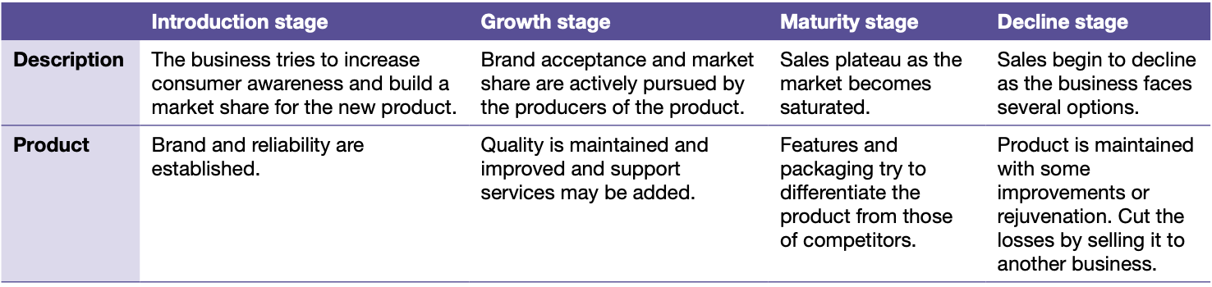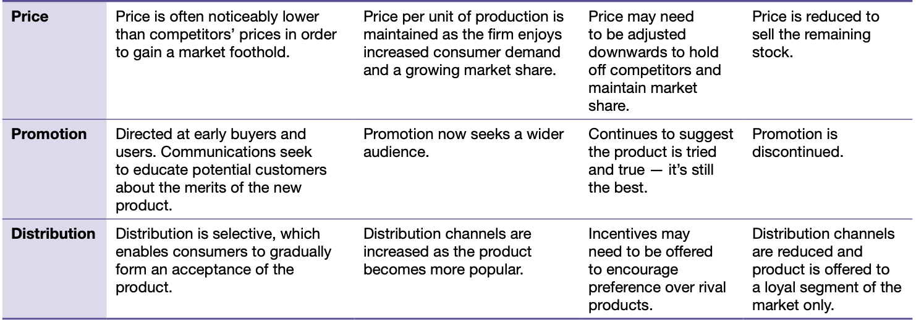  Why do products decline?  Various reasons include:  - Changing public perception of what is fashionable  - New technologies are constantly being introduced, replacing old products  - New products reduce demand for older ones  - Fluctuations in the level of economic activity constantly result in shifts in customer spending habits  - Currently, consumer behaviour is dramatically changing as a result of the need to reduce carbon emissions and greenhouse gases to prevent devastating climate change
    Product analysis examines the current position of the goods and/or services that a business produces in the marketplace.
    Business examples | McDonald’s  Introduction  - French fries replaced packets of potato chips at McDonald’s in the 1940s  Growth  - From the 1940’s to 1990, as McDonald’s rapidly expanded across the US, and then internationally, french fries became a menu favourite and grew in popularity  Maturity  - In 1990, Phil Sokolof campaigned against McDonald’s, claiming that the oil used to prepare french fries, which included beef tallow, was high in saturated fat and a danger to health. Under this pressure, McDonald’s changed the recipe for cooking the french fries, eliminating beef tallow.  - Change was met with resistance from customers who favoured the previous taste; McDonald’s shares fell in price on the New York Stock Exchange  Post Maturity/Renewal  - McDonald’s made slight changes to the recipe over the years in a bid to reduce saturated fat content and make the fries healthier.  - To stay relevant and ensure consistent sales, it adopted a renewal strategy of innovation and extension.  - McDonald’s has “extended” the base product (fries) to create new variations worldwide (some of which are only available for limited campaigns) – including “Loaded fries”, “Twisted fries”, “Chicken salt fries” and “Cheesy Bacon Fries.”
Market research | MARKET RESEARCH  Information must be based on accurate, up-to-date, detailed and relevant information  Steps of market research
  The process of systematically collecting, recording and analysing information.
  1 | Determine information needs | - Problem is clearly and accurately stated to determine what needs to be measured and the issues involved  - Information collected must be relevant to the issue of the problem being investigated  - Weigh up the costs of collecting information against the benefits it provides  Information is useful if:  - Results in marketing strategies that meet the needs of the business’s target market  - Assists the business to achieve its marketing objectives  - May be used to increase sales and profits
  2 | Collect the data from primary and secondary sources | - Researchers know the facts that are needed and those that are already available
    Marketing data | The information (facts/figures) relevant to the defined marketing problem
    Primary source | E.g. surveys, focus groups  - Time consuming and expensive  - Common for businesses to outsource this  Advantage: collection is directed at solving a specific marketing problem  Main function: to determine what the customer is thinking  Methods of gathering primary data:
      Facts and figures collected from original sources for the purpose of the specific research problem
      Survey method | Gathering data by asking or interviewing people.  - Personal interviews  - Focus groups  - Electronic methods of collection (internet, mail)  - Questionnaires  Benefit: Gathers first-hand information that provides details of customers’ opinions.  Challenge: Respondent rates are declining, thus leading to companies using electronic collection methods.
      Observation method | Involves recording the behaviour of customers.  - Personal observation (researcher poses a customer in a store)  - Electronic observation (camera, counting machine, checkout scanner analysing purchase patterns)  Ethical concerns of observation: relating to privacy  - Actions of customers are systematically observed  Advantage: Increasing in popularity, development of computerised technology allows a business to access its loyalty program, customer spending habits and customer databases all at once through using smart cards and barcoding. Highly accurate method.  Disadvantage: Main limitation is it only explains what happens.
      Experiment method | Involves gathering data by altering factors under tightly controlled conditions to evaluate cause and effect.  - To determine whether changing one of the factors will alter the behaviour of what is being studied → test marketing
    Secondary source | - Information has been collected for another purpose. E.g:  - Census data  - Household expenditure surveys  - Private organisations  - Research reports  - Australian Bureau of Statistics (ABS)  Types of secondary data:
      Information already collected by some other person or organisation
      Internal data | Information that has already been collected from inside the business  E.g. customer feedback, sales, management reports, research reports
      External data | Published data from outside the business  E.g. reports by Australian Bureau of Statistics (ABS)
  3 | Analyse and interpret the data | Facts need to be analysed and interpreted to determine what they mean  Statistical interpretation analysis:  - Analysing and interpreting the data  - Drawing conclusions from the information  - Use of spreadsheet or tabulation  - Cross-tabulation enables comparisons between individual categories
    Statistical interpretation analysis | The process of focusing on the data that represents average, typical or deviations from typical patterns
  Business examples | Apple  - Apple feedback surveys have been an especially useful way for Apple to gather primary research  - Apple emails surveys to customers following a purchase  - Customers are asked to rate satisfaction level and their likelihood of purchasing again  - Surveys reveal what drives people in each country to purchase iPhone, what features they use, customer demographics and level of satisfaction with different aspects of the iPhone  - Sales data and market share updates provide valuable insights to marketers of the iPhone  McDonald’s  - McDonald’s uses both qualitative and quantitative research to determine the needs of its customers  - Traditionally conducted market research using surveys and questionnaires, including sales data  - McDonald’s says one of the purposes of both apps and the website is “to obtain opinions or comments about products and/or services and to conduct other market research and development” (McDonald’s Privacy Policy)  - McDonald’s app enables real-time market information about what items are selling, at what time, where and to whom  - Helps them decide on the most popular products and what can be learned about individual customer preference that allows a more targeted and individualised marketing approach
Establishing market objectives | ESTABLISHING MARKET OBJECTIVES  Objectives can be measured and should include specific targets to be met  Key marketing objectives
  Marketing objectives are the realistic and measurable goals to be achieved through the marketing plan.
  Increasing the market share | - Businesses develop extensive market ranges using different brand names to gain market share  - Increasing market share is particularly Important for businesses that dominate the market → small market gains translate into large profits
    Market share | The business’s share of the total industry sales for a particular product.
  Expanding the product range/mix | - Businesses are keen to expand their product mix to increase profits in long term  - Same product mix will not remain effective for long because customers’ tastes and preferences change over time and demand for particular products may decrease  - Businesses must understand customer needs to develop an ideal product range  - Each item in a product line should attempt to satisfy the needs of different target markets
    Product mix | The total range of products offered by a business.
  Maximising customer service | - High levels of customer service → improved customer satisfaction, positive reaction from customers towards the products they purchase  - Establishes a sound customer base with possibility of repeat purchases  - Business must talk and listen to customers to keep existing customers and attract new ones  - Customer service is an attitude that should be adopted by everyone within the business  Strategies to maximise customer service:  - Asking customers what they want  - Training employees and rewarding them for excellent customer service  - Anticipating market trends by conducting research  - Determining what competitors are offering and then reviewing the product mix  - Establishing and maintaining long-term relationships with customers  - Encouraging employees to focus their attention on the customer’s needs (customer-oriented) and not just on making sales (sales-oriented)
    Customer service | How well a business meets and exceeds the expectations of customers in all aspects of its operations.
  Sales revenue
    Sales revenue | The income a business generates from the sale of goods or services.
  Profit maximisation
    Profit maximisation | The process businesses undergo to ensure the best output and price levels are achieved in order to maximise returns.
  Business examples | Apple  - Marketing objectives that may be set by Apple in marketing iPhones:  - Increase market share in India by 2% in the next 12 months by offering discounts on older models of iPhone and payment by monthly instalments for the latest versions of iPhone  - Increase global retail sales by 5% in the next quarter by establishing Apple stores in India  McDonald’s  - Launched a new marketing plan in October 2020, outlined as:  - “Raising our marketing ambition is about elevating our focus. Moving beyond brand engagement - when customers feel a personal connection and eat McDonald’s – to brand advocacy – when people feel really good about visiting McDonald’s. So good, in fact they encourage others to join them.”
Identifying target markets | IDENTIFYING TARGET MARKETS  - Customers within the target market share similar characteristics such as age, income, lifestyle, location and spending patterns  Why identify and select a target market?  - To direct marketing strategies towards that group of customers  - Allows the business to satisfy the wants and needs of the targeted group  - Occurs because the business is able to:  - Use its marketing resources more efficiently → leads to cost effective and time efficient marketing campaigns  - Promotion material is more relevant to customers’ needs → more likely to be noticed  - Better understand the consumer buying behaviour of the targeted market  - Collect data more effectively and make comparisons within the target market over time  - Refine marketing strategies used to influence customer choice  Three approaches to identifying and selecting a consumer target market:
  Target market | A group of present and potential customers to which a business intends to sell its product.
  Primary target market | The market segment at which most of the marketing resources are directed
  Secondary target market | Usually a smaller and less important market segment
  80/20 principle | Where 80% of sales comes from 20% of a business’s customer base
  Mass marketing approach | - Seller mass-produces, mass-distributes and mass-promotes one product to all buyers  - Seeks a large range of customers  - Assumes individuals in the target market have similar needs  - Business develops a single marketing mix, directing it at the entire market for the product  - One type of product is no variation  - One promotional program aimed at everyone  - One price  - One distribution system to reach all customers
    Seeks a large range of customers
  Market segmentation approach | - Business selects one segment to become the target market  - Segmenting enables a business to design a marketing plan that meets the needs of a relatively uniform group  Types of market segmentation:  - Demographic segmentation  - Geographic segmentation  - Psychographic segmentation  - Behavioural segmentation
    Occurs when the total market is subdivided into groups of people who share one or more common characteristics
  Niche market approach | - Businesses market to a narrow, specific customer base  - Needs of customers in these markets are often neglected by large businesses because it is rarely profitable for them to alter their marketing mix to cater for very small groups
    A narrowly selected target market segment; a segment within a segment, a ‘micro-market’
  Business examples | Apple  - Apple uses multiple strategies to target different segments of the global market for smartphones  - Executives → advertisements in business newspapers and magazines  - Teenagers → product placement and celebrity endorsement in music videos, movies, TV shows  - Young children → product placement in movies and TV shows  - Mass market → billboards, website, social media, digital and print media, TV commercials, Shot on iPhone campaign  McDonald’s  - Has multiple target markets  - “Aims to be a friendly, fun environment for everyone” - McDonald’s website  - McDonald’s still segments current and potential customers by characteristics including offering different products in different countries - geographic and cultural segmentation  - Shifting from mass marketing to mass personalisation
Developing market strategies | DEVELOPING MARKET STRATEGIES  - Aim is to develop marketing strategies to achieve the marketing objectives.  - Occurs once the following have been undertaken and completed:  - Situational analysis  - Market research  - Marketing objectives  - Target market  Products (goods/services)  - Business must determine features including product’s quality, packaging/labelling, design, brand name and guarantee  - Customers purchase products to satisfy needs and wants and for intangible benefits – security, prestige, satisfaction, influence  Price  - Must consider selecting the appropriate amount of money a customer is prepared to offer in exchange for a product  - Must consider competitors pricing, costs of production and level of consumer demand  - Price refers to the price itself and the method or strategy the business uses to decide its prices  Promotion  - Details methods to be used by a business to inform, persuade and remind customers about its products  - Main forms include advertising, personal selling, relationship marketing, sales promotion, publicity and public relations  - Information and Communication Technology (ICT) significantly impact how businesses promote their products – internet  Place/distribution  - Deals with the channels of distribution – the ways of getting the product to the customer  - Number of intermediaries chosen determine how widely the product will be distributed – intermediaries include the wholesaler and retailer  - Businesses may choose to restrict products to specialised outlets (e.g. Louis Vuitton) or be as widely distributed as possible (e.g. Coca-Cola)
  Marketing strategies | Actions undertaken to achieve the business’s marketing objectives through the marketing mix
  Marketing mix | Refers to the combination of the four elements of marketing, the four Ps – product, price, promotion and place – that make up the marketing strategy
  Business examples | Apple  - In 2022, Apple’s product mix and related marketing strategy for the iPhone consists of 4 positions in most developed economies:  - iPhone 14 Pro → launched September 2022  - iPhone 14 → launched September 2022  - iPhone 13 → launched September 2021  - iPhone SE → launched updated model in March 2022  McDonald’s  - Under the 2020 Accelerating the Arches growth plan, McDonald’s aims to:  - Maximise the marketing with the aim of encouraging brand advocacy  - Commit to the core - a renewed focus on chicken, burgers and coffee  - Double down on the 3 D’s (Digital, delivery and Drive-Thru) with a focus on how customers transact with the company
Implementation, monitoring and controlling  - Developing a financial forecast  - Comparing actual and planned results  - Revising the marketing strategy | IMPLEMENTATION, MONITORING AND CONTROLLING  The marketing plan starts to become relevant to a business only when it is implemented.  Developing a financial forecast  Requires two main steps:  - Cost estimate → cost based on market research, product development, promotion (advertising/packaging) and distribution  - Revenue estimate → how much revenue (sales) the marketing plan is expected to generate  Forecasting revenues helps with two major components:  - How much consumers are expected to purchase, for what price  - What sales staff predict they will sell  - Actual revenue compared with forecast revenue data to determine the effectiveness of the marketing strategy  Comparing actual and planned results  Three KPIs used to measure the success of the Marketing Plan:  Revising the marketing strategy
  Implementation | - Involves daily, weekly and monthly decisions to ensure the plan remains effective  - Unforeseen situations may arise and jeopardise the success of the entire marketing plan  Implementing a marketing plan effectively requires questions to be answered:  - Is the plan fully integrated with all other sections of the business?  - How should the business be structured and organised?  - Have effective lines of communication been established between the marketing department and all other departments?  - Who are the best people for the various tasks needed to implement the plan?  - Are the marketing personnel motivated and focused on achieving the marketing objectives?  - Are all other employees familiar with the marketing objectives and marketing strategies?
    The process of putting the marketing strategies into operation
  Monitoring | - Requires information to be gathered and to report any important changes, problems or opportunities that arise during the life of the marketing plan
    Process of measuring actual performance (through checking and observing) against the planned performance
  Controlling | Need to answer two questions:  - What does the business want the marketing plan to achieve; that is, what are the objectives?  - Are these objectives being achieved?  Controlling process includes:  - Establish KPIs  - Compare/evaluate actual performance against KPIs, budget, sales, statistics and costs analysis against projected KPI for that period → evaluate the effectiveness of a marketing plan
    Involves the comparison of planned performance against actual performance and taking corrective action to ensure the objectives are attained
    ESTABLISH MARKETING OBJECTIVES → MONITOR PERFORMANCE → TAKE CORRECTIVE ACTION → EVALUATE PERFORMANCE
  Details costs and revenues for each strategies based on measuring potential sales and revenue forecasts
  Financial forecast | Business’s predictions about the future
  1 | Sales analysis | Calculate difference: $Actual sales – Sales quota$  Calculate % change: $\frac{Difference}{Sales quota}×100$  Types of sales analysis:  Importance of sales analysis:  - Opportunities extend reach of the product  - Product mix  - Customer analysis  - Decision making  - Uses the sales data to evaluate a business’ current performance based on the effectiveness of a marketing strategy  - Used to measure the % of change due to the impact of the marketing strategy  Advantage: Sales figures are relatively inexpensive to collect and process  Weakness: Data for sales revenue do not reveal the exact profit level, information can only be gleaned from further investigations of total expenditure
    The comparing of actual sales with forecast sales to determine the effectiveness of the marketing strategy
    Descriptive analysis | Process of using current and historical data to identify trends and relationships – identifies what already occurred
    Predictive analysis | Use of data, statistical algorithms and machine learning techniques to identify the likelihood of future outcomes based on historical data – identifies what could occur
  2 | Market share analysis | - Evaluates marketing strategies as compared with those of its competitors  - Evaluation reveals whether changes in total sales (increase/decrease) have been due to some uncontrollable external factor
  3 | Marketing profitability analysis | - By comparing costs of specific marketing activities with the results achieved, effectiveness of each activity is determined  - Evaluation helps in deciding how to best allocate marketing resources in the future
    A method in which the business breaks down the total marketing costs into specific marketing activities
  Changes in the marketing mix | Changes that could be introduced:
    Product modifications | Continually upgrade products to maintain competitive advantage
    Price modifications | Revised in response to changes in the external business environment
    Promotional modifications | Promotion costs high when new product released, costs lower in later stages of the product’s life cycle
    Place modifications | Distribution channels expand to cater for growing market; overseas markets, electronic communications (internet)
  New product development | Typically, products have a lifespan between 5 to 10 years.  Continually introduce new products → maintain competitive advantage and long-term growth
  Product deletion | The elimination of some lines of products  - Outdated products → unfavourable image, negativity  - Decision must be made to delete or redevelop the product
  Business examples | Apple  - Apple must monitor sales data for the iPhone to identify market saturation  - Apple may require a new model of iPhone to be launched identifying new distribution channels to increase sales and market share  McDonald’s  - Monitoring the results of all aspects of the marketing plan with real-time data collected through their mobile app  - McDonald’s makes use of AI platforms to process the large quantity of data and produce meaningful reports for management  - After analysing the data, changes are made on a regular basis (controlling)
Marketing strategies
Market segmentation, product/service differentiation and positioning | MARKET SEGMENTATION, PRODUCT/SERVICE DIFFERENTIATION AND POSITIONING  - One strategy for the whole market won’t effectively meet specific wants and needs of customers
  Market segmentation | Process  - The business divides the entire market into different segments  - They analyse which segment is most attractive by comparing market size or level of competition  - They choose their target market and tailor their marketing strategies to them → more effective  Aim  - Boost market share, sales and profits by better understanding the needs of the target market  - Promotion will be more effective  - Products will better meet customer needs  - Price points will be more suitable
    When the total market is divided into subgroups of people who share one or more common characteristics
    Demographic segmentation | Dividing the market by personal features  - Personal features can be easily identified and measured  - Deeply impacts consumer spending  E.g. age, gender, income, education, occupation, social class, religion, ethnicity, family size
    Geographic segmentation | Dividing based on geographical location  - People in different locations have different needs and preferences  E.g. regions, climate, rural vs urban living, city/country size, landforms, population
    Psychographic segmentation | Dividing by psychological factors  - Difficult to measure, so it’s combined with other forms of segmentation  - All about why people behave the way they do  - Market research to determine customer values, likes, dislikes and hobbies  E.g. lifestyle, motives, personality, socioeconomic factors, consumer opinions
    Behavioural segmentation | Dividing by a customer’s relationship with the product  - Determining what customers want from the product  - Helps marketers design products that satisfy these preferences  E.g. purchase occasion, price sensitivity, product knowledge, product attitudes, benefit expectations, loyalty
    Business examples | Apple  Demographic segmentation  - High price of iPhones targeted to higher income customers in developed countries  - Low-cost models (iPhone SE) targets developing countries  - Apple India customise advertisements for iPhone to focus on the ritual of a Hindu wedding  Geographic segmentation  - Larger screen size of iPhones preferred by Asian smartphone users  - 2022 updated iPhone SE largely designed to target the high growth markets of China and India  - Highest demand and growth for smartphones recently is in the Asia Pacific region, particularly China and India  Psychographic segmentation  - iPhone users more concerned about viewing their iPhone as a status object  - iPhone users less concerned with owning devices that are preferred by most people  - iPhone users showing lower levels of honesty and humility but higher levels of emotionality  - iPhone users more extroverted than Android users  Behavioural segmentation  - Network carriers segment customers according to level of usage  McDonald’s  Demographic segmentation  - Age → Happy Meals targeted at young children, McCafé targeted at older customers  - Race/Ethnicity → Campaigns directed at different groups including Black, Hispanic and Asian consumers  - Religion → Provision of Halal and Kosher foods in certain locations. In India, no beef or pork products are sold due to prevailing Hindu belief. Fillet-o-Fish created in 1962 to cater for Catholic consumers who could not eat meat on Fridays  - Family size → McDonald’s Australia offers several Family Boxes  Psychographic segmentation  - To cater for health conscious consumers, McDonald’s expanded the range and availability of salad items  Behavioural segmentation  - Needs-based → Differentiating based off people who may be on a business trip and need a quick fill, or people who may come with their family on Saturday  Geographic segmentation  - McDonald’s adds or alters menu items to suit local tastes
  Product / service differentiation | Points of differentiation
    The process of developing and promoting differences between the business’s products or services and those of its competitors
    Customer service | Market research shows that consumers:  - Desire personalised service  - Tailored to individual needs  - Require caring service  - Courteous and efficient  - Want high quality and value  - Establish favourable conditions for service (fair prices, high-quality products)  Consumers expect a high level of customer service  Achievable through: presentation of the premises, atmosphere, range of products
    Environmental concerns | Businesses should promote a ‘green’ philosophy and produce environmentally friendly products to see sales increase.
    Convenience | Consumers are busy and often select products that are convenient to use.
    Social and ethical issues | Growing consumer ethical mindedness; purchasing products or brands that they believe do not exploit workers, producers or the environment.  Ethical consumerism  Involves buying products that are not harmful to the environment, animals and society.  - E.g. In response to the dislike of genetically modified (GM) foods by some consumers, various producers label their products as GM-free  - E.g. The Fair Trade movement gained influence with consumers increasingly prepared to pay more for guarantees of fair labour practices and sustainable, organic products. The FAIRTRADE Mark represents an independent certification system, assuring fair labour practices to consumers
    Value for money | Desire to obtain the best quality, features and performance for a given price of a product
    Business examples | Apple  - Apple differentiates through design, innovation and quality - permits them to charge a premium price (price skimming)  - Quality of features gives Apple a leading edge  - Apple differentiates psychologically more than physically  McDonald’s  - Informal eating outlet market contains approximately 10 million restaurants, thus process of differentiation has been an important focus for McDonald’s  - One strategy McDonald’s has utilised to differentiate itself from other food outlets, is its speed of service
  Positioning | Positioning: Occurs in the minds of the target market – how potential buyers perceive the product.  - Image gives the product its position within the market  - Using marketing mix to shape and maintain the image the business decides for its product / service  - Name, price, packaging, styling, promotion, channels of distribution  Repositioning  Changing what customers associate with the brand and sometimes competing brands.  Reasons for repositioning include:  - Changing market conditions  - Decline in sales  - Desire to focus on a new target market  - New competition  - Overcome negative customer perceptions of the brand
    Refers to the technique in which marketers try to create an image or identity for a product compared with the image of competing products
    Business examples | Apple  - Apple began relocating the production of some models to India in 2017, opening its Online Apple store in 2020 to better position iPhones  - Apple struggles to develop effective marketing strategies to compete with the key Asian smartphone manufacturers  McDonald’s  - McDonald’s phased out the Super-Sized option from its menu, providing customers with healthier food options  - McDonalds tries to change public opinion and ensure its brand remains current and relevant to consumers  - McDonald’s stated that it wants to be seen as a value option for as many consumers as possible and a good corporate citizen
Products - goods and/or services  - Branding  - Packaging | PRODUCTS – GOODS AND/OR SERVICES
  Product | A good or service offered to the market for exchange with the aim of satisfying a need or want  - Tangible → physical objects that can be owned (goods)  - Intangible → cannot be touched or owned (services can only be experienced)
  Total product concept | Refers to the tangible and intangible benefits (attributes) a product possesses.
  Branding | Benefits of branding  Branding strategies
    Brand | A name, term, symbol or design (or combination of these) that identifies a specific product and distinguishes it from its competition
    Brand name | That part of the brand that can be spoken
    Trademark | Signifies that the brand name or symbol is registered and the business has exclusive right of use (© ® ™)
    Brand symbol / logo | A graphic representation that identifies a business or product
    Consumers | Branding helps consumers:  - Identification – Identify the specific products that they like  - Evaluation – Evaluate the quality of products  - Reduce their level of perceived risk of purchase  - Gain a psychological reward that comes from purchasing a brand that symbolises status and prestige
    Businesses | Branding helps businesses:  - Gain repeat sales because consumers recognise the business’s products  - Familiarity – Introduce new products onto the market because consumers are already familiar with the business’s existing brands  - Differentiation – With their promotional activities because the promotion of one product indirectly promotes other similarly branded products  - Brand loyalty – Encourages customer loyalty. Added benefit of being able to charge a higher price for the product
    Manufacturer’s brand / national brand | Owned by a manufacturer  - Owned by the manufacturer and is widely recognised and available
    Private / house brand | Owned by a retailer or wholesaler  - Owned by retailers or wholesalers and typically sold at a lower price because their products are cheaper to produce
    Generic brands | Have no brand name  - Products don’t have a brand name, only the product name and usually sold in plain packaging
  Packaging | Functions of packaging  - Protection → protects products during transportation and in preservation  - Attention → attracts consumer attention through displaying the product  - Convenience → creates extra convenience for transporting, storing and using products  - Communication → achieved through labelling and colour  Labelling  Provides information about:  - Ingredients  - Operating procedures  - Shelf life  - Package size  - Country of origin  - Laws and government regulations enforce information that must be truthful and included in labelling for certain products  - Regulations protect consumers from misleading or deceptive claims and unsafe use of products  - Make it easier for consumers to compare products
    Packaging | Involves the development of a container and the graphic design for a product
    Labelling | Presentation of information on a product or its package
    Label | Part of the package that contains information
  Business examples | Apple  - Customers trust Apple products as they know they will last a few years  McDonald’s  - McDonald’s management found that burgers, chicken and coffee made 70% of sales across McDonald’s top 6 markets  Branding  - McDonald’s arches are more recognisable than the Christian cross  - Highlights the effectiveness of their global campaigns to build brand awareness  - McDonald’s has many trademarks including logos, words, phrases, designs and letters  Packaging  - Protects the burgers  - Used to reinforce information that the company wants consumers to know  - Promotes consistent brand design  - Helps with operations because crews can easily identify the correct package to use for the correct item
Price including pricing methods - cost, market, competition-based  - Pricing strategies  - Skimming  - Penetration  - Loss leaders  - Price points  - Price and quality interaction | PRICE INCLUDING PRICING METHODS – COST, MARKET, COMPETITION-BASED  Has to be consistent with how much money a customer is willing to spend on it.  Importance for customers – price is an indicator of value  Importance for businesses – allows businesses to generate revenue and make a profit  Pricing methods  Pricing strategies  Factors influencing price  - The marketing objective  - The life cycle of the product  - The market for the product  - The degree of product differentiation (unique/innovative)  - The level of economic activity  Price & quality interaction  Products that are higher in quality are sold for higher prices.  - Higher quality products require higher costs  Price and quality form part of the product’s image.  - Low price, cheap  - Prestigious, higher quality
  The amount of money a business charges for a product.
  Cost | $Price=Cost+(Cost×Mark–up percentage)$  Advantages:  Good starting point to make a profit  - Guarantees a profit  - Simple to use  Disadvantages:  - Difficult to determine mark-up percentage (doesn’t consider location of product):  - Price too high leads to overpriced and unsold  - Price too low results in lost profit  - Product is priced after production and associated costs are incurred without taking into account the other elements of the marketing mix or the state of the market
    Business determines cost of the production or purchasing and then adds a mark-up.
    Mark-up | Predetermined amount (%) that a business adds to the cost of a product to determine its basic price
  Market | Supply: quantity of products that businesses will sell at a particular price  - More supply than demand → prices fall  Demand: quantity of products that customers will buy at a particular price  - More demand than supply → prices rise  Advantage: Effective as it takes advantage of what’s occurring in the market to maximise profits  Disadvantage: Level of supply and demand fluctuates, making it hard to apply
    Prices are set according to the level of supply and demand in the market.
    Supply | The quantity of a product businesses are willing to offer for sale at a particular price
    Demand | The quantity of a product consumers are willing to purchase at a particular price
    Surplus | When the supply of a product is greater than its demand
  Competition-  based | Options:  Below competitors → used to break into new market  Equal to competitors → (safest) following the price set by the price leader  Above competitors → business create superior image to appeal to status-conscious buyers
    Prices are set to cover production and operating costs, and are comparable with competitors.
    Price leader | A major business in an industry whose pricing decisions heavily influence the pricing decisions of its competitors – guides the rest of the industry
  Bundle pricing | Where customers gain a ‘package’ of goods and services in addition to the tangible good they purchased
  Skimming | Used if a product is unique or prestigious.  Advantages:  - Allows for testing and feedback to be acquired  - Recovers costs of research and development early  - Improves brand image of the business  - Slow rise in Market Share for the business  Disadvantage: More difficult to raise prices significantly than to lower them
    Businesses charge the highest possible price for a product in its introduction stage, eventually lowering the price.
    Business example | Apple  - Apple use price skimming because of their innovative technology; people are willing to purchase their products regardless of the price
  Penetration | - Encourages customers to try before they buy, because they can purchase the product at a lower price than normal.  - Discourages competitors from entering the market due to a large number of products being sold at the introductory stage.  Advantages:  - Can build a large market share early in a competitive market  - Can discourage competitors from entering the market  - Businesses can increase their prices when the product is more established  Disadvantages:  - If the price is too lower, it’s harder to cover costs and make a profit  - It can be difficult to increase prices as customers are so use to them
    Businesses charge the lowest possible price for a product or service with the aim of achieving a large market share.
  Loss leaders | Psychological approach of loss leaders  - Customers will typically purchase other items within the store in addition to what attracted them.  - Loss leader attracts customers to the store in hope they’ll also buy other products.  - The business makes up for the loss from the loss leader by selling its other high-priced items.  Advantages:  - Used when a product is overstocked or difficult to sell  - Increasing traffic flow in expectation of gaining new customers  - Building a reputation of high-value, low-price  Disadvantage: Can lose money if done incorrectly
    Businesses deliberately sell their products at or below their cost so they don’t profit from the products.
  Price points | Business chooses a few key price points for each product line.  Based on the idea that customers form psychological associations with products at different price points.  Advantage:  - Easier for the customer to find the type of product they need  - Easier for the business to encourage the customer to ‘trade up’ the next price point
    (Price lining) Products are sold at predetermined prices.
  Prestige / premium pricing | Pricing strategy where a high price is charged to give the product an aura of quality and status
  Business examples | Apple  - Price skimming used when new iPhone is released, positioning it as a leading edge, quality product  - Older model price is reduced when new model is released to align with the latest Samsung model (competition-based pricing)  - Competition-based pricing adopted for low cost and older models  - Bundling plans offered by network providers allows customers to pay for their phone over a two-year period  - Buy-back program and discounted prices on older models in Asia  McDonald’s  Loss leaders  - McDonald’s Australia introduced the Loose Change Menu, using a loss-leader pricing strategy to undercut competitors and attract customers who may purchase both a cheap and expensive item  Price points  - Customers can select and modify menu items to accommodate varying levels of affordability, consistent with having multiple target markets  - McDonald’s is able to appeal to a wider pool of potential customers through offering different price points  Price bundling  - McValue Meals and Family Boxes are examples of price bundling, representing a 14% saving over purchasing each component items individually
Promotion  - Elements of the promotion mix  - Advertising  - Personal selling  - Relationship marketing  - Sales promotion  - Publicity  - Public relations  - The communication process  - Opinion leaders  - Word of mouth | PROMOTION  Elements of the promotion mix  The communication process  Customers are more willing to purchase a product if the message is communicated through a respected and trusted channel, such as an opinion leader or by word of mouth. Clear, effective and succinct communication is essential to maintain sales.  Importance of promotional strategy mix  It is important to maintain a mix of promotional strategies as each element has different benefits to cater to the needs of everyone in their target market.  - Aim of promotion is to satisfy and attract as many potential customers as possible  - Components should be coordinated and complement each other to help achieve the marketing objectives
  Promotion mix | Various promotion methods a business uses in its promotional campaign, including:  - Advertising  - Personal selling and relationship marketing  - Sales promotions  - Publicity and public relations
  Advertising | A paid, non-personal message communicated through a mass medium  Purpose: information, persuade, remind  Advantage: provides businesses with the flexibility to reach an extremely large audience or to focus on a small, distinct target market segment
    Advertising media | Six main advertising media:  The type of advertising media selected depends on:  - Type of product and its positioning  - Size of the target market and its characteristics  - Business’s marketing budget  - Cost of the advertising medium  - Product’s position on the product life cycle
      Refers to the many forms of communication used to reach an audience
      Mass marketing | Television, radio, newspapers, magazines
      Direct marketing catalogues | Catalogues mailed to individual households
      Telemarketing | Use of the telephone to personally contact a customer
      E-marketing | Use of internet to deliver advertising messages
      Social media advertising | Online advertising using social media platforms
      Billboards | Large signs placed at strategic locations
  Personal selling | Involves the activities of a sales representative directed to a customer in an attempt to make a sale  Advantages:  - Messages can be modified to suit the individual customer’s circumstances  - Individual assistance to a customer creates a long-term relationship resulting in repeat sales  - Sales consultant can provide after-sales customer service in relation to product features, installation, warranties and servicing
  Relationship marketing | The development of long-term and cost-effective relationships with individual customers  Aim: To create customer loyalty by meeting the needs of customers on an individual basis  - Offers a competitive advantage
    Loyalty program | Rewards-based program offered by a business to customers who frequently make purchases  - Offer rewards to customers who spend specified amounts or make repeat purchases
  Sales promotion | The use of activities or materials as direct inducements to customers  Aims:  - Entice new customers  - Encourage trial purchase of a new product  - Increase sales to existing customers and repeat purchases  - Increase the effectiveness of other promotion activities  Special promotions:  - Coupons → offer discounts of a stated amount on particular items at the time of purchase  - Premiums → a gift that a business offers the customer in return for using the product  - Refunds → part of the purchase is given back to those customers who send in a voucher with a specific proof of purchase  - Samples → free item or container of a product  - Point-of-purchase displays → special designs, displays and racks supplied and by the manufacturer in retail outlets
  Publicity | Any free news story about a business’s products  Aims:  - Enhance the image of a product  - Raise awareness of a product  - Highlight the business’s favourable features  - Help reduce any negative image that may have been created
  Public relations | Activities aimed at creating and maintaining favourable relations between a business and its customers  - Exposes a business or idea to an audience by using often unpaid third parties as outlets  Ways public relations activities can assist a business in achieving its objective of increased sales:  - Promoting a positive image → reinforcing favourable attitudes and perceptions consumers have regarding the business’s reputation  - Effective communication of messages → using advertising, sales promotion, publicity and personal selling to convey information about the business and its products  - Issues monitoring → protecting sales by providing an early warning of public trends that could affect the business’s sales; action can be taken before damage is done to sales  - Crisis management → protecting a business’s reputation as a result of negative or unfavourable rumours and adverse publicity; if unchecked could result in a loss of sales
  Channel | Any method used for carrying a message  - E.g. Print and electronic media advertising
  Noise | Any interference or distraction that affects any or all stages in the communication process  - E.g. Faulty printing, competing messages, inappropriate language or images, jargon, misinterpretations or people having conversations during commercial breaks
  Opinion leaders | Opinion leaders’ opinions are respected and sought out for advice.  Businesses use celebrity endorsement as part of marketing strategies.  - Ambassadors have a large social media following, being powerful so that the company gains instant followers and engagement
    A person who influences others
  Word of mouth | Consumers trust word-of-mouth more than business-sponsored commercials, particularly if the message is communicated by a friend or opinion leader. People place trust in someone they know.  - Social media platforms are used to engage in a form of word-of-mouth communication  - Friend recommendations are powerful especially when there are many competing products
    Word-of-mouth communication occurs when people influence each other during conversations
  Business examples | Apple  - Use of media to create highly publicised event of new product launches  - TV and mass media advertising focuses on innovation, quality and design features of iPhone as well as being connected with others through FaceTime  - Shot on iPhone campaign  - Celebrity endorsement in advertisements and product launches (rock band U2 and actor Samuel L. Jackson)  McDonald’s  Advertising  - Uses TV, radio, billboards, social media, sponsors teams and whole sport leagues and competitions  - McDonald’s adopts a regional approach to advertising, different countries have different advertisements to target different target markets  Relationship marketing  - Use of McDonald’s app to collect data and provides tools that enable relationship marketing and loyalty through rewards  Publicity  - McDonald’s has been subject to bad publicity from Super Size Me, “McLibel” case, the China meat scandal, the TV series McMillion$  Sales promotion  - In 2021, McDonald’s launched a major sales promotion with K-pop band BTS in 50 different markets worldwide through creating the BTS Meal
Place/distribution  - Distribution channels  - Channel choice  - Intensive  - Selective  - Exclusive  - Physical distribution issues  - Transport  - Warehousing  - Inventory | PLACE/DISTRIBUTION  Activities that make the products available to customers when and where they want to purchase them.  Distribution channels/Marketing channels  Routes taken to get the product from the factory to the customer.  Channel choice  Physical distribution issues
  Traditional distribution channels
    Producer to customer | Simplest channel, involving no intermediaries.  - Virtually all services use this method.
    Producer to retailer to customer | Retailer is an intermediary who buys from producers and resells to customers.  - Channel is often used for bulky or perishable products
    Producer to wholesaler to retailer to customer | Wholesaler is an intermediary who buys in bulk from the producer then resells in smaller quantities to retailers.  - Most common method used for distribution of consumer goods
    Producer to agent to wholesaler to retailer to customer | An agent distributes products to wholesalers but never owns the product. Agents are paid a commission by the producer.  - Agents are used for inexpensive, frequently used products  - Business that does not have any sales representatives use an agent instead
  Innovative distribution methods - non-store retailing
    Non-store retailing | Retailing activity conducted away from the traditional store
    E-commerce | Buying and selling of goods and services via the internet  - Rapidly gaining in popularity  - Convenient for ‘time poor’ consumers
    Mobile commerce (m-commerce) | Buying and selling goods and services via wireless handheld devices  - Rapidly growing proportion  - Achieved through devices like smartphones and tablets
  Market coverage | Number of outlets a firm chooses for its product
  Intensive | - Customers can purchase the product at local outlets  - Convenience goods are distributed this way (milk, lollies, newspapers)
    Occurs when a business wishes to saturate the market with its product
  Selective | - Customer is prepared to travel and seek out a specific retail outlet that stocks a certain brand  - Clothing, furniture, electrical appliances are distributed this way
    Involves using only a moderate proportion of all possible outlets.
  Exclusive | - Commonly used for exclusive, expensive products
    The use of only one retail outlet for a product in a large geographic area
  Physical distribution | All activities concerned with the efficient movement of the products from producer to the customer
  Transport | - Intricate network of transportation required to deliver vast array of products  - Method of transportation depends on the product and degree of service the business wishes to provide. Four most common methods:  - Rail, road, sea, air
  Warehousing | - Set of activities in receiving storing and dispatching goods  - Acts as a central organising point for the efficient delivery of products
  Inventory | - Businesses implement an inventory control system to manage stock levels  - Goal of inventory is to find the correct balance  Too much inventory → high storage costs  Too little inventory → lost sales (‘stock-out costs’)
    Inventory control | System that maintains quantities and varieties of products appropriate for the target market
  Business examples | Apple  - Distribution of iPhones by online sales, Apple stores, mobile carriers and retail mobile stores  - 30% of Apple sales are made through direct distribution channels  - 70& of Apple sales are through indirect channels (network carriers/other retailers)  - Sales to educational institutions and government are secured using direct selling  - Apple has plans to further develop technology that eliminates the need for network providers  McDonald’s  Distribution channels  - McDonald’s employs producer → retailer → customer distribution channel  Channel choice  - Uses a selective distribution channel with over 39,000 restaurants globally  - Encouraging use of delivery and Drive-Thru channels
People, processes and physical evidence | PEOPLE, PROCESSES AND PHYSICAL EVIDENCE  Apply especially to intangible products (services).  Connects the marketing function closer to human resource management and operations, illustrating interdependence.
  People | - Businesses must use appropriately recruited, qualified and trained employees  - Businesses must develop a culture of customer focus and put it into practice  Interaction between employees and people can determine the success of any marketing campaign
    Refers to the quality of interaction between the customer and those within the business who deliver the service
  Processes | - Processes must be highly efficient to achieve customer satisfaction  - Businesses must ensure that their processes and procedures are customer friendly and satisfy customer needs  Inefficient processes will lose customers and damage its reputation
    Refers to the flow of activities that a business will follow in its delivery of a service
  Physical evidence | - Customers buy services on trust and make judgements about the business based on the physical evidence  - Business should provide high-quality physical evidence to create an image of value and excellence
    Refers to the environment in which the service will be delivered
    - Also includes the location of where the service is being provided and the materials needed to carry out the service such as signage, brochures, business cards, business logo and website
  Business examples | Apple  People  - Strong focus on sales and customer service  - Job titles like “Genius” and “Specialists” to raise employee status  - In-store, online and phone support for after sales, repairs, complaints, warranties  Processes  - Online ordering system  - Free upgrades of iOS for existing customers  - Pre-ordering available prior to new product launches  - Roaming payment system in Apple stores so customers don’t need to wait at a check out  Physical evidence  - Apple store designed to reflect innovation and quality  - Encourage a hands-on approach, allowing customers to test Apple products  - Elaborate building entrances for most stores positioned in prime city locations
E-marketing | E-MARKETING  Technology provides a faster, more efficient way of business and is effective in attracting new customers.  E-marketing technologies  Social media advertising (SMA)  Advantages of SMA:  - Inexpensive in comparison to traditional advertising methods  - Easy to use and monitor  - Effective method to gain exposure  - Enables businesses to constantly build relationships with customers  - More engaging and inclusive  - Possible for marketers to accurately measure the reach and frequency of SMA  - Reach → the number of people exposed to a message  - Frequency → the average number of times someone is exposed to the message  Disadvantage: Marketers do not have complete control over what online consumers write about the business.  Concerns with SMA:  - Privacy  - Accuracy  - Honesty  - Customer trust  - Legal issues → establishing age limits for users, proliferation of fake and unofficial ‘fan pages’
  E-marketing (electronic marketing) | The practice of using the internet to perform marketing activities
  Web pages | - Conveys information in the form of text, graphics, animation, video (TGAV)  - Well-designed home page is powerful for marketing  - Home page links to other pages within the website that provide detailed information about the location of the business premises
  Podcasts | - Directed at users who subscribe to a particular podcasting service and receive regular updates  - Business’ primary use of podcasts is for marketing and advertising  - If a podcast is aimed at the same audience as the target customers of a business, podcast advertising can be a very effective way of reaching the customers
    Involves the distribution of digital audio or video files over the internet
  SMS | - Delivered automatically to one or more recipients without the need to dial or log on  - Text messages are used to:  - Alert regular customers of any special deals on offer  - Notify suppliers of the arrival of a goods shipment
  Blogs | Enables the possibility to add comments, ask questions, provide feedback, share opinions.  External blogs  Business can setup external blogs allowing for communication between the business and its existing and potential customers  - Used to announce new products, changes in trading hours, gather feedback and comments from stakeholders  Advantages:  - Allows the business owner and employees to establish a reputation for expertise, providing detailed information on products and services  - New ideas for products and services can be put to the public to gain comment and feedback  - Informal nature of a blog presents a human face to the public and builds trust with customers
    Online journal that can be added to by readers
  Web 2.0 | Development of:  - Social networking sites  - Twitter, Facebook  - Video sharing sites  - YouTube  - Information sharing sites  - Wikipedia  Networking sites provide a powerful public relations tool  - Key benefit → low cost.  - Content can be viewed by existing and potential customers  - Networking sites accept paid advertising that links to the site’s search engine, so it can be used for social media advertising
    Refers to the transformation of the world wide web into a more creative and interactive platform for information sharing, rather than just a means of retrieving information.
  Location-based marketing | - Enables adapting and delivering targeted marketing messages  - Brands can tap into daily habits and encourage customers with relevant offers and messages
    The ability for mobile devices to track and report a person’s location enabled businesses to tailor marketing messages based on location.
  Social media advertising (SMA) | A form of online advertising using social media platforms to deliver targeted commercial messages to potential customers
  Business examples | Apple  Use of e-marketing has influenced the marketing mix in ways including:  Product  - Websites provide detailed information on products and its specifications  - FAQs and technical specifications can be available online, reducing expenses of customer service in stores or printing physical brochures  Price  - Internet provides greater price transparency, allowing comparison with competitor prices  - Increased profit margins through selling online  Place  - Websites provide a platform for a global market, without costs of physical stores  - Websites can be tailored for different languages and cultural preferences  - Negatives: Customers may wish to view a product before purchasing or may not trust the security of online shopping  Promotion  - Provides images, audio, video clips and detailed information promotion on its website  - Online advertisements used on social media, online business journals, newspapers, search engines, leading retail websites  - Product placement has been adapted for content in streaming services
Global marketing  - Global branding  - Standardisation  - Customisation  - Global pricing  - Competitive positioning | GLOBAL MARKETING  Adapting the marketing plan to suit overseas markets.  Globalisation’s effect on marketing management  - Standardised vs customised approach → TNCs adopt a standardised approach to global marketing strategy, others choose a customised strategy to take into account differences in culture, religion and tastes of countries  - Uncertainty and risk → Uncertainty and increased risk in developing global marketing strategies due to most businesses viewing overseas markets as different to domestic markets  - Market research → Global marketing relies heavily on market research to understand complexities of the global marketing environment  - Requires knowledge about: price, type of packaging, distribution channel, product characteristics requiring modification, information about the country’s economic, political, social and cultural features
  Transnational corporation (TNC) | Any business that has production facilities in two or more countries and that operates on a worldwide scale
  Global branding | Advantages:  - Cost effective because one advertisement can be used in many locations; standardisation  - Provides a uniform worldwide image  - Successful brand name can be linked to new products being introduced  Disadvantages:  - Any inconsistency in global branding standards can impact global brand image  Global branding equates to global recognition, irrespective of the language barrier.
    Worldwide use of a name, term, symbol or logo to identify the seller’s products
  Standardisation | If standardisation is used, the marketing mix will be the same in all markets.  Advantages:  - Cost savings  - Production runs are longer, thus achieving economies of scale  - Reduced research and development costs  - Spare parts and after-sales service is simplified  - Promotion strategies can be standardised  - Any evaluation and modification of the plan is much simpler  E.g. electrical equipment, mobile phones, soft drinks, music, cosmetics, movies, fast foods
    Global marketing strategy that assumes the way the product is used and the needs it satisfies are the same globally.
  Customisation / local approach | If customisation is used, the marketing mix will need to be modified or a new one developed.  - Requires the marketing plan to be customised according to the economic, political and sociocultural characteristics of the target country.
    Global marketing strategy that assumes the way the product is used and the needs it satisfies are different between countries.
  Global pricing | Major determinant of profits.
    How businesses coordinate their pricing policy across different countries
    International pricing drivers
    EXTERNAL | BOTH | INTERNAL
    - Currency  - Tariffs  - Quotas  - Exchange systems | - Taxes  - Laws  - Competition  - Consumers | - Costs  - Capacity  - Export assistance  - Export/global aims
    Customised pricing | Common use of cost-plus method to cover added costs of exploration  - Costs include: transportation, taxes, warehousing, tariffs
      Customised pricing | Occurs whenever consumers in different countries are charged different prices for the same product
      Tariff | A tax on an imported product
    Market-customised pricing | - Allows for more flexibility  - Allows marketers to vary the price depending on the level of demand and competition within the overseas market  - Competitive market → lower price  - Monopoly market → higher price  - Price charged in other countries is influenced by foreign currency exchange rates  - Fluctuations in exchange rate can change the price charged across countries
      Market-customised pricing | Sets prices according to local market conditions
    Standard worldwide price | Succeeds only if the foreign marketing costs remain low enough not to affect overall costs.  Two major risks:  - A domestic business may undercut the standardised price  - Changes in the exchange rate may negatively impact on the exported price
      Standard worldwide price | The practice of charging customers the same price for a product anywhere in the world
  Competitive positioning | - Like a domestic business, a global business must clearly show how its products are better than competitors  - Without differentiation, it takes more time, money and effort to encourage potential customers to purchase a business’ products  - Business should develop product leadership, positive customer relationships and operational excellence  - Businesses must gain a deep understanding of their dynamic environments in which they operate, forming their strategies according to evolving conditions
    Relates to how a business will differentiate its products.
  Business examples | Apple  Global branding  - Apples logo is well suited to the global market, both simple and globally recognisable  - Competitive advantage due to global brand recognition  - Able to use the same strategies in the global market, reducing costs by creating marketing economies of scale  Standardisation  - Same iPhone is found in every country it sells in  - Images of the iPhone are the same in all promotional strategies  - Through standardised marketing strategies, Apple benefits from marketing economies of scale  Customisation  - iPhone 6 Plus was designed for high growth Asian market where large screens were proving popular  - Capturing Indian market with India-specific television commercial based around the great Indian wedding  Global pricing  - iPhones priced higher in particular countries due to currency exchange rates, transportation costs and local taxes  Competitive positioning  - Apple secured a contract with China Mobile Inc, China’s largest phone carrier  - Resulted in significant increase in iPhone sales and Apple’s market share  - Apple Online in India led to a new distribution channel being achieved  - Apple increased the production of new models of iPhones in India including the iPhone 14 series  McDonald’s  Global branding  - McDonald’s logo is more recognisable than the Christian cross  - McDonald’s is an official sponsor of the Olympic Games  - Its affiliation with major world events gives a platform to further advance the unified worldwide image  Standardisation & customisation  - McDonald’s uses a middle path of standardisation and customisation  - Standardised its name, logo, production methods and much of its menu but there are local variations  - Has the McArabia (flatbread sandwich) in the Middle East, macaroons in France, the McSpaghetti in the Philippines, a green chilli cheeseburger in Mexico, bulgogi burgers in South Korea  - Coffee is customised locally

