12 Business Studies Task 3 2023 Assessment Notification.pdf Business Studies Task 3

Syllabus Points | Notes
Financial Ratios
  Balance sheet
  - Accounting equation: $Assets=Liabilities+Owners' equity$
  - $Owners' equity=Assets-Liabilities$
  - $Liabilities=Assets-Owners' equity$
  Liquidity
  - $Current ratio (working capital)=\frac{Current assets}{Current liabilities}$
  - $Gearing ratio=\frac{Total liabilities}{Total equity}$
  Profitability
  - $COGS=opening stock+purchases-closing stock$
  - $Gross profit ratio =\frac{Gross profit}{Sales}$
  - $Net profit ratio=\frac{Net profit}{Sales}$
  - $Return on equity ratio =\frac{Net profit}{Total equity}$
  Efficiency
  - $Expense ratio =\frac{Total expenses}{Sales}$
  - $Accounts receivable turnover ratio =\frac{Sales}{Accounts receivable}$ then $\frac{365}{ANSWER}$
  Working capital management
  - $Current (working capital) ratio =Current assets-Current liabilities$
Role of financial management
Strategic role of financial management | STRATEGIC ROLE OF FINANCIAL MANAGEMENT  The strategic role of financial management refers to the specific planning and management of a business’s financial resources in order to assist the business achieve its objectives.  The long-term or strategic role of financial management is to ensure that a business achieves its goals and objectives. This can only be accomplished if the business’s finances are managed adequately.  Strategic role of financial management includes:  - Setting financial objectives and ensuring the business is able to achieve these goals  - Sourcing finance  - Preparing budgets and forecasting future finances  - Preparing financial statements  - Maintaining sufficient cash flow  - Distributing funds to other parts of the business
  Financial management | The planning and monitoring of a business’s financial resources to enable the business to achieve its financial objectives.
  Strategy | Long-term, broad aims affecting all key business areas. The strategic role of each key business function involves the managers of each function contributing to the strategic direction or plan of the business.
  Strategic plan | Encompasses strategies that a business will use to achieve its long-term goals.
  Financial resources | Those resources in a business that have a monetary or money value.
Objectives of financial management  - Profitability, growth, efficiency, liquidity, solvency  - Short-term and long-term | OBJECTIVES OF FINANCIAL MANAGEMENT  Objectives are to maximise the business’s:  - Liquidity, Efficiency, Growth, Solvency, Profitability  Short-term and long-term financial objectives  Financial objectives are based on the goals of its strategic plan, translated into both long and short-term goals.  Potential conflicts between short-term and long-term financial objectives  - In order to achieve long-term profitability, businesses need to invest in human and physical resources  - This minimises the business’s ability to meet their short-term obligations  - Financial managers must constantly assess the achievement of the specific objectives and attempt to satisfy as many goals as possible  E.g. Financial long-term objective of expansion, having the support of managers, employees, suppliers and the local community, although growth is often associated with increased costs and may require higher level of gearing, leading to lower overall profits in the short term, causing conflict with business owners of shareholders and investors.
  L | Liquidity  The extent to which a business can meet its financial commitments in the short term (< 12 months).  E.g. a business that relies on suppliers of vital components might need an overdraft to pay the supplier whilst they continue to produce and before they have cash available from sales.
  E | Efficiency  The ability of a business to minimise its costs and manage its assets so that maximum profit is achieved with the lowest possible level of assets.
    Business examples | McDonald’s  McDonald’s studies each task scientifically and devises the fastest and most efficient procedure to make hamburgers such that minimal movements between stations are possible. This makes the best possible use of human resources and machinery to get more burgers made in a shorter time frame.
  G | Growth  The ability of the business to increase in its size in the longer term.  - Depends on its ability to develop and use its asset structure to increase sales, profits and market share  - Ensures that the business is sustainable into the future
  S | Solvency  The extent to which the business can meet its financial commitments in the longer term (> 12 months).  - Solvency indicates whether a business will be able to repay amounts that have been borrowed for investments in capital (equipment/machinery/premises).  Indicator to measure solvency:  Gearing → the proportion of debt (external finance) and the proportion of equity (internal finance) that is used to finance the activities of a business. Gearing ratios determine the firm’s solvency.  - If a business has a high proportion of debt, the business is highly geared.
  P | Profitability  Means the excess of revenue or income over expenses or costs  - Profits satisfy owners or shareholders in the short term but are also important for the longer term sustainability of a firm
  Short-term objectives | Short-term financial objectives are tactical (one or two years) and operational (day-to-day) plans of a business.  - Regularly reviewed to see if targets are being met and if resources are being used efficiently
  Long-term objectives | Long-term financial objectives are the strategic plans of a business. They are determined for a set period of time, generally more than five years.  - Tend to be broad goals like increasing profit or market share, requiring a series of short-term goals to assist in its achievement  - Progress is reviewed annually to determine if changes need to be implemented
Interdependence with other key business functions | INTERDEPENDENCE WITH OTHER KEY BUSINESS FUNCTIONS  Each function is dependent on the other if it is to perform at its capacity.  Each function helps to generate sales and provide income to the finance department.  - Marketing, operations and human resources rely on finance to allocate adequate funds  - Operations requires inputs to be purchased and transformation processes  - Marketing requires funds to undertake various forms of promotion  - Human resources requires funds to pay for staff  - Finance relies on marketing, operations and human resources  - Finance relies on operations to produce the products  - Finance relies on marketing to promote the products  - Finance relies on human resources to manage staff
  Interdependence | Mutual dependence that the key business functions have on one another.
Influences on financial management
Internal sources of finance  - Retained profits | INTERNAL SOURCES OF FINANCE  Funds generated from within the business.
  Financial decision making | Requires relevant information to be identified, collected and analysed to determine an appropriate course of action.
  Retained profits | Earnings made through previous financial gain that are reinvested into the business.  - Profits are retained as a cheap and accessible source of finance for future activities.  Advantages:  - Not indebted to a lender  - No interest  - Unlimited access to funds  Disadvantages:  - Potential for owners to dissolve their funds
  Owners’ equity | Funds contributed by owners of a business.  Advantages:  - Not indebted to a lender  - No interest  - Unlimited access to funds  Disadvantages:  - Potential for owners to dissolve their funds
External sources of finance  - Debt  - Short-term borrowing  - Overdraft  - Commercial bills  - Factoring  - Long-term borrowing  - Mortgage  - Debentures  - Unsecured notes  - Leasing  - Equity  - Ordinary shares  - New issues  - Rights issues  - Placements  - Share purchase plans  - Private equity | EXTERNAL SOURCES OF FINANCE  Funds that are provided from sources outside the business.  - Business must match the source of finance with purpose and time frame.  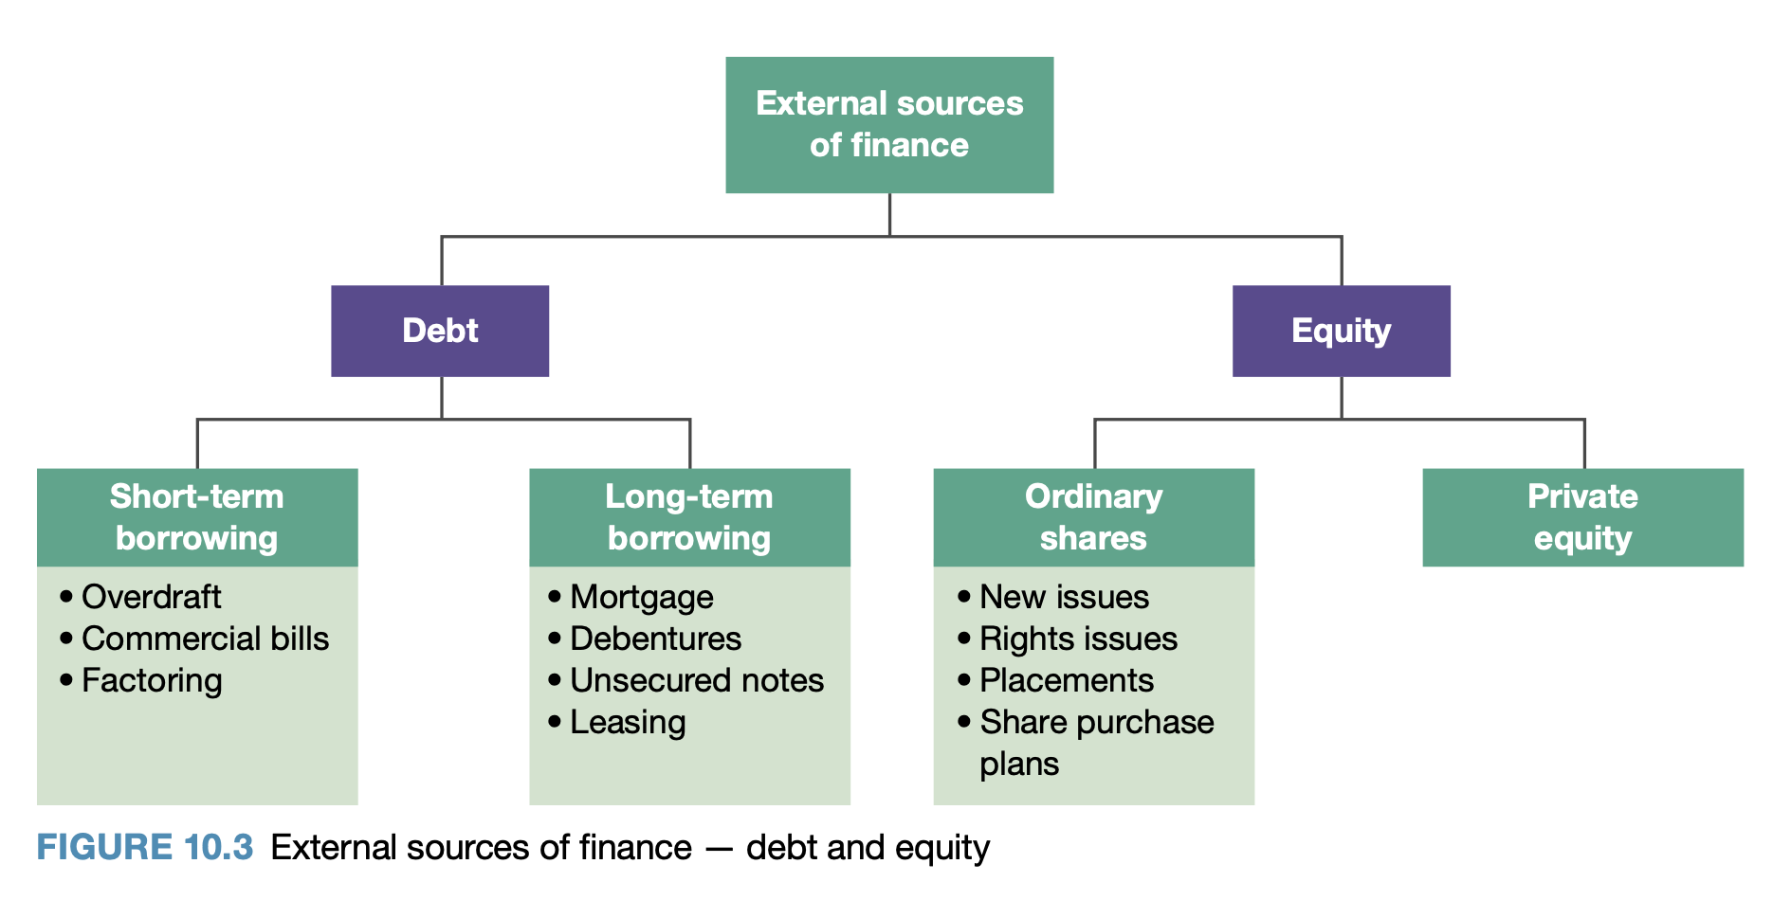
  Debt | Relates to short-term and long-term borrowing from external sources by a business.  - Increased access to funds leading to increased earnings and profits  - Regular repayments must be made so firms have to generate sufficient earnings to make payments  - Increased risk for businesses as interest, bank and government charges must be paid on top of the borrowed amount  - Australia provides tax deductions for interest payments, promoting debt finance
    Short-term borrowing | Used to finance temporary shortages in cash flow or finance for working capital.  - Funds repaid within 12 months  - Short-term debts are recorded as current liabilities on the balance sheet
      Overdraft | Bank allows a business or individual to overdraw their account up to an agreed limit and for a specified time, to help overcome a temporary cash shortfall.  - Assist with short-term liquidity issues  - Minimal costs and interest rates are lower  - Banks require security and the agreed limits to be maintained  - Higher flexibility compared to short-term loans
      Commercial bills | Primarily short-term loans issued by financial institutions, for larger amounts (usually over $100,000) for a period of generally between 30 to 180 days.  - Borrower receives the sum immediately  - Flexible in relation to the interest needed to be paid and the repayment period  - Secured against the business’s assets  - Rolled over until the borrower has funds to repay the loan in full
      Factoring | Selling of accounts receivable for a discounted price to a finance or factoring company.  - Business receives funds immediately  - Business will receive up to 90% of the amount of receivables within 48 hours of submitting its invoices to the factoring company  - Immediate access to funds improves cash flow and gearing  - Greater risk due to likelihood of unpaid debts  - Expensive source of finance as businesses are responsible for debts that remain unpaid and commission is paid on the debt  A factoring company may offer its services with or without recourse.  - Without recourse: business transfers responsibility for non-collection to the factoring company  - With recourse: bad debts will still be the responsibility of the business
    Long-term borrowing | Relates to funds borrowed for periods longer than 12 months.  - Used to purchase major assets (e.g. buildings and equipment)  - Assets often serve as security on the loan  - Long-term debts are recorded as non-current liabilities on the balance sheet
      Mortgage | A loan secured by the property of the borrower (business).  - Mortgaged property cannot be sold or used as security until the mortgage is repaid  - Mortgage loans are used to finance property purchases  - Repaid with interest through regular repayments over an agreed period
      Debentures | Issued by a company for a fixed rate of interest and for a fixed period of time.  - Provided as a way to raise funds from investors  - A promise made by a company to repay money lent to the business  - Companies that borrow offer security to the lender  - On maturity, the company repays the amount of the debenture by buying back the debenture  - Debentures carry a fixed rate of interest  - Debenture products must have a prospectus  - Investor lends money to a company and in return the company issues a debenture with a promise to make regular interest payments for a defined term and then repay the loan at a particular date in the future
      Unsecured notes | A loan from investors for a set period of time. Unsecured notes are not secured against the business’s assets.  - Most risk to the investors (lender)  - Higher rate of interest than secured notes  - Companies sell unsecured notes to generate money for their initiatives (e.g. share repurchases and acquisitions)
      Leasing | Involves the payment of money for the use of equipment that is owned by another party.  - Long-term source of borrowing  - Required by law to reveal significant leases in published financial statements  - Enables borrowing funds and using equipment without the large capital outlay required  - Business assets that are suitable for leasing include: business cars, plant and machinery, equipment, computers and software  Types of leases:  - Operating lease: assets leased for short periods, usually shorter than the life of the asset. Owner carries out the maintenance on the asset. Operating leases can be cancelled without penalty.  - Financial lease: lessor purchases the asset on behalf of the lessee. Financial leases are usually for the life of the asset. Lease repayments are fixed for the economic life of the asset (typically between 3-5 years). Penalties for cancellation of financial leases. Leasing assets for long periods as financial leases is cheaper than leasing them as operating leases.  - E.g. plant, vehicles, equipment, furniture, fittings leased as financial leases  Advantages of leasing as a source of finance:  - Assists businesses with their cash flow because cash outflows / payments are spread out over several years  - Costs of establishing leases may be lower than other methods  - If some assets are leased, the business may be in a better position to borrow funds  - Provides long-term financing without reducing control of ownership  - Permits 100% financing of assets  - Repayments of the lease are fixed for a period so cash flow can be monitored  - Lease repayments are a tax deduction  - Payment usually includes maintenance, insurance and finance costs  Disadvantage:  Interest charges may be higher than for other forms of borrowing.
  Equity | Refers to the finance raised by a company through inviting new owners.  - Alternative to debt funding
    Ordinary shares | - Purchase of ordinary shares by individuals means they have become part-owners of a publicly listed company  - Individuals get voting rights according to the number of shares and dividends they have  - Shareholders provide finance to the company by purchasing shares  - Value of the share is determined by a company’s current or future performance  Variations in the type or issue of ordinary shares:
      Dividend | A distribution of a company’s profits (yearly or half-yearly) to shareholders and is calculated as a number of cents per share.
      New issues | A security that has been issued and sold for the first time on a public market.  - Referred to as primary shares or new offerings  - Initial public offering (IPO) → when a company issues shares to the public for the first time  - Businesses are required to issue a prospectus so investors can make informed decisions
      Rights issues | The privilege granted to shareholders to buy new shares in the same company.  - Occurs after the IPO and provides existing shareholders with the opportunity to purchase more shares  - Current shareholders will have the right to purchase new shares in proportion to the number of shares they currently own  - Shareholder does not have to take up the rights issue
      Placements | Allotment of shares made directly from the company to investors.  - Additional shares are offered at a discount to their current trading price to special institutions or investors  - The discount is intended to persuade specific investors to invest in the company
      Share purchase plans | An offer to existing shareholders in a listed company to purchase more shares in that company without brokerage fees.  - Shares can be offered at a discount to the current market price  - Share purchase plans allow companies to issue new shares to current shareholders without issuing a prospectus  - Can only issue a maximum of $15,000 in new shares to each shareholder
    Private equity | The money invested in a private company not listed on the Australian Securities Exchange (ASX).  Aim of a private company: is to raise capital to finance future expansion / investment of the business
  Business examples | Apple  Debt and equity  - Increase in Apple’s debt compared to equity in recent years  - Apple’s total liabilities increased in the measured period however there was a 31% decrease in owner’s equity  - For every $1 contributed by owners, Apple has raised $4.56 in debt funds  - Apple has never been so highly geared  - Strategy of increasing debt finance enabled Apple to take advantage of historically low interest rates globally  McDonald’s  Short-term/medium-term debt  - McDonald’s has an overdraft facility of $3.5 billion USD  - McDonald’s issues commercial paper to raise funds  - McDonald’s raises funds through its global medium-term notes facility  Long-term debt  - Mortgage → take out a chattel mortgage for specific assets where the lender keeps a legal right to the financed asset whilst money is owed (equipment and machinery)  - Leasing → Pays leases for land and buildings, typically on 20 year contracts  - Can reduce the initial capital outlay required for new stores, enabling more to be opened in a shorter time frame  - Retains cash that can be used elsewhere  - McDonald’s uses this strategy to match cash outflow with cash inflow  Equity  - Initially raised capital when on the New York Stock Exchange (NYSE) on April 21, 1965  - McDonald’s consistently pays its shareholders a high dividend and does not appear to be interested in raising additional equity via share sales
Financial institutions  - Banks  - Investment banks  - Finance companies  - Superannuation funds  - Life insurance companies  - Unit trusts  - Australian Securities Exchange | FINANCIAL INSTITUTIONS  Organisations that provide financial services to individuals and businesses.  - Finance managers must consider which options and best suited to their business
  Banks | Influence  - Businesses must pay interest on the funds they borrow  - Interest is then shared with those who save money with the bank  - Provide general services to a wide range of different customers
    Receive deposits from individuals, businesses and governments which are then lended to fund business activities
  Investment banks | Assist businesses seeking to raise large amounts of capital for activities  - E.g. company expansions, acquisitions, mergers, projects, working capital  Investment banks:  - Trade in money, securities and financial futures  - Arrange long-term finance for company expansion  - Provide working capital  - Arrange project finance  - Advise clients on foreign exchange cover  - Advise on mergers and takeovers  - Provide portfolio investment management services  - Underwrite corporate and semi-government issues of securities  - Operate unit trusts including cash management trusts, property trusts and equity trusts  - Arrange overseas finance  Influence  - Specialised knowledge on how large businesses can maximise their finance  - Offer tailored services  - E.g. customised loans, portfolio investing, foreign exchange cover, overseas finance
    Lend funds and provide advice to large institutional clients and governments
  Finance companies | - Provide loans, lease equipment, offer factoring services  Raise money through share issues (debentures).  - Have security of priority over the firm’s assets in the event of liquidation.  Finance and insurance companies are regulated by the Australian Prudential Regulation Authority (APRA).  Influence  - Immediate access to funds  - Higher interest rates than other financial institutions  - Lend more freely to borrowers, so the risk is higher for the lender
    Non-bank financial intermediaries provide financial services for small-medium businesses
  Superannuation funds | - Purchase shares in businesses listed on the ASX  Employers are required by the government to make superannuation contributions for all employees aged between 18 and 69 who are paid more than $450 before tax in a calendar month. Obligated to make contributions for people under 18 who work more than 30 hours a week.  - Must pay 9.5% of an employee’s salary into a super fund account (this is on top of the employees salary or wages
    Invests employees superannuation contributions into organisations
    Superannuation | A scheme set up by the federal government, which requires all employers to make a financial contribution to a fund which will provide benefits to an employee when they retire.
  Life insurance companies | Provide both equity and loans to the corporate sector through receipts of insurance premiums which provide funds for investment.  - Funds received in premiums (reserves) are invested in financial assets.  Influence  - Life insurance companies must invest premiums to growth wealth  - Purchase shares in businesses  - Provide loans to businesses
    Non-bank financial intermediaries who provide life insurance to individuals
  Unit trusts | - Unit trusts may purchase shares in a business, providing funding  - Businesses can invest in a unit trust, earning dividends  Influence  - Allow businesses to diversify their income  - Small businesses can make investments they otherwise wouldn’t be able to  - Economies of scale reduces transaction costs  - Have to pay intermediary manager → cost  How unit trust funds work  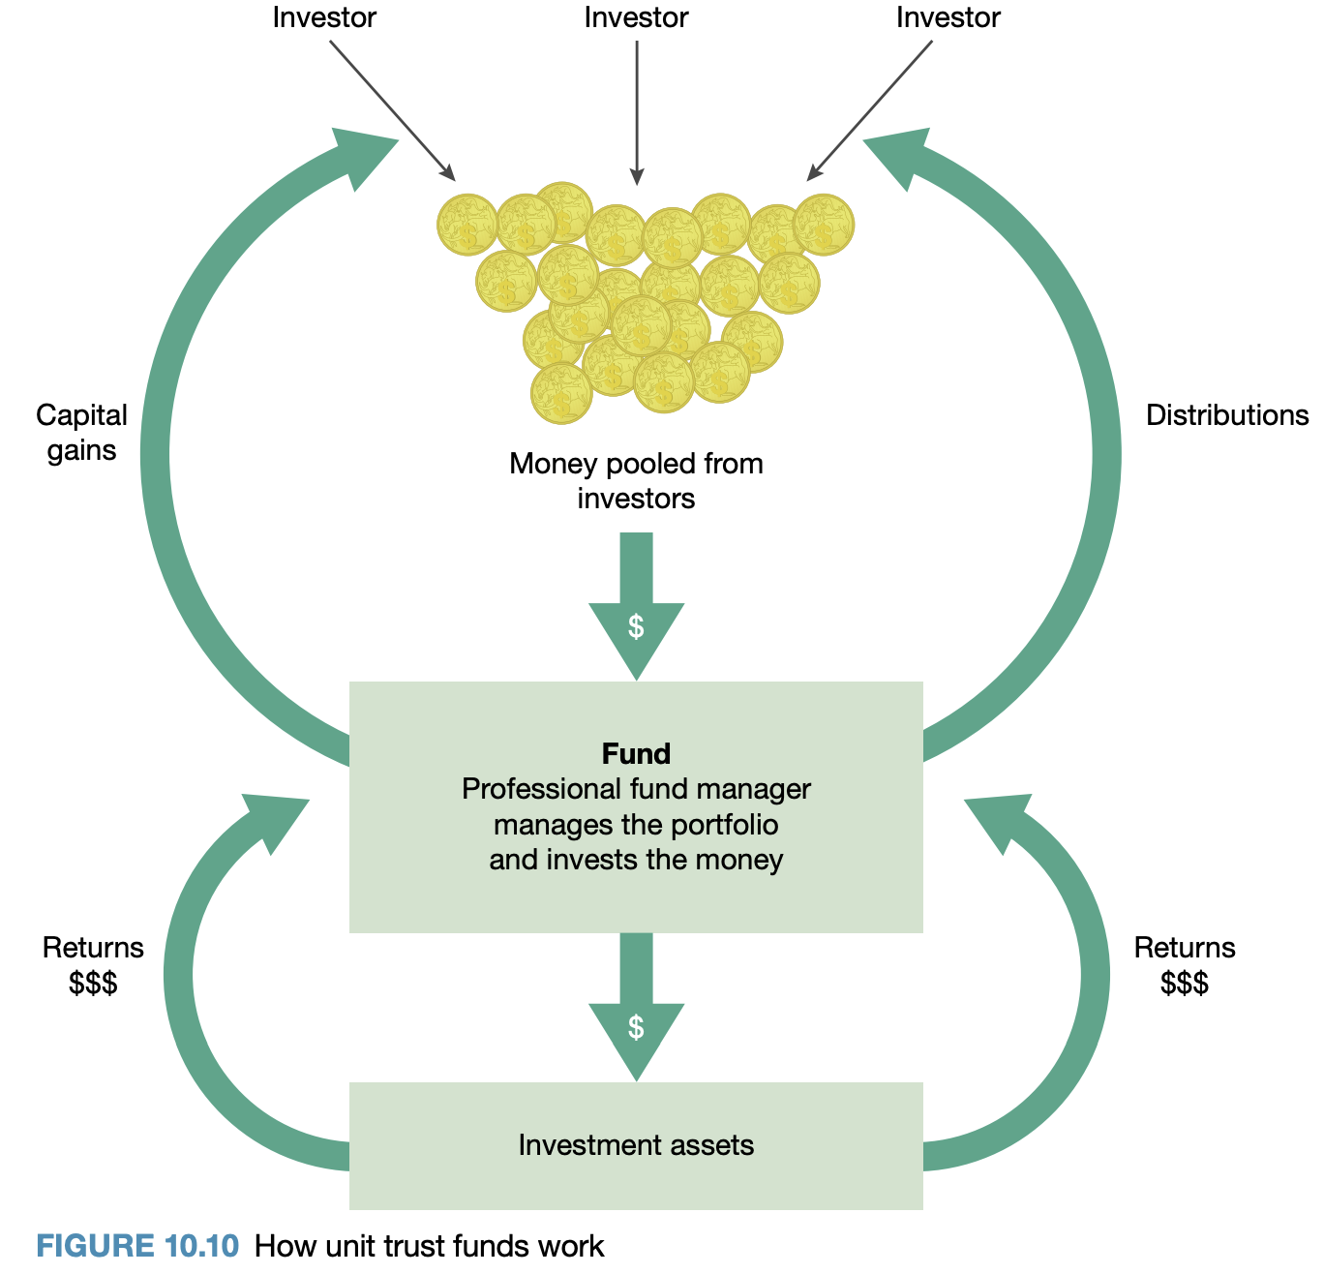
    Take and invest funds from a large group of smaller investors into financial assets
  Australian Securities Exchange (ASX) | - Functions as a market operator, clearing house and payments system facilitator  - Oversees compliance with its operating rules and promotes standards of corporate governance among Australia’s listed companies  Offers products and services, including:  - Shares  - Futures  - Exchange traded options  - Warrants  - Contracts for difference  - Real estate investment trusts  - Listed investment companies  - Interest rate securities  Influence  ASX operates in both a primary and secondary market.
    Market for purchasing and exchanging shares and other securities
    ASX | The primary stock exchange group in Australia
    Primary market | Deal with the new issue of debt instruments by the borrower of funds  - Raise new capital through the issues of shares  - Purchase shares in other companies (dividends)
    Secondary market | Deal with the purchase and sale of existing securities  - Pre-owned securities are traded between investors  - Shares purchased in other companies can be traded  - Trading securities at the right time can generate revenue (greater dividends)
  Business examples | McDonald’s  - Uses a range of bank and finance companies worldwide  - Abides by rules of the NYSE including disclosing financial and other important information publicly  - Financial rating agencies McDonald’s financial position and performance and assign its financial instruments a credit rating  - Higher rating → easier these instruments are to sell
Influence of government  - Australian Securities and Investments Commission (ASIC)  - Company taxation | INFLUENCE OF GOVERNMENT  Influences business financial management decisions with economic policies (fiscal policy, legislation).  Implications for businesses in relation to the influence of the government  - Legislation influence the decisions businesses make about their finances  - Businesses must comply with legal obligations  - Legislation impacts the choice of legal structure as different obligations are imposed on different business types  - ASIC can pursue a range of remedies which influences a business’s finance if they fail to comply  - Negative publicity for businesses that fail to comply with government regulations  - Taxation regulations affect business’s financial decisions as some may be better for taxation purposes  - Taxation regulations require sound financial management so the business will have adequate financial resources available for when their taxation obligations are due
  Australian Securities and Investments Commission (ASIC) | Purpose  - Enforce the Corporations Act 2001  - Ensures companies adhere to the law  - Protect consumers in areas of investments, life and general insurance, superannuation and banking (except lending)  - Collects information about companies and makes it available to the public  - Including annual financial information  Aim  To assist in reducing fraud and unfair practices in financial markets and financial products.  Investigations  ASIC investigates breaches of the Corporations Act and determines an appropriate remedy.  - ASIC is able to pursue a variety of remedies depending on the seriousness of the misconduct, including:  - Imprisonment and monetary penalties  - Failure to comply generates negative publicity
    Independent statutory commission accountable to the Commonwealth parliament.
  Company taxation | Tax is paid before profits are distributed to shareholders as dividends.  Rates  - Tax is levied at a rate of 30% of net profit  - Tax rate is 27.5% for small businesses with turnover less than $10 million
    All incorporated businesses (private and public) are required to pay tax on profits.
  Business examples | Apple  - Subject to 21% corporate tax in the U.S.  McDonald’s  - Minimum rate of pay, minimum ages, taxation systems in various countries  - In Australia, McDonald’s must report information to ASIC who enforces the Corporations Act 2001  - The Corporations Act 2001 compels McDonald’s Australia to submit audited financial statements that can be accessed by the general public  - McDonald’s has been the subject of media reports claiming that it uses inter-company transfer payments to shift profit from Australia to countries that have low or zero tax rates  - McDonald’s Australia is obligated to pay income tax on profit made in Australia
Global market influences  - Economic outlook  - Availability of funds  - Interest rates | GLOBAL MARKET INFLUENCES  Influences part of the external business environment, not controlled by the business.  Implications for businesses in relation to the influences of the global market  - Global economic outlook has a direct effect on the demand for Australian exports  - Positive outlook → increase demand for Australian products  - Negative outlook → decrease demand for Australian products  - Availability of funds impacts whether Australian businesses can access money needed to expand  - Overseas interest rates affect Australian businesses who borrow funds from overseas  - Interest rates of exchange rates change → potential increase in repayments and thus a reduction in profits
  Global economic outlook | If world economic growth is to increase (positive outlook) then this may impact a business:  - Increasing demand for products and services  - Requires increased production to meet demand  - Requires funds to purchase equipment, employ or train staff  - Requires funds to expand the size of the business  - A decrease in the interest rates on funds borrowed internationally from the financial money market  Factors that impact the global economy  - An increase in manufacturing and trade  - Increasing customer confidence  - Increased investment spending  - Uncertainty surrounding the economic policies of the US administration and their global ramifications  - Uncertainty resulting from the Brexit referendum resulting in the United Kingdom withdrawing from the European Union  - Expected slowing in the growth in the Chinese economy  - Increase in commodity and oil prices  - Financial risks from high and rising credit growth and house price increases
    The projected changes to the level of economic growth throughout the world.
  Availability of funds | International financial markets are made up of many institutions, companies and governments prepared to lend money to individuals, companies or governments who may need to raise capital.  Various conditions and rates apply, these being based on:  - Risk  - Demand and supply  - Domestic economic conditions
    Refers to the ease with which a business can access funds (for borrowing) on the international financial markets.
  Interest rates | Higher level of risk in lending to a business → higher interest rates  Advantage of borrowing finance from overseas sources  Australian interest rates are typically higher than other countries. Thus, businesses would benefit from borrowing finance from an overseas source to gain the advantage of lower interest rates. However, this creates an additional risk of the exchange rate movements. Long-term implications must be considered.
    The cost of borrowing money.
  Business examples | Apple  - Taking advantage of China and India as they have the highest levels of economic growth recently  - Covid health and economic crisis had numerous implications including high levels of unemployment and business failure, significantly impacting Apple  McDonald’s  - Increased labour and material costs as inflation rises to its highest levels  - Low global interest rates ensure that McDonald’s have relatively easy access to funds  - Debt finance will become more expensive and less readily available as interest rates rise
Processes of financial management
Planning and implementing  - Financial needs  - Budgets  - Record systems  - Financial risks  - Financial controls  - Debt and equity financing - advantages and disadvantages of each  - Matching the terms and source of finance to business purpose | 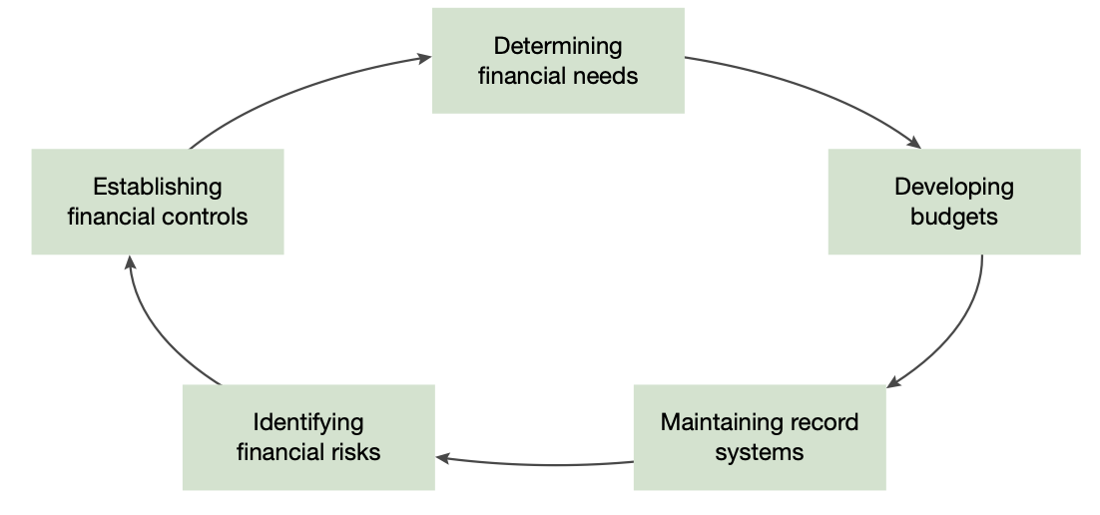  PLANNING AND IMPLEMENTING  Important part of financial management is establishing effective financial processes:  - Planning and implementing  - Monitoring and controlling  - Calculating financial ratios  - Identifying limitations of financial reports  - Identifying ethical issues related to financial reports  Debt and equity financing  Matching the terms and source of finance to business purpose  Short-term finance → used to purchase short-term assets  Long-term finance → used to purchase long-term assets  Length/term of the loan should be matched with the economic lifetime of the asset the finance is being used to purchase.  - Short-term finance used for long-term assets → financial problems – amount borrowed must be repaid before the long-term assets have had time to generate increased cash flow  - Long-term finance used for short-term assets → business is still paying the mortgage long after the situation is resolved or the stock has been sold – profits will be reduced
  Financial needs | Important financial information needs to be collected before future plans can be made.  Includes:  - Balance sheets, income statements, cash flow statements, sales and price forecasts, bank statements, weekly reports from departments, break-even analysis, reports from financial ratio analysis, interpretation, budgets  Factors that determine the financial needs of a business:  - The size of the business  - The current phase of the business cycle  - Future plans for growth and development  - Capacity to source finance – debt and/or equity  Business plan might be used when seeking finance or support for a project from a bank, potential investor or other financial institution.  - Institutions require a guarantee that their financial commitment to the business will be successful  - Sets out finance required, proposed sources of finance and a range of financial statements  Financial information is required to show that the business can generate an acceptable return for the investment being sought and should include an analysis of financial performance, income statement, cash flow statement, balance sheet and financial ratio analysis reports.
    The business must know its needs to determine where it is headed and how it will get there.
  Budgets | Budgets can show:  - Cash required for planned outlays for a particular period  - The cost of capital expenditure and associated expenses against earning capacity  - Estimated use and cost of raw materials or inventory  - Number and cost of labour hours required for production  Budgets reflect the strategic planning decisions about how resources are to be used.  Provide financial information for a business’s specific goals and are used in planning.  Enable constant monitoring of objectives and provide a basis for administrative control, direction of sales effort, production planning, control of stocks, price setting, financial requirements, control of expenses and of production cost.  Factors that must be considered in preparing a budget:  - Review of past figures and trends and estimates gathered from departments in the business  - Potential market or market share and trends and seasonal fluctuations in the market  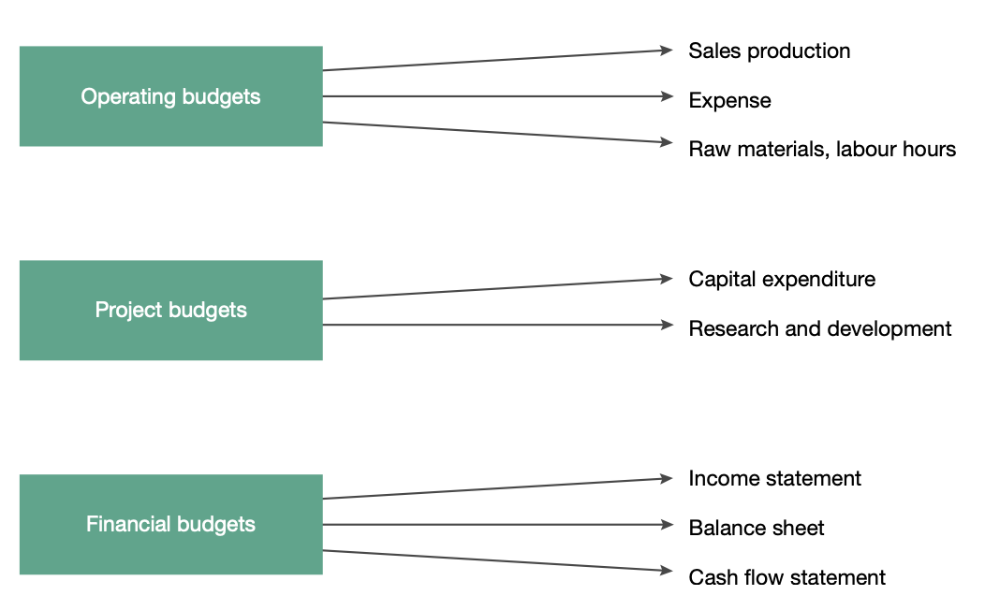  - Proposed expansion or discontinuation of projects  - Proposals to alter price or quality of products  - Current orders and plant capacity  - Considerations from the external environment  - E.g. financial trends, availability of materials and labour  Types of budgets
    Provide information in quantitative terms (facts and figures) about financial requirements of a business
    Operating budgets | Information is used in preparing budgeted financial statements.
      Relate to the main activities of a business and may include budgets relating to sales, production, raw materials, direct labour, expenses and cost of goods sold
    Project budgets | Information from project budgets is included in the budgeted financial statements.
      Relate to capital expenditure and research and development
    Financial budgets | - Financial budgets include the budgeted income statement, balance sheet and cash flows  - Income statement and balance sheet reflect the results of operating activities and the cash flow statement shows the liquidity of a business
      Relate to financial data of a business and include the budgeted income statement, balance sheet and cash flows
  Record systems | Enables managers to record all information needed.  Example of record system:  Double entry system of accounting is an important control aspect.  - By recording all items twice, the entries can be seen to balance and checks to find errors can be carried out quickly.  Legal requirements:  ATO requires businesses to keep records for a minimum 5 years.
    The mechanisms employed by a business to ensure that data are recorded and the information provided by record systems is accurate, reliable, efficient and accessible.
  Financial risks | Questions in relation to financial risk:  - Should finance be borrowed to expand operations?  - Will shareholders be prepared to contribute or will expansion be financed through borrowing?  - Should excess funds be used to purchase assets or invest on the short-term money market?  - Will interest rates go up?  - Fluctuations in exchange rates?  In assessing financial risk for a business, consideration must be given to:  - The amount of the business’s borrowings  - When borrowings are due to be repaid  - Interest rates  - The required level of current assets needed to finance operations  Financed from borrowings → higher risk  Higher risk → greater expectations of profits or dividends  Minimising financial risk  - Businesses must consider the amount of profit that will be generated  - Profit must be sufficient to cover the cost of debt as well as increasing profits to justify the amount of risk taken by owners and shareholders  - Businesses must consider the liquidity of a business’s assets  - Short-term debt → must have liquid assets so that debts can be covered
    The risk to a business of being unable to cover its financial obligations.
  Financial controls | Common causes of financial problems and losses:  - Theft  - Fraud  - Damage or loss of assets  - Errors in record systems  Financial controls ensure that the plans that have been determined will lead to the achievement of the business’s goals in the most efficient way.  - Must establish financial controls to reduce finance risks  Policies and procedures that promote control:  - Clear authorisation and responsibility for tasks in the business  - Separation of duties → individual people responsible for individual tasks  - Rotation of duties → staff skilled in multiple areas allows for rotating  - Control of cash → use of cash registers, daily banked cash, no money kept on premise overnight, payments made by cheque or card, not cash  - Protection of assets → buildings locked, security, CCTV, registry of assets maintained and checks of inventory  - Control of credit procedures → following up on overdue accounts and customer credit checks  Assist a business to estimate resource requirements for a specified future period to predict what will be achieved by a business.
    Policies and procedures that ensure that the plans of a business will be achieved in the most efficient way.
  Debt finance | - Funds readily available and interest payments are tax deductible → reducing the cost of debt financing  - Risk and return must be considered when determining whether debt or equity finance is used  - Consideration to the impact of borrowing on future profitability and financial stability of the business
    The short-term and long-term borrowing from external sources by a business
    Advantages of debt | Disadvantages of debt
    - Funds are usually readily available and can be acquired at short notice  - Increased funds should lead to increased earnings and profits  - Interest payments are tax deductible  - Flexible payment periods and types of debt are available  - It will not dilute the current ownership in the business | - There is an increased risk if debt comes from financial institutions because interest, bank charges and government charges may increase  - Security is required by the business  - Regular repayments have to be made  - Lenders have first claim on any money if the business ends in bankruptcy  - Debt can be expensive (e.g. interest)
  Equity finance | - Shareholders’ funds represent the highest proportion of total funds to finance business operations and assets  - Funds do not have to be repaid at a set date
    The internal sources of finance in the business
    Advantages of equity | Disadvantages of equity
    - Does not have to be repaid unless the owner leaves the business  - Cheaper than other sources of finance as there are no interest payments  - The wonders who have contributed the equity retain control over how that finance is used  - Low gearing – use resources of the owner and not external sources of finance  - Less risk for the business and the owner | - Lower profits and lower returns for the owner  - The expectation that the owner will have about the return on investment (ROI)  - Long, expensive process to obtain funds this way  - Ownership is diluted – the current owners will have less control
  DEBT | EQUITY
  - Lenders have prior claim in the event of liquidation | - Shareholders have a residual claim on assets
  - Debt must be repaid by periodic repayments | - Equity has no maturity date
  - Interest payments are tax deductible | - Dividends are not tax deductible
  - Lenders usually require a lower rate of return | - Dividend payments are not fixed and may be reduced through lack of funds
  - Debt providers have no voting rights | - Equity holders have voting rights
  Business examples | Apple  - Apple’s total liabilities increased by almost 400% in the past decade due to increased long-term debts and related interest payable  - Adapting to the environment of low interest rates in Europe  - Raises equity finance by selling shares on the U.S. stock market, NASDAQ  - Through paying a higher dividend, Apple’s shares become more appealing to investors making it easier to raise equity funds in the future  - Apple pays dividends to shareholders each quarter  McDonald’s  Assessing financial needs and budgets  - Strict budgets are set for hourly, daily, weekly and monthly targets  - Metrics (e.g. wage vs sales) are used to assist with budgeting  Using record systems  - Franchisees agree to use bookkeeping and accounting methods of McDonald’s  - McDonald’s uses a POS system called NP6 to record sales, assemble food, roster staff, order supplies and perform other operational activities  - Used by head office to monitor sales and collect royalties  Managing financial risks  - Interest swap rates → contracts to give certainty on the amount of interest payable on loans  - Foreign currency forwards and options → contracts McDonald’s enters to give more certainty for the next 18 months, locking in exchange rates to protect McDonald’s from adverse exchange rate fluctuations  - Cross-currency swaps  Implementing financial controls  - Uses external auditor to assess the effectiveness of its financial controls annually  Debt and equity financing  - Debt → Increased debt as they believe the advantages outweigh the disadvantages  - Equity → Company can choose not to pay dividends in a particular year, thus retaining cash for expansion  Matching the terms and source of finance to the business purpose  - McDonald’s leases or owns most of the land and buildings where its franchises run  - Twenty-year lease taken by McDonald’s is matched with a corresponding lease with the franchise for twenty years → thus, the terms and business purpose of the finance are matched
Monitoring and controlling  - Cash flow statement  - Income statement  - Balance sheet | MONITORING AND CONTROLLING  Primary financial controls:
  Cash flow statement | Only cash transactions are included in the cash flow statement.  - Used by creditors and lenders of finance, owners and shareholders  - Potential shareholders check that a business has had a positive cash flow over a number of years  - Cash flows can be a better predictor of a business’s status than profitability  Statement of cash flows shows whether a firm can:  - Generate a favourable cash flow – inflows exceed outflows  - Pay its financial commitments as they fall due – interest on borrowings, repayment of borrowings, accounts payable  - Have sufficient funds for future expansion or change  - Obtain finance from external sources when needed  - Pay drawings to owners or dividends to shareholders  Activities:  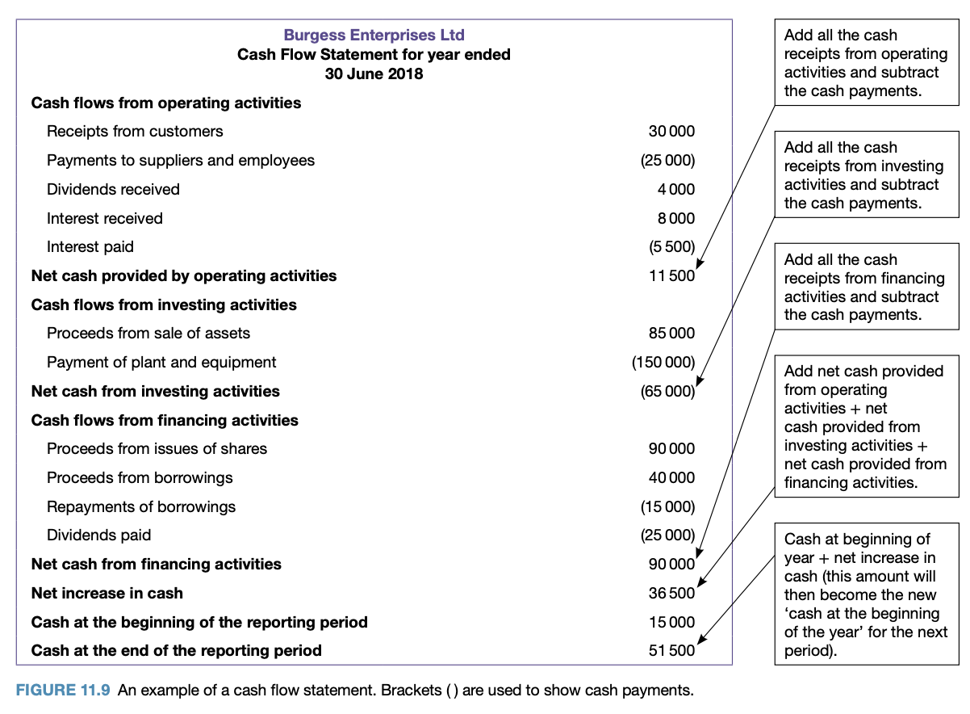
    A financial statement that indicates the movement of cash receipts and cash payments resulting from transactions over a period of time.
    Operating activities | Cash inflows and outflows relating to the main activities of the business – the provision of goods and services.  Operating inflows  - Income from sales (cash and credit) plus dividends and interest received  Operating outflows  - Suppliers  - Employees  - Other operating expenses – insurance, rent, advertising
    Investment activities | Cash inflows and outflows relating to the purchase and sale of non-current assets and investments.  - Assets and investments are used to generate income for the business  Examples:  - Selling old motor vehicle  - Purchasing new plant, equipment, property
    Financing activities | Cash inflows and outflows relating to the borrowing activities of the business.  Borrowing inflows  - Can relate to equity or debt  Financing outflows  - Can relate to the repayments of debt and cash drawings of the owner or payments of dividends to shareholders
  Income statement  OR  Statement of financial performance | Helps users of information see exactly how much money has come into the business as revenue, how much has gone out as expenditure and how much has been derived as profit.  Income statement shows:  - Operating income earned from the main function of the business  - Sales, inventories, services and non-operating revenue earned from interest, rent and commission  - Operating expenses incurred from the purchase of:  - Inventories, payment for services, advertising, rent, telephone, insurance  Steps to write an income statement  - Record income earned  - Record the cost of goods sold and calculate gross profit  - Calculate net profit  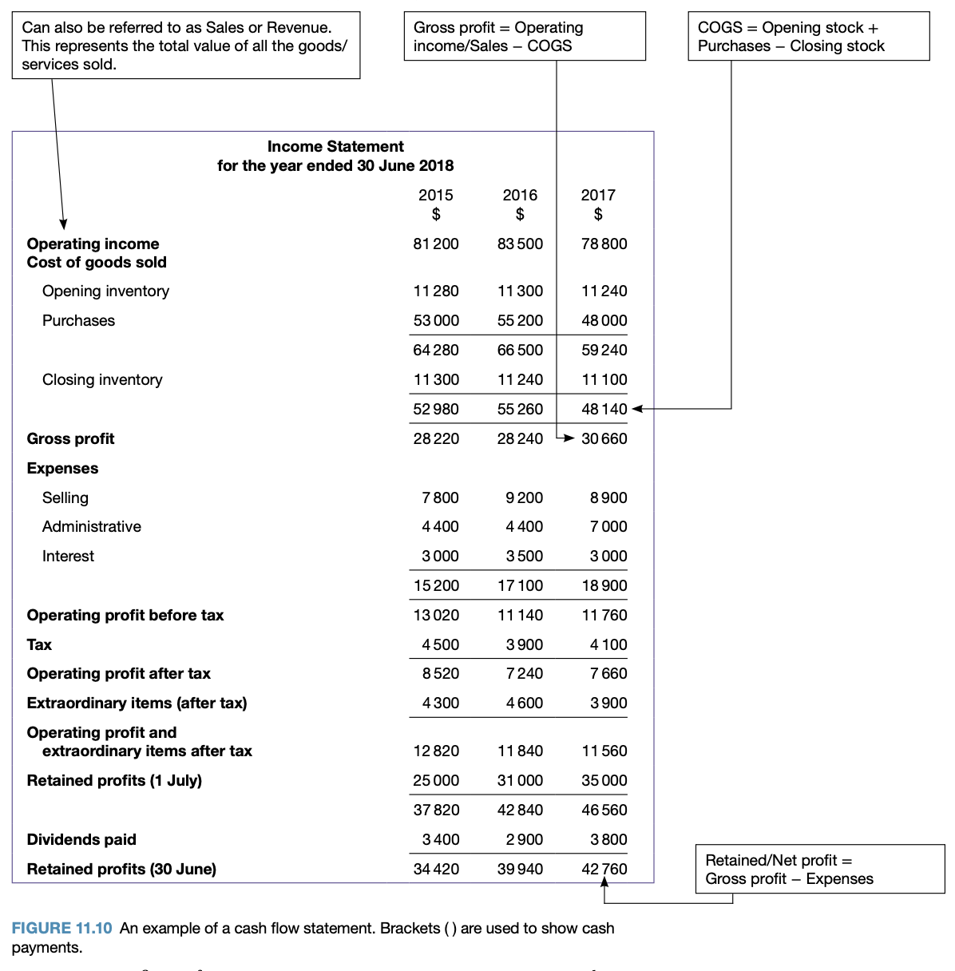
    Summary of the income earned and the expenses incurred over a period of trading.
    Cost of goods sold | The value of stock that a business has sold to its customers
    Gross profit | The part of a business’s profit that represents: operating income - COGS
    Net profit | The difference between the gross profit and expenses
    Expenses | Costs. Costs incurred in the process of acquiring or manufacturing a good or service to sell and the costs associated with managing all aspects of the sales of that good or service.  Types of expenses
      Expenses
      Selling  Costs related to the process of selling the good or service. | Administrative  Costs related to the general running of the business. | Financial  Costs associated with borrowing money from external people.
      - Commission  - Salaries  - Wages  - Advertising  - Delivery expenses  - Electricity  - Depreciation on shop fittings | - Stationary  - Office salaries  - Rent  - Rates  - Telephone  - Depreciation on buildings  - Audit fees  - Accountant’s fees  - Insurances | - Interest payments  - Lease payments  - Dividends  - Insurance payments
  Balance sheet | - Prepared at the end of the accounting period.  - Shows the financial stability of the business  - Shows the return on the owners’ investment, the sources and extent of borrowings, the level of inventories, etc.  - Figures show whether the business has sufficient assets to continue to make profits in the longer term  Balance sheet shows the level of:  - Current and non-current assets  - Current and non-current liabilities  - Including: investments, owners’ equity  Analysis of the balance sheet can indicate whether the:  - Business has enough assets to cover its debts  - Interest and money borrowed can be paid  - Assets of the business are being used to maximise profits  - Owners of the business are making a good return on their investment  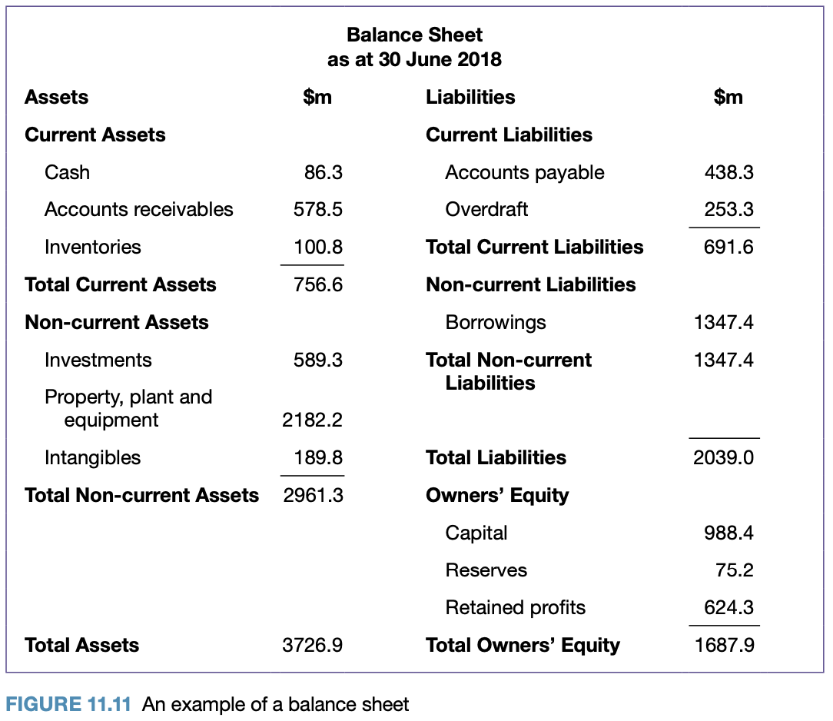  Balance sheet – accounting equation and relationships  - Balance sheet shows the outcome of the accounting process  - Accounting equation shows the effect of the business’s operations on owners’ equity  Owners’ equity comprises two elements:  - Capital – funds contributed by the owner or owners to the business  - Retained profits –The profit (or loss) figure is transferred to the owners’ equity as retained profits.
    Represents a business’s assets and liabilities at a particular point in time, expressed in money terms, and represents the net worth of the business.
    Assets | Items of value owned by the business.  - Current assets → turned into cash within 12 months  - Non-current assets → not expected to be turned into cash within 12 months
    Liabilities | Claims by people other than owners against assets and represent what is owned by the business.  - Current liabilities → must be repaid within 12 months  - Non-current liabilities → must be met some time after the next 12 months
    Owners’ equity | The funds contributed by the owner(s) and represents the net worth of the business.
    Forms the basis of the accounting process, shows the relationship between assets, liabilities and owners’ equity
    $Assets=Liabilities+Owners' equity$
    $Owners' equity=Assets-Liabilities$
    $Liabilities=Assets-Owners' equity$
Financial ratios  - Liquidity - current ratio  $current assets÷current liabilities$  - Gearing - debt to equity ratio  $total liabilities÷total equity$  - Profitability  - Gross profit ratio  $gross profit÷sales$  - Net profit ratio  $net profit÷sales$  - Return on equity ratio  $net profit÷total equity$  - Efficiency  - Expense ratio  $total expenses÷sales$  - Accounts receivable turnover ratio  $sales÷accounts receivable\backslash$  - Comparative ratio analysis  - Over time periods  - Against standards  - With similar businesses | FINANCIAL RATIOS  Analysis of financial statements are aimed at the areas of:  - Liquidity  - Gearing  - Profitability  - Efficiency  The types of analysis are vertical, horizontal and trend analysis:  - Analysis requires interpretation to make meaning
  Analysis | Involves working the financial information into significant and acceptable forms that make it more meaningful, and highlighting relationships between different aspects of a business
  Interpretation | Making judgements and decisions using the data gathered from analysis
  Vertical analysis | Compares figures within one financial year
  Horizontal analysis | Compares figures from different financial years
  Trend analysis | Compares for periods of three to five years
  Liquidity - current ratio | Found on the BALANCE SHEET.  Measures a business’s ability to pay back their current liabilities with their current assets.  Is there sufficient cash and a level of assets and inventories that can be converted to cash quickly to repay the firm’s debts?  - Higher ratio > more capable of meeting short-term obligations  - 2:1 Ratio indicates a sound financial position  - Double the amount of current assets to cover current liabilities  - Acceptable ratio depends on the type of firm and how other firms in the industry are operating and factors in the external environment  - Current ratio gives a limited indication of the ability of the business to meet short-term liabilities  - Current assets and liabilities determine the liquidity or short-term financial stability of a business  Strategies to improve liquidity  - Factoring  - Selling non-essential, non-current assets and using those funds to reduce current liabilities  - Injecting more equity into the business to pay off liabilities
    The ability of a business to meet its financial commitments in the short-term (<12 months)
    $Current ratio (working capital)=\frac{Current assets}{Current liabilities}$
    Example – Expressed as $x$:1
    Industry average: 2.7:1
    Current assets: $495000
    Current liabilities: $160000
    $Current ratio=\frac{495000}{160000}$
    $=3.09$
    $=3.09 :1$
    For every $1 of current liabilities, there are $3.09 of current assets. The business has a high level of liquidity, making them extremely liquid. The business’ liquidity is higher than the ideal liquidity of 2:1 and the industry average of 2.7:1.
  Gearing - debt to equity ratio | Found on the BALANCE SHEET.  - Potential investors and creditors are interested in gearing ratios  - Gearing measures the relationship between debt and equity  - Gearing is a proportion of debt and equity that is used to finance the activities of a business  - An industry that carries higher risk but is likely to generate large profits may have a higher debt to equity ratio – that is, it is highly geared (e.g. mining)  More highly geared (higher proportion of debt to equity) > greater risk for the business but the greater potential for profit  No optimal level of gearing but businesses must consider  - Return on investment  - Cost of debt  - Size and stability of the busines’s earning capacity  - Liquidity of the business’s assets – the greater the cash flow and the more liquid the assets, the more likely the interest charges will be paid  - Purposes of short-term debt  Strategies to help improve or manage gearing/solvency  - To decrease debt:  - Sell non-essential assets to pay off their debts  - Renegotiate their loans to spread their payments over a longer period  - Business could lease assets as opposed to purchasing them  - To increase equity:  - Retaining more profits  - Injecting more equity funding by either selling more shares (if a public company) or inviting new owners
    The proportion of debt (external finance) and the proportion of equity (internal finance) that is used to finance the activities of a business. Gearing ratios determine the firm’s solvency.
    $Gearing ratio=\frac{Total liabilities}{Total equity}$
    Solvency | The ability of a business to meet its financial commitments in the long-term (>12 months)
    Example – Expressed as $x$:1
    Total liabilities: $130000
    Total equity: $115000
    $Gearing ratio=\frac{130000}{115000}$
    $=1.13$
    $=1.13 :1$
    For every $1 of owner’s equity, the firm has $1.13 in liabilities. Depending on the firm, the industry and past trends the level of gearing may need to be reduced in order to meet their long term financial commitments. Gearing of 1:1 is generally considered sound.
  Profitability | - Depends on the revenue earned by a business and the ability of the business to increase selling prices to cover purchase costs and other expenses incurred in earning income.  - Amount of profits is determined by a number of factors such as the volume of sales, the mark-up on purchases and the level of expenses  - Financial information must be examined to see where changes have occurred and where changes need to be made in the future  People interested in the profitability ratios:  - Owners and shareholders → whether the firm is earning an acceptable return on their investment  - Creditors → whether they will be paid and should offer credit in the future  - Leaders → whether the principal on the loan and interest will be repaid, whether to lend to the firm in the future  - Management → uses profitability to decide on the need for adjustments to policies  Income statement is used to measure the profitability of the earning capacity of the firm.  The profitability ratios are the:  - Gross profit ratio  - Net profit ratio  - Return on equity ratio
    The earning performance of the business and indicates its capacity to use its resources to maximise profits
    Gross profit value | Found on the INCOME STATEMENT.  Gives the percentage of sales revenue that results in gross profit.  - Shows the changes from one accounting period to another  - Indicates the effectiveness of planning policies concerning price, sales, discounts, the valuation of stock, etc.  - Fall in the rate of gross profit → fall in the amount of net profit  - Amount of decrease depends on such factors as price reductions  - Specials, sales  - Mark-downs  - Out-of-date stock  - Theft of stock  - Errors in determining prices  - Changes in the mark-up  - Changes in the mix of sales  - Shows changes from one accounting period to another  - Indicates the effectiveness of planning policies in price, sales, discounts and the valuation of stock
      $Gross profit ratio =\frac{Gross profit}{Sales}$
      Example – Expressed as %
      Total gross profit: $15000
      Total sales: $40000
      $Gross profit ratio=\frac{15000}{40000}×100$
      $=0.375$
      $=37.5\%$
      For every $1 of sales, the business generates 37.5 cents in gross profit.
    Net profit value | Found on the INCOME STATEMENT.  Represents the profit or return to the owners which is revenue – expenses.  - Sole traders and partnerships → net profit represents a return on their contribution to the business  - Usual for a company to return part of net profit to shareholders as dividends and retain a part for future expansion  - Sales must be sufficiently high to cover the costs or expenses and still generate a profit  - Costs or expenses after gross profit must be low enough to generate a net profit  - Shows the amount of sales revenue that results in net profit  - A business would be aiming at a higher gross and net profit ratio  - Businesses need to focus on strategies to reduce costs and increase revenue  - Comparisons need to be made with a business’s past performance, their competitors and the industry average  - Gives a more accurate indication of the profitability of a business because other expenses are deducted from the gross profit to determine the net profit
      $Net profit ratio=\frac{Net profit}{Sales}$
      Example – Expressed as %
      Total net profit: $7800
      Total sales: $40000
      $Net profit ratio=\frac{7800}{40000}×100$
      $=0.195$
      $=19.5\%$
      For every $1 of sales, the business generates 19.5 cents in net profit.
    Return on equity ratio | Found on the BALANCE SHEET.  - Shows how effective the funds contributed by the owners have been in generating profit, and hence a return on their investment  - Return for owners must be better than any return that could be gained from alternative investments
      $Return on equity ratio =\frac{Net profit}{Total equity}$
      Example – Expressed as %
      $Net profit ratio=\frac{15000}{150000}×100$
      $=0.10$
      $=10\%$
      For every $1 of equity contributed by the owners, they receive 10 cents in return. This is a reasonable investment.
  Efficiency | - Efficiency relates to effectiveness of management in directing and maintaining the goals  - More efficient → greater profits and financial stability  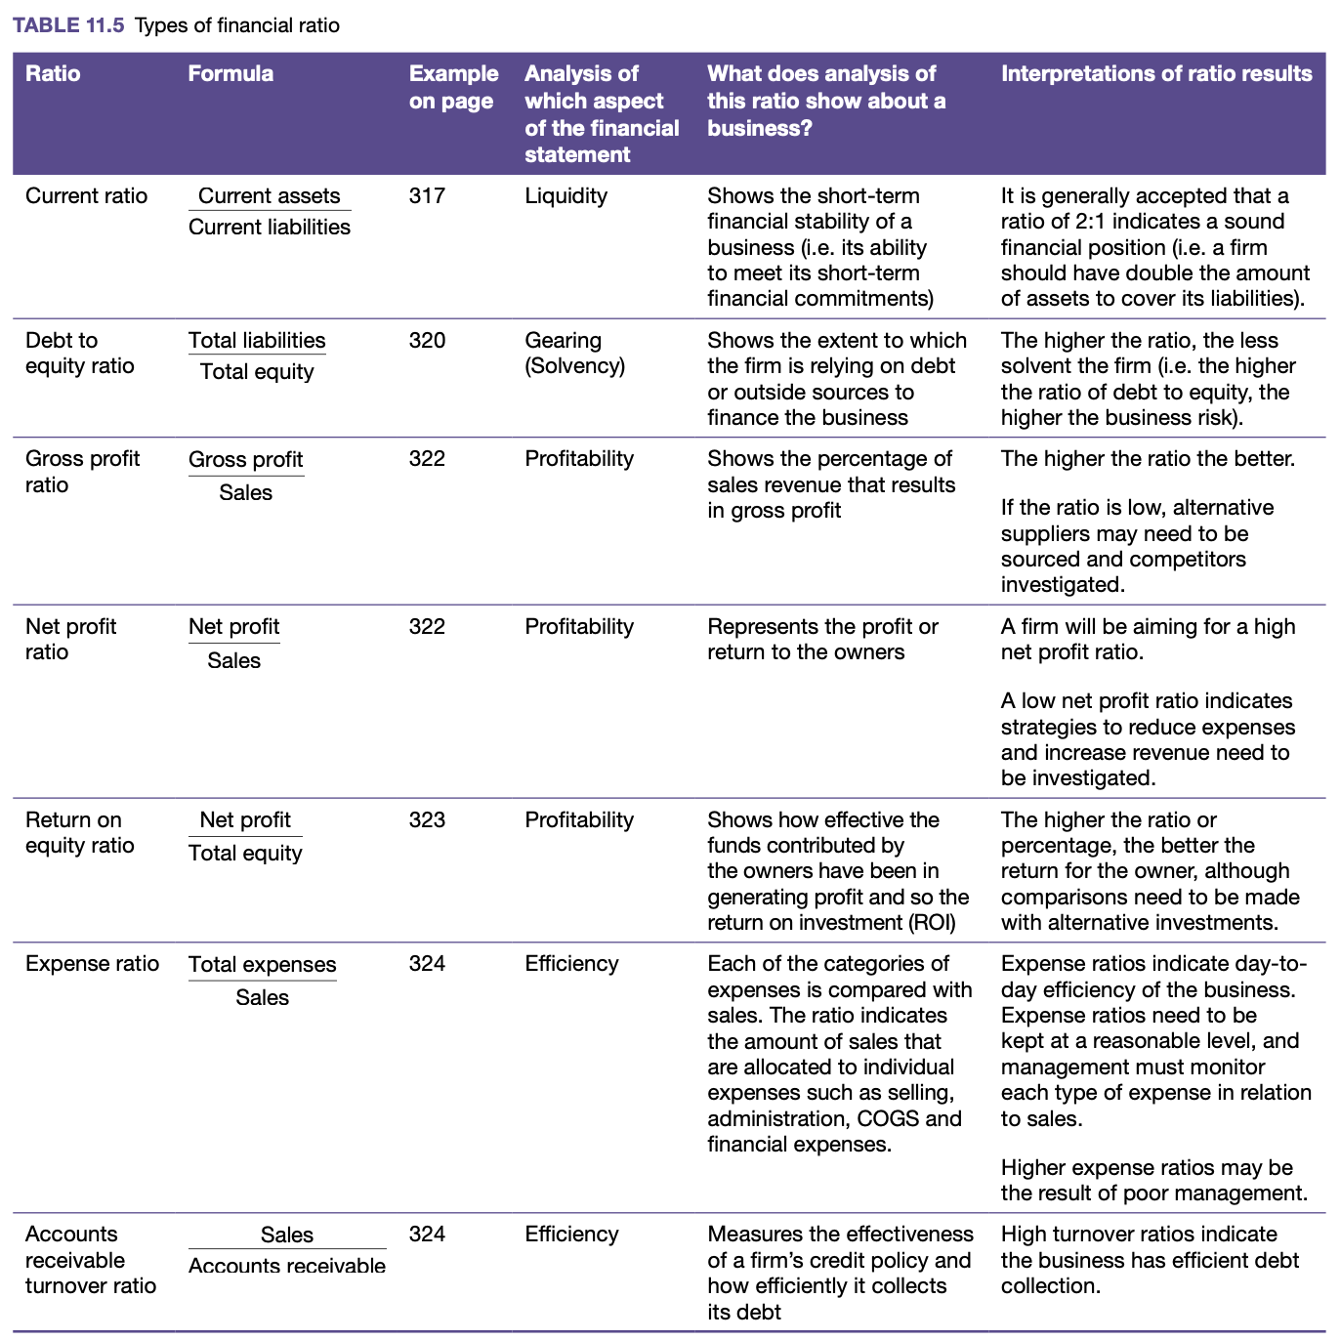
    The ability of a business to minimise its costs and manage its assets so that maximum profit is achieved with the lowest possible level of assets.
    Expense ratio | - The expense ratio indicates the day-to-day efficiency of the business  - The power the percentage, the better
      $Expense ratio =\frac{Total expenses}{Sales}$
      Example – Expressed as %
      Administrative expenses: $1500
      Total selling expenses: $3000
      Total sales: $100000
      $Expense ratio (selling expenses)=\frac{3000}{100000}×100$
      $=3\%$
      For every $1 returned as sales, 3 cents is absorbed by selling expenses.
      –––––––––––––––––––––––––––––––––––––––––––––––––––––––––––––––––––––––––––
      $Expense ratio (administrative expenses)=\frac{1500}{100000}×100$
      $=1.5\%$
      For every $1 returned as sales, 1.5 cents is absorbed by administrative expenses.
    Accounts receivable turnover ratio | - Accounts receivable turnover ratio measures the effectiveness of a firm’s credit policy and how efficiently it collects its debts  - Measures how many times the accounts receivable balance is converted into cash or how quickly debtors pay their accounts  - If a business is not efficient in collecting their accounts receivable they need to implement strategies to improve this, such as charging interest on overdue payments or offering discounts for early payments
      $Accounts receivable turnover ratio =\frac{Sales}{Accounts receivable}$
      Example – Expressed as days
      Total sales: $100000
      Accounts receivable: $10000
      $Accounts receivable turnover ratio =\frac{100000}{10000}=10$
      $\frac{365}{10}=36.5 days$
      Depending on the type of business and past trends, the firm has made a reasonable gross and net profit and their expense ratios are quite low. The business should compare the accounts receivable result with their credit policy to determine whether this length is satisfactory.
  Comparative ratio analysis | Businesses could compare ratios with their results from previous years, with similar businesses and against common industry standards or benchmarks.  - Ratios provide a ‘snapshot’ at a particular point in time  - Figures from previous years can indicate trends or make more meaning from ratio data  Comparative ratio analysis:  - Over time periods  - Against standards  - With similar businesses
Limitations of financial reports  - Normalised earnings  - Capitalising expenses  - Valuing assets  - Timing issues  - Debt repayments  - Notes to the financial statements | LIMITATIONS OF FINANCIAL REPORTS
  Normalised earnings
  Earnings that have been adjusted to take into account changes in the economic cycle or to remove one off/unusual items that will affect profitability.
  - Done to give a more accurate depiction of the true earnings of a company
  - Enables easier comparison of profitability figures for a business from one year to the next, and against other businesses
  - E.g. removal of a land sale, which would achieve a large capital gain
  Capitalising expenses
  Refers to an accounting method where a business records an expense as an asset on the balance sheet rather than as an expense on the income statement.
  - Does not accurately represent the true financial condition as it understates the expenses and overstates the profits as well as the assets of the business
  - E.g. McDonald’s Australia recorded the expenses of a new restaurant site as an asset (building) and depreciated over the useful life of the asset, therefore spreading costs over periods of up to 40 years. This is in line with standard accounting practices but it can have the effect of overstating current year profit.
  - E.g. Examples of capitalising expenses include research and development and development expenditure
  Valuing assets
  Process of estimating the value of assets when recording them on a balance sheet.
  - Difficult for financial managers or accountants to estimate, particularly for non-current assets
  - Considerations when valuing assets:
    - Historical cost
    - Depreciation
      - Businesses have to estimate how much value they lose every year
      - Some non-current assets like land increase in value
    - Valuing intangible assets
      - Intangible assets are difficult to value including goodwill, trademarks, patents and brand names
  - E.g. McDonald’s Australia has almost $442 million in goodwill on the balance sheet at 31/12/2018. When McDonald’s Australia purchases a business back from a franchisee, the amount it pays that is over and above the fair value of the tangible assets of the store it is purchasing is called goodwill.
    - McDonald’s could pay back too much
    - The goodwill figure could not be relevant years after a purchase → check for impairment is conducted to check for any possible decline
  Timing issues
  Limitations arising due to timing issues.
  - Matching principle → expenses incurred by a business must be recorded on the income statement for the accounting period in which the revenue to which those expenses relate, is earned
  - Under the principle, the revenue will match the costs that were incurred to earn that revenue. Results in a presentation of a more accurate representation of the financial position of a business
  - E.g. Real estate agent may have sold a property in June, they receive a 2% commission for sales, but their employer did not pay them until July. This expense should be recorded in June.
  - E.g. McDonald’s uses a straight line depreciation method for their assets. May not reflect economic reality (because some assets depreciate faster early in their useful life), and the effect of this policy, which is about the timing of expenses, could potentially overstate current year profits.
  Debt repayments
  Higher gearing indicates higher risk but potential profit is greater.
  - Financial reports can be limited because they do not have the capacity to disclose specific information about debt repayments such as:
    - How long the business has had or has been recovering the debt
    - The capacity of the business or its debtors to pay the amount owed
    - The adequacy of provisions and methods the business has for the recovery
    - What provision the business has in place for doubtful debts
    - When debts are due
  Notes to the financial statements
  Report the details and additional information that are left out of the main reporting documents (balance sheets, income statements and cash flow statements).
  - Contain useful information to stakeholders as to help them make sense of the financial statements and explain them
  - Notes contain accounting methodologies
  - E.g. McDonald’s Corporation and McDonald’s Australia have more than 100 pages of notes. Only 6 pages are used for the financial statements, the rest of the pages explain, analyse, justify and project the future by way of estimates.
Ethical issues related to financial reports | ETHICAL ISSUES RELATED TO FINANCIAL REPORTS  The moral standards that are commonly established which guide ‘right’ and ‘wrong’.  Audits  Malpractices
  Internal audit | Conducted where a business or organisation will seek to ensure that proper and consistent accounting practices are being followed throughout their branches.
  External audit | Aimed at establishing that the financial reports of a business are a true reflection of the financial position of that business.
  Management audit | Aimed at reviewing strategic plans to determine if changes need to be made to them.
  Inappropriate cut-off periods | Enables businesses to declare some items at a later date when it would suit them better financially and act to reduce their tax liabilities.
  Corporate raider | Where a business will attempt to grow rapidly by taking over another business that is badly managed and is in decline. The raiding business is able to take over the business at a price well below its true market value.
  Asset stripping | Where management may sell off parts of a business at a time in order to maximise their gains when they see no long-term visibility of the business.
Financial management strategies
Cash flow management  - Cash flow statements  - Distribution of payments, discounts for early payment, factoring | CASH FLOW MANAGEMENT  Cash flow statements  Indicates the movement of cash receipts and cash payments resulting from transactions over a period of time. It can also identify trends and can be a useful predictor of change.  Distribution of payments  Involves distributing payments throughout the month, year or other period so that large expenses do not occur at the same time and cash shortfalls do not occur.  Discounts for early payments  Beneficial for the debtors who are able to save money and therefore improve their cash flow, but it also positively affects the business’s cash flow status.  Factoring  Factoring is the selling of accounts receivable for a discounted price to a finance or specialist factoring company. The business saves on the costs involved in following up on unpaid accounts and debt collection
  Cash flow | The movement of cash in and out of a business over a period of time
Working capital management  - Control of current assets  - Cash  - Receivables  - Inventories  - Control of current liabilities  - Payables  - Lones  - Overdrafts  - Strategies  - Leasing  - Sale and lease back | WORKING CAPITAL MANAGEMENT  Shows if current assets can cover current liabilities  - Indicates the amount of risk taken by a business in relation to profitability and liquidity  Management must achieve a balance between using funds to create profits and holding sufficient funds to cover payments.  - The more efficient a business is in organising and using its working capital, the more effective and profitable it is.  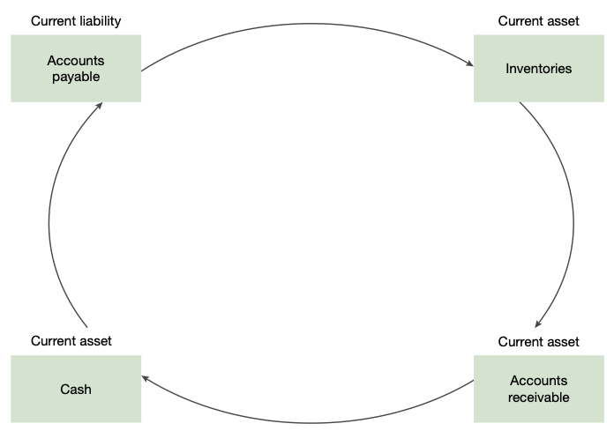  Working capital cycle  The length of time it takes a business to convert its net current assets and current liabilities into cash.  - E.g. The time when a business purchases inventory to resell to when they receive the cash once it's sold.  Control of current assets  - Essential for monitoring working capital  - Requires management to select the optimal amount of each current asset held and raising the finance required to fund the assets  - Cost and benefits of holding too much or too little of each asset must be assessed  - Working capital must be sufficient to maintain liquidity and access to credit to meet unexpected or unforeseen circumstances  Control of current liabilities  Strategies for managing working capital
  $Current (working capital) ratio =\frac{Current assets}{Current liabilities}$
  $Current (working capital) ratio =\frac{Current assets}{Current liabilities}$
  $=\frac{500000}{250000}$
  $=2:1 or 200\%$
  In this example, the ratio indicates that, within the next 12 months, twice the amount of assets needed to be sold to generate cash to meet the short-term debts of the business for the same period.
  Working capital management | Determining the best mix of current assets and current liabilities needed to achieve the objectives of the business.
  Current assets | Assets that a business can expect to convert into cash within 12 months. They include cash and accounts receivable.
  Working capital | Funds available for the short-term financial commitments of a business.
  Net working capital | The difference between current assets and current liabilities. It represents those funds that are needed for the day-to-day operations of a business to produce profits and provide cash for short-term liquidity.
  Current liabilities | Liabilities that a business must repay within the short term. Usually include overdraft and accounts payable.
  Cash | - Planning for the timing of cash receipts, cash payments and asset purchases avoids the situation of cash shortages or excess cash  - Money may need to be borrowed, incurring interest and perhaps set-up costs  - Businesses try to keep their cash balances at a minimum and hold marketable securities as reserves of liquidity  - Overdraft can be arranged to allow a business to overdraw its account to an agreed overdraft amount
  Receivables | Quicker the debtors pay, the better the firm’s cash position.  Procedures for managing accounts receivable:  - Checking the credit rating of prospective customers  - Sending customers’ statements monthly and at the same time each month so that debtors know when to expect accounts  - Following up on accounts that are not paid by the due date  - Stipulating a reasonable period, usually 30 days, for the payment of accounts  - Putting policies in place for collecting bad debts, such as using a debt collection agency  Disadvantage of operating a tight credit control policy is the possibility that customers might choose to buy from other firms.
    Sums of money due to a business from customers to whom it has supplied goods or services. Receivables are recorded as accounts receivables.
  Inventories | - Too much inventory or slow-moving inventory will lead to cash shortages  - Insufficient inventory of quick-selling items may also lead to loss of customers  - Holding of too much stock means unnecessary expenses
  Payables | Holding back accounts payable until their final due date can be a cheap means to improve a firm’s liquidity.  Take advantage of discounts offered by some creditors:  - Discounts  - Interest-free credit periods  - Extended terms for payments, sometimes offered by established suppliers without interest or other penalty
    Sums of money owed by the business to other businesses. Recorded as accounts payable.
    Floor or consignment finance | Goods are supplied for a particular period of time and payment is generally not required until goods are sold
  Loans | - Expensive form of borrowing and should be minimised  - Short-term loans and bridging finance are important sources of short-term funding  - Management of loans is important, as costs for establishment, interest rates and ongoing charges must be investigated and monitored to minimise costs
  Overdrafts | - Convenient and relatively cheap form of short-term borrowing  - Enable overcoming temporary cash shortages  - Business’s account can be overdrawn to a certain amount
  Leasing | Advantages:  - Make use of good quality assets previously unaffordable  - Leasing costs are spread out compared to a one lump sum purchase → improves working capital  - Lease payments are tax deductible because they are operating expenses  - Reduces risk of technological obsolescence  - Reduces risk of unpredictable costs with maintenance and repairs
    A contract between the lessor (owner of the asset) and the leasee.
  Sale and lease-back | Improves a business’s liquidity since it enables the business to receive a large cash injection from the sale of the asset.
    Selling an owned asset to a lessor and then leasing the asset back through fixed payments for a specified period of time.
Profitability management  - Cost controls  - Fixed and variable  - Cost centres  - Expense minimisation  - Revenue controls  - Marketing objectives | PROFITABILITY MANAGEMENT  Control of both the business’s costs and its revenue.  Cost controls  Revenue controls  → Marketing objectives  Pricing policy affects revenue and, therefore, affects working capital. Pricing decisions should be closely monitored and controlled.  - A business must have clear ideas and policies, particularly about its marketing objectives including the sales objectives, sales mix or pricing policy  - Consider the customer base on which most of the revenue depends before diversifying or extending product ranges or ceasing production on particular lines  Factors influencing pricing:  - Costs associated with production (labour, material, overheads)  - Prices charged by competition  - Short and long term business goals  - Image and level of quality associated with the business  - Government policies
  Fixed and variable costs | Changes in the volume of activity need to be managed – comparing budgets, standards with previous periods ensure costs are minimised and profits are maximised.
    Fixed costs | Not dependent on the level of operating activity  (e.g. sales, depreciation, insurance, lease)
    Variable costs | Dependent on the level of operating activity  (e.g. material, labour, energy costs)
  Cost centres | Particular areas, departments or sections of a business to which costs can be directly attributed.  - Enables management to measure, budget and control costs for each specific function  - Helps management utilise resources more efficiently as it gives them a better understanding of how those resources are being used  Examples → IT department, human resources department, accounting department, maintenance staff
  Expense minimisation | Guidelines and policies should be established to encourage staff to minimise expenses where possible.
Global financial management  - Exchange rates  - Interest rates  - Methods of international payment  - Payment in advance  - Letter of credit  - Clean payment  - Bill of exchange  - Hedging  - Derivatives | GLOBAL FINANCIAL MANAGEMENT  Globalisation exposes uncontrollable risks.
  Exchange rates | Currencies must be converted when transactions are conducted globally.  This impacts importers and exporters:  Exchange rates  - Transaction is performed through the foreign exchange market (abbreviated to forex or fx) which determines the price of one currency relative to another  - The daily rate of FX is known as the SPOT rate  - Borrowing in a local currency is a strategy to avoid exchange rates
    Foreign exchange rate is the ratio of one currency to another, telling how much a unit of one currency is worth in terms of another.
    Importer | A business that buys goods from overseas to sell to firms and individuals in the domestic market
    Exporter | A business that sells goods made in the domestic market to firms and individuals overseas
    Appreciation | Reduces competitiveness  - Imports from Australia become more expensive for international consumers  - Imports from overseas become less expensive for international consumers
    Depreciation | Increases competitiveness  - Has to opposite effect of appreciation
    Business examples | Qantas  - Exposed to fluctuations of exchange rates because of purchasing jet fuel, operational expenditure like lease payments, interest repayments and capital expenditure such as the purchase of new planes are predominantly denominated in foreign currency, typically US dollars  McDonald’s  - Has a policy of financing local asset purchase with debt in local currency as well as purchasing goods and services in local currency where possible, acting as a natural hedge
  Interest rates | - Australian interest rates tend to be higher than other countries  - Risk of exchange rate movements  - Changing interest rates could be a major impact on a business’s profitability if they have borrowed money from finance markets overseas  - Interest rates affect the cost of borrowing and return on cash invested with banks
    Costs of borrowing money. The rate of return for cash held in banks.
    Business examples | Qantas  - Qantas is exposed to movements in interest rates through its portfolio of corporate debt, leases and cash  McDonald’s  - McDonald’s has liabilities in various denominations and pays varying rates of interest around the world. It makes use of interest rate swaps.
  Methods of international payment | 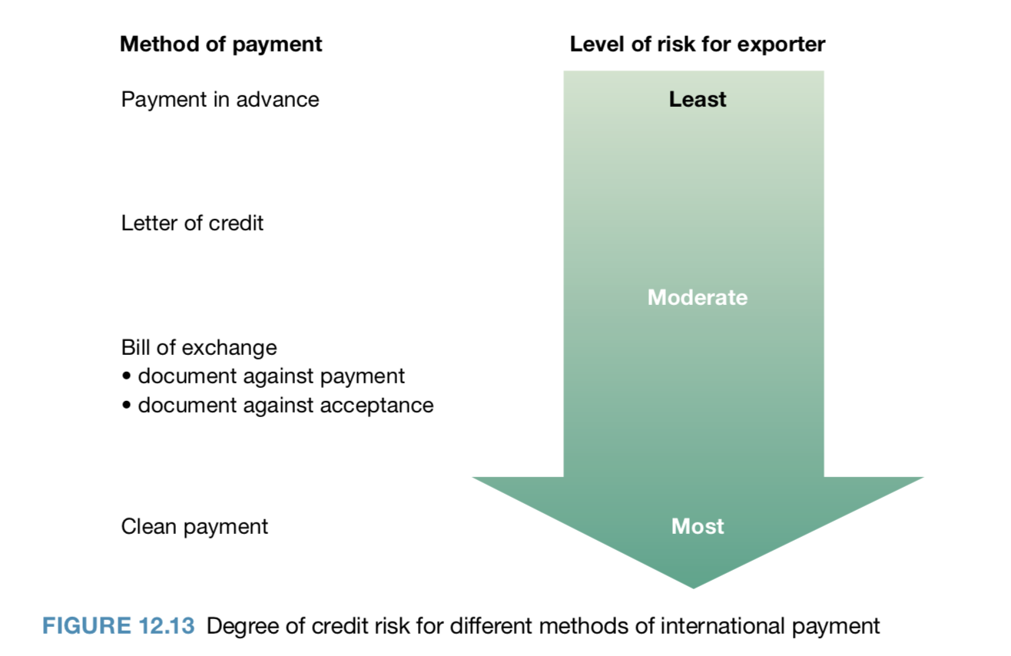
    Payment in advance | Allows the exporter to receive payment and then arrange for goods to be sent.  - Exposes the exporter to no risk  - Importers are exposed to the most risk, they have no guarantee they will receive what is ordered
    Letter of credit | Document that a buyer can request from their bank that guarantees the payment of goods will be transferred to the seller.  - Issued by the importer’s bank to the exporter promising to pay them a specified amount once certain conditions have been met  - In order for the payment to occur, the seller has to present the bank with the necessary documents proving shipment of the goods  - If the buyer cannot make the payment, the bank must cover the purchase  - Exporter is guaranteed to get the money, low risk for both exporter and importer
    Clean payment | An open account payment method. The exporter ships the goods directly to the importer before payment is received.  - Importer doesn’t send the payment until after they receive the goods  - Only used when the exporter is confident that the importer will pay back by the agreed time (typically 30, 60, 90 days)  - Riskiest for exporter, low risk for importer. Only used if the exporter is confident that the importer can pay.
    Bills of exchange | Document drawn up by the exporter demanding payment from the importer at a specified time.  - Allows the exporter to maintain control over the goods until payment is either made or guaranteed  Two types of bill of exchange:  - Document (bill) against payment  - Importer can collect the goods only after paying for them  - The exporter draws up a bill of exchange with his or her Australian bank and sends it to the importer’s bank along with a set of documents that will allow the importer to collect the goods  - Low risk for both importer and exporter  - Document (bill) against acceptance  - Importer can collect goods before paying for them  - Bill specifies when payment must be received  - Low risk for importer, exporter must be able to trust the importer so they can guarantee payment  - Importer must sign only acceptance of the goods and the terms of a bill exchange to receive the documents that allow them to pay for the goods at a later date
  Hedging | Natural hedging  Adopting a number of strategies to eliminate or minimise the risk of foreign exchange exposure.  - Provides the business with a natural hedge  Natural hedging strategies  - Establishing offshore subsidiaries → opening a branch in a foreign country removing the need for exchanging currencies  - Use the same foreign currency for import payments and export receipts  - Establish import and export contracts in AUDs  - Implement marketing strategies to reduce price sensitivity  Financial instrument hedging  - Derivatives can be used to minimise or spread the risk of exchange rate fluctuations
    Refers to the process of minimising the risk of currency fluctuations to help reduce the level of uncertainty involved with international financial transactions.
  Derivatives | Derivatives are ways the business can protect themselves from the risks of buying foreign currency.  Three main derivatives available for exporters:
    Simple financial instruments that may be used to lessen the exporting risks associated with currency fluctuations.
    Forward exchange contract | Contract to exchange one currency for another currency at an agreed exchange rate on a future date, usually after a period of 30, 90 or 180 days  - Bank guarantees the exporter, within the set time, a fixed rate of exchange for the money generated from the sale of the exported goods
      EXAMPLE
      Business sells $50,000 worth of products to a Japanese customer with an invoice payable in 30 days. Derivatives will allow them to lock in the value of the asset by selling Japanese yen and buying Australian dollars for a fixed rate, to be settled at the same time the invoice will be paid, thus locking in the value of the currency.
    Options contract | - Gives the buyer (option holder) the right, but not the obligation, to buy or sell foreign currency at some time in the future  - Protected from unfavourable exchange rate fluctuations, yet maintain the opportunity for gain should exchange rate movements be favourable
      EXAMPLE
      Australian business may need to buy US dollars in six months (180 days) to pay for equipment from a US supplier. They think the exchange rate will see the Australian Dollar depreciate (effectively make the equipment more expensive) at that time so they enter an options contract to buy US in six months at a predetermined price set now. The reality is that the AUD actually appreciates and so because there is no obligation to fulfil the contract they choose to buy USD at the spot rate which is more favourable.
    Swap contract | An agreement to exchange currency in the spot market with an agreement to reverse the transaction in the future.  - Involves a spot sale of one currency together with a forward repurchase of the currency at a specific date in the future  - Used when businesses need to raise finance in a currency issued by a country in which they are not well known and are forced to pay a higher interest rate than better known or local business  - Allows the business to alter its exposure to exchange fluctuations without discarding the original transaction
      EXAMPLES
      - Swapping $50 million AUD for US dollars now and an agreement to reverse the swap within 3 months.
      - A medium-sized Australian business may need Japanese yen, but even though it is a reputable business and has a good credit rating, it may not be well known in Japan. If it can find, or if a broker or bank can team it with, a Japanese busi- ness that wants Australian dollars, the swap would work as follows. The Australian business would borrow Australian dollars in Australia, where it is well known and can arrange a loan at cheaper interest rates; the Japanese business would borrow yen in Japan for the same reason. They would then agree to swap the currencies and repay each other’s loan; that is, the Japanese business would repay the Australian dollar loan, while the Australian business would repay the Japanese yen loan.

